1.I have an inherited process named “agile1” from Agile and I test on User Story of this process.

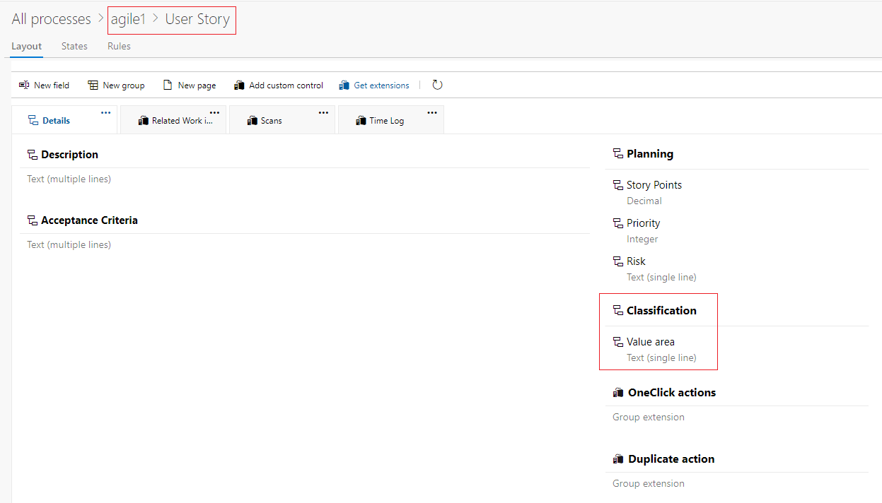

2.You mentioned that you want to create control to an existing group. Then I use “Classification” as an example.

3.Use Field-Create api to create a new field “NewFieldForTest”:

<https://docs.microsoft.com/zh-cn/rest/api/azure/devops/wit/fields/create?view=azure-devops-rest-5.0>

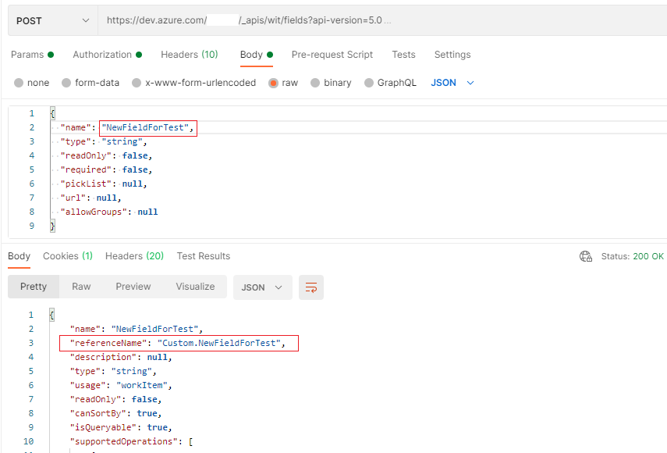

Note: Pay attention to the referenceName in response body.

3.Use Fields-Add api to add my field to User Story:

<https://docs.microsoft.com/zh-cn/rest/api/azure/devops/processes/fields/add?view=azure-devops-rest-5.0>

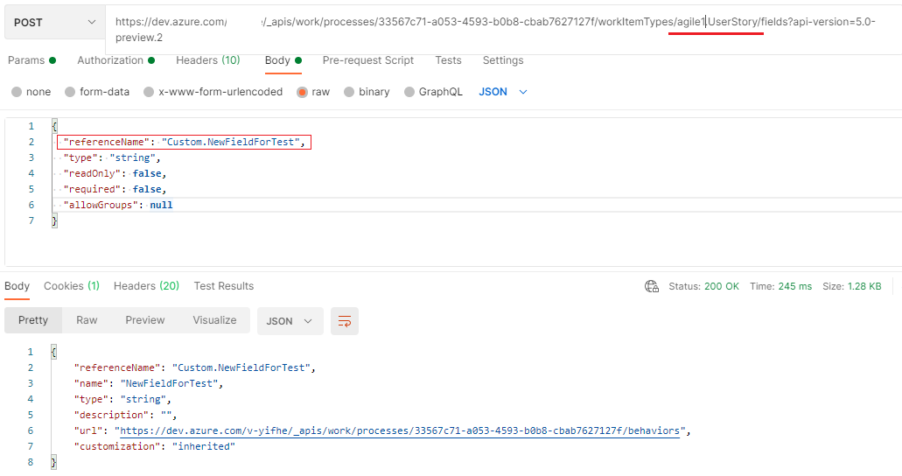

4.Use Controls-Create api to create a control in a group:

<https://docs.microsoft.com/zh-cn/rest/api/azure/devops/processes/controls/create?view=azure-devops-rest-5.0>

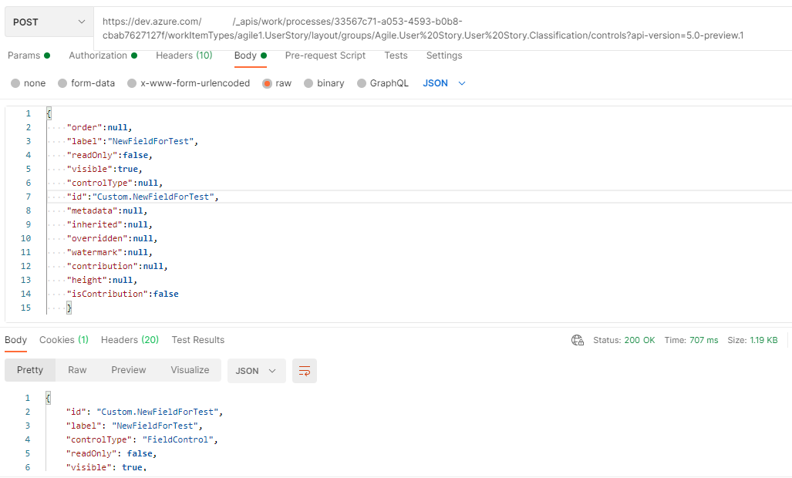

I create this new field in Classification group. Then back to the UI to check the result.

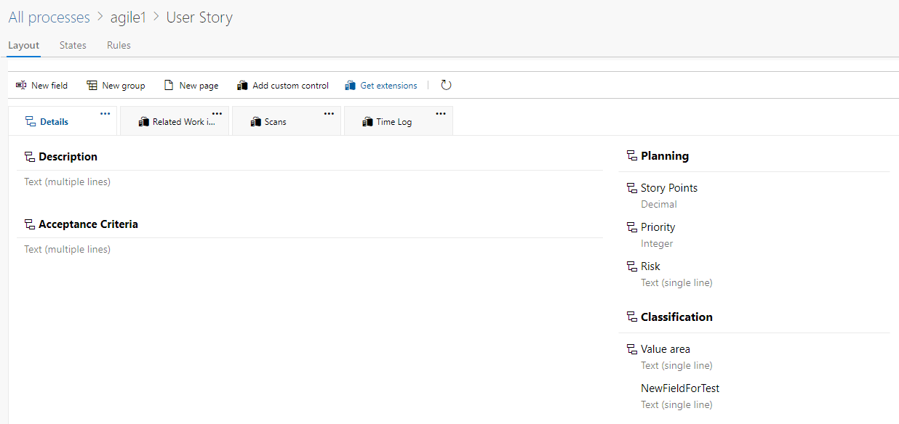

The new field has been added to this group in User Story. If you don’t see it the first time after refreshing page, you could back to organization page and refresh the page then access Organization Settings-> Process -> your process-> work item type to check the result.