电子科技大学
计算机科学与工程学院

第 二 次 实 验 报 告

（实验）课程名称 C++语言程序设计

电子科技大学教务处制表

电 子 科 技 大 学
实 验 报 告
学生姓名： 黄俊杰 | 学 号：2023080903009
- 实验室名称：计算机学院实验中心
二、实验项目名称： 需求2-支持加速功能
三、实验目的：
Executor组件增加执⾏加速指令功能

四、实验内容：
F: 加速指令，接收到该指令，车进入加速状态，该状态下：
M：前进2格（不能跳跃，只能一格一格前进）
L：先前进1格，然后左转90度
R：先前进1格，然后右转90度

再接收一次F指令，对应的状态取消

五、实验器材（设备、元器件）：
个人笔记本电脑

六、实验步骤及操作：
Executor组件代码：
#include <cassert>
#include <iostream>
#include <string>
using namespace std;

class Executor
{
public:
enum Direction { N = 'N', S = 'S', E = 'E', W = 'W' };

void GetPositionAndHeading(int32_t& x, int32_t& y, char& heading) const
{
x = this->x;
y = this->y;
heading = this->heading;
}

void Init(int32_t x = 0, int32_t y = 0, char heading = 'N')
{
this->x = x;
this->y = y;
this->heading = static_cast<Direction>(heading);
}

void DoCommands(string commands)
{
is = 0;
for (char command : commands) {
if (!IsFast(command)) {
switch (command) {
case 'M':
MoveForward();
break;
case 'L':
TurnLeft();
break;
case 'R':
TurnRight();
break;
}
} else {
switch (command) {
case 'M':
MoveForward();
MoveForward();
break;
case 'L':
MoveForward();
TurnLeft();
break;
case 'R':
MoveForward();
TurnRight();
break;
}
}
}
}

private:
int32_t x, y;
Direction heading;
bool is;

bool IsFast(char cmd)
{
if (is == 0 && cmd == 'F') {
is = 1;
} else if (is == 1 && cmd == 'F') {
is = 0;
}
return is;
}

void MoveForward()
{
switch (heading) {
case N:
++y;
break;
case S:
--y;
break;
case E:
++x;
break;
case W:
--x;
break;
}
}

void TurnLeft()
{
switch (heading) {
case N:
heading = W;
break;
case S:
heading = E;
break;
case E:
heading = N;
break;
case W:
heading = S;
break;
}
}

void TurnRight()
{
switch (heading) {
case N:
heading = E;
break;
case S:
heading = W;
break;
case E:
heading = S;
break;
case W:
heading = N;
break;
}
}
};
测试用例代码：
#include <gtest/gtest.h>

#include <iostream>
#include <string>

#include "Executor.h"

TEST(ExecutorTest, Initialization)
{
Executor executor;
executor.Init(1, 2, 'E');

int32_t x, y;
char heading;
executor.GetPositionAndHeading(x, y, heading);

EXPECT_EQ(x, 1);
EXPECT_EQ(y, 2);
EXPECT_EQ(heading, 'E');
}

TEST(ExecutorTest, MoveForward)
{
Executor executor;
executor.Init(1, 2, 'E');
executor.DoCommands("M");

int32_t x, y;
char heading;
executor.GetPositionAndHeading(x, y, heading);

EXPECT_EQ(x, 2);
EXPECT_EQ(y, 2);
EXPECT_EQ(heading, 'E');
}

TEST(ExecutorTest, TurnLeft)
{
Executor executor;
executor.Init(1, 2, 'E');
executor.DoCommands("L");

int32_t x, y;
char heading;
executor.GetPositionAndHeading(x, y, heading);

EXPECT_EQ(x, 1);
EXPECT_EQ(y, 2);
EXPECT_EQ(heading, 'N');
}

TEST(ExecutorTest, TurnRight)
{
Executor executor;
executor.Init(1, 2, 'E');
executor.DoCommands("R");

int32_t x, y;
char heading;
executor.GetPositionAndHeading(x, y, heading);

EXPECT_EQ(x, 1);
EXPECT_EQ(y, 2);
EXPECT_EQ(heading, 'S');
}

TEST(ExecutorTest, ExecuteCommands)
{
Executor executor;
executor.Init();
executor.DoCommands("MMRMMRMM");

int32_t x, y;
char heading;
executor.GetPositionAndHeading(x, y, heading);

EXPECT_EQ(x, 2);
EXPECT_EQ(y, 0);
EXPECT_EQ(heading, 'S');
}

TEST(ExecutorTest, ComplexCommands)
{
Executor executor;
executor.Init();

executor.DoCommands("MLMLMLML");

int32_t x, y;
char heading;
executor.GetPositionAndHeading(x, y, heading);

EXPECT_EQ(x, 0);
EXPECT_EQ(y, 0);
EXPECT_EQ(heading, 'N');
}

TEST(ExecutorTest, MixedCommands)
{
Executor executor;
executor.Init(1, 1, 'W');

executor.DoCommands("MRMLMMRMM");

int32_t x, y;
char heading;
executor.GetPositionAndHeading(x, y, heading);

EXPECT_EQ(x, -2);
EXPECT_EQ(y, 4);
EXPECT_EQ(heading, 'N');
}

TEST(ExecutorTest, FastMove)
{
Executor executor;
executor.Init();

executor.DoCommands("FMLMLMFR");

int32_t x, y;
char heading;
executor.GetPositionAndHeading(x, y, heading);

EXPECT_EQ(x, -3);
EXPECT_EQ(y, 1);
EXPECT_EQ(heading, 'W');
}

int main(int argc, char **argv)
{
::testing::InitGoogleTest(&argc, argv);
return RUN_ALL_TESTS();
}
八、实验数据及结果分析：
测试结果截图如下：
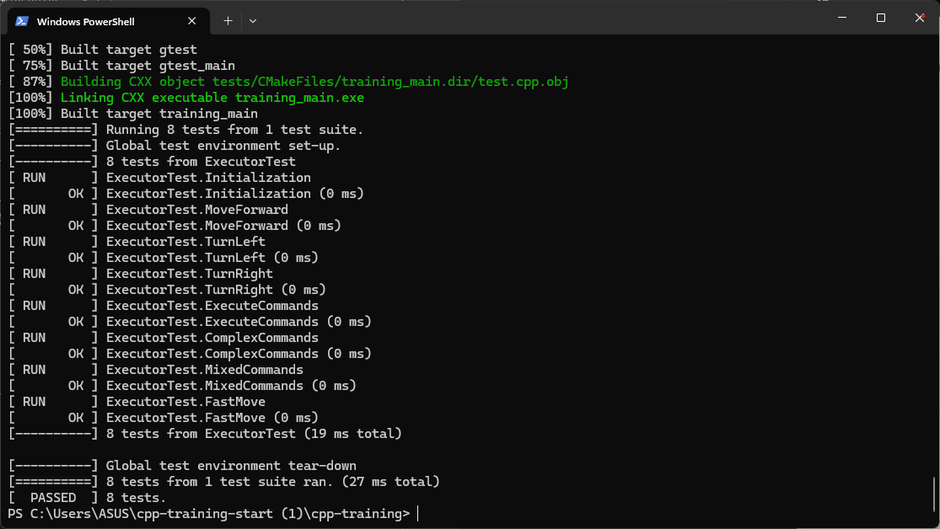
九、实验结论：
代码功能正常，基本实现需求
十、总结及心得体会：
加深了对面向对象封装的理解，了解了划分成员函数的好处
十一、对本实验过程及方法、手段的改进建议：
无
报告评分：
指导教师签字：

