PCA Covariance Estimation and Minimum-Variance Portfolios
  - Written summary of a summer quantitative project
This project compares three portfolio construction methods. In the current results, the PCA-based portfolio has almost the same realised volatility as the sample-covariance minimum-variance portfolio, while showing lower average turnover and smaller average individual positions.

The question I wanted to answer
A minimum-variance portfolio requires a covariance matrix for asset returns. The true future covariance matrix is unknown, so it must be estimated from historical data. Because the historical sample is finite, the estimate contains noise. The optimisation can react strongly to that noise, producing large long and short positions or frequent changes in portfolio weights.
I therefore asked whether, for the same stock universe, training window and optimisation objective, applying principal component analysis (PCA) to the covariance matrix could reduce out-of-sample volatility and make the portfolio weights more stable.

What I did
I used adjusted closing prices (adjClose) from Tiingo to construct a fixed universe of 30 US stocks. The price data run from 4 January 2010 to 31 July 2026, giving 4,169 price observations. Simple daily returns were calculated as today’s price divided by the previous price minus one, producing 4,168 return observations for each of the 30 assets.
The data audit found no missing values, infinite values or duplicated dates, and the dates were in increasing order. The longest consecutive run of zero returns was two days. There were 14 observations with an absolute daily return of at least 20%. The code retained these extreme observations, but the Notebook did not independently verify each one, so these checks alone do not establish that every market observation is correct.
In the first 252-day training window, I calculated the sample covariance matrix manually and compared it with the pandas implementation; the two agreed to floating-point precision. The mean pairwise correlation was approximately 0.461. The first principal component explained about 48.4% of total variance, and the first ten explained about 82.2%. This indicates that a substantial part of the variation in that window lay in a small number of directions, providing a reason to test PCA, without implying that all remaining directions were noise.

Portfolio methods and backtest design
I compared an equal-weight portfolio, a sample-covariance minimum-variance portfolio, and a PCA-covariance minimum-variance portfolio. The equal-weight portfolio assigns a target weight of 1/30 to each stock. The two minimum-variance portfolios minimise their respective estimated portfolio variance subject to weights summing to one. Short positions are allowed, and there is no gross-exposure cap.
The PCA estimator keeps the k largest eigenvalues and their corresponding eigenvectors, then replaces the remaining eigenvalues with their average. It therefore preserves the main covariance directions while retaining a non-zero risk estimate for the remaining directions. The main comparison uses k = 10, with additional tests for k = 5, 15 and 20.
The backtest uses a rolling 252-trading-day training window. On each test day, I estimate the covariance matrix using only the preceding 252 returns, calculate the portfolio weights, and apply those weights to the return on that test day. All three portfolios use the same test period, from 4 January 2011 to 31 July 2026, covering 3,916 trading days. This is an idealised daily-rebalanced backtest before transaction costs.

Results: similar risk, more moderate holdings
Table 1 Overall comparison of the three portfolios
Metric | Equal weight | Sample min-variance | PCA (k = 10)
Annualised realised volatility | 16.76% | 13.47% | 13.45%
Mean target-weight turnover / day | 0.00% | 4.80% | 4.30%
Mean drifted turnover / day | 0.44% | 4.98% | 4.50%
Mean gross exposure | 1.000× | 2.089× | 1.996×
Mean maximum absolute weight | 3.33% | 28.26% | 20.86%
Compound annual growth rate (CAGR) | 18.19% | 12.81% | 13.62%
Source: saved outputs from the backtest Notebook. Volatility is the standard deviation of daily returns multiplied by √252; CAGR uses the number of trading days divided by 252 as the year count. Turnover averages exclude the initial portfolio formation and use 3,915 consecutive-date adjustments. Returns are before costs.
The annualised volatility of the PCA and sample minimum-variance portfolios differs by only about 0.02 percentage points. The experiment therefore does not provide enough evidence to claim that PCA materially reduced risk. The clearer differences are in the holdings: mean target-weight turnover falls from about 4.80% to 4.30%, and mean maximum absolute weight falls from about 28.26% to 20.86%.

How I interpret these results
Target-weight turnover is half the sum of the absolute changes in target weights between two consecutive dates. Drifted turnover first accounts for the change in actual weights caused by the previous day’s asset returns, then measures the adjustment needed to reach the new target. Equal weighting has zero target-weight turnover because its targets do not change, but prices still create a need to rebalance the actual portfolio.
Gross exposure is the sum of the absolute portfolio weights. The maximum absolute weight describes the size of the largest individual position; neither quantity directly measures stability over time. PCA reduces mean drifted turnover by about 9.6%, but its maximum single-day drifted turnover is approximately 75.0%, above the sample method’s 72.2%. An improvement in the average therefore does not mean that PCA is better on every day.
Table 2 Results for different numbers of retained components
Retained components k | Annualised realised volatility | Mean target-weight turnover / day
5 | 13.61% | 3.28%
10 | 13.45% | 4.30%
15 | 13.49% | 4.88%
20 | 13.44% | 5.10%
Source: parameter comparison over the same backtest period; values are rounded for display.
Across these candidate values, realised volatility remains between about 13.44% and 13.61%, while turnover rises clearly as k increases. Smaller k values produce lower mean turnover but do not necessarily produce the lowest realised volatility; at k = 20, turnover is even higher than for the sample method. The results therefore suggest a trade-off between risk and weight stability rather than a universally optimal k.
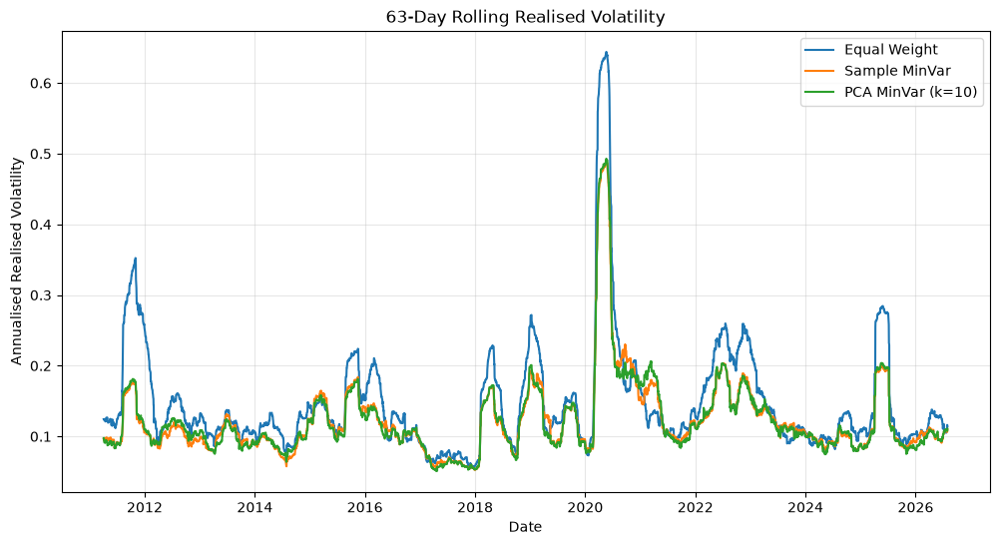
Figure 1 63-day rolling annualised realised volatility. The blue line is equal weight, orange is sample minimum variance, and green is PCA with k = 10. The two minimum-variance methods are generally close, and PCA is not lower in every period. Figure reproduced from the original Notebook.

Limitations
The return results need to be interpreted alongside the project objective. The equal-weight portfolio has a higher CAGR than both minimum-variance portfolios, but also higher volatility. The PCA portfolio has a higher CAGR than the sample portfolio in this historical sample. Minimising estimated variance is not the same as maximising return, so these results do not establish that any one method is best overall.
The stock universe is a fixed selection of 30 stocks. It was not reconstructed at each historical date, and delisted stocks were not systematically included. The results may therefore be affected by selection and survivorship bias and should not be treated as representative of the entire US equity market.
The experiment uses only a 252-day training window, and the candidate k values are compared on the same test period. If a parameter is selected after inspecting this period, its performance is no longer a fully independent validation result. Testing additional time periods would help assess stability.
The backtest does not include commissions, bid-ask spreads, slippage, financing costs or stock-borrow costs, and it does not model the exact time of execution. Although the covariance estimate excludes the test-day return, applying weights formed from the previous close to the next close-to-close return remains an idealised execution assumption. Unconstrained short positions and gross exposure also differ from the conditions of many real accounts.
Finally, the comparison is descriptive and does not include statistical significance tests. The extreme-return records were not all independently checked. The project should therefore be treated as an exploratory study of covariance estimation and portfolio construction.

What I learned and project conclusion
This project connected covariance matrices, eigenvalues and PCA from linear algebra with data handling and portfolio backtesting. I also learned how to audit a dataset, keep training information separate from test information, and evaluate a model using several complementary metrics. Distinguishing changes in target weights from the extra rebalancing caused by price drift was an especially useful part of the exercise.
The results provide partial support for the original hypothesis. Under the current sample and settings, PCA with k = 10 keeps realised volatility close to that of the sample minimum-variance portfolio while reducing mean turnover, mean gross exposure and mean maximum absolute weight. Its main value in this experiment is therefore improved portfolio characteristics, while the reduction in realised risk is small and does not support a claim of a decisive advantage.
A natural extension of this project would be to make the Notebook’s result references and summary calculations fully consistent, then test whether the difference between the two minimum-variance methods remains after reasonable transaction costs are included. This would move the analysis closer to practical implementation.

