- 私有仓库
官方提供了一个registry镜像来简单的搭建一个本地私有仓库环境：
先将镜像拉取过来吧：
[root@cxp ~]# docker pull registry
Pulling repository registry
d849e35be7b0: Pulling dependent layers
d849e35be7b0: Pulling image (latest) from registry
。。。省略。。。

[root@cxp ~]# docker images
REPOSITORY TAG IMAGE ID CREATED VIRTUAL SIZE
registry latest d849e35be7b0 Less than a second ago 413.9 MB

接下来，我们启动一个registry容器：
[root@cxp ~]# docker run -it registry /bin/bash
root@54e93f51a1b9:/#
root@54e93f51a1b9:/# ls
bin dev etc lib media opt root sbin sys usr
boot docker-registry home lib64 mnt proc run srv tmp var
看到没有，启动的容器默认镜像仓库的目录是 /tmp/registry/

我可以通过-v（后面会讲数据卷）参数将镜像文件存放在本地文件制定的路径上：
[root@cxp ~]# docker run -d -p 5000:5000 -v /opt/data/registry/:/tmp/registry registry
7ec9af39d6cf67103bc44e01ed44c2471ccaf5ed998f69fa164b31eed7e25419

[root@cxp ~]# docker ps -a
CONTAINER ID IMAGE COMMAND CREATED STATUS PORTS NAMES
7ec9af39d6cf registry:latest "docker-registry" 6 seconds ago Up 4 seconds 0.0.0.0:5000->5000/tcp stoic_einstein

上面是以-d守护进程的形式创建的，这时小西想到那以-it形式会怎么样呢？
[root@cxp ~]# docker run -it -p 5001:5001 -v /opt/data/registry/:/tmp/registry registry /bin/bash
root@a7e7c4f1d27b:/# ls
bin dev etc lib media opt root sbin sys usr
boot docker-registry home lib64 mnt proc run srv tmp var
root@a7e7c4f1d27b:/#
root@a7e7c4f1d27b:/# exit
exit

[root@cxp ~]# docker ps -a
CONTAINER ID IMAGE COMMAND CREATED STATUS PORTS NAMES
a7e7c4f1d27b registry:latest "/bin/bash" About a minute ago Exited (0) About a minute ago sharp_hoover
7ec9af39d6cf registry:latest "docker-registry" 2 minutes ago Up 2 minutes 0.0.0.0:5000->5000/tcp stoic_einstein

是不是发现一个奇怪的问题呢？ 其实，前已经出现过类似的问题了，我们来解析一下吧：
- 我们用参数-it形式，是以交互形式启动容器的，当我们用exit命令会临时退出容器，查看的时候显示状态：Exited (0) About a minute ago ，因此，我们就看不到端口信息了。
2.当用-d参数时，是以守护进程（daemon）的形式运行 ，是在后台的挂起的状态： Up 2 minutes ，所以我们能够看到端口的信息。

细心的朋友可能会发现：当以-d参数启动容器时，我们并没有输入任何命令，而查看的时候却显示有命令，且为“docker-registry”，这是因为程序调用了容器的docker-registry的服务。不明白也别急，下面就会涉及到哦！
本地的私有仓库我们已经搭建完成了，下面就是来管理自己的私有仓库：
我们先来查看一下地址：
[root@cxp ~]# ifconfig
docker0 Link encap:Ethernet HWaddr 6A:5A:A2:14:FA:40
inet addr:172.17.42.1 Bcast:0.0.0.0 Mask:255.255.0.0
inet6 addr: fe80::8c95:dcff:fe6f:3efb/64 Scope:Link
UP BROADCAST RUNNING MULTICAST MTU:1500 Metric:1
RX packets:26195 errors:0 dropped:0 overruns:0 frame:0
TX packets:64902 errors:0 dropped:0 overruns:0 carrier:0
collisions:0 txqueuelen:0
RX bytes:1068117 (1.0 MiB) TX bytes:96527670 (92.0 MiB)

eth2 Link encap:Ethernet HWaddr 00:0C:29:72:E2:00
inet addr:192.168.159.141 Bcast:192.168.159.255 Mask:255.255.255.0
inet6 addr: fe80::20c:29ff:fe72:e200/64 Scope:Link
UP BROADCAST RUNNING MULTICAST MTU:1500 Metric:1
RX packets:692735 errors:0 dropped:0 overruns:0 frame:0
TX packets:342670 errors:0 dropped:0 overruns:0 carrier:0
collisions:0 txqueuelen:1000
RX bytes:895859674 (854.3 MiB) TX bytes:42439596 (40.4 MiB)

#经测试上面两个ip都可以
测试一下：
[root@cxp ~]# curl http://172.17.42.1:5000
"\"docker-registry server\"" #返回响应的信息

将自己的镜像山传到本低仓库：
（1）查看镜像
[root@cxp ~]# docker images
REPOSITORY TAG IMAGE ID CREATED VIRTUAL SIZE
debian 7 497e13ba472a 11 da

- 用docker tag命令更改标签
[root@cxp ~]# docker tag debian:7 172.17.42.1:5000/debain:self
（3）检查
[root@cxp ~]# docker images
REPOSITORY TAG IMAGE ID CREATED VIRTUAL SIZE
172.17.42.1:5000/debain self 497e13ba472a 11 days ago 552.8 MB
debian 7 497e13ba472a 11 days ago
- 推送镜像
[root@cxp ~]# docker push 172.17.42.1:5000/debain:self
FATA[0004] Error: v1 ping attempt failed with error: Get https://172.17.42.1:5000/v1/_ping: EOF. If this private registry supports only HTTP or HTTPS with an unknown CA certificate, please add `--insecure-registry 172.17.42.1:5000` to the daemon's arguments. In the case of HTTPS, if you have access to the registry's CA certificate, no need for the flag; simply place the CA certificate at /etc/docker/certs.d/172.17.42.1:5000/ca.crt
出问题了！有问题就要解决！
来一起分析一下：
错误提示：需要安全证书，经查询：Docker从1.3.X之后默认docker registry使用的是https，所以当用docker pull命令下载远程镜像时，如果远程docker registry是非https的时候就会报上面的错误。

官网和大神们给出了以下有两种方案：
（1）在启动配置文件中添加--insecure-registry参数
（2）不要使用docker-registry，在registry前面套一层nginx代理，在nginx里自己签一组证书，把ca.crt拷贝到 /etc/docker/certs.d/10.0.1.44:5000/ca.crt 就可以了。这样的好处是，今后你还有第二套registry，你也只是把新的registry证书加入对应的目录，即可下载，而不是再加--insecure-registry重启。
Nginx我们会在后面的搭建注册服务器端时候会涉及，这里先不采用。

解决方法：（这里小西掉进了一个大坑，不过问题还是自己解决了）
[root@cxp ~]# vim /etc/init.d/docker
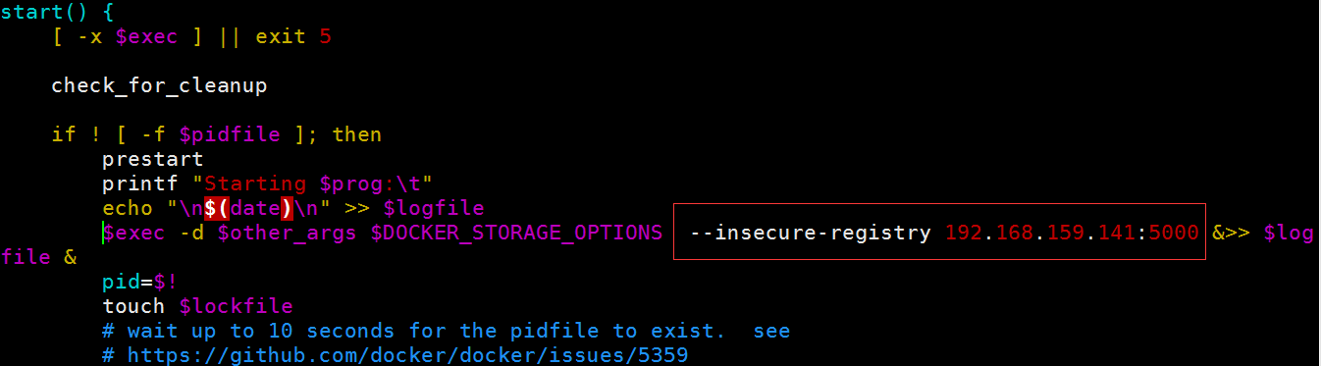

重启docker：
[root@cxp ~]# /etc/init.d/docker restart
Stopping docker: [ OK ]
Starting docker: [ OK ]
查看一下进程：
[root@cxp ~]# ps -ef|grep docker
root 39705 1 0 07:06 pts/7 00:00:00 /usr/bin/docker -d --insecure-registry 192.168.159.141:5000
root 39776 35435 0 07:07 pts/7 00:00:00 grep docker
然而之前的进程是这样的：
[root@cxp ~]# ps -ef|grep docker
root 39116 1 1 06:51 pts/7 00:00:00 /usr/bin/docker -d
root 39186 35435 3 06:51 pts/7 00:00:00 grep docker

接下来，我们来推送镜像吧：
[root@cxp ~]# docker push 172.17.42.1:5000/debian:self
FATA[0000] Error: v1 ping attempt failed with error: Get http://172.17.42.1:5000/v1/_ping: dial tcp 172.17.42.1:5000: connection refused
Fuck！问题又来了！
继续分析：
错误提示：拒绝连接！
排查：
- 经过各种重启服务，ping命令，关闭防火墙，SELINUX全部无效；
- 推测肯定不是系统服务问题，查看一下Docker版本和registry版本：
[root@cxp ~]# docker version
Client version: 1.5.0
Client API version: 1.17
Go version (client): go1.3.3
Git commit (client): a8a31ef/1.5.0
OS/Arch (client): linux/amd64
Server version: 1.5.0
Server API version: 1.17
Go version (server): go1.3.3
Git commit (server): a8a31ef/1.5.0
[root@cxp ~]# docker inspect registry
[{
。。。省略。。。
"Created": "2015-05-27T05:15:48.671480943Z",
"DockerVersion": "1.6.0",
"Id": "d849e35be7b03151e51319c103d7c19df0b6e9f29567d46011127d61aa2e3b50",
}
。。。省略。。。
]
搜嘎，原来问题出在这里！
- 原因找到了，该怎么解决呢？小西特地到官方查了一下：If a docker client has a version less than 1.6, Nginx will route its requests to the 1.0 registry. Requests from newer clients will route to the 2.0 registry.
- Docker最新版本是1.6，而对应的registry版本是v2；小西用Docker版本是1.5，对应的registry应该是v1

解决方法：
- 升级现在的Docker
- 降级registry

这里选择方案1，下面的学习都将采用Docker 1.6版本，基础方面差别不大哦！

我们采用手动更新，yum更新到不了1.6版本问题：
[root@cxp ~]#wget https://get.docker.io/builds/Linux/x86_64/docker-latest -O docker
[root@cxp ~]#mv -f docker /usr/bin/docker
升级后：
授权：[root@cxp ~]# chmod +x /usr/bin/docker
启动：[root@cxp ~]# /etc/init.d/docker restart
Stopping docker: [ OK ]
Starting docker: [ OK ]
开机自启动：
[root@cxp ~]# chkconfig docker on

再次重新启动：
[root@cxp ~]# /etc/init.d/docker restart
Stopping docker: [ OK ]
Starting docker: [ OK ]

检查：
[root@cxp ~]# docker version
Client version: 1.6.2
Client API version: 1.18
Go version (client): go1.4.2
Git commit (client): 7c8fca2
OS/Arch (client): linux/amd64
Server version: 1.6.2
Server API version: 1.18
Go version (server): go1.4.2
Git commit (server): 7c8fca2
OS/Arch (server): linux/amd64

中途出现的小问题：
[root@cxp ~]# docker version
Client version: 1.6.2
Client API version: 1.18
Go version (client): go1.4.2
Git commit (client): 7c8fca2
OS/Arch (client): linux/amd64
FATA[0000] Error response from daemon: client and server don't have same version (client : 1.18, server: 1.17)
解决方法：
重启即可：[root@cxp ~]# /etc/init.d/docker restart
[root@cxp ~]# docker push 172.17.42.1:5000/ubuntu:self
FATA[0020] Error response from daemon: v1 ping attempt failed with error: Get http://172.17.42.1:5000/v1/_ping: dial tcp 172.17.42.1:5000: i/o timeout
Fuck了！什么鸟情况？
小西继续排错：
- 简单的回顾了一下，自己的排错流程，发现没有什么错误，然后自己又把docker所有配置文件，查了一遍果然发现了一个大坑
- 之前小西更改的是/etc/init.d/docker 启动脚本的配置文件，网上给的参考都是/etc/default/docker.conf配置文件，经过小西的排错分析和实验，原来centos的配置文件在/etc/sysconfig/docker中，如下图：
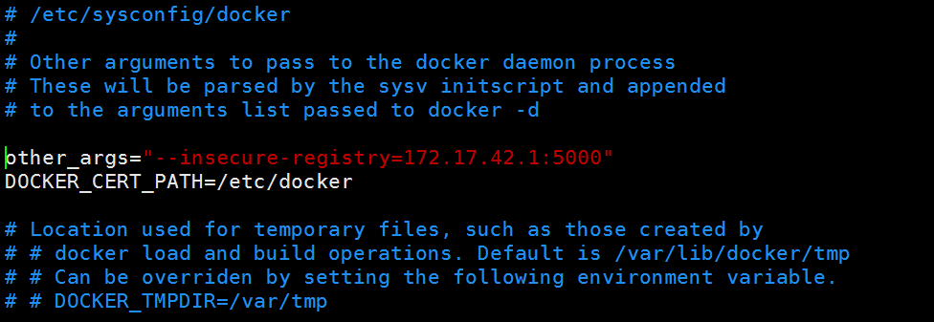
小西提示：网上的资料仅供参考，要经过自己的实战来验证哦！

配置文件已经更改完毕，然后还是重启生效：
[root@cxp ~]# service docker restart #另一种方式
Stopping docker: [ OK ]
Starting docker: [ OK ]

启动容器：
[root@cxp ~]# docker ps -a
CONTAINER ID IMAGE COMMAND CREATED STATUS PORTS NAMES
30985a553d4b registry:latest "docker-registry" 28 minutes ago Exited (3) 12 minutes ago kickass_albattani
[root@cxp ~]# docker start 30985a553d4b
30985a553d4b

终于到了最后成功的时候了：
[root@cxp ~]# docker push 172.17.42.1:5000/ubuntu
The push refers to a repository [172.17.42.1:5000/ubuntu] (len: 1)
Sending image list
Pushing repository 172.17.42.1:5000/ubuntu (1 tags)
e9e06b06e14c: Image successfully pushed
a82efea989f9: Image successfully pushed
37bea4ee0c81: Image successfully pushed
07f8e8c5e660: Image successfully pushed
Pushing tag for rev [07f8e8c5e660] on {http://172.17.42.1:5000/v1/repositories/ubuntu/tags/self}

赶紧查看一下吧：
[root@cxp images]# curl http://172.17.42.1:5000/v1/search
{"num_results": 1, "query": "", "results": [{"description": "", "name": "library/ubuntu"}]}[root@cxp images]#
上述表明已经成功上传了！
然后我们在另外一台机器上测试：

- 私有仓库服务器
随着时间的推移，我们的镜像越来越多，本地的镜像的管理也不是很方便，这时我们就有必要搭建一个私有仓库的注册服务器啦。
我们使用基于python的开源项目：docker-registry，同时官方也提供了docker-registry镜像，所以我们可以通过容器运行和源码安装方式来使用docker-registry。
参考来源：https://github.com/docker/docker-registry
- 基于容器运行
前面我们已经做过了：
[root@cxp ~]# docker run -d -p 5001:5001 registry
ad178ad326f9dc2683bdcec4f36114d3db9abe3bd608812558e660b129a17545

启动后将容器中的配置文件和仓库的存储路径挂载到本地：
指定端口启动容器：
[root@cxp ~]# docker run -d -p 5001:5001 registry
ad178ad326f9dc2683bdcec4f36114d3db9abe3bd608812558e660b129a17545
指定容器的配置文件到本地的路径：
[root@cxp ~]# docker run -d -p 5002:5002 -v /home/Siffre/registry-conf:/registry-conf -e DOKCER_REGISTRY_CONFIG=/registry-conf/config.yaml registry
76ba156d7871219068fe6bf6eb3abab9d1e96c74454b499a22d5a62b99dc8b7e
指定镜像存储到本地的路径：
[root@cxp ~]# docker run -d -p 5003:5003 -v /opt/data/registry/:/tmp/registry registry
e2349de3802b14bdff36a435645c15f26530f86f5db250fa1fd6d042cf2c7674
以上是分别实现的，下面通过一条命令实现：
[root@cxp ~]# docker run -d -p 4998:4998 -v /home/Siffre/registry-conf:/registry-conf -v /opt/data/registry/:/tmp/registry registry
ef07e01541a16aea047555a4145989f00337a004dd740dc3cb2fc27445d60abf
#指定多个-v参数即可
[root@cxp ~]# docker ps
CONTAINER ID IMAGE COMMAND CREATED STATUS PORTS NAMES
ef07e01541a1 registry:latest "docker-registry" 5 seconds ago Up 2 seconds 0.0.0.0:4998->4998/tcp, 5000/tcp naughty_goodall

- 本地安装运行
我们将通过两种方式来搭建自己的注册服务器：
安装docker-registry （基于本地的安装，后期会基于openstack的项目安装）
- 基于官方的镜像安装（参考：http://my.oschina.net/wstone/blog/355560 ）
1.安装依赖包
[root@cxp /]#yum -y install gcc make file && yum -y install tar pcre-devel pcre-staticopenssl openssl-devel httpd-tools
- 配置SSL
（1）添加域名和ip
[root@cxp /]# vim /etc/hosts
192.168.159.141 docker.test.com
- 生成根密钥
[root@cxp etc]# cd ./pki/CA
[root@cxp CA]# openssl genrsa -out private/cakey.pem 2048
Generating RSA private key, 2048 bit long modulus
....................+++
..................................+++
e is 65537 (0x10001)
- 生成根证书
[root@cxp CA]# openssl req -new -x509 -key private/cakey.pem -out caert.pem
You are about to be asked to enter information that will be incorporated
into your certificate request.
What you are about to enter is what is called a Distinguished Name or a DN.
There are quite a few fields but you can leave some blank
For some fields there will be a default value,
If you enter '.', the field will be left blank.
-----
Country Name (2 letter code) [XX]:CN
State or Province Name (full name) []:beijing
Locality Name (eg, city) [Default City]:guomao
Organization Name (eg, company) [Default Company Ltd]:
Organizational Unit Name (eg, section) []:
Common Name (eg, your name or your server's hostname) []:docker.test.com
Email Address []:
#会提示输入一些内容，因为是私有的，所以可以随便输入，最好记住能与后面保持一致,特别是"Common Name”。上面的自签证书cacert.pem应该生成在/etc/pki/CA下
[root@cxp CA]# ls
caert.pem certs crl newcerts private

- 为Nginx web服务器生成ssl密钥
[root@cxp /]# mkdir -p /etc/nginx/ssl
[root@cxp /]# cd /etc/nginx/ssl
[root@cxp ssl]# openssl genrsa -out nginx.key 2048
Generating RSA private key, 2048 bit long modulus
...+++
..................................................+++
e is 65537 (0x10001)
[root@cxp ssl]# ls
nginx.key

#我们的CA中心与要申请证书的服务器是同一个，否则应该在另一台需要用到证书的服务器上生成。

- 为Nginx生成证书签署请求
[root@cxp ssl]# openssl req -new -key nginx.key -out nginx.csr
You are about to be asked to enter information that will be incorporated
into your certificate request.
What you are about to enter is what is called a Distinguished Name or a DN.
There are quite a few fields but you can leave some blank
For some fields there will be a default value,
If you enter '.', the field will be left blank.
-----
Country Name (2 letter code) [XX]:CN
State or Province Name (full name) []:beijing
Locality Name (eg, city) [Default City]:guomao
Organization Name (eg, company) [Default Company Ltd]:
Organizational Unit Name (eg, section) []:
Common Name (eg, your name or your server's hostname) []:docker.test.com
Email Address []:

Please enter the following 'extra' attributes
to be sent with your certificate request
A challenge password []:
An optional company name []:
#同样会提示上面输入的内容，Commone Name一定要是我们授予证书的服务器域名或主机名，密码可不填。

- 私有CA根据请求来签发证书
[root@cxp CA]# touch index.txt
[root@cxp CA]# touch serial
[root@cxp CA]# echo 00 > serial
[root@cxp CA]# openssl ca -in /etc/nginx/ssl/nginx.csr -out nginx.crt #nginx.csr 全路径，不然会提示找不到文件错误
Using configuration from /etc/pki/tls/openssl.cnf
Check that the request matches the signature
Signature ok
Certificate Details:
Serial Number: 0 (0x0)
Validity
Not Before: Jun 2 22:35:05 2015 GMT
Not After : Jun 1 22:35:05 2016 GMT
Subject:
countryName = CN
stateOrProvinceName = beijing
organizationName = Default Company Ltd
commonName = docker.test.com
X509v3 extensions:
X509v3 Basic Constraints:
CA:FALSE
Netscape Comment:
OpenSSL Generated Certificate
X509v3 Subject Key Identifier:
15:D1:7F:7A:A0:B2:80:B9:3D:E1:A0:95:B7:ED:D5:34:77:21:60:42
X509v3 Authority Key Identifier:
keyid:F2:6B:FE:1E:DE:3C:CB:10:36:15:BB:00:71:CF:C1:55:F9:65:21:B0

Certificate is to be certified until Jun 1 22:35:05 2016 GMT (365 days)
Sign the certificate? [y/n]:y #输入y即可

1 out of 1 certificate requests certified, commit? [y/n]y
Write out database with 1 new entries
Data Base Updated

- 编译安装nginx （依赖包，前面已经yum安装无需再次安装）
- 为nginx添加用户和组
[root@cxp CA]# useradd nginx -s /sbin/nologin -M
- 下载nginx源文件
[root@cxp CA]#cd /home/Siffre/tools
[root@cxp CA]#wget http://nginx.org/download/nginx-1.6.3.tar.gz
[root@cxp tools]#tar -xvf nginx-1.6.3.tar.gz #尽量不要用-v参数，减少系统的IO
（3）编译安装
[root@cxp tools]#cd nginx-1.6.3
[root@cxp tools]# ./configure --user=www --group=www --prefix=/opt/nginx --with-pcre --with-http_stub_status_module --with-http_ssl_module --with-http_addition_module --with-http_realip_module --with-http_flv_module && make && make install
#也可以分步完成编译安装，便于检查错误（推荐新手分步安装）
- 更改配置文件nginx.conf的用户名和组
[root@cxp conf]#vim nginx.conf

- 检查语法
[root@cxp conf]# /opt/nginx/sbin/nginx -t
nginx: the configuration file /opt/nginx/conf/nginx.conf syntax is ok
nginx: configuration file /opt/nginx/conf/nginx.conf test is successful
#nginx编译安装到此就完成了

- 生成.htpasswd密码文件
[root@cxp conf]# htpasswd -cb /opt/nginx/conf/.htpasswd nginx nginx #${USER} ${PASSWD} USER最好是nginx用户，密码自定义即可

- 编辑nginx.conf配置文件 #注意：不同版本默认参数可能不同，按照下面参数配置即可

# 使用的用户和组
user www www;
# 指定工作进程数(一般等于CPU总核数)
worker_processes auto;
# 指定错误日志的存放路径,错误日志记录级别选项为:[debug | info | notic | warn | error | crit] error_log
/var/log/nginx_error.log error;
#指定pid存放的路径
#pid logs/nginx.pid;
# 指定文件描述符数量
worker_rlimit_nofile 51200;
events {
# 使用的网络I/O模型,Linux推荐epoll;FreeBSD推荐kqueue
use epoll;
# 允许的最大连接数
worker_connections 51200;
multi_accept on;
}
http {
include mime.types;
#日志格式
log_format main '$remote_addr - $remote_user [$time_local] "$request" ' '$status $body_bytes_sent "$http_referer" ' '"$http_user_agent" "$upstream_addr"';
#访问日志的形式
access_log /var/log/nginx_access.log main;
# 服务器名称哈希表的桶大小,该默认值取决于CPU缓存 server_names_hash_bucket_size 128;
# 客户端请求的Header头缓冲区大小
client_header_buffer_size 32k;
large_client_header_buffers 4 32k;
# 启用sendfile()函数
sendfile on;
tcp_nopush on;
tcp_nodelay on;
keepalive_timeout 65;
#nginx代理模块
upstream registry {
server 127.0.0.1:5000;
}
server {
listen 443;
server_name 192.168.2.114;
ssl on;
ssl_certificate /etc/pki/CA/nginx.crt; #注意路径
ssl_certificate_key /etc/nginx/ssl/nginx.key; #路径 client_max_body_size 0;
# disable any limits to avoid HTTP 413 for large image uploads
# required to avoid HTTP 411: see Issue
#1486 (https://github.com/docker/docker/issues/1486) chunked_transfer_encoding on;

location / {
auth_basic "registry";
auth_basic_user_file /opt/nginx/conf/.htpasswd;#我们生成的文件
root html;
index index.html index.htm;
proxy_pass http://registry; #指向upstream模块
#以下是获得通过代理访问的主机header内容，获取ip
proxy_set_header Host $http_host;
proxy_set_header X-Real-IP $remote_addr;
proxy_set_header Authorization "";

client_body_buffer_size 128k;
proxy_connect_timeout 90;
proxy_send_timeout 90;
proxy_read_timeout 90;
proxy_buffer_size 8k;
proxy_buffers 4 32k;
#如果系统很忙的时候可以申请更大的proxy_buffers 官方推荐*2
proxy_busy_buffers_size 64k;
#proxy缓存临时文件的大小
proxy_temp_file_write_size 64k;
}
location /_ping {
auth_basic off;
proxy_pass http://registry;
}
location /v1/_ping {
auth_basic off;
proxy_pass http://registry;
}
}
}

- 检查语法
[root@cxp conf]# /opt/nginx/sbin/nginx -t
nginx: the configuration file /opt/nginx/conf/nginx.conf syntax is ok
nginx: configuration file /opt/nginx/conf/nginx.conf test is successful

- 启动nginx
[root@cxp nginx]# ./sbin/nginx

- 验证nginx启动
[root@cxp nginx]# ps -ef|grep nginx
root 28124 1 0 08:28 ? 00:00:00 nginx: master process ./sbin/nginx
nginx 28125 28124 0 08:28 ? 00:00:00 nginx: worker process
nginx 28126 28124 0 08:28 ? 00:00:00 nginx: worker process
nginx 28127 28124 0 08:28 ? 00:00:00 nginx: worker process
nginx 28128 28124 0 08:28 ? 00:00:00 nginx: worker process
root 28135 23733 2 08:29 pts/1 00:00:00 grep nginx

- 配置，运行docker
- 先停止运行的docker
[root@cxp /]# /etc/init.d/docker stop
Stopping docker: [ OK ]
- 编辑/etc/sysconfig/docker文件，加如下内容：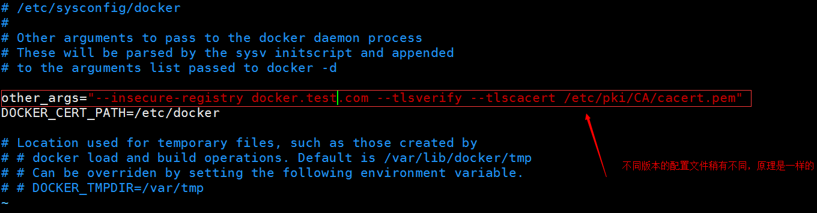
- 把根证书复制到/etc/docker/certs.d/docker.test.com/目录下 [root@cxp certs.d]# mkdir -p /etc/docker/certs.d/docker.test.com
[root@cxp certs.d]# cp /etc/pki/CA/cacert.pem /etc/docker/certs.d/docker.test.com/ca-certificates.crt
[root@cxp certs.d]# ls /etc/docker/certs.d/docker.test.com/
ca-certificates.crt
- 启动docker
[root@cxp certs.d]# /etc/init.d/docker start
Starting docker: [ OK ]
#到此我们的基本证书配置就结束了，下面我们开始配置docker镜像服务。

- 获取官方的镜像：registry
[root@cxp certs.d]# docker pull registry
[root@cxp certs.d]# docker images
REPOSITORY TAG IMAGE ID CREATED VIRTUAL SIZE
registry latest d849e35be7b0 6 days ago 413.9 MB

- 运行官方镜像，生成容器即可
[root@cxp certs.d]# mkdir -p /opt/data/registry
生成容器：
[root@cxp certs.d]# docker run -d -e STORAGE_PATH=/tmp/registry -v /opt/data/registry:/tmp/registr27.0.0.1:5005:5005 --name local-registry registry
5c954d67ead031d130e33201cd1191ab79217c99f2089fc6ed3db8d59b4d43d0
查看：
[root@cxp certs.d]# docker ps
CONTAINER ID IMAGE COMMAND CREATED STATUS PORTS NAMES
5c954d67ead0 registry:latest "docker-registry" 5 seconds ago Up 4 seconds 5000/tcp, 127.0.0.1:5005->5005/tcp local-registry
#注意ip，不要用nginx服务器的，-p 127.0.0.1:5005:5005 local-registry 作为上游服务器，这个 5005端口可以不用映射出来，因为所有的外部访问都是通过前端的nginx来提供，nginx 可以在私有网络访问 registry

2.我们通过源码包的方式安装
把项目 https://github.com/docker/docker-registry.git 克隆到本地，然后使用Dockerfile来build镜像：

[root@cxp ~]# git clone https://github.com/docker/docker-registry.git
Initialized empty Git repository in /root/docker-registry/.git/
remote: Counting objects: 7002, done.
remote: Total 7002 (delta 0), reused 0 (delta 0), pack-reused 7002
Receiving objects: 100% (7002/7002), 1.76 MiB | 50 KiB/s, done.
Resolving deltas: 100% (4051/4051), done.

[root@cxp ~]# ls
anaconda-ks.cfg docker-latest docker-registry install.log install.log.syslog

[root@cxp docker-registry]# ls
ADVANCED.md config depends FAQ.md requirements tests
AUTHORS contrib Dockerfile LICENSE scripts tox.ini
CHANGELOG.md CONTRIBUTING.md docker_registry MANIFEST.in setup.cfg
circle.yml DEBUGGING.md DRIVERS.md README.md setup.py

目录里面有已经编好的Dockerfile文件，我们直接运行命令生成即可：
[root@cxp docker-registry]# docker build -t "local-registry" .
#可能会被被墙哦！建议采用pull官方镜像

然后我们先配置自己的config.yml文件：
[root@cxp docker-registry]# mkdir -p /opt/data/registry
[root@cxp docker-registry]# cp config/config_sample.yml /opt/data/registry/config.yml
设置本地存储和存储路径：
[root@cxp docker-registry]# vim /opt/data/registry/config.yml
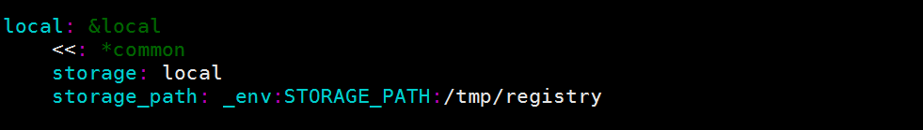
将 storage_path: _env:STORAGE_PATH:/tmp/registry更改为： storage_path: _env:STORAGE_PATH:/opt/data/registry

