**Topics: Descriptive Statistics and Probability**

1. Look at the data given below. Plot the data, find the outliers and find out $μ, σ, σ^{2}$

|  |  |
| --- | --- |
| **Name of company** | **Measure X** |
| Allied Signal | 24.23% |
| Bankers Trust | 25.53% |
| General Mills | 25.41% |
| ITT Industries | 24.14% |
| J. P. Morgan & Co. | 29.62% |
| Lehman Brothers | 28.25% |
| Marriott | 25.81% |
| MCI | 24.39% |
| Merrill Lynch | 40.26% |
| Microsoft | 32.95% |
| Morgan Stanley | 91.36% |
| Sun Microsystems | 25.99% |
| Travelers | 39.42% |
| US Airways | 26.71% |
| Warner-Lambert | 35.00% |

A: 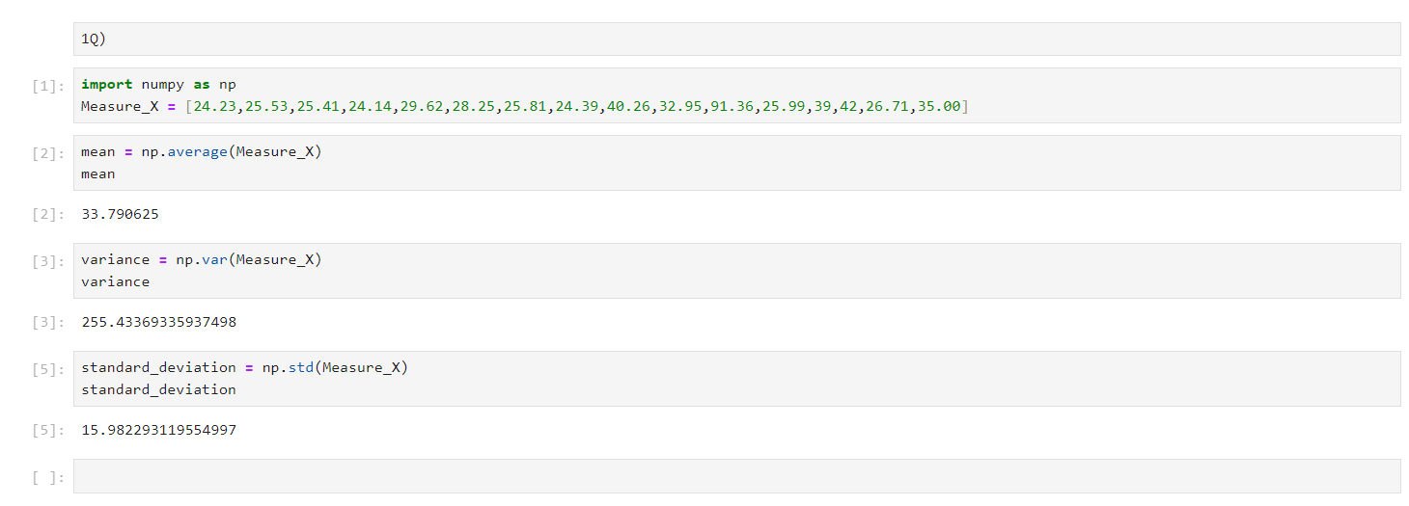



Answer the following three questions based on the box-plot above.

1. What is inter-quartile range of this dataset? (Please approximate the numbers) In one line, explain what this value implies.

A: IQR = 12 – 5 = 7.

1. What can we say about the skewness of this dataset?

A: Positive Skewness and tail towards its right.

1. If it was found that the data point with the value 25 is actually 2.5, how would the new box-plot be affected?

A: Q1 will moves towards left and data don’t have outliers.



Answer the following three questions based on the histogram above.

1. Where would the mode of this dataset lie?

A: 4 to 8.

1. Comment on the skewness of the dataset.

A: positive Skewness.

1. Suppose that the above histogram and the box-plot in question 2 are plotted for the same dataset. Explain how these graphs complement each other in providing information about any dataset.

A: Both will give the information about the data but in the histogram additionally will get the mode.

1. AT&T was running commercials in 1990 aimed at luring back customers who had switched to one of the other long-distance phone service providers. One such commercial shows a businessman trying to reach Phoenix and mistakenly getting Fiji, where a half-naked native on a beach responds incomprehensibly in Polynesian. When asked about this advertisement, AT&T admitted that the portrayed incident did not actually take place but added that this was an enactment of something that “could happen.” Suppose that one in 200 long-distance telephone calls is misdirected. What is the probability that at least one in five attempted telephone calls reaches the wrong number? (Assume independence of attempts.)

A:

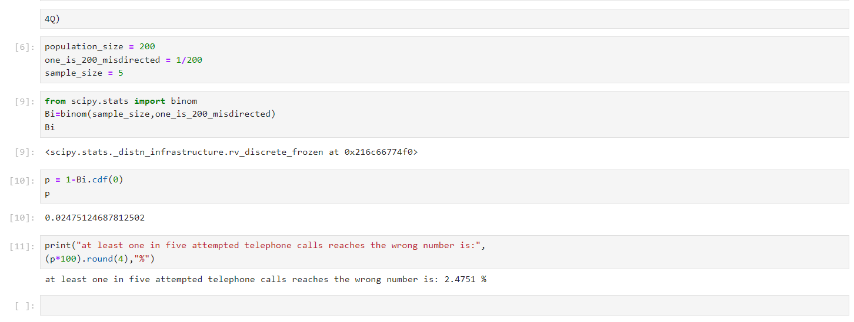

1. Returns on a certain business venture, to the nearest $1,000, are known to follow the following probability distribution

|  |  |
| --- | --- |
| x | P(x) |
| -2,000 | 0.1 |
| -1,000 | 0.1 |
| 0 | 0.2 |
| 1000 | 0.2 |
| 2000 | 0.3 |
| 3000 | 0.1 |

1. What is the most likely monetary outcome of the business venture?

A: From the table, we can see that the highest Probability (0.3) is associated with X value is being 2000. Therefore, the most likely monetary outcome of the business venture is $2000(to the nearest $1000).

1. Is the venture likely to be successful? Explain

A: Yes, venture likely to be successful, because sum of Probability is more than (0.5).

1. What is the long-term average earning of business ventures of this kind? Explain

A: The long-term average earning of business ventures of this kind is $800.

The formula for Expected Value is:

EV = $Σ(X∗p\left(X\right))$ = $800

1. What is the good measure of the risk involved in a venture of this kind? Compute this measure.

A:

