**Lecture Room Reservation System**

# Software Design Document

Author : Seungho Hong

Team : MIA

Revision Chart

|  |  |  |  |
| --- | --- | --- | --- |
| **Version** | **Date of Issue** | **Author(s)** | **Description of Change** |
| 1.0 | 2015-05-29 | Seungho Hong | Initial SDD Release |
|  |  |  |  |

**TABLE OF CONTENTS**

Software Design Document 1

1. INTRODUCTION 2

1.3 Overview 2

2. SYSTEM OVERVIEW 2

3. SYSTEM ARCHITECTURE 2

3.2 Decomposition Description 3

3.3 Design Rationale 3

4. DATA DESIGN 3

4.2 Data Dictionary 3

5. USER INTERFACE DESIGN 3

5.2 Screen Images 4

5.3 Screen Objects and Actions 6

### INTRODUCTION

* 1. **Purpose**

The purpose of this design document is to show how configuration our webpage.

We provide through this document our webpage’s design of each component and structure

We can show this Things:

* System architecture design
* Data design
* User interface design
* Flow Chart
* Constraint
  1. **Scope**

The Lecture Room Reservation System will be used for Hanyang University’s students and professors who need some places. So this document, SDD, will deal : how the project was designed, how to use the system.

## Overview

This document will explain of the project’s system overview. The architectural design and rationale of design. The data design will be shown by a relation diagram among users and informations. And the document will show overall UI.

### SYSTEM OVERVIEW

Give a general description of the functionality, context and design of your project. Provide any background information if necessary.

### SYSTEM ARCHITECTURE

* 1. **Architectural Design**

없다

## Decomposition Description

없어

## Design Rationale

없구만

### DATA DESIGN

* 1. **Data Description**

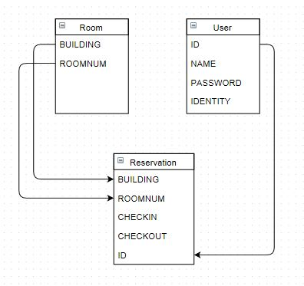

## Data Dictionary

The users and rooms will be connected with Reservation. Users have ID, name, password and Identity. Identity indicates whether he or she is a student of professor. And Rooms have building name and roomnumber. When a user reserve a room, the reservation makes a record consists of building, roomnumber, checkin, checkout, user’s ID.

### USER INTERFACE DESIGN

* 1. **Overview of User Interface**

Our webpage have just one flow. So webpage design is simple to use. First if the user opens a webpage, can see login page. In there, user can register user information through Sign up page. And user must be login in order to see about Lecture room information. And then next page is consist of three part. In left-top side is represent user information. And in center of page user can see overall university map included buildings. In right side, user can select building, room number, and time through sidebar.

## Screen Images

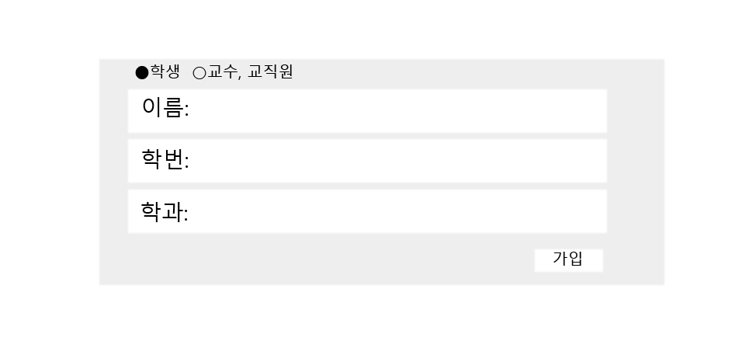- **Login page** - **Registration**

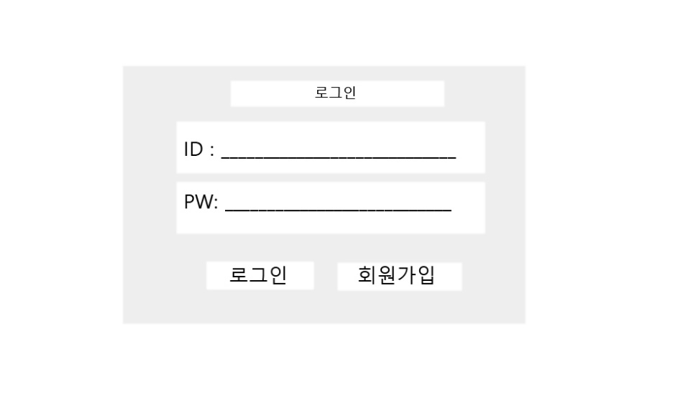

-**Select a Building**

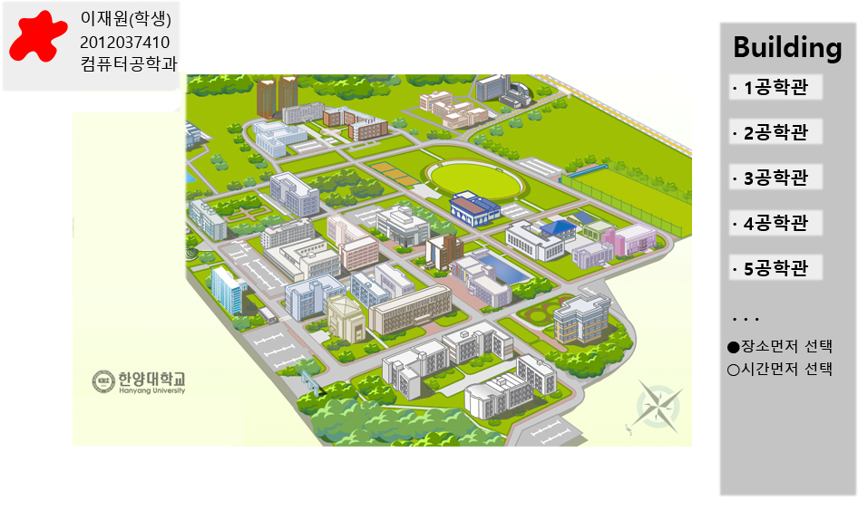

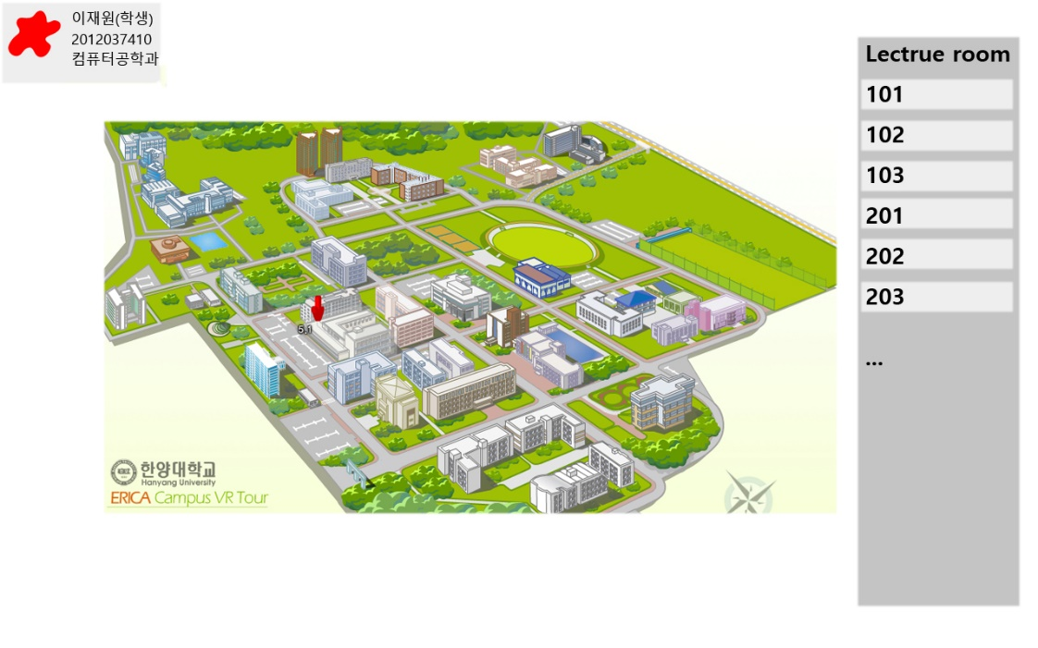 -**Select a lecture room**

-**Select times**

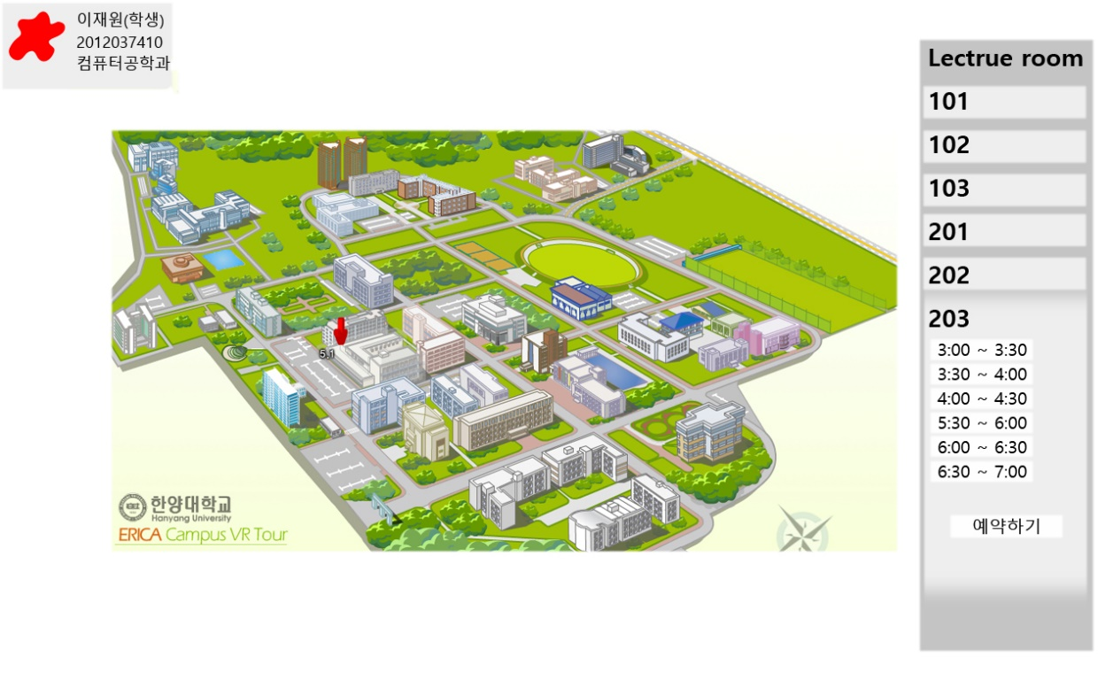

## Screen Objects and Actions

* **Login**

A user can login at this page. If the user has an ID, just put one’s id and password to login. If the user doesn’t have an ID, press Registration button to register.

* **Registration**

A user can register at this page. The user put contents on the page and press Submit button to complete registration. Then the page will go back to Login page.

* **Select a Building**

Entering this page, a user can see whole map of Hanyang university or see whole buildings on the sider bar. Then the user just click a building the user wants at the map. The user also can choose a building at the side bar.

* **Select a lecture room**

If the user click a building, the side bar indicates lecture rooms of the building. And user can click a lecture room.

* **Select times**

A user can choose times that user want. But the side bar indicates lecture rooms which have no courses at the same time. And the times are 30minutes each. A user can click continuous times and the times can’t be chosen more than 2 hours.