Software Project Management Plan (SPMP)

for

< Application for Borrowing Classroom>

<Author / Project Team>

MIA Team

<Date>

2015/5/12

Revision Chart

|  |  |  |  |
| --- | --- | --- | --- |
| **Version** | **Date of Issue** | **Author(s)** | **Description of Change** |
| 1.0 | 2015-04-16 | Scott Uk-Jin Lee | Initial SPMP Release |
|  |  |  |  |

Abstract / Preface

*A brief summary or a preliminary statement introducing the software project management plan for the project.*

This is the Software Project Management Plan (SPMP) for the Software Engineering project. This document complies with the SPMP from the Software Engineering Standard. The SPMP is used by the Project Manager (PM) to guide the project and to come to an agreement with the customer about budgets and planning. The PM uses the SPMP to organize the project in different phases, i.e. to arrange the teams and their tasks and to set deadlines.

Table of Contents

1. Introduction 4

1.1. Project Overview 4

1.2. Project Deliverables 4

1.3. Evolution of the SPMP 4

1.4. Reference Materials 4

1.5. Definitions and Acronyms 4

2. Project Organization 4

2.1. Process Model 4

2.2. Organizational Structure 4

2.3. Organizational Interfaces 5

2.4. Project Responsibilities 5

3. Managerial Process 5

3.1. Management Objectives and Priorities 5

3.2. Assumptions, Dependencies, and Constraints 5

3.3. Risk Management 5

3.4. Monitoring and Controlling Mechanisms 6

3.5. Staffing Approach. 6

4. Technical Process 6

4.1. Methods, Tools, and Techniques 6

4.2. Software Documentation 6

4.2.1 Software Requirements Specification (SRS) 7

4.2.2 Software Design Description (SDD) 7

4.2.3 Software Test Plan 7

4.2.4 … 7

4.3. User Documentation 7

4.4. Project Support Functions 7

5. Work Packages, Schedule, and Budget 7

5.1. Work Packages 7

5.2. Dependencies 8

5.3. Resource Requirements 8

5.4. Budget and Resource Allocation 8

5.5. Schedule 8

6. Additional Components. 8

6.1. Index. 8

6.2. Appendices 8

# Introduction

This section of the SPMP provides an overview of the project.

## Project Overview

Our project is lectureroom reservation system and our project team is consist of six students in Software Engineering lecture. The objective of project is not making good result but manage and analyze well while processing project. Some deliverables will be required before dead line. If we can’t complete project in time, we have to analyze why we can’t complete project.

## Project Deliverables

Project should be completed within June 10th. We have delivered project plan,SRS,Use Case Diagram, etc… and there will be more requirements from now on.

## Evolution of the SPMP

This document will be updated when proper change(scheduled or unscheduled update) is occurred.

## Reference Materials

We don’t reference any materials so far, but it will be updated if we reference any materials.

# Project Organization

This section specifies the process model for the project and its organizational structure.

## Process Model

Specify the life cycle model to be used for this project or refer to an organizational standard model that will be followed. The process model must include roles, activities, entry criteria and exit criteria for project initiation, product development, product release, and project termination.  
- We use XP for Process Model. Through this model, we communicate more actively, we exchange more feedbacks. And we are like three teams consist of two members. So we can do pair programming well. And we release each cycle. Also we can adapt requirements immediately. For these reasons, XP is fit to us.

## Organizational Structure

Describe the internal management structure of the project, as well as how the project relates to the rest of the organization. It is recommended that charts be used to show the lines of authority.

|  |  |
| --- | --- |
| Project Manager | |
| Period | Name |
| 15.03.11-15.03.31 | Seongwoong Kim |
| 15.04.01-15.04.14 | Dohwan Ahn |
| 15.04.15-15.04.28 | Seungho Hong |
| 15.04.29-15.05.12 | Jaewon Lee |
| 15.05.13-15.05.26 | Minho Kim |
| 15.05.27-15.06.11 | Jongwon Sim |

Project Manager

User Interface

DB

Web

## Organizational Interfaces

Describe the administrative and managerial interfaces between the project and the primary entities with which it interacts. A table may be a useful way to represent this.

|  |  |  |
| --- | --- | --- |
| Organization | Liaison | Contact Information |
| Customer: Scott Lee. | T.A: Gayeon Kim. | E-mail :  [scottlee@hanyang.ac.kr](mailto:scottlee@hanyang.ac.kr)  [gayeonkim91@gmail.com](mailto:gayeonkim91@gmail.com) |

Table 1. Project Interfaces

## Project Responsibilities

Identify and state the nature of each major project function and activity, and identify the individuals who are responsible for those functions and activities. Tables or subsection of functions and activities may be used to depict project responsibilities.

|  |  |  |
| --- | --- | --- |
| Role | Description | Person |
| Project Manager | leads project team; responsible for project deliverables | Seonwoon Kim, Dohwan Ahn Seungho Hong, Jaewon Lee Minho Kim, Jongwon Sim |
| UI team | Describe a page. the team make user interface’s view better. | Seungho Hong, Jaewon Lee |
| DB team | The team manages a database for Lecture Room Reservation System. | Dohwan Ahn, Minho Kim |
| Web team | Links between the DB and the UI. | Seonwoong Kim, Jongwon Sim |

Table 2. Project Responsibilities.

# Managerial Process

This section of the SPMP specifies the management process for this project.

## Management Objectives and Priorities

The purpose of this project(Lecture Room Reservation System) is to build according to the project plan within deadline. It should be the first priority is the deadline. Because this is term project and it is important to release. So keep the deadline of time is very significant. And project function should be worked. Because project is Lecture Room Reservation system, Reservation function should be worked, and then to fix the unexpected bug.

## Assumptions, Dependencies, and Constraints

While proceeding with this project, it is assumed that students and professors database data. Because We doesn’t get student and professor of Hanyang University’s DB data. Our project will be proceed in 3 parts ( DB, UI, WEB ). So Each things should be communication with other things. This project is term project. So Deadline is fixed. We must finish before the time runs out.

## Risk Management

The duration of the project is fixed. So maybe project plan is failed, it will not be finished because of running out time. Our project will be proceed in 3parts ( DB, UI, WEB ), so each process also may be different from each other. And then the 3parts code will be connected. When this time, it can not fit the code of each other.

## Monitoring and Controlling Mechanisms

Project Team members take turns with each role and he is make a Meeting minutes and submissions(SRS-document, use case diagrams) results. Inspection and Review is professor can read above results through git hub. And through final presentation, submit final results to professor.

|  |  |  |  |
| --- | --- | --- | --- |
| Communicated  Information | From | To | Time Period |
| Meeting minutes | Project Team | Professor | Weekly |
| SRS-document | Project Team | Professor | - |
| Presentation PPT | Project Team | Professor | - |

Table 3: Communication and Reporting Plan

## Staffing Approach.

Each project team members can web coding and can read and use DB schema.

# Technical Process

This section specifies the technical methods, tools, and techniques to be used on the project. It also includes identification of the work products and reviews to be held and the plans for the support group activities in user documentation, training, software quality assurance, and configuration management.

## Methods, Tools, and Techniques

The project will be provided in the form of a Web site that acts as a client server system. Users can utilize this service by using an Internet web browser. The service with the resources of a personal computer that is used in general works. In order to operate the project, the following techniques are required:

Apache HTTP Server: The Apache HTTP Server is the world's most widely used web server software. Apache supports a variety of features, many implemented as compiled modules which extend the core functionality. These can range from server-side programming language support to authentication schemes. Some common language interfaces support Perl, Python, Tcl, and PHP.

(Source: http://en.wikipedia.org/wiki/Apache_HTTP_Server)

MySQL: MySQL is the world`s second most widely used relational database management system and most widely used open-source relational database management system.

(Source: http://en.wikipedia.org/wiki/MySQL)

PHP: PHP is a server-side scripting language designed for web development but also used as a general-purpose programming language. As of January 2013, PHP was installed on more than 240 million websites (39% of those sampled) and 2.1 million web servers. Originally created by Rasmus Lerdorf in 1994, the reference implementation of PHP (powered by the Zend Engine) is now produced by The PHP Group. While PHP originally stood for *Personal Home Page*, it now stands for *PHP: Hypertext Preprocessor*, which is a recursive backronym. PHP code can be simply mixed with HTML code, or it can be used in combination with various templating engines and web frameworks. PHP code is usually processed by a PHP interpreter, which is usually implemented as a web server's native module or a Common Gateway Interface (CGI) executable. After the PHP code is interpreted and executed, the web server sends resulting output to its client, usually in form of a part of the generated web page; for example, PHP code can generate a web page's HTML code, an image, or some other data. PHP has also evolved to include a command-line interface (CLI) capability and can be used in standalone graphical applications. The canonical PHP interpreter, powered by the Zend Engine, is free software released under the PHP License. PHP has been widely ported and can be deployed on most web servers on almost every operating system and platform, free of charge.

(Source: http://en.wikipedia.org/wiki/PHP)

## Software Documentation

Specify

To ensure that the implementation of the software satisfies the requirements, the following documentation is required:

### 4.2.1. Software Requirements Specification (SRS)

The SRS

### 4.2.2. Software Design Description (SDD)

The SDD

### 4.2.3. Software Test Plan

The

### 4.2.4. …

…

## User Documentation

User documentation of this project will be made in the form of an online help or downloadable file. For online help it can be provided in the form of a web page or a tutorial. If provided in the form of a downloadable file it will determine the type of the file through the later discussion.

## Project Support Functions

Project support functions are used for the management of the project, the following functions are that we can use: Verification and Validation: The software developed in the project undergoes a check that matches the specifications. Follow the test suite documentation when we will test.

# Work Packages, Schedule, and Budget

Specify the work packages, dependency relationships, resource requirements, allocation of budget and resources to work packages, and a project schedule. Much of the content may be in appendices that are living documents, updated as the work proceeds.

## Work Packages

5.1.1. Work breakdown structure

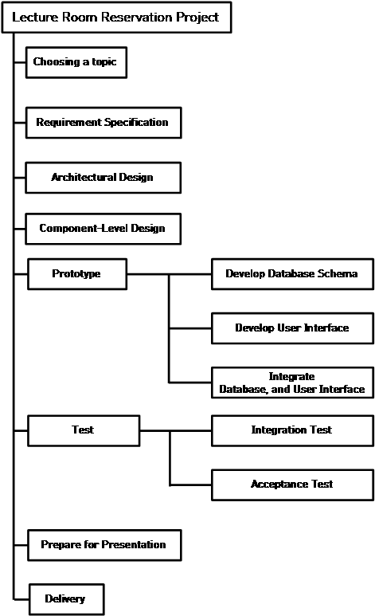

## Dependencies

|  |  |  |
| --- | --- | --- |
| Task# | Task name | Prerequisite |
| 1 | Choosing a topic |  |
| 2 | Requirement Specification |  |
| 3 | Architectural Design | 2 |
| 4 | Component-Level Design | 3 |
| 5 | Prototype | 4 |
| 6 | DB Schema Prototype | 4 |
| 7 | UI Prototype | 4 |
| 8 | DB – UI Integration | 6,7 |
| 9 | Test | 6,7 |
| 10 | Integration Test | 6,7 |
| 11 | Acceptance Test | 10 |
| 12 | Prepare for Presentation | 11 |
| 13 | Delivery | 12 |

## Resource Requirements

* + 1. Man-Month Table

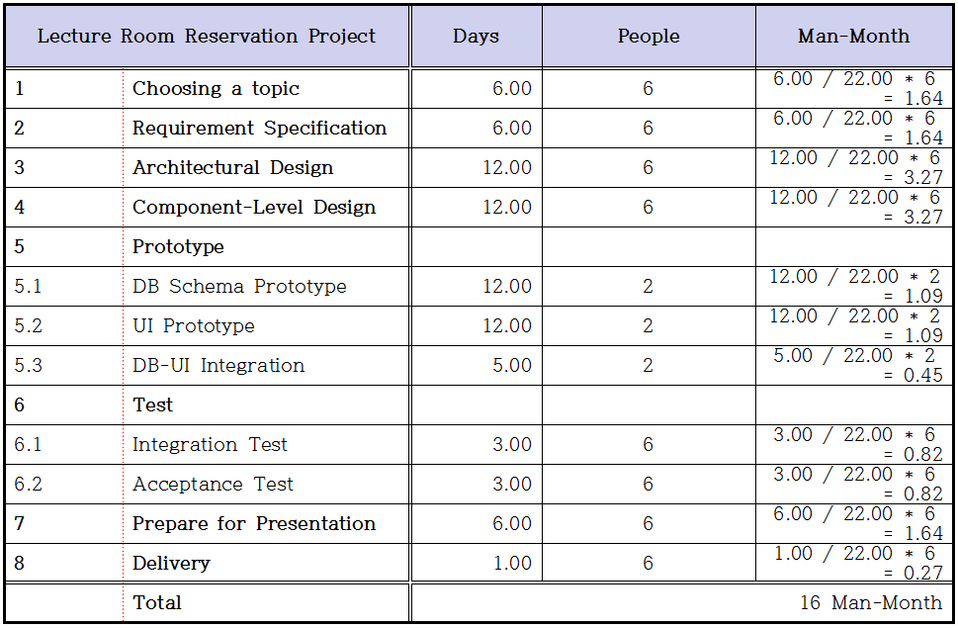

## Budget and Resource Allocation

By default, the allocation of human resources in the field during development divided into three species. (UI, DB, web)Task 1(Choosing a topic)~Task 4(Component-Level Design) will be to put all the team members. (PM is organized every meeting. The secretary writes the minutes.) And that step is 54 days, if it is thought necessary, exchanged views over the meeting. After the Task 5 (Prototype), each member is committed to their field (been assigned). Each time members are available during the day, people exchange ideas or writing code.

## Schedule

* + 1. Gantt Chart

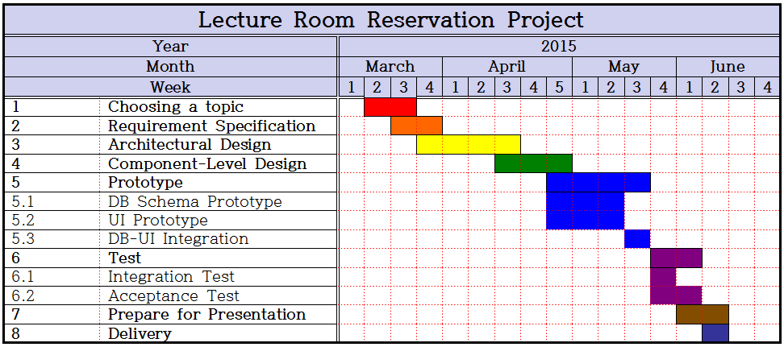

5.5.2. Project Schedule

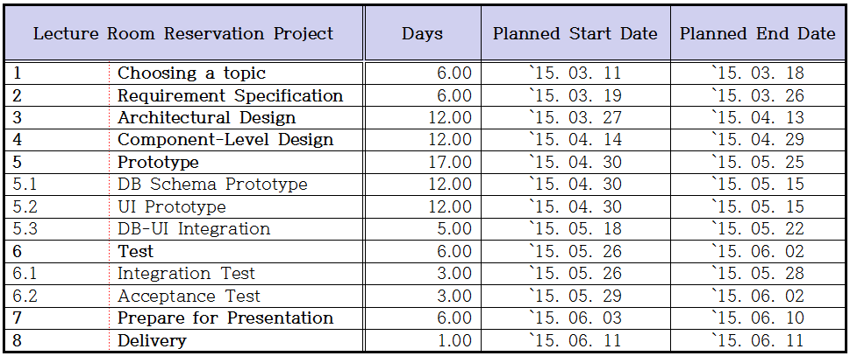

# Additional Components.

Certain additional components may be required and may be appended as additional sections or subsections to the SPMP. Additional items of importance on any particular project may include subcontractor management plans, security plans, independent verification and validation plans, training plans, hardware procurement plans, facilities plans, installation plans, data conversion plans, system transition plans, or the product maintenance plan.

## Index.

An index to the key terms and acronyms used throughout the SPMP is optional, but recommended to improve usability of the SPMP.

## Appendices

Appendices may be included, either directly or by reference, to provide supporting details that could detract from the SPMP if included in the body of the SPMP. Suggested appendices include:

A. Current Top 10 Risk Chart

B. Current Project Work Breakdown Structure

C. Current Detailed Project Schedule