Meeting Minutes

|  |  |  |
| --- | --- | --- |
| Attendees | Meeting place : HYCube Room | Date : 2015. 03. 26. |
| 김하령 | 이은재 | 황교준 |

Auditor : 황교준

* Agenda
  + Old Business
    - DB design
    - Creating Milestones
    - Search index design decisions
    - The name of the application
  + New Business
    - Design the class diagram
    - Draw gantt chart
  + Old Business
    - DB design
      * Create a schema based on the imported data in the public data, we designed a database.
    - Creating Milestones
      * We defined in detail the implemented features in the future
    - Search index design decisions
      * Decide search index design
    - The name of the application
      * Decide name of the application as ‘오늘의 시세’
  + New Business
    - Design the class diagram
      * Class Diagram is draft and show just class name and method name. later, it describe in detail.

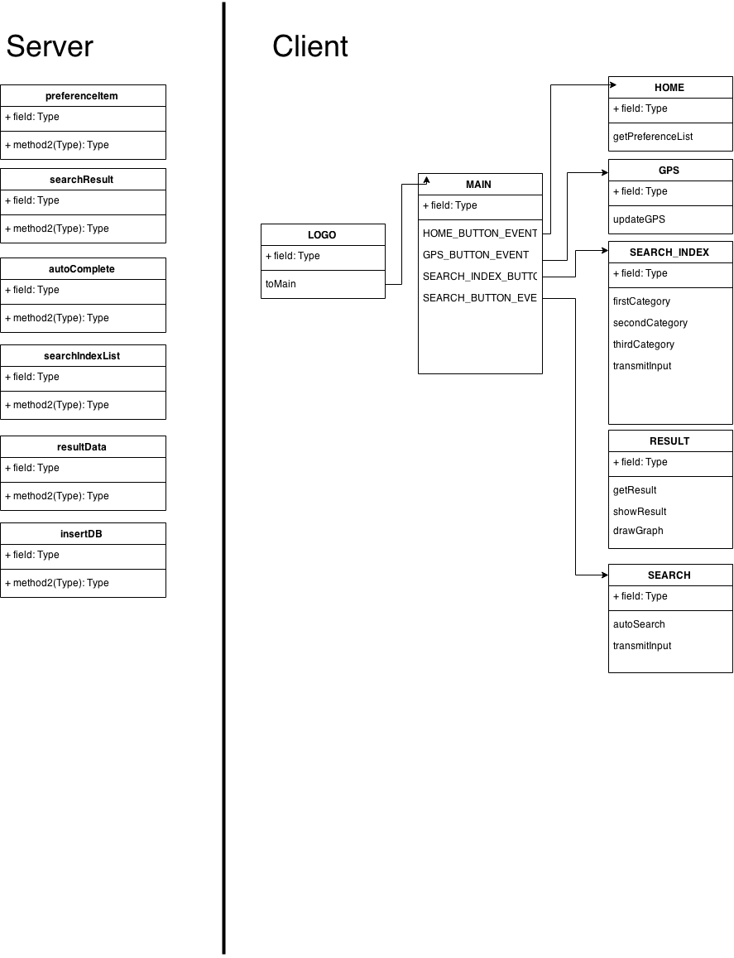

* + - Draw gantt chart
      * Divide the functions implemented in the previous milestones based on the priority and design a Gantt chart.

|  |  |  |  |  |  |  |  |
| --- | --- | --- | --- | --- | --- | --- | --- |
|  |  | 1 Week | 2 Week | 3 Week | 4 Week | 5 Week | 6 Week |
| ProtoType 1 | |  |  |  |  |  |  |
|  | User Identification |  |  |  |  |  |  |
|  | Show Logo |  |  |  |  |  |  |
|  | Main Frame Layout |  |  |  |  |  |  |
|  | Button Frame Layout |  |  |  |  |  |  |
|  | DB Insertion |  |  |  |  |  |  |
| ProtoType 2 | |  |  |  |  |  |  |
|  | Result Data |  |  |  |  |  |  |
|  | Result |  |  |  |  |  |  |
|  | Repositioning |  |  |  |  |  |  |
| ProtoType 3 | |  |  |  |  |  |  |
|  | Home |  |  |  |  |  |  |
|  | Preference item |  |  |  |  |  |  |
| ProtoType 4 | |  |  |  |  |  |  |
|  | Retrieve |  |  |  |  |  |  |
|  | Search Results |  |  |  |  |  |  |
|  | Search Autocomplete |  |  |  |  |  |  |
| ProtoType 5 | |  |  |  |  |  |  |
|  | Search index |  |  |  |  |  |  |
|  | Search index list |  |  |  |  |  |  |

* Next Meeting
* March 30 (HYCube Room OR SMaSH ROOM)
* Next Meeting Agenda Items
  + Create Project plan
  + Create ppt