Project Plan

오늘의 시세

**Project Name:** 오늘의 시세

**Team:** HYU-SE

**Creation Date:** March 30

**Last Revised:** March 30

**Version:** 1.0

**Document Change Control**

|  |  |  |  |
| --- | --- | --- | --- |
| Version Number | Author | Date | Brief Description of Change |
| 1.0 | Kyojun Hwang | March 30 | Make Project Plan structure |
|  |  |  |  |

**Table of Contents**

**1. Project Plan Overview**

**1.1 Project Definition**

**1.2 Project Overview**

**2. Project Work Plans**

**2.1 Product Backlogs**

**2.2 Work Breakdown Structure**

**2.3 Milestones & Gantt Chart**

**2.4 Class Diagram**

**3. Project Control Plans**

**3.1 Communications Plan**

**3.2 Quality Management Plan**

**3.3 Change Management Plan**

**3.4 Issue Management Plan**

**3.5 Risk Management Plan**

**1. Project Plan Overview**

**1.1 Project Definition**

‘오늘의 시세' will lead to enrichment of aquatic wise choice to find out the current market price of the local user, and presented a plan the use of public data.

**1.2 Project Overview**

Price of agricultural and marine products is greatly affected in the distribution process. Therefore, be it over the same area, there is a difference in the distribution process is always different price. Also by the climate change prices greatly affected. Even if a storm suddenly came prices of agricultural and marine products will rise significantly. However, consumers will be interested to know because they cannot always know the cheapest price of the items that they want to buy. Although this application currently exists, information provided by that application is not necessary for these consumer. In addition, because a very slow speed of the application itself, the problem seems to be some improvement. By modifying and supplementing these things we will induce a wise consumer choice and make the reliable application, which is the purpose of our project.

**2. Project Work Plans**

**2.1 Product Backlogs**

|  |  |  |
| --- | --- | --- |
|  | **Item #** | **Description** |
| **High** | | |
|  |  | **Provide a market price** |
|  | **1** | - According to the user's position market price in that area is provied |
|  |  | **Provide a preference item** |
|  | **2** | - Provides the user to sort the wish list -> the number of search on the main screen by name |
|  |  | **Comfortable** **design for users** |
|  | **3** | - Provides items that searched or items prefered by user on the main screen |
|  | **4** | - Create a menu button (Search index, Repositioning, Retrieve, Home) |
| **Medium** | | |
|  |  | **Search index** |
|  | **5** | - Divided by the total of the tertiary classification |
|  |  | **Retrieve** |
|  | **6** | - Support auto complete |
|  | **7** | - Support previous searches list |
| **Low** | | |
|  |  | **Repositioning** |
|  | **8** | - GPS |
|  | **9** | - Set user’ position passively |

**2.2 Work Breakdown Structure**

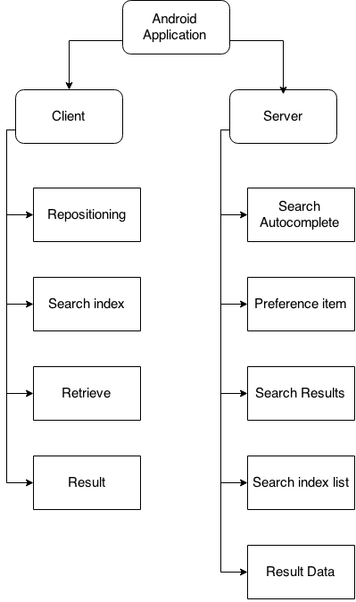

**2.3 Milestones & Gantt Chart**

|  |  |  |  |  |  |  |  |  |
| --- | --- | --- | --- | --- | --- | --- | --- | --- |
|  |  | 1 Week | 2 Week | 3 Week | 4 Week | 5 Week | 6 Week | 7 Week |
| ProtoType 1 | |  | | | | | | |
|  | User Identification |  |  |  |  |  |  |  |
|  | Show Logo |  |  |  |  |  |  |  |
|  | Main Frame Layout |  |  |  |  |  |  |  |
|  | Button Frame Layout |  |  |  |  |  |  |  |
|  | DB Insertion |  |  |  |  |  |  |  |
| ProtoType 2 | |  | | | | | | |
|  | Result Data |  |  |  |  |  |  |  |
|  | Result |  |  |  |  |  |  |  |
|  | Repositioning |  |  |  |  |  |  |  |
| ProtoType 3 | |  | | | | | | |
|  | Home |  |  |  |  |  |  |  |
|  | Preference item |  |  |  |  |  |  |  |
| ProtoType 4 | |  | | | | | | |
|  | Retrieve |  |  |  |  |  |  |  |
|  | Search Results |  |  |  |  |  |  |  |
|  | Search Autocomplete |  |  |  |  |  |  |  |
| ProtoType 5 | |  | | | | | | |
|  | Search index |  |  |  |  |  |  |  |
|  | Search index list |  |  |  |  |  |  |  |

|  |  |  |
| --- | --- | --- |
| Member | Role | Color |
| Haryeong Kim | Server Developer |  |
| Eunjae Lee | App Developer |  |
| Kyojun Hwang | Project Manager, App Developer |  |

**2.4 Class Diagram**

Class Diagram is draft and show just class name and method name. later, it describe in detail.

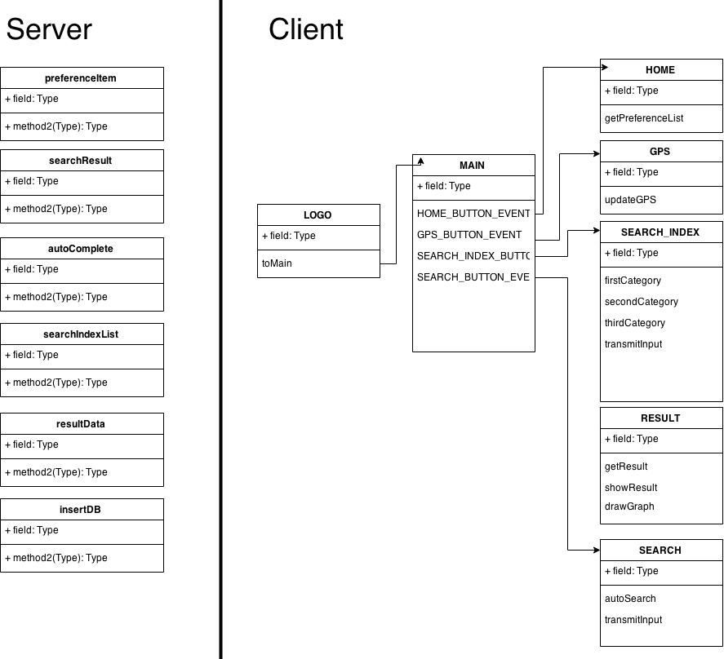

**3. Project Control Plans**

**3.1 Communications Plan**

|  |  |  |  |
| --- | --- | --- | --- |
| Audience | Information | Method | Frequency |
| Team members | Sprint meeting | Meeting | Weekly |
| Stakeholder, customer | The progress of project report | Meeting | Monthly |
| Team members | Brief report | Messenger | Daily |

**3.2 Quality Management Plan**

PM is reliable for quality mangement.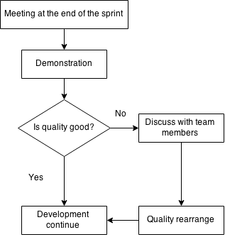

|  |
| --- |
| Things to consider |
| * Users are comfortable to use? * Is the features of the application consistent with the objectives of the project. * Does the application work properly in function that we originally want to make? |

**3.3 Change Management Plan**

1. Apprehend the progress of development.
2. Predict the situation after the change.  
   ex) The user's access will be worse. or The pace of development will be faster.
3. Check the risk after the change.
4. Consider A-C elements and meet together.

**3.4 Issue Management Plan**

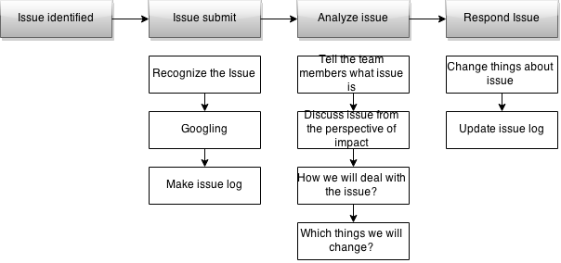

**3.5 Risk Management Plan**

