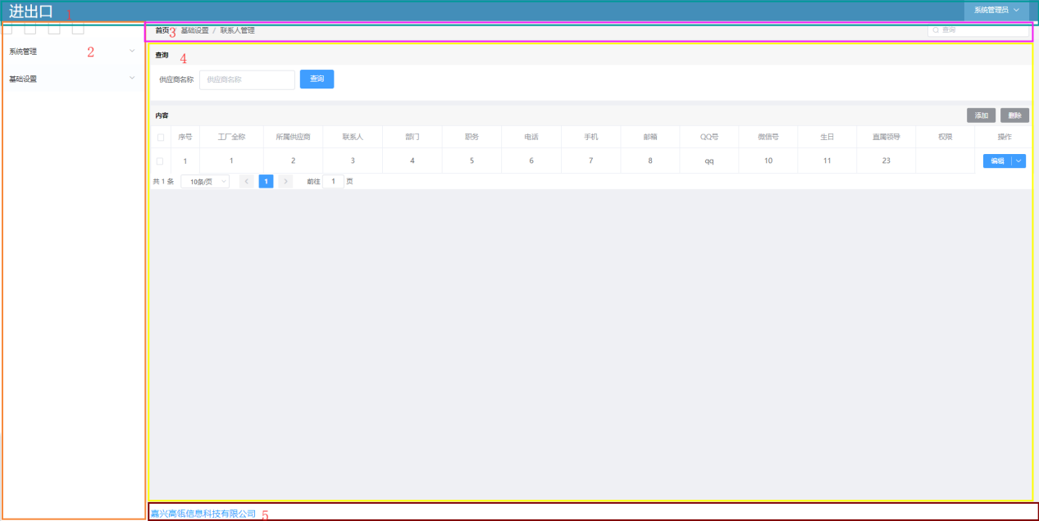

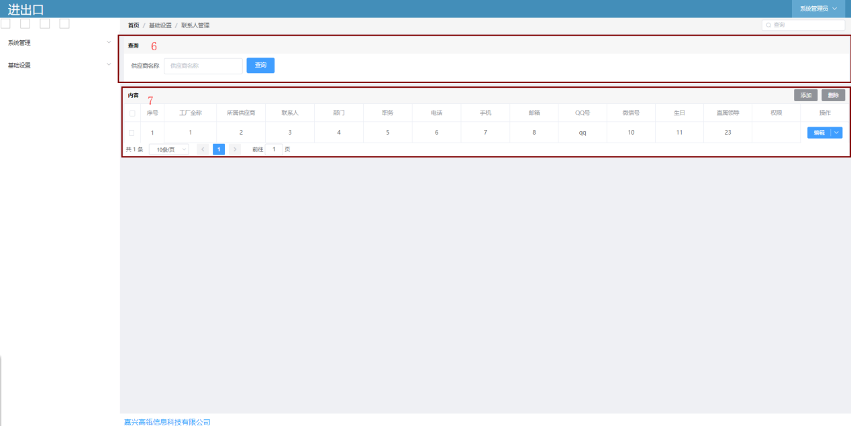

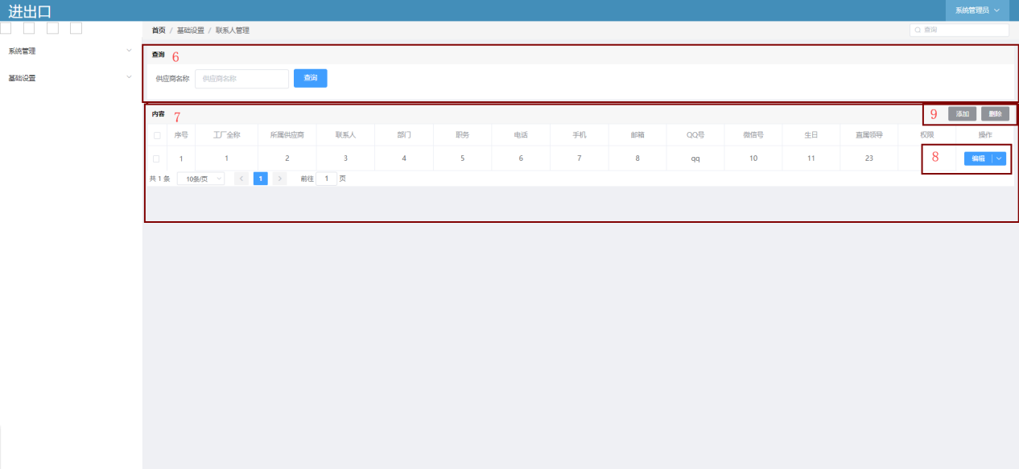

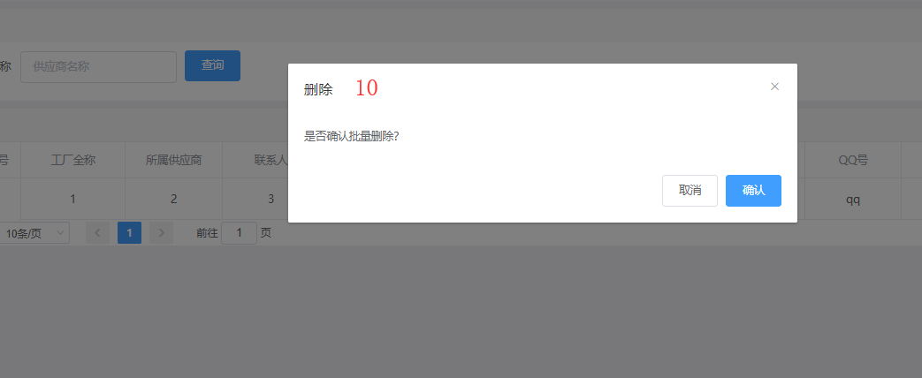

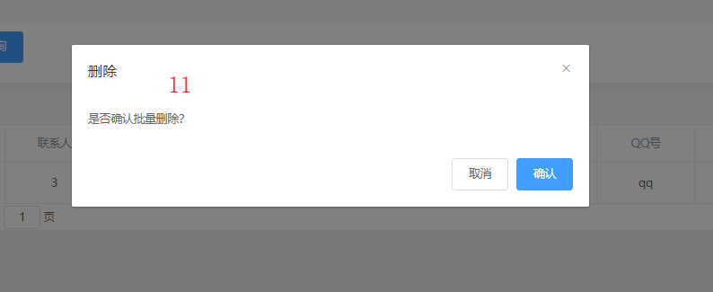

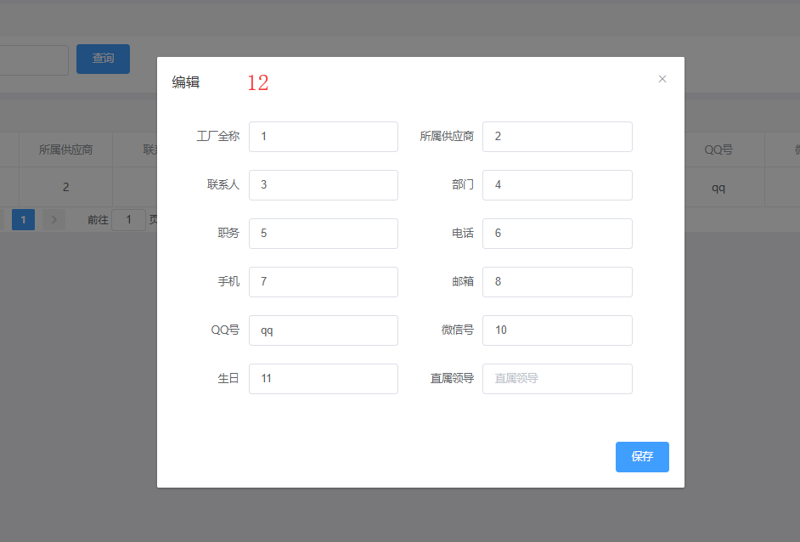

1. 头部
2. 栏目
3. 面包屑
4. 主体内容
5. 底部信息
6. 查询
7. 数据显示
8. 数据按钮
9. 工具按钮
10. 删除弹出框
11. 批量删除弹出框
12. 添加和编辑弹出框

对应代码

// 完整

{  
 **type**:**'normal'**, //类型  
 **name**:**'sys_contacts'**, //页面url

**version**:**'PageNormal'**, //页面布局组件----就是上面的布局  
 **api**:{ //api 所有api放这里   
 **query**: **"/contacts/query"**,  
 **queryByAll**: **"/contacts/queryByAll"**,  
 **queryById**: **"/contacts/queryById"**,  
 **save**: **"/contacts/save"**,  
 **delete**: **"/contacts/delete"**,  
 },  
 **components**:[  
 { **modelName**:**'menu'**, **type**: **'AssemblyMenu'**}, //对应页面里面的2 这一行可以不写,默认就是他   
 { **modelName**:**'header'**, **type**: **'AssemblyHeader'**}, //对应页面里面的1 这一行可以不写,默认就是他  
 { **modelName**:**'breadcrumbs'**,**type**: **'AssemblyBreadcrumbs'**}, //对应页面里面的3 这一行可以不写,默认就是他   
 { **modelName**:**'footer'**,**type**: **'AssemblyFooter'**}, //对应页面里面的5 这一行可以不写,默认就是他  
 { //对应页面里面的4-6  
 **modelName**:**'content'**, **type**: **'AssemblyQuery'**,  
 **components**:[  
 {**modelName**:**'query'**,**type**: **'AssemblyFrom'**,**components**:[  
 {**modelName**:**'content'**,**name**:**"text1"**,**label**:**"供应商名称"**,**type**: **'ComponentsInputEmail'**},  
 ]}  
 ]  
 },  
 {  
 **modelName**:**'content'**,**type**: **'AssemblyContent'**, //对应页面里面的4-7  
 **components**:[  
 {**modelName**:**'tableControl'**,**name**:**"text1"**,**label**:**"工厂全称"**,**type**: **'ComponentsInputEmail'**},  
 {**modelName**:**'tableControl'**,**name**:**"text2"**,**label**:**"所属供应商"**,**type**: **'ComponentsInputEmail'**},  
 {**modelName**:**'tableControl'**,**name**:**"text3"**,**label**:**"联系人"**,**type**: **'ComponentsInputEmail'**},  
 {**modelName**:**'tableControl'**,**name**:**"text4"**,**label**:**"部门"**,**type**: **'ComponentsInputEmail'**},  
 {**modelName**:**'tableControl'**,**name**:**"text5"**,**label**:**"职务"**,**type**: **'ComponentsInputEmail'**},  
 {**modelName**:**'tableControl'**,**name**:**"text6"**,**label**:**"电话"**,**type**: **'ComponentsInputEmail'**},  
 {**modelName**:**'tableControl'**,**name**:**"text7"**,**label**:**"手机"**,**type**: **'ComponentsInputEmail'**},  
 {**modelName**:**'tableControl'**,**name**:**"text8"**,**label**:**"邮箱"**,**type**: **'ComponentsInputEmail'**},  
 {**modelName**:**'tableControl'**,**name**:**"text9"**,**label**:**"QQ号"**,**type**: **'ComponentsInputEmail'**},  
 {**modelName**:**'tableControl'**,**name**:**"text10"**,**label**:**"微信号"**,**type**: **'ComponentsInputEmail'**},  
 {**modelName**:**'tableControl'**,**name**:**"text11"**,**label**:**"生日"**,**type**: **'ComponentsInputEmail'**},  
 {**modelName**:**'tableControl'**,**name**:**"text12"**,**label**:**"直属领导"**,**type**: **'ComponentsInputEmail'**},  
 {**modelName**:**'tableControl'**,**name**:**"text13"**,**label**:**"权限"**,**type**: **'ComponentsInputEmail'**},  
 ],  
 **tableBtn**:[ //对应页面里面的8 这一行可以不写,默认就是他  
 {**label**:**"编辑"**,click:**function**(data:**any**){  
 **let** edit = utils.getStore().openDialog({**name**:**'edit'**})  
 edit.query()  
 }},  
 {**label**:**"删除"**,click:**function**(data:**any**){utils.getStore().openDialog({**name**:**'delete'**})}},  
 ],  
 **toolBtn**:[ //对应页面里面的9 这一行可以不写,默认就是他  
 {**label**:**"添加"**,click:**function**(data:**any**){  
 **let** edit =utils.getStore().openDialog({**name**:**'edit'**})  
 edit.initValue()  
 }},  
 {**label**:**"删除"**,click:**function**(data:**any**){utils.getStore().openDialog({**name**:**'deleteAll'**})}},  
 ]  
 },   
 {**modelName**:**'dialog'**,**name**:**"delete"**,**type**: **'DialogDelete'**}, //对应单选的删除弹出框 10 这一行可以不写,默认就是他  
 {**modelName**:**'dialog'**,**name**:**"deleteAll"**,**type**: **'DialogDeleteAll'**}, //对应多选的删除弹出框11 这一行可以不写,默认就是他  
 {**modelName**:**'dialog'**,**name**:**"edit"**,**type**: **'DialogEdit'**,**components**:[ //对应添加和编辑的弹出框12  
 {**modelName**:**'from'**,**type**: **'AssemblyFrom'**,**components**:[  
 {**modelName**:**'content'**,**name**:**"text1"**,**label**:**"工厂全称"**,**type**: **'ComponentsInputEmail'**,**value_default**:**"x工厂"**},  
 {**modelName**:**'content'**,**name**:**"text2"**,**label**:**"所属供应商"**,**type**: **'ComponentsInputEmail'**,**value_default**:**"y供应商"**},  
 {**modelName**:**'content'**,**name**:**"text3"**,**label**:**"联系人"**,**type**: **'ComponentsInputEmail'**},  
 {**modelName**:**'content'**,**name**:**"text4"**,**label**:**"部门"**,**type**: **'ComponentsInputEmail'**},  
 {**modelName**:**'content'**,**name**:**"text5"**,**label**:**"职务"**,**type**: **'ComponentsInputEmail'**},  
 {**modelName**:**'content'**,**name**:**"text6"**,**label**:**"电话"**,**type**: **'ComponentsInputEmail'**},  
 {**modelName**:**'content'**,**name**:**"text7"**,**label**:**"手机"**,**type**: **'ComponentsInputEmail'**},  
 {**modelName**:**'content'**,**name**:**"text8"**,**label**:**"邮箱"**,**type**: **'ComponentsInputEmail'**},  
 {**modelName**:**'content'**,**name**:**"text9"**,**label**:**"QQ号"**,**type**: **'ComponentsInputEmail'**},  
 {**modelName**:**'content'**,**name**:**"text10"**,**label**:**"微信号"**,**type**: **'ComponentsInputEmail'**},  
 {**modelName**:**'content'**,**name**:**"text11"**,**label**:**"生日"**,**type**: **'ComponentsInputEmail'**},  
 {**modelName**:**'content'**,**name**:**"text123"**,**label**:**"直属领导"**,**type**: **'ComponentsInputEmail'**},  
 {**modelName**:**'content'**,**name**: **'id'**, **label**: **'id'**,**type**:**'ComponentsInputHidden'**},  
 ]},  
 ]},  
 ]  
}

// 精简后

{  
 **type**:**'normal'**,  
 **name**:**'sys_contacts'**,  
 **version**:**'PageNormal'**,  
 **api**:{  
 **query**: **"/contacts/query"**,  
 **queryByAll**: **"/contacts/queryByAll"**,  
 **queryById**: **"/contacts/queryById"**,  
 **save**: **"/contacts/save"**,  
 **delete**: **"/contacts/delete"**,  
 },  
 **components**:[  
 {  
 **modelName**:**'content'**, **type**: **'AssemblyQuery'**,  
 **components**:[  
 {**modelName**:**'query'**,**type**: **'AssemblyFrom'**,**components**:[  
 {**modelName**:**'content'**,**name**:**"text1"**,**label**:**"供应商名称"**,**type**: **'ComponentsInputEmail'**},  
 ]}  
 ]  
 },  
 {  
 **modelName**:**'content'**,**type**: **'AssemblyContent'**,  
 **components**:[  
 {**modelName**:**'tableControl'**,**name**:**"text1"**,**label**:**"工厂全称"**,**type**: **'ComponentsInputEmail'**},  
 {**modelName**:**'tableControl'**,**name**:**"text2"**,**label**:**"所属供应商"**,**type**: **'ComponentsInputEmail'**},  
 {**modelName**:**'tableControl'**,**name**:**"text3"**,**label**:**"联系人"**,**type**: **'ComponentsInputEmail'**},  
 {**modelName**:**'tableControl'**,**name**:**"text4"**,**label**:**"部门"**,**type**: **'ComponentsInputEmail'**},  
 {**modelName**:**'tableControl'**,**name**:**"text5"**,**label**:**"职务"**,**type**: **'ComponentsInputEmail'**},  
 {**modelName**:**'tableControl'**,**name**:**"text6"**,**label**:**"电话"**,**type**: **'ComponentsInputEmail'**},  
 {**modelName**:**'tableControl'**,**name**:**"text7"**,**label**:**"手机"**,**type**: **'ComponentsInputEmail'**},  
 {**modelName**:**'tableControl'**,**name**:**"text8"**,**label**:**"邮箱"**,**type**: **'ComponentsInputEmail'**},  
 {**modelName**:**'tableControl'**,**name**:**"text9"**,**label**:**"QQ号"**,**type**: **'ComponentsInputEmail'**},  
 {**modelName**:**'tableControl'**,**name**:**"text10"**,**label**:**"微信号"**,**type**: **'ComponentsInputEmail'**},  
 {**modelName**:**'tableControl'**,**name**:**"text11"**,**label**:**"生日"**,**type**: **'ComponentsInputEmail'**},  
 {**modelName**:**'tableControl'**,**name**:**"text12"**,**label**:**"直属领导"**,**type**: **'ComponentsInputEmail'**},  
 {**modelName**:**'tableControl'**,**name**:**"text13"**,**label**:**"权限"**,**type**: **'ComponentsInputEmail'**},  
 ],  
 },  
 {**modelName**:**'dialog'**,**name**:**"edit"**,**type**: **'DialogEdit'**,**components**:[  
 {**modelName**:**'from'**,**type**: **'AssemblyFrom'**,**components**:[  
 {**modelName**:**'content'**,**name**:**"text1"**,**label**:**"工厂全称"**,**type**: **'ComponentsInputEmail'**,**value_default**:**"x工厂"**},  
 {**modelName**:**'content'**,**name**:**"text2"**,**label**:**"所属供应商"**,**type**: **'ComponentsInputEmail'**},  
 {**modelName**:**'content'**,**name**:**"text3"**,**label**:**"联系人"**,**type**: **'ComponentsInputEmail'**},  
 {**modelName**:**'content'**,**name**:**"text4"**,**label**:**"部门"**,**type**: **'ComponentsInputEmail'**},  
 {**modelName**:**'content'**,**name**:**"text5"**,**label**:**"职务"**,**type**: **'ComponentsInputEmail'**},  
 {**modelName**:**'content'**,**name**:**"text6"**,**label**:**"电话"**,**type**: **'ComponentsInputEmail'**},  
 {**modelName**:**'content'**,**name**:**"text7"**,**label**:**"手机"**,**type**: **'ComponentsInputEmail'**},  
 {**modelName**:**'content'**,**name**:**"text8"**,**label**:**"邮箱"**,**type**: **'ComponentsInputEmail'**},  
 {**modelName**:**'content'**,**name**:**"text9"**,**label**:**"QQ号"**,**type**: **'ComponentsInputEmail'**},  
 {**modelName**:**'content'**,**name**:**"text10"**,**label**:**"微信号"**,**type**: **'ComponentsInputEmail'**},  
 {**modelName**:**'content'**,**name**:**"text11"**,**label**:**"生日"**,**type**: **'ComponentsInputEmail'**},  
 {**modelName**:**'content'**,**name**:**"text123"**,**label**:**"直属领导"**,**type**: **'ComponentsInputEmail'**},  
 {**modelName**:**'content'**,**name**: **'id'**, **label**: **'id'**,**type**:**'ComponentsInputHidden'**},  
 ]},  
 ]},  
 ]  
}