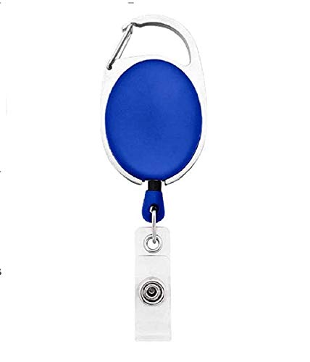



|  |  |
| --- | --- |
| **_Name** |  |
| **_Department** |
| **_DOJ** |
| **_BloodGrp** |
| **_Emergency** |



Questions / Queries – Drop an email to [jueejamsandekar504@gmail.com](mailto:jueejamsandekar504@gmail.com)

Juee/Harini/Anjani