Model Development Report

1. Overview
The model development process for the wine quality prediction application involved loading a dataset, preprocessing the data, training multiple machine learning models, evaluating their performance, and selecting the best-performing model for deployment.

2. Data Loading and Preprocessing
- Data Loading: The dataset is loaded from a CSV file using Pandas.
- Preprocessing:
  - Features (X) are separated from the target variable (Y, which is Quality).
  - The dataset is split into training and testing sets (80/20) while preserving the distribution of the target variable using stratification.
  - Optionally, SMOTE (Synthetic Minority Over-sampling Technique) is applied to address class imbalance in the training data.

3. Model Selection
Three classifiers were selected for comparison:
- Logistic Regression
- Support Vector Classifier (SVC)
- Random Forest Classifier
Each classifier is encapsulated in a pipeline that includes a StandardScaler for feature scaling.

4. Model Training and Evaluation
- Cross-Validation: Each model was evaluated using 5-fold cross-validation to assess its generalization performance.
- Accuracy and Classification Report: For each model, accuracy and a classification report (including precision, recall, and F1-score) were generated based on predictions made on the test set.
- Confusion Matrix: Visual representation of model performance was plotted for each classifier.

5. Hyperparameter Tuning
Grid search was employed to optimize hyperparameters for the SVC and Random Forest models:
- Random Forest:
  - Tuned parameters included n_estimators, max_depth, and min_samples_split.
- Support Vector Classifier:
  - Tuned parameters included C, gamma, and kernel.

6. Best Model Selection
After tuning, the best models were selected based on test accuracy:
- Best Random Forest Model:
  - Test accuracy was reported, along with the classification report and confusion matrix visualization.
- Best SVC Model:
  - Similarly, test accuracy, classification report, and confusion matrix were displayed.

7. Feature Importance
For the Random Forest model, feature importances were extracted and plotted to identify which features had the most significant impact on predicting wine quality.

8. Model Persistence
Finally, the best-performing models (Random Forest and SVC), along with the scaler, were saved using joblib for later use in the Flask application.

9. Results Summary
- Best Random Forest Model:
  - Test Accuracy: 0.62
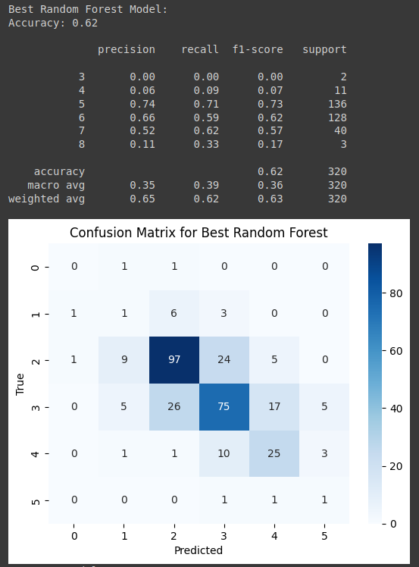

- Best SVC Model:
  - Test Accuracy: 0.64
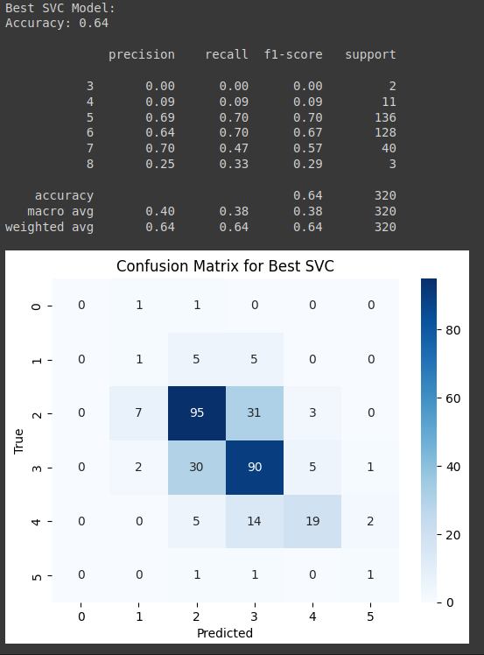
GitHub Repository Link: https://github.com/Ha04Bh0530/Red-Wine-Quality-Project

