Student B – Evidence

E1 – SSH Remote Configuration
Command: git remote -v
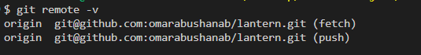
git remote -v: origin uses the SSH form git@github.com:omarabushanab/lantern.git (fetch and push)
Supporting: SSH authentication test
ssh -T git@github.com: successfully authenticated as Ha29la10
Supporting: SSH key generation
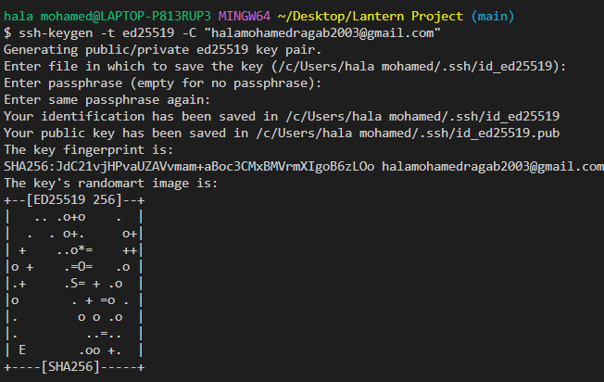
ssh-keygen -t ed25519 – SSH key pair created

E3 – Commit and Tree Object Inspection
Commit 1:
- Commit SHA: 3566945462f7935d85e73ed0686b40267a1dc509 (feat(storage): add JSON persistence)
- Root tree SHA: 3831bf2aa5db8a8df67007816e33176adacfcc85
Commit 2:
- Commit SHA: 49cc97adb3d37a6b363e1769e84b6344700debcc (merge commit)
- Root tree SHA: b22d94adfcf58bbff2976291d7461f213b237c15
Command: git show -s --format="commit: %H%ntree: %T" 3566945 49cc97a
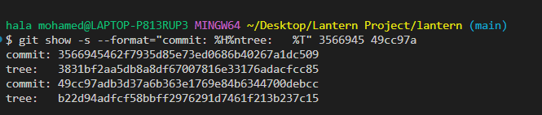
Commit SHAs and root tree SHAs of commits 3566945 and 49cc97a
Identical file and different file
 | Commit 1 (3566945) | Commit 2 (49cc97a)
Identical: stoarge.py | e0336cd081dca3f356d140809e35e25d6fceaa8b | e0336cd081dca3f356d140809e35e25d6fceaa8b
Different: README.md | f0d61ea2f9323c034a99534fe3ee677f42054a50 | 49f8909a8e995b147168a683c76f11f39a98ddc5

- Identical file: stoarge.py – same hash, same object in both commits
- Different file: README.md – different hash, different object
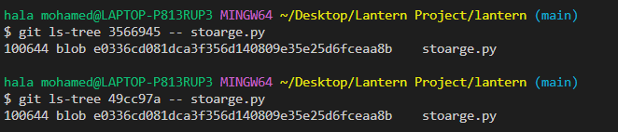
git ls-tree 3566945 -- stoarge.py and git ls-tree 49cc97a -- stoarge.py → identical blob SHA
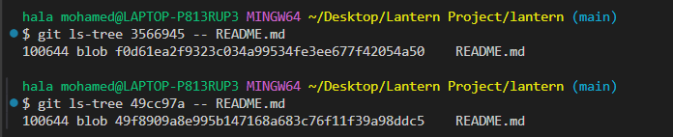
git ls-tree 3566945 -- README.md and git ls-tree 49cc97a -- README.md → different blob SHA

E4 – Branch and Merge History
Command: git log --graph --oneline --decorate --all
$ git --no-pager log --graph --oneline --decorate --all
* 46ea2e0 (HEAD -> main, origin/main, origin/HEAD, myfork/main) Merge pull request #10 from Ha29la10/docs/contributing
|\
| * 82c1a71 (myfork/docs/contributing, docs/contributing) docs(contributing): add contribution guidelines
|/
* d34b507 Merge pull request #9 from omarabushanab/feature/export-csv
|\
| * 35e38e2 Merge branch 'feature/export-csv' of https://github.com/omarabushanab/lantern into feature/export-csv
| |\
| | * 94d6d4e Merge branch 'main' into feature/export-csv
| | |\
| |_|/
|/| |
| | * a9e4904 (origin/feature/export-csv) chore(export): handle exporting csv
| * | 4af6910 chore(export): handle exporting csv
|/ /
* | 16a4b0a Merge pull request #8 from omarabushanab/feature/list-sort
|\ \
| |/
|/|
| * 10baf1b (origin/feature/list-sort) Add comment to the add command parser
| * 7a46fdc (feature/list-sort) merge(list): combine done and sort options
| |\
| |/
|/|
* | 6e1c66a Merge pull request #7 from omarabushanab/feature/list-done
|\ \
| * | be1a4cc (origin/feature/list-done) refactor(lantern): reformat code
| * | 173618d fix(lantern.py): add the list
|/ /
* | 66628bc fix(cli): handle empty task lists (#4)
| * b35745e feat(cli): add list sort option
|/
| * a4d1be3 (origin/fix/empty-list-message, fix/empty-list-message) fix(cli): handle empty task lists
|/
* 4d443b0 Merge branch 'docs/usage-heading'
|\
| * c998b53 (docs/usage-heading) docs(usage): add usage heading
* | fd77d76 (tag: v0.1.0) Revert "docs(usage): document remove command"
* | 18b3dac docs(usage): document remove command
|/
* edebd5b Merge branch 'main' of https://github.com/omarabushanab/lantern
|\
| * 3ca90b7 chore(git): ignore generated files
| * 9fd9d6a chore(git): stop tracking generated files
| * 7b2596a chore(git): track generated files
* | 5f777e7 feat(notes.txt): add second line
|/
* 491bb74 Merge branch 'main' of https://github.com/omarabushanab/lantern
|\
| * 991a0dc fix(git): ignore generated files
| * 9a21d75 chore(repo): add generated files by mistake
| * 5cf928f merge(storage): combine JSON formatting options
| |\
| | * ff50a40 feat(storage): format JSON output
| * | 6130e02 fix(storage): sort JSON keys
| |/
* | 475e33d feat(notes.txt): this message has no typo
* | d9ff78d fix(gitignore): fix file format from utf-16 to utf-8 for git to be able to read
* | e9bff65 fix(gitignore): ignore .env
|/
* 3ea1fae fix(env): untrack env file
* 38824e6 feat(env): add secret key
* 193cb87 Merge branch 'feature/done-flag'
|\
| * dd096a1 feat(tasks.py): add done flag in task
* | 2c0ae22 fix(tasks.py): clean title task
|/
* cdf554f Merge branch 'main' of https://github.com/omarabushanab/Lantern
|\
| * 48a1874 chore(git): remove scratch file
| * e6993de test(git): add temporary scratch file
| * 84b36ef docs: add usage guide
| * 49cc97a Merge branch 'main' of github.com:omarabushanab/lantern
| |\
| * | 3566945 feat(storage): add JSON persistence
* | | 69bc885 feat(lantern.py): add argument handler
* | | ba8a2b5 fix(drafts.txt): rename drafts.txt to notes.txt
* | | bda8841 feat(drafts.txt): add a drafts placeholder file
* | | b4ca910 feat(lantern.py): add command line entry point
* | | 7ff26de feat(tasks): add task function
| |/
|/|
* | 596eabf resolve(readme): merge both names in table
|\|
| * 24791bb docs(readme): add student B to team
* | c7e8de2 docs(readme): add member details
|/
* f14aeaa Initial commit
Full history from Initial commit f14aeaa to HEAD 46ea2e0: feature branches merged into main (e.g. 5cf928f, 49cc97a, 4d443b0, 16a4b0a, d34b507) and pull requests #7 to #10.
Supporting: the merges shown in the graph
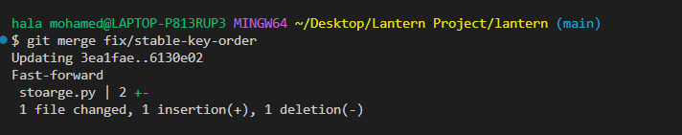
git merge fix/stable-key-order – fast-forward
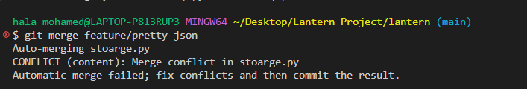
git merge feature/pretty-json – merge conflict in stoarge.py
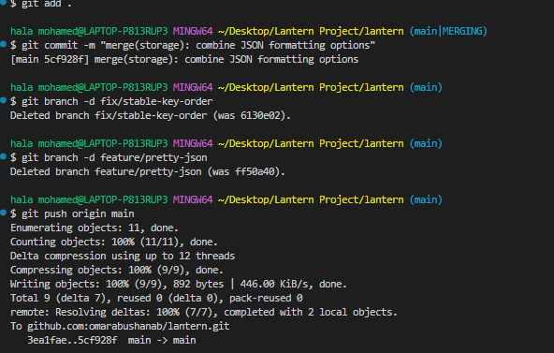
Conflict resolved: merge commit 5cf928f, feature branches deleted, pushed to origin/main

E5 – Drill (b): Wrong Branch
Command: git reflog --date=local
Summary
- Original accidental commit on main: 24d4b7b
- Recovery branch: docs/usage-heading
- Recovered commit (cherry-pick): c998b53
- Final merge commit: 4d443b0
- Local main: reset to origin/main; the recovery branch was then merged into main and pushed
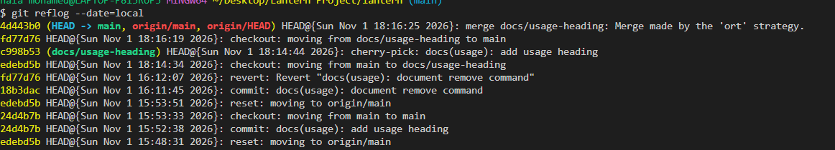
Reflog: cherry-pick c998b53 onto docs/usage-heading, checkout main, merge commit 4d443b0
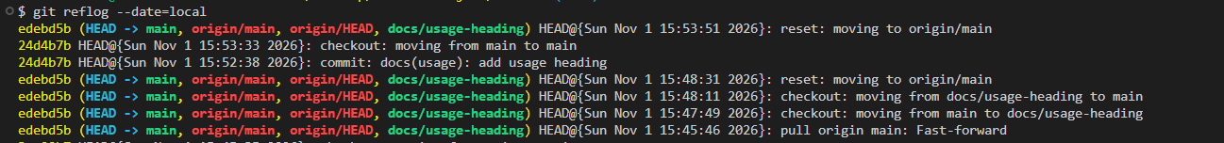
Reflog (earlier part): accidental commit 24d4b7b on main, then reset: moving to origin/main
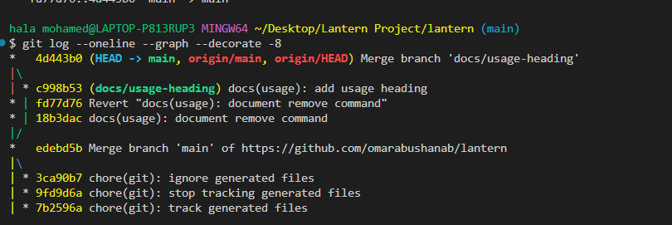
Final history: git log --oneline --graph --decorate -8

E6 – Stash Evidence
Command: git stash list
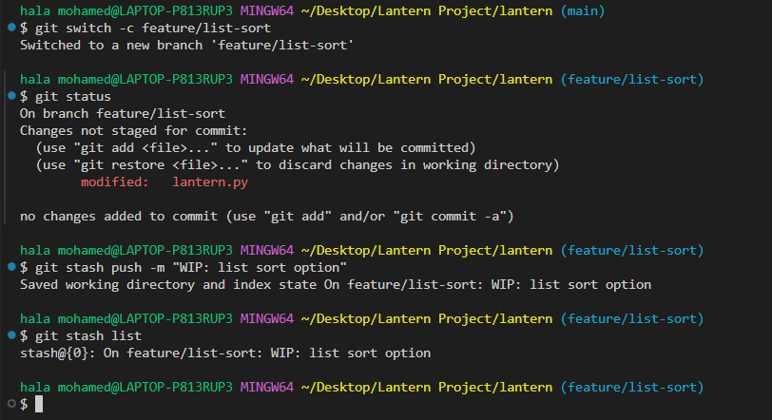
git stash push -m "WIP: list sort option" and git stash list → stash@{0}: On feature/list-sort: WIP: list sort option

