MFE5209 ARCH/GARCH

Wu Fuheng

Monday, October 06, 2014

## Problem 1

Author: [Wu Fuheng([a0095704@nus.edu.sg](mailto:a0095704@nus.edu.sg))](http://rpubs.com/wujucong/32751)

This is a AR(1)/ARCH(1) model, the conditional mean and variance of $u_{t}$ will be **non-constant**.

Since $μ=0.4,ϕ=0.45,ω=1$ and $α_{1}=0.3$, we can rewrite the equation of $u_{t}$ as follows:

$$\begin{matrix}u_{t} & =(1−ϕ)μ+ϕu_{t−1}+h_{t} \\ & =(1−0.45)0.4+0.45u_{t−1}+h_{t} \\ & =0.22+0.45u_{t−1}+h_{t}\end{matrix}$$

**a)**Conditional Expectation

The conditional mean of $u_{t}$ is

$$\begin{matrix}E[u_{t}∣u_{t−1},...] & =0.22+0.45u_{t−1}+E[h_{t}∣h_{t−1}...]\end{matrix}$$

According to P479 of *SDAFE*, for a ARCH(1) process $h_{t}$, the conditional mean $E[h_{t}∣h_{t−1}...]$ =0. Thus we have

$$\begin{matrix}E[u_{t}∣u_{t−1},...] & =0.22+0.45u_{t−1}\end{matrix}$$

So,

$$\begin{matrix}E[u_{2}∣u_{1}=1,u_{0}=0.2] & =0.22+0.45u_{1} \\ & =0.67\end{matrix}$$

**b)**Conditional Variance

The conditional variance of $u_{t}$ is

$$\begin{matrix}Var[u_{t}∣u_{t−1},...] & =E[(u_{t}−E[u_{t}∣u_{t−1},...])^{2}∣u_{t−1},...] \\ & =E[(h_{t})^{2}∣u_{t−1},...] \\ & =ω+α_{1}h_{t−1}^{2}\end{matrix}$$

Thus, we have

$$\begin{matrix}Var[u_{2}∣u_{1}=1,u_{0}=0.2] & =ω+α_{1}h_{1}^{2} \\ & =1+0.3h_{1}^{2}\end{matrix}$$

And we also know

$$\begin{matrix}u_{1}−μ=ϕ(u_{0}−μ)+h_{1} \\ →1−0.4=0.45(0.2−0.4)+h_{1} \\ →h_{1}=0.51\end{matrix}$$

Therefore, $Var[u_{2}∣u_{1}=1,u_{0}=0.2]=1+0.3*0.{51}^{2}=1.07803$

## Problem 2

Assume $β_{0}=0.06,β_{1}=0.35,δ=0.22$, we can rewrite the model

$$\begin{matrix}Y_{t}=0.06+0.35X_{t}+0.22σ_{t}+h_{t}\end{matrix}$$

**a)**Conditional Expectation

$$\begin{matrix}E[Y_{t}∣X_{t}=0.1,h_{t−1}=0.6] & =0.06+0.35*0.1+0.22σ_{t} \\ & =0.095+0.22σ_{t}\end{matrix}$$

**b)**Conditional Variance

$$\begin{matrix}Var[Y_{t}∣X_{t}=0.1,h_{t−1}=0.6] & =E[(Y_{t}−E[Y_{t}∣X_{t}=0.1,h_{t−1}=0.6])^{2}∣X_{t}=0.1,h_{t−1}=0.6] \\ & =E[h_{t}^{2}∣X_{t}=0.1,h_{t−1}=0.6] \\ & =1+0.5h_{t−1}^{2} \\ & =1+0.5*0.6^{2} \\ & =1.18\end{matrix}$$

**c)**Is the conditional distribution of $Y_{t}$ given $X_{t}$ and $h_{t−1}$ normal? Why or why not?

Yes, it is normal. Reason: There is only one stochastic item $ɛ$ in the formula which is normal. And we know the linear combination of a normal distribution is normal.

**d)**Is the marginal distribution of $Y_{t}$ normal? Why or why not?

No, it isn't. Reason: In this case, $h_{t}$ is a ARCH(1) process, which is of a non-Gaussian distribution with a heavy tail. So $Y_{t}$ is also not Gaussian/normal.

## Problem 3

This problem uses monthly observations of the two-month yield, that is, $Y_{T}$ with T equal to two months, in the data set Irates in the Ecdat package. The rates are log-transformed to stabilize the variance. To fit a GARCH model to the changes in the log rates, run the following R code.

library(fGarch)  
library(Ecdat)  
data(Irates)  
r = as.numeric(log(Irates[,2]))  
n = length(r)  
lagr = r[1:(n-1)]  
diffr = r[2:n] - lagr  
g=garchFit(~arma(1,0)+garch(1,1),data=diffr, cond.dist = "std")

**a)** What model is being fit to the changes in $r$? Describe the model in detail.

The model is a AR(1)/GARCH(1,1) model, assuming a t-distributed errors. We are trying to use AR(1) to model the return conditional mean and GARCH(1,1) to model its conditional variance. We can write is mathematically as follows:

$$\begin{align*}
\Delta r_t=Y_t=\mu+ar_1 Y_{t-1}+a_t\\
\\
a_t=\varepsilon_t \sqrt{\omega + \alpha_1 a_{t-1}^2+ \beta_1 \sigma_{t-1}^2},
\varepsilon_t \thicksim t(.)
\end{align*}$$

In this case, the fitted model is:

$$\begin{align}
\Delta r_t=Y_t=0.00910873+0.09508060 Y_{t-1}+a_t\\
\\
a_t=\varepsilon_t \sqrt{0.00054864 + 0.32444019 a_{t-1}^2+ 0.74026870 \sigma_{t-1}^2}\\
\\
\varepsilon_t \thicksim t(2.83060758)
\end{align}$$

The details of the fitted model are as follows:

summary(g)

##   
## Title:  
## GARCH Modelling   
##   
## Call:  
## garchFit(formula = ~arma(1, 0) + garch(1, 1), data = diffr, cond.dist = "std")   
##   
## Mean and Variance Equation:  
## data ~ arma(1, 0) + garch(1, 1)  
## <environment: 0x000000000b840608>  
## [data = diffr]  
##   
## Conditional Distribution:  
## std   
##   
## Coefficient(s):  
## mu ar1 omega alpha1 beta1 shape   
## 0.00910873 0.09508060 0.00054864 0.32444019 0.74026870 2.83060758   
##   
## Std. Errors:  
## based on Hessian   
##   
## Error Analysis:  
## Estimate Std. Error t value Pr(>|t|)   
## mu 0.0091087 0.0023895 3.812 0.000138 ***  
## ar1 0.0950806 0.0432758 2.197 0.028014 *   
## omega 0.0005486 0.0002968 1.848 0.064564 .   
## alpha1 0.3244402 0.1368876 2.370 0.017782 *   
## beta1 0.7402687 0.0656629 11.274 < 2e-16 ***  
## shape 2.8306076 0.4243716 6.670 2.56e-11 ***  
## ---  
## Signif. codes: 0 '***' 0.001 '**' 0.01 '*' 0.05 '.' 0.1 ' ' 1  
##   
## Log Likelihood:  
## 630.9 normalized: 1.19   
##   
## Description:  
## Sat Oct 11 00:35:58 2014 by user: wufuh_000   
##   
##   
## Standardised Residuals Tests:  
## Statistic p-Value  
## Jarque-Bera Test R Chi^2 1048 0   
## Shapiro-Wilk Test R W 0.9114 0   
## Ljung-Box Test R Q(10) 7.962 0.6326   
## Ljung-Box Test R Q(15) 11.93 0.6846   
## Ljung-Box Test R Q(20) 12.76 0.8874   
## Ljung-Box Test R^2 Q(10) 13.12 0.2173   
## Ljung-Box Test R^2 Q(15) 14.7 0.4736   
## Ljung-Box Test R^2 Q(20) 17.79 0.6014   
## LM Arch Test R TR^2 14.28 0.2829   
##   
## Information Criterion Statistics:  
## AIC BIC SIC HQIC   
## -2.358 -2.310 -2.358 -2.339

**b)** What are the estimates of the parameters of the model?

The estimates of the model parameters are as follows

**c)** What is the estimated ACF of $Δr_{t}$?

acf(diffr)

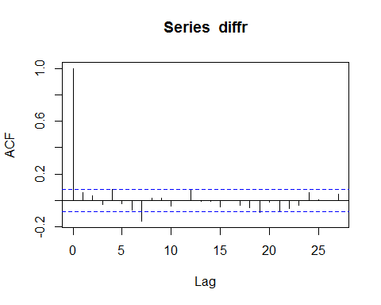

**d)** What is the estimated ACF of $a_{t}$?

$a_{t}$ is uncorrelated, aka $ACF(a_{t})=ρ_{a}(h)=0$ if $h≠0$.

acf(residuals(g))

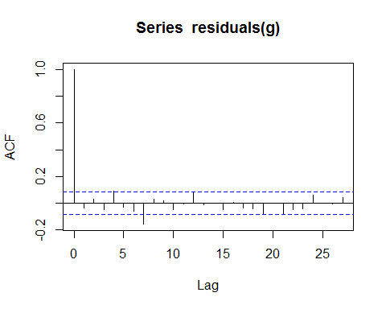

**e)** What is the estimated ACF of ${a_{t}}^{2}$?

acf(residuals(g)^2)

