**Optimizing System Performance Programm**

* Introduction  
    
  - Welcome to our presentation on optimizing system performance through efficient cleanup and defragmentation.  
  Today, we'll introduce a powerful utility designed to streamline your computer's operations and enhance its speed and efficiency.
* Understanding the Need  
    
  - In the digital age, our computers accumulate clutter over time, slowing down operations and affecting productivity.  
  - Fragmented drives and cluttered directories contribute to sluggish performance and decreased system responsiveness.

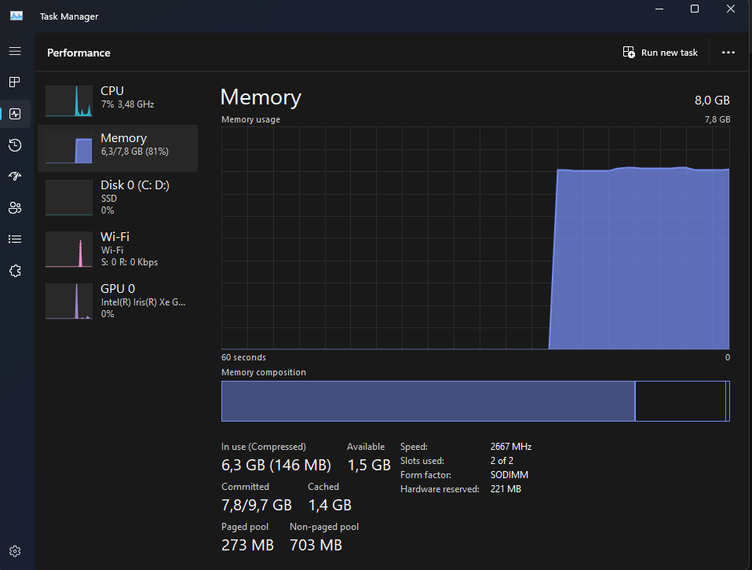

* Our Solution  
  - Our solution offers a comprehensive approach to address these issues, combining directory cleanup and drive defragmentation into a single, easy-to-use tool.

- By automating these essential tasks, our utility saves time and ensures optimal system performance.

* Key Features  
    
  - Directory Cleanup: Removes unnecessary files and directories from key system and user folders, reclaiming valuable disk space.  
  Drive Defragmentation: Optimizes disk performance by rearranging fragmented data for faster access and improved efficiency.  
  Memory Management: Additionally, our utility includes a memory cleanup feature to terminate memory-intensive processes, further enhancing system responsiveness.
* How It Works  
    
  - Users simply initiate the program, which prompts for confirmation before executing cleanup and defragmentation tasks.

- The utility intelligently targets system and user directories prone to clutter accumulation, ensuring thorough cleanup without risking critical system files.

- Drive defragmentation is performed using the built-in Windows defrag utility, optimizing disk performance with minimal user intervention.

* Benefits  
    
  - Improved Performance: By regularly cleaning up directories and defragmenting drives, users experience faster boot times, reduced file access latency, and smoother overall system operation.  
    
  - Enhanced Reliability: Removing unnecessary files and organizing data reduces the risk of disk errors and improves the longevity of storage drives.

- User Convenience: Our utility simplifies system maintenance, allowing users to optimize performance with just a few clicks, without the need for complex manual procedures.

* Use Cases  
    
  - Personal Computers: Ideal for individual users looking to maintain their system's performance and reliability.  
    
  - Enterprise Environments: Scalable for use in corporate IT environments, where system optimization is essential for productivity and cost-efficiency.  
    
  - System Administrators: Offers a valuable tool for system administrators tasked with managing multiple computers across a network.  
  Conclusion  
    
  - In conclusion, our comprehensive cleanup and defragmentation utility offers an effective solution to enhance system performance, reliability, and user experience.  
    
    
  - By automating essential maintenance tasks, users can enjoy faster, more responsive computing with minimal effort.  
    
  -- Thank you for considering our solution. We look forward to optimizing your system's performance.--

--HaNguyen--