**Assignment 4.1**

Setup IP and default-gateway for PC1 and PC2 ( 192.168.12.2 cho ip còn .1 là default-gateway )

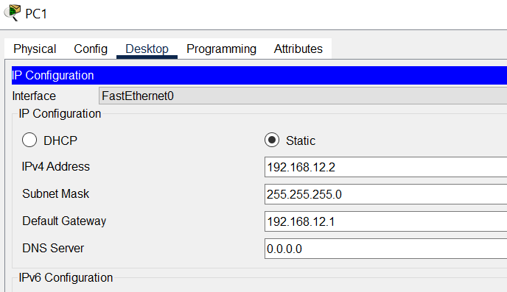

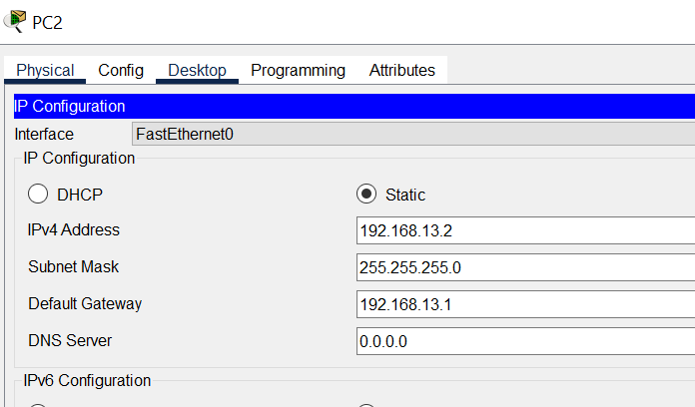

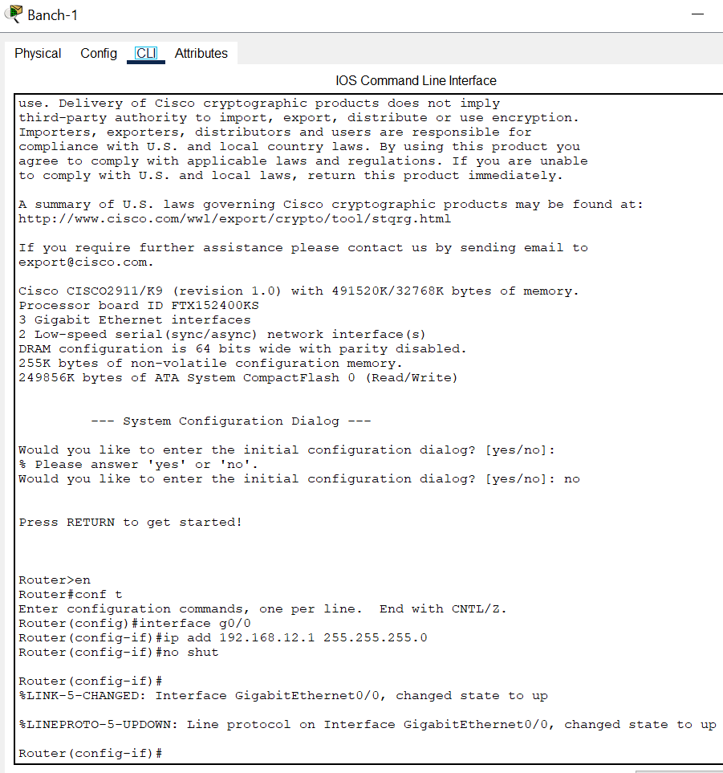

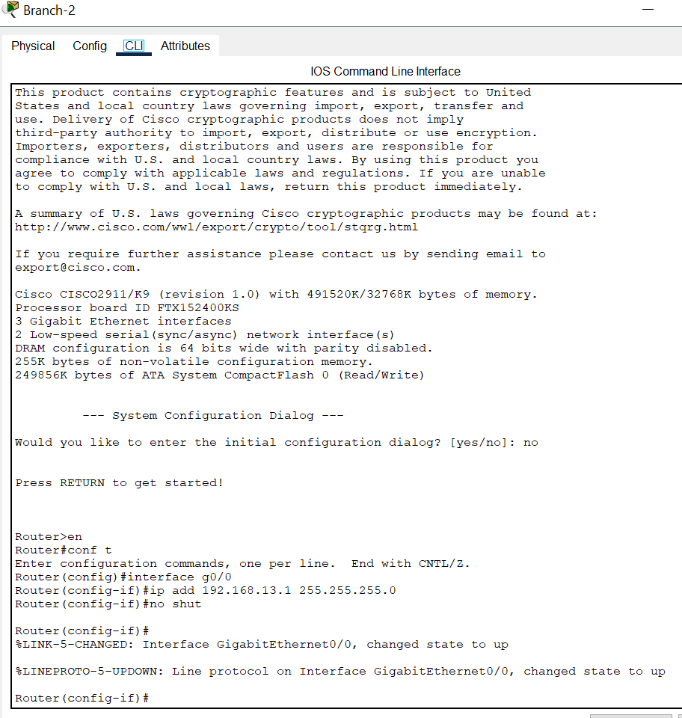

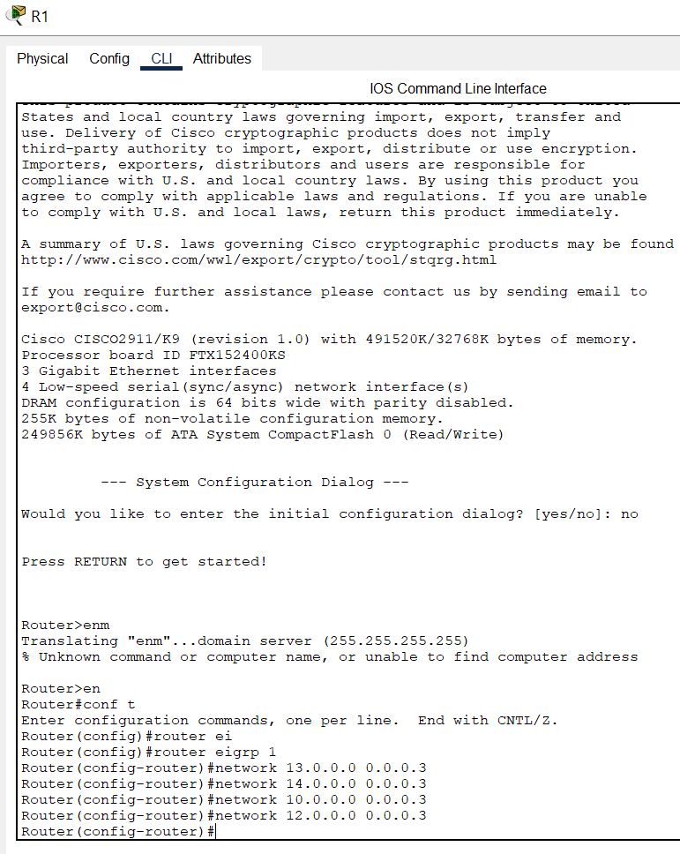

Official

