Setup ospf cho 3 router

Thêm câu passive interface g0/0 vào 3 router

Bước 2 :

Official :

**Lab 3.2**

Score : 100

**Lab 3.3**

**Lab 3.4**

**Important**

**Lab 3.5**

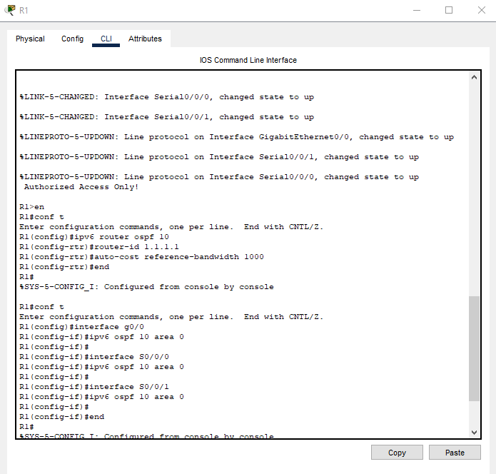

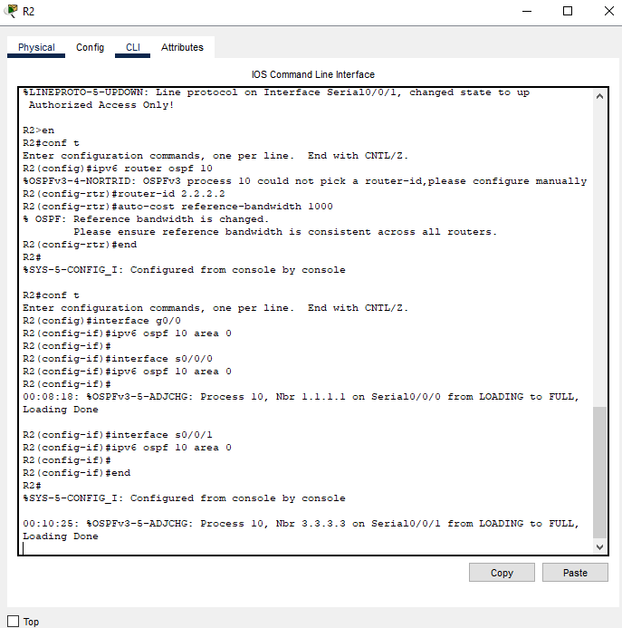

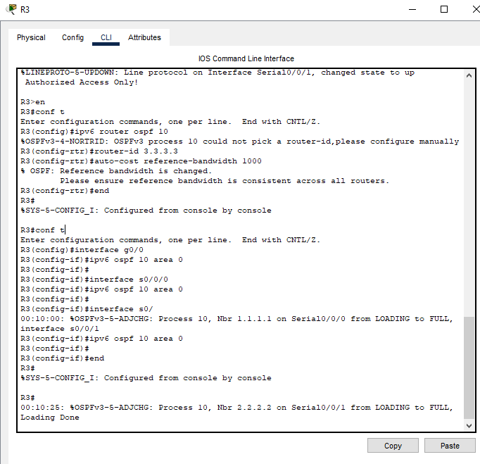

**Lab 3.6**

