**Solution**

**ID : 1931220012 : Hà Quang Minh**

1. Install the software named **mc (midnight).** Capture the screenshot of mc after it starts.

- Duyệt thư mục và tệp

1. Display the current user ‘s name.

1. Display the Operating System Information.

1. Display the default version of the shell.

1. Display the path of the Shell.

1. Display the user id and corresponding name.

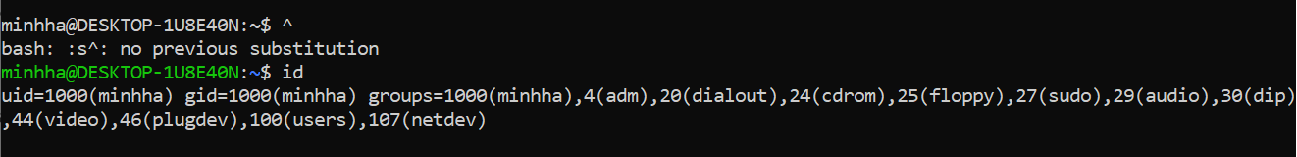

1. Display the available disk space.

1. Display currently running all processes with both user and root privilege.

1. Display how much system resources have been used by the current running processes.

1. Display the current date only

1. Display the current time only

1. Ensure that you are in your home directory.

1. Create a new directory called “final” in your home directory.

1. View the permissions of the newly created directory, “final”.

1. Create a new blank file named 'display.sh' in the “final” directory

1. Create a copy of “display.sh” called “report.sh.”

1. Delete the file 'display.sh'.

1. List the files in “/etc” directory in the ascending order of their access time.

1. Find out all text files in /etc directory.

1. Copy the file /var/log/bootstrap.log to your current directory.

1. Show the system's host name.

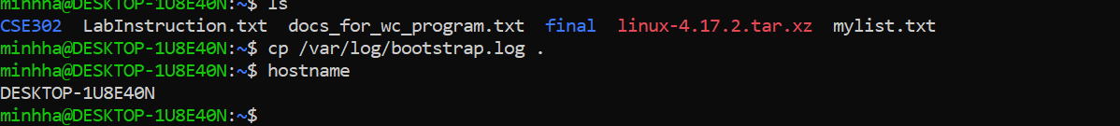

1. Show the system's IP address only.

1. Test if a host is reachable.

1. Display the number of lines in the /etc/passwd file.

24. Display the lines that contain the string 'not installed' in /var/log/bootstrap.log.

