**Lab9_NgoQuangKhiem_2031220025**

**1. Extract lines between two line numbers: example: 2 & 4 => extract line3.**

khiem@Khimmm:~/CSE306$ sed -n '3p' filename

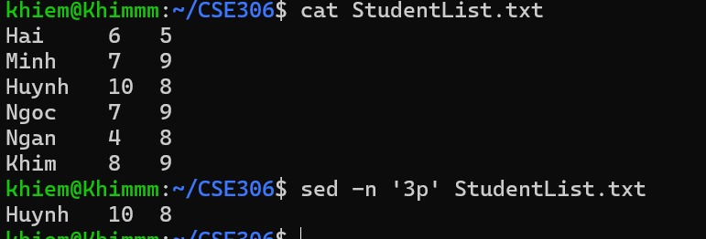

**2. Write a command to print the first field in the passwd file**

khiem@Khimmm:~/CSE306$ cut -d':' -f1 /etc/passwd

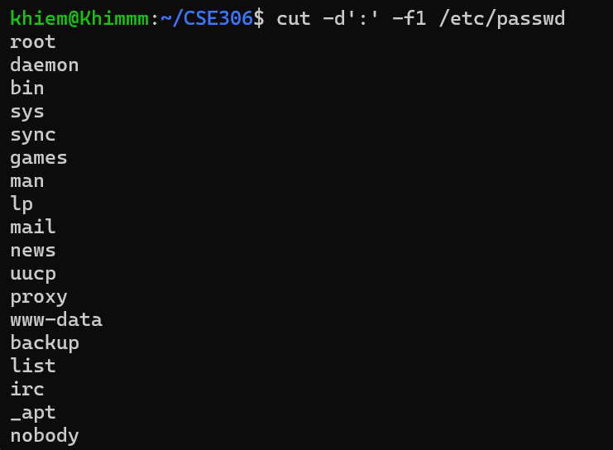

**3. Print the username and its home path from /etc/passwd**

**ex: root home at /root**

awk -F: '{print $1 " home at " $6}' /etc/passwd

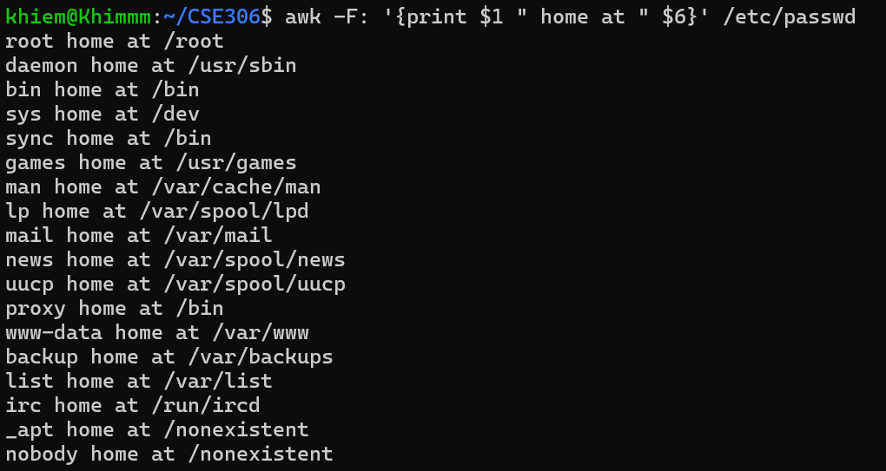

**4. Change the second word of a string ("Hello world") (=>using with echo command)**

khiem@Khimmm:~/CSE306$ echo "Hello world" | awk '{ $2="Linux"; print }'



**5. Replace the name “Ngoc” into your name using gsub() command**

khiem@Khimmm:~/CSE306$ awk '{gsub(/Ngoc/, "Khiem"); print}' StudentList.txt

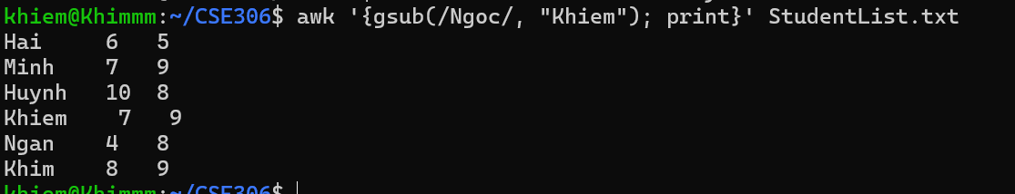

**6. Add the Header and the Footer for the content**

awk 'BEGIN {print "Welcome!"} {print} END {print "This is the end."}' StudentList.txt

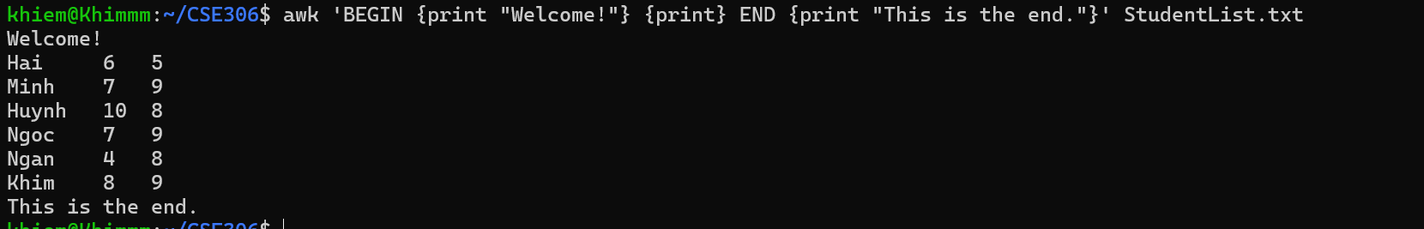

**7. Convert data from line format to column format, and print line 1 and line 3**

awk 'BEGIN {FS="\n"; RS=""} {print $1, $3}' StudentList.txt



**8. Write a script to calculate average score and save into new file grade.txt**

awk '{avg=($2+$3)/2; print $1, avg > "grade.txt"}' StudentList.txt

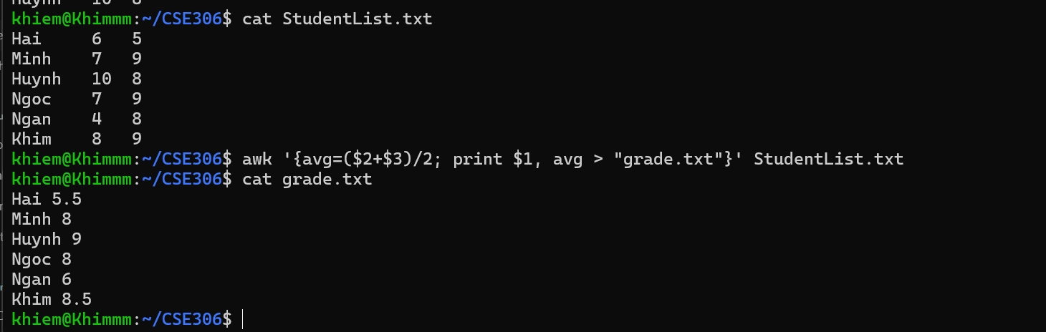

**9. Sort the average score list in descending order and show top 3**

awk '{avg=($2+$3)/2; print $1, avg }' StudentList.txt | sort -k2r | head -n3



**10. Add ascending numbers before the name column**

awk '{print NR ". " $1, $2, $3}' StudentList.txt

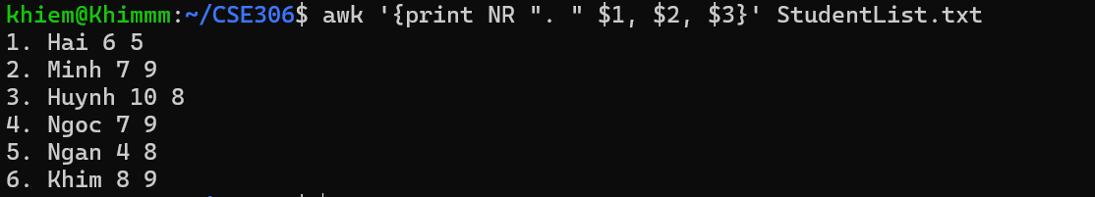

**11. Suppose there are 2 files: course.txt (student’s name, course ) and grade.txt (student’s name,grade), write a command to concatenate student names and their grades based on the course.**

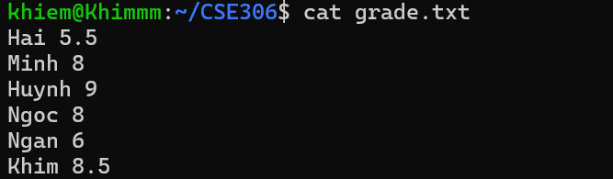

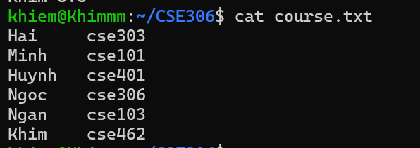

awk 'NR==FNR{a[$1]=$2; next} $1 in a {print $1, a[$1], $2}' course.txt grade.txt

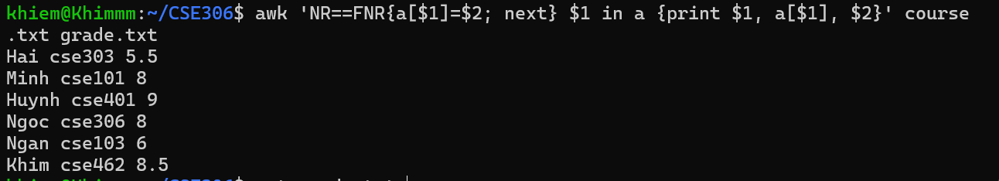

**12. Filter only students with the score >=8**

awk 'NR==FNR{a[$1]=$2; next} $1 in a {print $1, a[$1], $2}' course.txt grade.txt |awk '$3 >= 8'

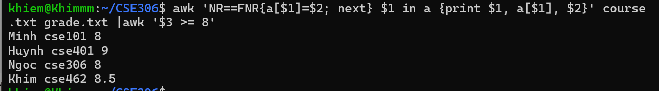

**12. Print the student with the highest score and lowest ones.**

awk 'NR==FNR{a[$1]=$2; next} $1 in a {print $1, a[$1], $2}' course.txt grade.txt |sort -k3r | awk 'NR==1{first=$0} {last=$0} END {print first;print last}'

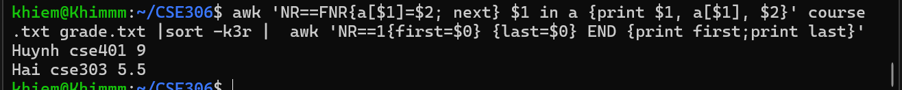

**13. Classify students by score (excellent, good, average, poor) => using if-else**

nano classify_students.sh

—-----------------------------------------------------------------------------------------------

#!/bin/bash

# Check if the required files exist

if [[ ! -f course.txt || ! -f grade.txt ]]; then

echo "Error: course.txt or grade.txt not found!"

exit 1

fi

# Process files with awk to classify students by score

awk 'NR==FNR{a[$1]=$2; next} {score=$2; course=a[$1];

if(score >= 8) {grade="Excellent"}

else if(score >= 6.5) {grade="Good"}

else if(score >= 5) {grade="Average"}

else {grade="Poor"}

print $1, course, score, "(" grade ")"}' course.txt grade.txt

—---------------------------------------------------------------------------------------------------------

chmod +x classify_students.sh

./classify_students.sh

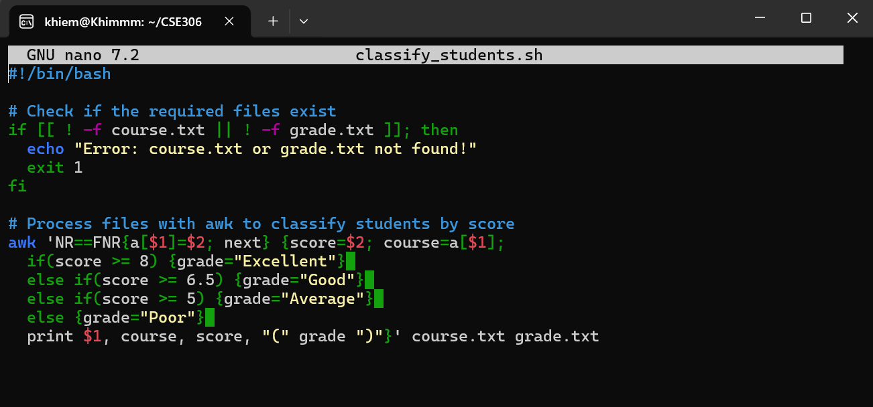

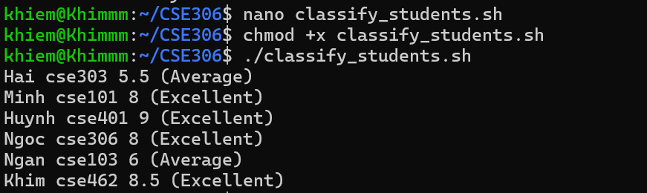

**14. Count the number of each category.**

nano Count_each_category.sh

—------------------------------------------------

#!/bin/bash

# Check if the required files exist

if [[ ! -f course.txt || ! -f grade.txt ]]; then

echo "Error: course.txt or grade.txt not found!"

exit 1

fi

# Initialize counters for each category

excellent_count=0

good_count=0

average_count=0

poor_count=0

# Process files with awk to classify students by score and count categories

awk 'NR==FNR{a[$1]=$2; next} {

score=$2;

course=a[$1];

if(score >= 8) {excellent_count++}

else if(score >= 6.5) {good_count++}

else if(score >= 5) {average_count++}

else {poor_count++}

}

END {

print "Excellent: " (excellent_count ? excellent_count : 0);

print "Good: " (good_count ? good_count : 0);

print "Average: " (average_count ? average_count : 0);

print "Poor: " (poor_count ? poor_count : 0)

}' course.txt grade.txt

—------------------------------------------------------------------------

chmod +x Count_each_category.sh

./Count_each_category.sh

