Design

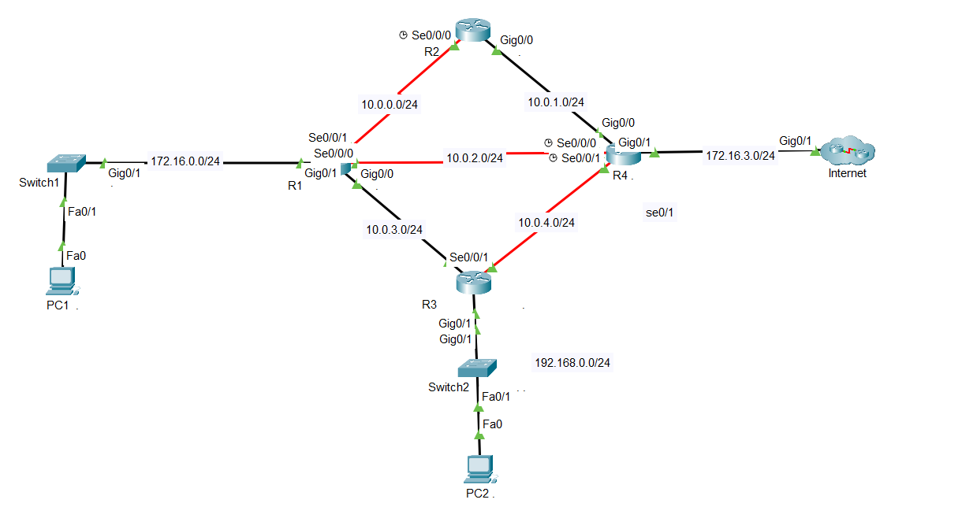

BASIC CONFIGURE

## R1

interface GigabitEthernet0/1

ip address 172.16.0.1 255.255.255.0

no shutdown

exit

interface Serial0/0/1

ip address 10.0.0.1 255.255.255.0

no shutdown

exit

interface Serial0/0/0

ip address 10.0.2.1 255.255.255.0

no shutdown

exit

interface gi0/0

ip address 10.0.3.1 255.255.255.0

no shutdown

ip dhcp pool net172

network 172.16.0.0 255.255.255.0

default-router 172.16.0.1

dns-server 8.8.8.8

ip dhcp excluded-address 172.16.0.1 172.16.0.10

## R2

interface Serial0/0/0

no ip address

ip address 10.0.0.2 255.255.255.0

no shutdown

exit

interface gi0/0

ip address 10.0.1.1 255.255.255.0

no shutdown

## R3

interface gi0/0

ip address 10.0.3.2 255.255.255.0

no shutdown

exit

interface Serial0/0/1

ip address 10.0.4.1 255.255.255.0

no shutdown

exit

interface GigabitEthernet0/1

ip address 192.168.0.1 255.255.255.0

no shutdown

ip dhcp pool net198

network 192.168.0.0 255.255.255.0

default-router 192.168.0.1

dns-server 8.8.8.8

ip dhcp excluded-address 192.168.0.1 192.168.0.10

## R4

interface Serial0/0/0

ip address 10.0.2.2 255.255.255.0

no shutdown

exit

interface Serial0/0/1

ip address 10.0.4.2 255.255.255.0

no shutdown

exit

interface gi0/0

ip address 10.0.1.2 255.255.255.0

no shutdown

interface gi0/1

ip address 172.16.3.120 255.255.255.0

no shutdown

# OSPF

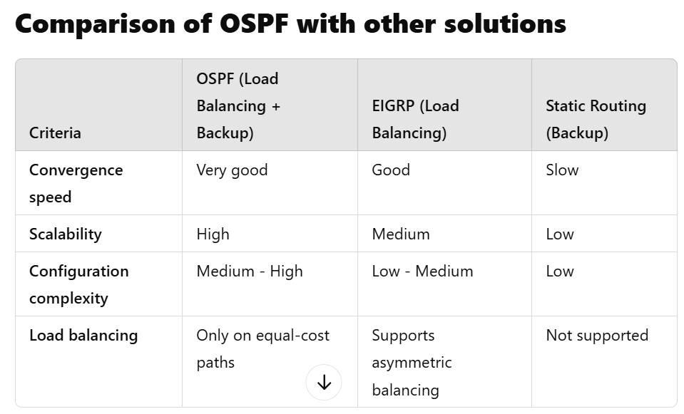

OSPF has the advantage of multiple path backup and EIGRP will have the advantage of load balancing.

## Principle of OSPF Cost

Cost in OSPF is a value that measures the cost of a link.

Cost calculation formula:

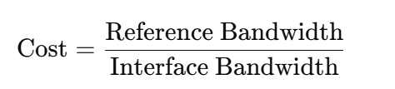

Reference Bandwidth: Reference value, default is 100 Mbps (100,000 Kbps).

Interface Bandwidth: Interface bandwidth, measured in Kbps.

A high bandwidth link will have a lower cost. For example:

100 Mbps → Cost = 1

10 Mbps → Cost = 10

1 Mbps → Cost = 100

Note: If two or more paths have equal costs, OSPF will perform load balancing using Equal-Cost Multi-Path (ECMP).

Advantages

* **Automatic switching:** When the primary path fails, OSPF automatically redirects traffic without manual intervention.
* **High efficiency:** Makes the most of network resources.
* **Simple:** Easy configuration with cost adjustment.

## **Demo configure**

### R1

router ospf 1

network 172.16.0.0 0.0.0.255 area 0

network 10.0.0.0 0.0.7.255 area 0

### R2

router ospf 1

network 10.0.0.0 0.0.7.255 area 0

### R3

router ospf 1

network 192.168.0.0 0.0.0.255 area 0

network 10.0.0.0 0.0.7.255 area 0

### R4

router ospf 1

network 10.0.0.0 0.0.7.255 area 0

network 172.16.3.0 0.0.0.255 area 0

## backup

**Đường chính (Primary Path)**: Qua R1 → R2 → R4.

**Các đường dự phòng (Backup Paths)**:

* R1 → R4 trực tiếp
* R1 → R3 → R4.

### R1

interface se0/0/1

ip ospf cost 10

interface g0/0

ip ospf cost 50

interface se0/0/0

ip ospf cost 50

### R2

interface se0/0/0

ip ospf cost 10

interface gi0/0

ip ospf cost 10

### R3

interface gi0/0

ip ospf cost 50

interface se0/0/1

ip ospf cost 50

### R4

interface se0/0/0

ip ospf cost 50

interface gi0/0

ip ospf cost 10

interface se0/0/1

ip ospf cost 50

access-list 1 permit 10.0.0.0 0.0.7.255

access-list 1 permit 172.16.0.0 0.0.0.255

access-list 1 permit 192.168.0.0 0.0.0.255

int se 0/0/0

ip nat inside

ex

int gi0/0

ip nat inside

ex

int se 0/0/1

ip nat inside

ex

int gi0/1

ip nat outside

ex

ip nat inside source list 1 int gi0/1 overload

ip route 172.16.3.0 255.255.255.0 g0/1

ip route 0.0.0.0 0.0.0.0 172.16.3.1

router ospf 1

default-information originate

ex

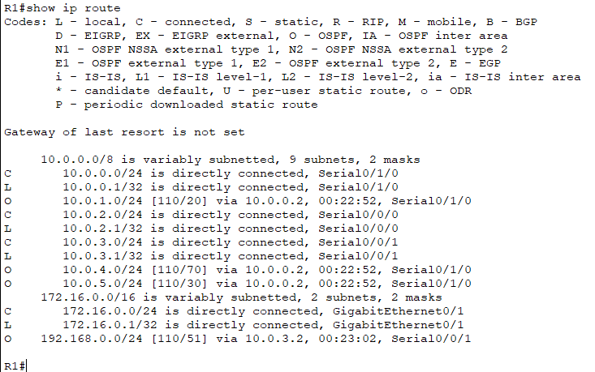

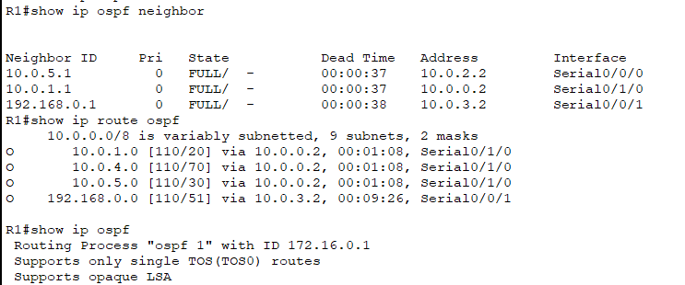

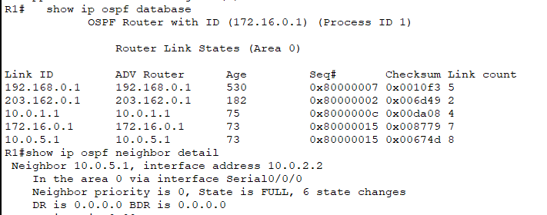

EIGRP

## Configure

### R1

interface GigabitEthernet0/1

ip address 172.16.0.1 255.255.255.0

no shutdown

exit

interface Serial0/0/1

ip address 10.0.0.1 255.255.255.0

bandwidth 1000000

delay 10

no shutdown

exit

interface Serial0/0/0

ip address 10.0.2.1 255.255.255.0

bandwidth 100000

delay 1000

no shutdown

exit

interface gi0/0

ip address 10.0.3.1 255.255.255.0

bandwidth 1544

delay 20000

no shutdown

exit

ip dhcp pool net172

network 172.16.0.0 255.255.255.0

default-router 172.16.0.1

dns-server 8.8.8.8

ip dhcp excluded-address 172.16.0.1 172.16.0.10

### R2

interface Serial0/0/0

ip address 10.0.0.2 255.255.255.0

bandwidth 1000000

delay 10

no shutdown

exit

interface gi0/0

ip address 10.0.1.1 255.255.255.0

bandwidth 100000

delay 100

no shutdown

### R3

interface gi0/0

ip address 10.0.3.2 255.255.255.0

bandwidth 1544

delay 20000

no shutdown

exit

interface Serial0/0/1

ip address 10.0.4.1 255.255.255.0

bandwidth 1000000

delay 10

no shutdown

exit

interface GigabitEthernet0/1

ip address 192.168.0.1 255.255.255.0

no shutdown

ip dhcp pool net198

network 192.168.0.0 255.255.255.0

default-router 192.168.0.1

dns-server 8.8.8.8

ip dhcp excluded-address 192.168.0.1 192.168.0.10

### R4

interface Serial0/0/0

ip address 10.0.2.2 255.255.255.0

bandwidth 100000

delay 1000

no shutdown

exit

interface Serial0/0/1

ip address 10.0.4.2 255.255.255.0

bandwidth 1000000

delay 10

no shutdown

exit

interface gi0/0

ip address 10.0.1.2 255.255.255.0

bandwidth 100000

delay 100

no shutdown

exit

interface gi0/1

ip address 172.16.3.120 255.255.255.0

no shutdown

## Routing

### R1

router eigrp 1

network 172.16.0.0 0.0.0.255

network 10.0.0.0 0.0.7.255

### R2

router eigrp 1

network 10.0.0.0 0.0.7.255

### R3

router eigrp 1

network 192.168.0.0 0.0.0.255

network 10.0.0.0 0.0.7.255

### R4

router eigrp 1

network 10.0.0.0 0.0.7.255

network 172.16.3.0 0.0.0.255

access-list 1 permit 10.0.0.0 0.0.7.255

access-list 1 permit 172.16.0.0 0.0.0.255

access-list 1 permit 192.168.0.0 0.0.0.255

int se 0/0/0

ip nat inside

ex

int gi0/0

ip nat inside

ex

int se 0/0/1

ip nat inside

ex

int gi0/1

ip nat outside

ex

ip nat inside source list 1 int gi0/1 overload

ip route 0.0.0.0 0.0.0.0 172.16.3.1

router eigrp 1

redistribute static

ex

## Unequal-cost load balancing

### R1

router eigrp 1

variance 126

traffic-share balanced

### R2

router eigrp 1

variance 126

traffic-share balanced

### R3

router eigrp 1

variance 126

traffic-share balanced

### R4

router eigrp 1

variance 126

traffic-share balanced

show ip route

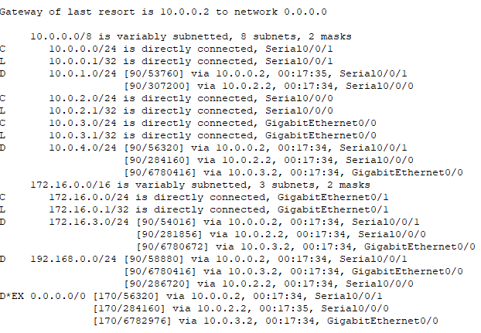

show ip route eigrp

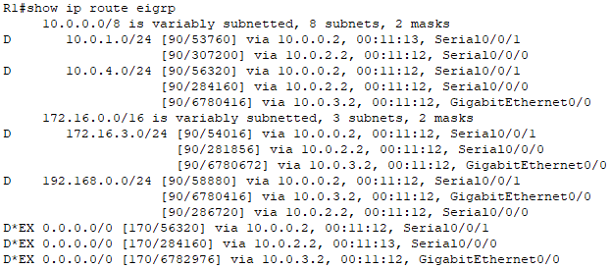

Paths to Network 172.16.3.0/24:

1. **Path 1**: via 10.0.0.2 (FD: 54016)
2. **Path 2**: via 10.0.2.2 (FD: 281856)
3. **Path 3**: via 10.0.3.2 (FD: 6780672)

**Successor(s)**: The number of best paths to the destination.

**FD (Feasible Distance)**: The total distance metric to the destination network.

The Feasible Distance (FD) of the best path: 54016

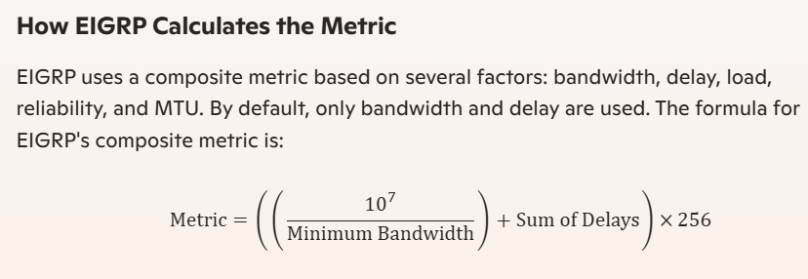

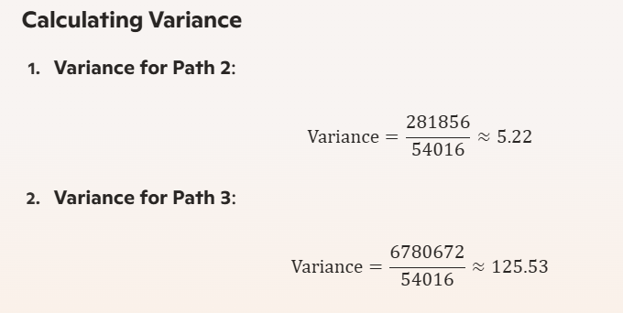

# PACKET FILTER

Packet filter là một cách quản lý luồng dữ liệu qua mạng, dựa trên việc kiểm tra thông tin trong header của gói tin (packet) như địa chỉ IP, cổng, và giao thức.

Packet filter có thể thực hiện dựa trên:

* **Source IP Address**: Lọc theo địa chỉ IP nguồn.
* **Destination IP Address**: Lọc theo địa chỉ IP đích.
* **Port Number**: Lọc dựa trên số cổng (port) như HTTP (80), HTTPS (443).
* **Protocol**: Lọc theo giao thức như TCP, UDP, ICMP.

Object :

* **Chặn các gói HTTP (port 80)** từ LAN 1 đến LAN 2.
* **Cho phép các gói tin khác** (như ICMP hoặc FTP).

## Kham khảo code + hướng đi ( Access Control List (ACL) )

### In OSPF :

* Chọn router nào sẽ áp dụng packet filtering
* chọn giao diện sẽ áp dụng ACL

**Chặn mạng** : 10.0.4.0 /24 Không giao tiếp được với mạng 192.168.0.0/24

* Cấu hình R3 : g0/1

#### R3

en

conf t

access-list 100 deny ip 10.0.4.0 0.0.0.255 192.168.0.0 0.0.0.255

access-list 100 permit ip any any

int g0/1

ip access-group 100 out

exit

lệnh check

show access-lists

Muốn gỡ bỏ và xoá lun ACL 100 :

access-list 100 deny ip 10.0.4.0 0.0.0.255 192.168.0.0 0.0.0.255

access-list 100 permit ip any any

int g0/1

ip access-group 100 out

Còn không muốn chặn mạng đó mà chỉ xoá chặn thôi, không xoá ACL 100

no access-list 100 deny ip 10.0.4.0 0.0.0.255 192.168.0.0 0.0.0.255

Thực tế :

#### R4

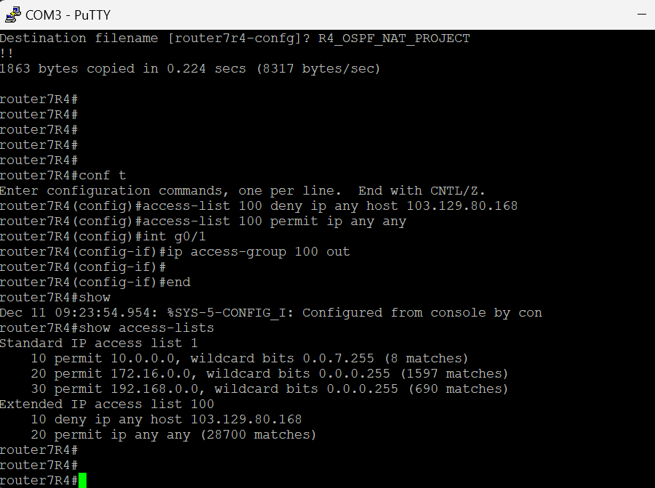

conf t

access-list 100 deny ip any host 103.129.80.168

access-list 100 permit ip any any

int g0/1

ip access-group 100 out

router7R4(config-if)#

router7R4(config-if)#end

router7R4#show

Dec 11 09:23:54.954: %SYS-5-CONFIG_I: Configured from console by con

router7R4#show access-lists

Xóa lệnh và xóa lun ACL

router7R4(config)#int g0/1

router7R4(config-if)#no ip access-group 100 out

router7R4(config-if)#no access-list 100

### In EIGRP :

Chặn gói tin từ **192.168.0.0/24** đến **10.0.4.0/24** trên R3.

#### R3

access-list 100 deny ip 192.168.0.0 0.0.0.255 10.0.4.0 0.0.0.255

access-list 100 permit ip any any

Cho phép chỉ ICMP (ping) từ PC0 đến R5.

access-list 101 permit icmp 169.254.229.156 0.0.0.0 10.5.0.0 0.0.0.255

access-list 101 deny ip any any

Áp dụng ACL 100 trên R3 cho giao diện nối với PC1.

**R3**

int g0/1

ip access-group 100 in

check cấu hình

#### R3

show access-lists

Đưa ra ví dụ :

**R3**: Có thể lọc các gói tin từ mạng **192.168.0.0/24** đi đến **10.0.4.0/24**.

**R1**: Có thể chặn gói tin từ PC0 đến các mạng phía sau R5.