An Explainable Hybrid Spatiotemporal Framework for Deepfake Detection in Images and Videos

Dr. Ashwini S. Gavali*, Harshal S. More* and Purva A. Bangale*
* Department of Artificial Intelligence and Data Science, CSMSS Chh. Shahu College of Engineering, Chhatrapati Sambhajinagar, Maharashtra, India
Email: ashwini.gavli@csmssengg.org

Abstract: Deepfake media generated using advanced artificial intelligence techniques poses significant challenges to digital security, media authenticity, and public trust. This paper presents a hybrid deepfake detection framework that combines XceptionNet and Bidirectional Long Short-Term Memory (BiLSTM) networks for accurate image and video analysis. The proposed system employs Multi-task Cascaded Convolutional Neural Networks (MTCNN) for face detection and alignment, followed by preprocessing to generate standardized facial inputs. XceptionNet extracts discriminative spatial features, while the BiLSTM network captures temporal dependencies across consecutive video frames to improve video-level detection. An identity-based dataset split strategy is adopted to minimize data leakage and enhance model generalization. The model is trained and evaluated on the FaceForensics++ (FF++) benchmark dataset using standard classification metrics, with separate training, validation, and testing sets created through identity-based partitioning. Experimental results demonstrate strong performance, achieving a validation accuracy of 97.22% with an AUC of 99.42%, and a test accuracy of 95.37%, F1-score of 95.02%, and AUC of 99.19%. To improve transparency, Explainable Artificial Intelligence (XAI) techniques, including Grad-CAM and LIME, are integrated to visualize the facial regions influencing model predictions. The proposed framework provides an accurate, interpretable, and scalable solution for practical deepfake detection in digital forensics, cybersecurity, and social media content verification.
Keywords: Deepfake Detection; XceptionNet-BiLSTM; Multi-task Cascaded Convolutional Neural Networks (MTCNN); Explainable Artificial Intelligence (XAI); FaceForensics++; Image and Video Forensics.

1. Introduction
The rapid advancement of Artificial Intelligence (AI) and Deep Learning (DL) has revolutionized digital media generation, enabling the creation of highly realistic synthetic images and videos, commonly referred to as deepfakes. Recent deepfake generation techniques, particularly those based on Generative Adversarial Networks (GANs) and other deep learning architectures, have demonstrated remarkable capabilities in producing manipulated media that closely resemble authentic visual content. While these technologies offer numerous benefits in applications such as entertainment, filmmaking, virtual reality, education, and digital content creation, they have also introduced significant challenges related to cybersecurity, digital forensics, information integrity, and public trust.
The increasing accessibility of deepfake generation tools has led to their misuse in a wide range of malicious activities, including identity theft, financial fraud, misinformation campaigns, political manipulation, social engineering, and the dissemination of fabricated multimedia content. As deepfakes continue to evolve in visual quality and realism, distinguishing manipulated media from genuine content has become increasingly difficult for human observers. Consequently, the development of accurate, reliable, and automated deepfake detection systems has emerged as an important research area within computer vision and artificial intelligence.
Deepfake detection has witnessed substantial progress through the adoption of deep learning techniques, particularly convolutional neural networks (CNNs), attention mechanisms, transformer-based architectures, and temporal sequence learning models. Among these, XceptionNet has demonstrated remarkable effectiveness in learning discriminative spatial representations from manipulated facial images due to its depthwise separable convolution architecture. However, many existing approaches primarily perform frame-level analysis and often overlook the temporal inconsistencies that naturally exist across consecutive video frames. Furthermore, several detection frameworks suffer from challenges such as limited generalization to unseen identities, identity leakage during dataset partitioning, high computational complexity, and insufficient model interpretability. These limitations reduce the practical applicability of deepfake detection systems in real-world environments.
To address these challenges, this paper proposes an explainable hybrid deepfake detection framework that integrates Multi-task Cascaded Convolutional Neural Networks (MTCNN), XceptionNet, and Bidirectional Long Short-Term Memory (BiLSTM) networks for accurate image and video analysis. The proposed framework employs MTCNN for robust face detection and alignment, XceptionNet for discriminative spatial feature extraction, and BiLSTM for learning temporal dependencies across consecutive video frames. In addition, Explainable Artificial Intelligence (XAI) techniques, namely Gradient-weighted Class Activation Mapping (Grad-CAM) and Local Interpretable Model-agnostic Explanations (LIME), are incorporated to provide visual explanations of the model's predictions, thereby enhancing transparency and interpretability. Furthermore, an identity-based dataset partitioning strategy is adopted to minimize identity leakage and improve the generalization capability of the proposed framework.
The proposed framework is evaluated using the FaceForensics++ benchmark dataset through identity-based training, validation, and testing partitions. Experimental evaluation demonstrates strong performance across multiple classification metrics, indicating the effectiveness of combining spatial feature extraction, temporal sequence modelling, and explainable artificial intelligence within a unified deepfake detection framework.
2. Related Work
Deepfake detection has become an active area of research due to the rapid advancement of facial manipulation techniques and the increasing misuse of synthetic media. Existing approaches have focused on improving detection performance by exploiting spatial and temporal feature learning, attention mechanisms, frequency-domain representations, robust feature extraction, lightweight architectures, uncertainty estimation, and explainable artificial intelligence. Despite significant progress, achieving a balance between detection accuracy, robustness, computational efficiency, interpretability, and generalization across unseen manipulations remains a challenging problem.
Several studies have explored spatio-temporal learning to capture both spatial manipulation artifacts and temporal inconsistencies in manipulated videos. Jugade et al. [1] conducted a comprehensive comparative study by integrating multiple pre-trained Convolutional Neural Network (CNN) architectures, including ResNeXt50, XceptionNet, MobileNet, and VGG16, with Long Short-Term Memory (LSTM) networks. Their framework employed CNNs for spatial feature extraction and LSTM networks for temporal sequence modeling, demonstrating the effectiveness of jointly learning spatial and temporal representations. Balaji et al. [4] proposed the IP-GTA Net framework, which combines intra prediction, MobileNetV3, gated convolutional Gated Recurrent Units (GRUs), and temporal attention to detect manipulation artifacts through frame-wise temporal modeling. Similarly, Son and Kim [11] introduced a supervised contrastive learning framework based on a dual-stream architecture that combines a three-dimensional CNN for temporal feature extraction with a two-dimensional CNN for spatial representation learning. By integrating domain-aware contrastive learning with Support Vector Machine (SVM) classification, the proposed method significantly improves cross-dataset generalization. Xiong et al. [12] proposed the BiLSTM Multi-Head Self-Attention Network (BMNet), which combines Bidirectional Long Short-Term Memory (BiLSTM) networks with a Multi-Head Self-Attention (MHSA) mechanism to simultaneously model temporal dependencies and localized forgery features extracted from facial landmarks. Likewise, Lu et al. [20] developed the iCapsNet–TSF framework, which integrates an improved Capsule Network (CapsNet) with optical flow-based temporal feature extraction to jointly learn temporal-spatial representations for robust video-level deepfake detection.
Improving spatial feature representation has also received considerable attention. Lal et al. [2] proposed a visual attention-based deep learning framework that extracts facial regions using a pre-trained ResNeXt-50 network and employs a visual attention mechanism to identify manipulation-specific artifacts. The model demonstrated strong cross-dataset generalization when trained on FaceForensics++ and evaluated on Celeb-DFv2 and DFDC datasets. Kou et al. [3] introduced a Spatial-Frequency Feature Integration (SFFI) framework that combines spatial-domain and frequency-domain features to improve detection performance. To address class imbalance, the authors proposed an Authenticity-Aware Margin Loss (AAML), which dynamically adjusts the decision boundary for improved recognition of minority-class samples. Sheng et al. [9] proposed an identity-insensitive multi-attention framework incorporating CondenseNet-based texture feature enhancement, multi-scale artifact detection, and multiple attention mechanisms to reduce identity leakage while improving cross-dataset performance. Zhang et al. [17] developed the Multi-Stage Edge Refinement Network (MSER-Net), which exploits edge inconsistencies, residual information, and multidimensional attention mechanisms to capture subtle forgery traces while maintaining robustness against post-processing attacks. Javed et al. [19] further investigated localized facial analysis by proposing a real-time deepfake detection framework based on gaze direction and blink pattern analysis using TimeSformer and hybrid Transformer-CNN architectures, achieving robust performance across multiple benchmark datasets.
Another important research direction focuses on improving model robustness and generalization under diverse real-world conditions. Jin et al. [5] introduced the concept of deepfake detection calibration to address the problem of overconfident predictions by proposing a Packed-Ensembles (PE) framework for uncertainty estimation without increasing computational complexity. Chatterjee [7] proposed an Optimal Transport-guided deepfake detection framework that employs Wasserstein distance-based regularization to align feature distributions of authentic and manipulated media while incorporating adversarial training to improve robustness against adversarial attacks and unseen manipulations. Lai et al. [10] presented the Unimodal-generated Multimodal Contrastive Learning (UMCL) framework, which transforms a single visual modality into complementary representations, including remote photoplethysmography (rPPG) signals, temporal landmark dynamics, and semantic embeddings. The proposed Affinity-driven Semantic Alignment (ASA) and Cross-Quality Similarity Learning (CQSL) strategies significantly improve robustness across varying compression levels. Khormali and Yuan [13] introduced a self-supervised graph transformer framework that combines a self-supervised Vision Transformer, Graph Convolutional Network (GCN), and Transformer-based discriminator to improve cross-dataset generalization while providing interpretable Graph Transformer Relevancy Maps. Liu et al. [15] proposed a deep forgery detection framework based on fine-grained artifact features by generating diverse facial synthesis data through color conversion, frequency-domain conversion, mask deformation, and blurring, thereby improving adaptability to multiple forgery techniques and enhancing detection stability.
Several researchers have also focused on improving computational efficiency and practical deployment. Javiya et al. [6] proposed a deepfake detection framework integrating an Adaptive Deep Convolutional Generative Adversarial Network (Adaptive-DCGAN) with a lightweight Convolutional Neural Network (Lite-CNN). The Adaptive-DCGAN enhances the training dataset by generating high-quality synthetic images, whereas the Lite-CNN performs efficient classification with low computational overhead, resulting in improved scalability for digital media platforms. Balafrej and Dahmane [8] addressed the computational limitations of existing deepfake detectors by introducing lightweight inference techniques inspired by steganalysis. Their approach substantially reduces network complexity while maintaining competitive detection performance, making it suitable for edge computing and real-time applications.
Model interpretability has recently emerged as an important aspect of trustworthy deepfake detection. Shi et al. [14] proposed a Full-Defense Framework (FDF) that combines passive deepfake detection with proactive defense through separable watermarking for copyright protection and source tracing. The framework further integrates cross-domain feature fusion of spatial- and frequency-domain representations to distinguish deepfake content from watermark removal attacks. Eutamene et al. [16] introduced a multimodal deepfake detection framework that combines low-level perceptual quality features, artifact analysis, and caption-based semantic representations using a fine-tuned DeepSeek-V2 Lite model, thereby improving both classification accuracy and cross-dataset generalization. Du et al. [18] proposed the Two-Branch Autoencoder Network (TAENet), which disentangles real and forged content through dual encoders and generates pixel-level content maps that provide visual explanations of model decisions while maintaining competitive detection performance.
Although these studies have significantly advanced deepfake detection, several challenges remain. Many existing approaches either emphasize spatial feature extraction or temporal sequence modeling rather than jointly exploiting both within a unified framework. In addition, several high-performing models involve complex architectures with considerable computational requirements, limiting their applicability in resource-constrained environments. While recent studies have improved robustness, uncertainty estimation, and cross-dataset generalization, model interpretability and reliable deployment under real-world conditions remain active research challenges. Motivated by these limitations, the proposed framework integrates MTCNN, XceptionNet, and BiLSTM to jointly learn discriminative spatial and temporal representations while incorporating Grad-CAM and LIME to provide transparent and interpretable deepfake detection.
3. Proposed Methodology
3.1 Overview of the proposed framework
The proposed deepfake detection framework integrates XceptionNet and Bidirectional Long Short-Term Memory (BiLSTM) networks to jointly learn spatial and temporal characteristics of manipulated facial media. The framework is designed to detect deepfakes in both images and videos while providing interpretable predictions through Explainable Artificial Intelligence (XAI) techniques. The overall architecture of the proposed framework is illustrated in Figure 1.
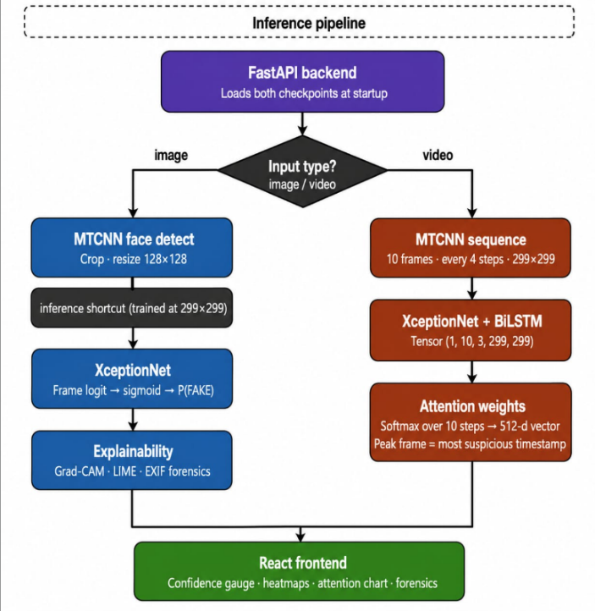
Fig. 1. System Workflow of the Proposed Model
The processing pipeline begins with an input image or video. MTCNN is employed to detect, align, and crop facial regions, which are then resized to 299 × 299 pixels and normalized using ImageNet statistics. For video inputs, representative frames are extracted and preprocessed similarly to generate a sequence of aligned facial images.
The preprocessed faces are passed to an ImageNet-pretrained XceptionNet backbone, which is fine-tuned on the FaceForensics++ dataset to extract discriminative spatial features associated with deepfake manipulations. For video analysis, the extracted feature sequences are subsequently processed by a Bidirectional Long Short-Term Memory (BiLSTM) network to capture temporal dependencies and frame-to-frame inconsistencies. The learned representation is forwarded to a fully connected layer with a sigmoid activation function for binary classification into Real or Fake classes.
The model is trained using the Adam optimizer and Binary Cross-Entropy loss function, while an identity-based dataset partitioning strategy improves generalization to unseen identities. To enhance interpretability, Grad-CAM and LIME are employed to generate visual explanations highlighting the facial regions that influence the model's predictions. By combining spatial feature extraction, temporal sequence learning, and explainable decision-making, the proposed framework provides an accurate and interpretable solution for automated deepfake detection.
3.2 Face detection and preprocessing
Accurate face localization and standardized preprocessing are essential for effective deepfake detection, as facial manipulation artifacts are primarily concentrated within the face region. Therefore, the proposed framework performs face detection and preprocessing before feature extraction.
Initially, the input image or each selected video frame is processed using the Multi-task Cascaded Convolutional Neural Network (MTCNN) to detect, align, and crop the facial region while removing irrelevant background information. MTCNN is selected for its robustness to variations in pose, illumination, facial expression, and partial occlusion.
The detected face is resized to 299 × 299 pixels and normalized using ImageNet statistics to match the input requirements of the pretrained XceptionNet model. This standardized preprocessing ensures consistent feature representation and improves training stability.
To improve generalization and reduce overfitting, data augmentation is applied only to the training set using random rotations, horizontal flipping, vertical flipping, and color jittering. No augmentation is performed on the validation and testing sets to ensure unbiased performance evaluation.
The resulting preprocessed facial images provide standardized, high-quality inputs for the subsequent XceptionNet-based spatial feature extraction stage.
3.3 Spatial feature extraction using XceptionNet
Deepfake images and video frames contain subtle spatial artifacts such as texture distortions, blending inconsistencies, illumination mismatches, and boundary irregularities that are difficult to identify using conventional image processing techniques. To effectively capture these features, the proposed framework employs XceptionNet as the spatial feature extraction backbone due to its depthwise separable convolution architecture, which provides high feature representation capability with reduced computational complexity.
Unlike conventional CNNs, XceptionNet factorizes standard convolution into depthwise and pointwise convolutions, enabling efficient extraction of spatial information while significantly reducing the number of trainable parameters. The network is initialized with ImageNet-pretrained weights and fine-tuned on the FaceForensics++ dataset using transfer learning, allowing it to adapt to deepfake-specific visual artifacts while improving convergence and generalization.
Each preprocessed facial image (299 × 299 × 3) is passed through the XceptionNet backbone to extract high-level feature representations that encode discriminative manipulation cues, including abnormal textures, compression artifacts, lighting inconsistencies, and facial boundary distortions. For image inputs, these features are directly used for binary classification through a fully connected layer with sigmoid activation. For video inputs, the extracted feature vectors from consecutive frames are forwarded to the BiLSTM network for temporal sequence learning.
The combination of efficient feature extraction, transfer learning, and strong spatial representation makes XceptionNet a suitable backbone for the proposed XceptionNet–BiLSTM framework, providing robust spatial features for accurate deepfake detection.
3.4 Temporal feature learning using BiLSTM
Although XceptionNet effectively captures spatial manipulation artifacts from individual frames, deepfake videos also contain temporal inconsistencies such as unnatural facial movements, blinking patterns, and frame-to-frame transitions that cannot be detected through frame-level analysis alone. To exploit these temporal cues, the proposed framework incorporates a Bidirectional Long Short-Term Memory (BiLSTM) network.
For each input video, representative frames are first processed by XceptionNet to extract high-level spatial feature vectors. These feature vectors are arranged sequentially and provided as input to the BiLSTM. Unlike a conventional LSTM, the BiLSTM processes the sequence in both forward and backward directions, enabling the model to utilize contextual information from both past and future frames. This bidirectional learning improves the detection of subtle temporal inconsistencies commonly observed in manipulated videos.
The output of the BiLSTM is passed through a fully connected layer followed by a sigmoid activation function to perform binary classification into Real or Fake classes. During training, the network parameters are optimized using the Adam optimizer and Binary Cross-Entropy loss function.
By combining XceptionNet-based spatial feature extraction with BiLSTM-based temporal modeling, the proposed framework effectively captures both appearance-based and temporal manipulation artifacts, resulting in improved accuracy and robustness for video-based deepfake detection.
3.5 Explainability using Grad-CAM and LIME
Although deep learning models achieve high detection accuracy, their predictions are often difficult to interpret due to their black-box nature. To improve transparency and support trustworthy decision-making, the proposed framework incorporates Gradient-weighted Class Activation Mapping (Grad-CAM) and Local Interpretable Model-agnostic Explanations (LIME) as post-hoc Explainable Artificial Intelligence (XAI) techniques.
Grad-CAM generates visual heatmaps by analyzing the gradients of the target class with respect to the final convolutional feature maps of XceptionNet. These heatmaps highlight the facial regions that contribute most significantly to the prediction, enabling visualization of manipulation artifacts such as abnormal textures, blending boundaries, and facial inconsistencies. The Grad-CAM localization map is computed as
 | $$L_{Grad-CAM}^{c}=ReLU\left(\sum_{k}{α_{k}}A^{k}\right) .$$ | (1)

where $A^{k}$represents the feature maps of the final convolutional layer and $α_{k}$denotes their corresponding importance weights.
Complementing Grad-CAM, LIME provides local explanations by partitioning the input image into superpixels and evaluating the influence of each region on the model's prediction. By approximating the model behavior around a specific input, LIME identifies the image regions that positively or negatively contribute to the final classification.
The combined use of Grad-CAM and LIME provides both global and local interpretability, allowing qualitative verification that the model focuses on meaningful facial manipulation artifacts rather than irrelevant background regions. These visual explanations improve prediction transparency, increase user confidence, and support the practical deployment of the proposed XceptionNet–BiLSTM framework in digital forensics and multimedia authentication.
4. Experimental Setup
4.1 Dataset description
The proposed deepfake detection framework is evaluated using the FaceForensics++ (FF++) dataset, a widely used benchmark for deepfake detection research. The dataset contains more than 6,000 original and manipulated videos, including 1,000 authentic source videos and their corresponding forged versions generated using various facial manipulation techniques.
In this study, experiments are conducted using the C23 compression setting, which provides high-quality videos with mild compression while preserving the visual characteristics required for detecting facial manipulation artifacts. The dataset comprises multiple forgery generation methods, including DeepFakes, Face2Face, FaceSwap, FaceShifter, NeuralTextures, and DeepFakeDetection, representing diverse categories of face swapping, facial reenactment, and neural rendering techniques.
The dataset metadata is obtained from FF++_Metadata.csv, which contains information related to video paths, class labels, and other associated attributes. The metadata is utilized to organize authentic and manipulated samples before applying the proposed identity-based dataset partitioning strategy described in the following subsection.
4.2 Identity-based dataset split
To ensure a reliable and unbiased evaluation of the proposed deepfake detection framework, the FaceForensics++ dataset is partitioned using an identity-based splitting strategy instead of a conventional random video-level split. In this approach, all videos associated with a particular individual are assigned exclusively to a single subset, ensuring that the same identity does not appear across the training, validation, and testing sets. This strategy effectively prevents identity leakage, allowing the model to learn manipulation-specific features rather than memorizing identity-dependent facial characteristics. Consequently, the evaluation provides a more realistic assessment of the model's ability to generalize to previously unseen individuals.
The final dataset distribution used for training and evaluation is presented in Table 1.
Table 1. Identity-based dataset partitioning
Dataset Split | Number of Identities | Number of Samples
Training | 699 | 102,211
Validation | 149 | 9,240
Testing | 151 | 8,986

The identity-based partitioning strategy enhances the robustness and fairness of model evaluation by eliminating identity overlap between dataset subsets. As a result, the reported performance metrics more accurately reflect the framework's capability to detect deepfakes involving previously unseen subjects, thereby improving its applicability to real-world deployment scenarios.
4.3 Implementation details
The proposed deepfake detection framework is implemented using a hybrid deep learning architecture that combines XceptionNet for spatial feature extraction and Bidirectional Long Short-Term Memory (BiLSTM) for temporal sequence learning. The XceptionNet backbone is initialized with ImageNet-pretrained weights and subsequently fine-tuned on the FaceForensics++ dataset to learn discriminative representations of manipulated facial content.
The extracted facial images are resized to 299 × 299 pixels and normalized using ImageNet statistics before being forwarded to the network. During training, the XceptionNet backbone remains frozen for the initial two epochs to preserve pretrained visual representations and promote stable convergence. The complete training configuration adopted in this study is summarized in Table 2.
Table 2. Training configuration of the proposed framework
Parameter | Setting
Backbone Network | XceptionNet (ImageNet-pretrained)
Temporal Model | Bidirectional LSTM (BiLSTM)
Input Resolution | 299 × 299 pixels
Batch Size | 32
Number of Epochs | 12
Frozen Epochs | 2
Learning Rate | 0.0001
Weight Decay | 0.0001
Optimizer | Adam
Loss Function | Binary Cross-Entropy Loss
Sampling Strategy | Weighted Sampler
Mixed Precision Training | Enabled (AMP)
Early Stopping Patience | 4 epochs
Training Time | 521.54 minutes

To improve model robustness, a weighted sampling strategy is employed to alleviate the effects of class imbalance during training. Automatic Mixed Precision (AMP) is enabled to reduce memory consumption and accelerate computation while maintaining numerical stability. Furthermore, early stopping with a patience of four epochs is adopted to prevent overfitting by retaining the model parameters corresponding to the best validation performance. These implementation settings contribute to stable optimization and improved generalization of the proposed XceptionNet–BiLSTM framework.
4.4 Evaluation metrics
The performance of the proposed deepfake detection framework is evaluated using multiple classification metrics, including Accuracy, Precision, Recall, F1-score, and Area Under the Receiver Operating Characteristic Curve (AUC-ROC). These metrics provide a comprehensive evaluation of the model’s ability to correctly classify real and manipulated facial media.
Accuracy measures the overall proportion of correctly classified samples among all evaluated samples and is defined as:
 | $$\text{Accuracy =}\frac{\text{TP + TN}}{\text{TP + TN + FP + FN}} ,$$ | (2)
where TP, TN, FP, and FN represent true positives, true negatives, false positives, and false negatives, respectively.
Precision indicates the proportion of correctly identified fake samples among all samples predicted as fake:
 | $$Precision=\frac{TP}{TP + FP} ,$$ | (3)

Recall measures the ability of the model to correctly detect actual fake samples:
 | $$Recall =\frac{TP}{TP + FN} ,$$ | (4)

F1-score provides a balance between precision and recall by calculating their harmonic mean:
 | $$F1= 2 ×\frac{Precision × Recall}{Precision + Recall} .$$ | (5)

Additionally, the Area Under the Receiver Operating Characteristic Curve (AUC-ROC) is used to evaluate the model’s classification capability across different decision thresholds. A higher AUC value indicates better separation between real and fake samples and reflects the robustness and reliability of the proposed framework. Collectively, these evaluation metrics provide a comprehensive assessment of the classification performance, reliability, and generalization capability of the proposed XceptionNet–BiLSTM deepfake detection framework.

5. Results and Discussion
5.1 Quantitative results
The performance of the proposed XceptionNet–BiLSTM framework was evaluated on the FaceForensics++ dataset using the identity-based dataset split described in Section 4.2. The model was assessed using Accuracy, Precision, Recall, F1-score, AUC-ROC, and Loss to comprehensively evaluate its deepfake detection capability.
The proposed framework achieved excellent performance on both the validation and testing datasets. On the validation set, the model obtained an accuracy of 97.22%, precision of 96.33%, recall of 97.99%, F1-score of 97.16%, and an AUC of 99.42%, indicating strong learning capability and reliable classification performance. On the independent test set, the framework achieved an accuracy of 95.37%, precision of 94.59%, recall of 95.45%, F1-score of 95.02%, AUC of 99.19%, and a test loss of 0.1123, demonstrating excellent generalization to previously unseen identities.
Table 3. Performance of the Proposed XceptionNet–BiLSTM Framework
Metric | Validation Set | Test Set
Accuracy (%) | 97.22 | 95.37
Precision (%) | 96.33 | 94.59
Recall (%) | 97.99 | 95.45
F1-score (%) | 97.16 | 95.02
AUC (%) | 99.42 | 99.19

The consistently high values obtained for Accuracy, Precision, Recall, F1-score, and AUC demonstrate that the proposed hybrid framework effectively captures both spatial and temporal manipulation artifacts. The high validation and test performance further indicate that the identity-based dataset partitioning strategy successfully improves model generalization while preventing identity leakage. Overall, the experimental results confirm that the proposed XceptionNet–BiLSTM framework provides accurate, robust, and reliable deepfake detection for both images and videos.
5.1.1. Training and validation curves for Loss, Accuracy, F1-Score, and ROC-AUC across epochs
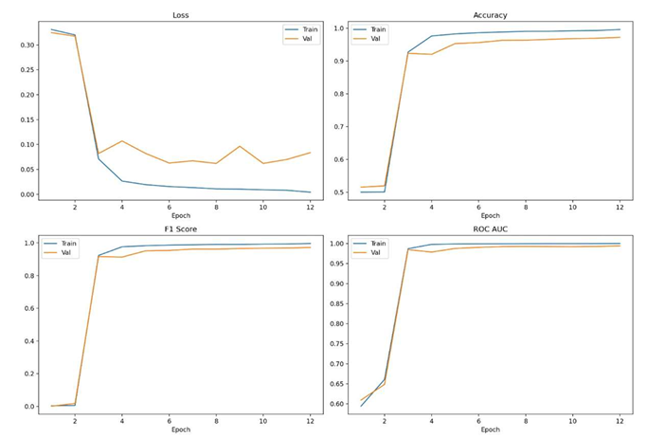
Fig. 2. Training and Validation Performance Graph

The training curves demonstrate stable convergence throughout the training process. Accuracy and F1-score consistently increase with successive epochs, while the training loss decreases steadily, indicating effective optimization without significant overfitting. The AUC curve further confirms the model's strong classification capability across different decision thresholds.

5.1.2. ROC Curve Results
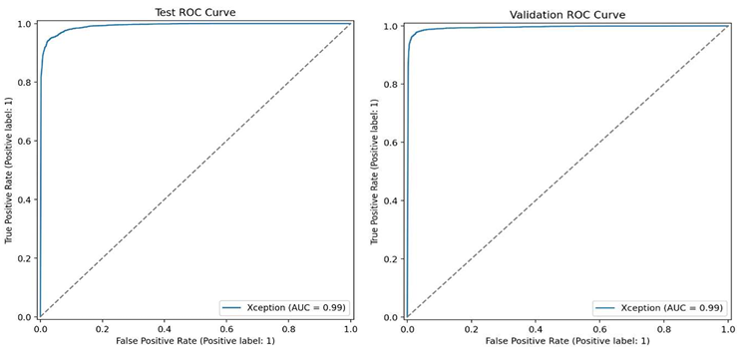
Fig. 3. Test and Validation ROC Curves

The ROC curves for both the validation and test sets are positioned close to the top-left corner, indicating excellent classification capability and a high degree of separability between real and fake samples. The high AUC values obtained on both sets demonstrate that the proposed XceptionNet-BiLSTM model provides reliable and consistent detection performance. Furthermore, the close similarity between the validation and test ROC curves indicates good generalization with minimal overfitting. The identity-based dataset split further confirms that the model maintains robust performance on previously unseen identities within the FaceForensics++ dataset.

5.1.3. Confusion Matrix

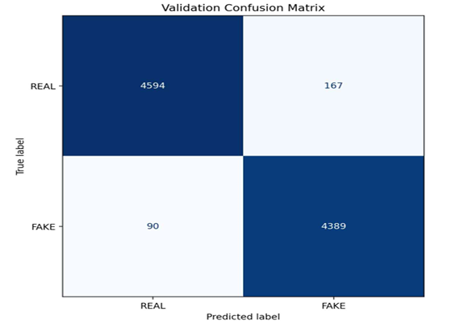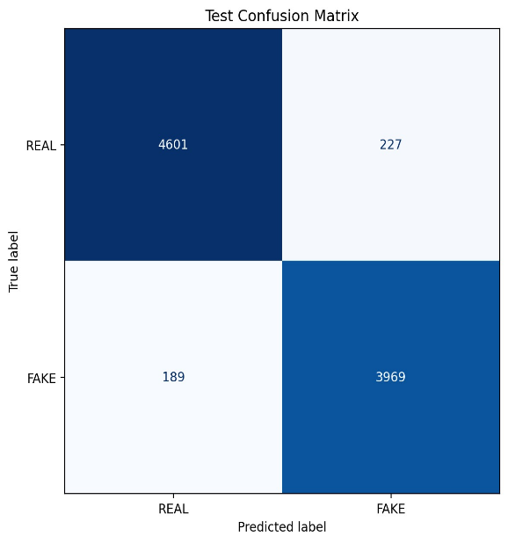

Fig. 4. Confusion Matrix for FaceForensics++ Dataset

The confusion matrices demonstrate the strong classification performance of the proposed XceptionNet-BiLSTM framework on both the validation and test sets. In the validation set, 4,594 real samples and 4,389 fake samples were correctly classified, with only 167 false positives and 90 false negatives, resulting in a validation accuracy of 97.22%. Similarly, in the test set, the model correctly identified 4,601 real samples and 3,969 fake samples, while only 227 real samples were misclassified as fake and 189 fake samples were classified as real, achieving a test accuracy of 95.37%. The low number of misclassifications across both sets indicates that the proposed framework effectively distinguishes authentic and manipulated facial media with high reliability. Furthermore, the consistent classification performance demonstrates stable learning behaviour, minimal overfitting, and good generalization to previously unseen identities.
5.2 Comparison with existing methods
To evaluate the effectiveness of the proposed XceptionNet-BiLSTM framework, its performance is compared with several recent deepfake detection methods evaluated on the FaceForensics++ dataset. The comparison includes conventional CNN-based models, attention-based approaches, lightweight architectures, and hybrid spatial-temporal frameworks. The comparative results are presented in Table 4.

Table 4. Performance Comparison with Existing Deepfake Detection Methods
Model | Dataset | Accuracy (%) | F1-Score (%) | AUC (%)
ResNeXt-50 + Attention [2] | FF++ | 92.88 | 94.40 | 96.20
VGG16 + LSTM [1] | FF++ | 91.75 | 91.90 | 91.00
Adaptive DCGAN + Lite-CNN [6] | FF++ | 95.00 | 95.00 | -
CondenseNet + Multi-Attention[9] | FF++ | 91.20 | - | 94.59
BMNet [12] | FF++ | 95.54 | - | 98.60
Proposed XceptionNet-BiLSTM (Present Work) | FF++ | 95.37 | 95.02 | 99.19

The results demonstrate that the proposed framework achieves a test accuracy of 95.37%, an F1-score of 95.02%, and an AUC of 99.19%, indicating competitive performance among existing approaches. Although BMNet [12] reports a slightly higher accuracy, the proposed model achieves the highest AUC, demonstrating superior discrimination between real and manipulated samples. The combination of XceptionNet for spatial feature extraction and BiLSTM for temporal sequence learning enables effective detection of both spatial artifacts and temporal inconsistencies. In addition, identity-based dataset partitioning and the integration of Grad-CAM and LIME improve the framework's generalization and interpretability, making it suitable for practical deepfake detection applications.

5.3 Qualitative analysis (Grad-CAM & LIME)
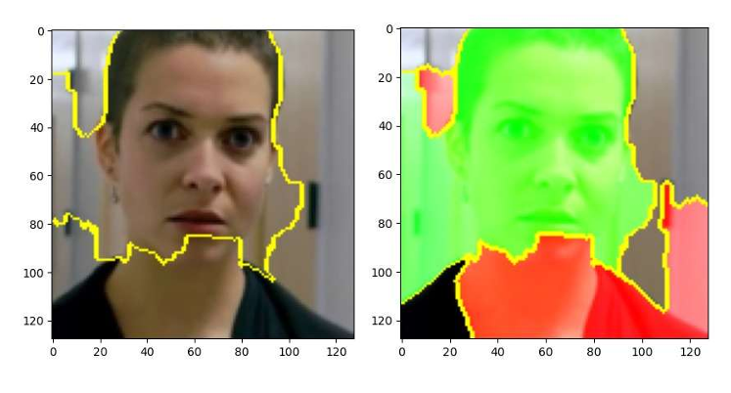
Fig. 5. LIME Results for Deepfake Image

LIME provides a local explanation of the model's prediction by highlighting the facial regions that positively and negatively influence the classification outcome. The visualization demonstrates that the proposed model primarily focuses on meaningful facial features rather than irrelevant background information, confirming that the prediction is based on discriminative manipulation artifacts. The green highlighted regions represent features that positively contribute towards classifying the image as Fake, whereas the red highlighted regions indicate areas with a negative influence on the prediction. The concentration of highlighted regions around the face suggests that the model effectively detects manipulation-related artifacts such as blending inconsistencies, unnatural facial transitions, and subtle texture variations introduced during deepfake generation.

Furthermore, the presence of red-highlighted regions may correspond to portions of the original image that retain authentic visual characteristics, as the manipulated face is often superimposed onto a real background. Overall, the LIME visualization improves the interpretability of the proposed framework by providing a clear understanding of the reasoning behind the model's prediction, thereby increasing the transparency and reliability of the deepfake detection system.
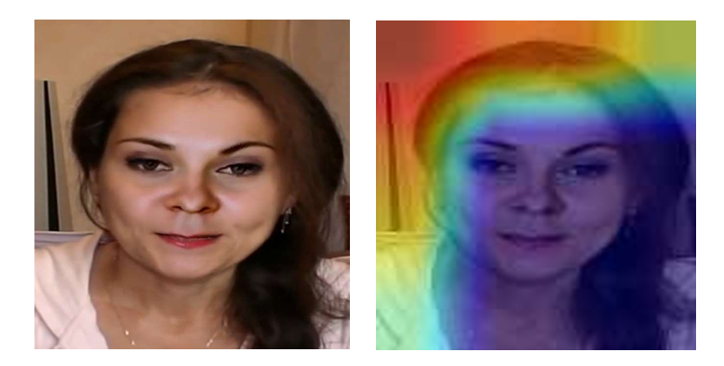
Fig. 6. Input Image and Grad-CAM Output

Grad-CAM provides a visual explanation of the model's prediction by generating class activation heatmaps that highlight the facial regions contributing most to the classification. The visualization shows that the proposed model primarily focuses on central facial regions such as the eyes, nose, forehead, and cheeks, indicating that the prediction is based on meaningful facial features rather than irrelevant background information.

The warmer colors (red and yellow) represent regions with high activation that strongly influence the prediction of the image as Fake, whereas the cooler colors (green and blue) indicate regions with relatively lower contribution. The concentration of high activation around the facial area demonstrates that the model effectively identifies manipulation-related artifacts, including blending inconsistencies, texture distortions, and unnatural facial transitions commonly introduced during deepfake generation.

Overall, the Grad-CAM visualization validates that the proposed model has successfully learned discriminative spatial features required for accurate deepfake detection. By providing a clear visual interpretation of the model's decision-making process, Grad-CAM enhances the transparency, reliability, and interpretability of the proposed deepfake detection framework.

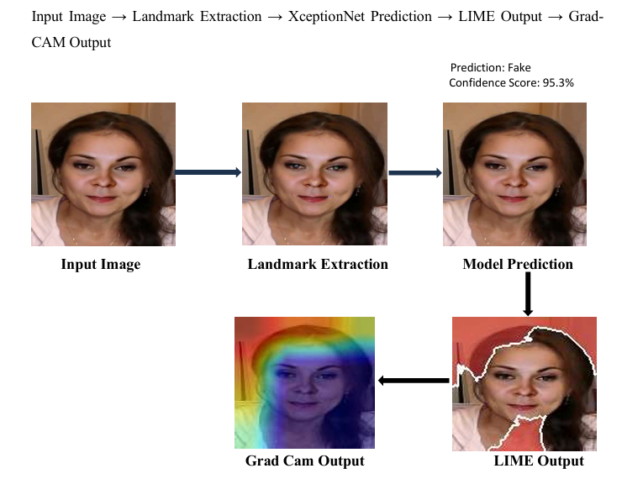
Fig. 7. Prediction Pipeline with Grad-CAM and LIME Visualization
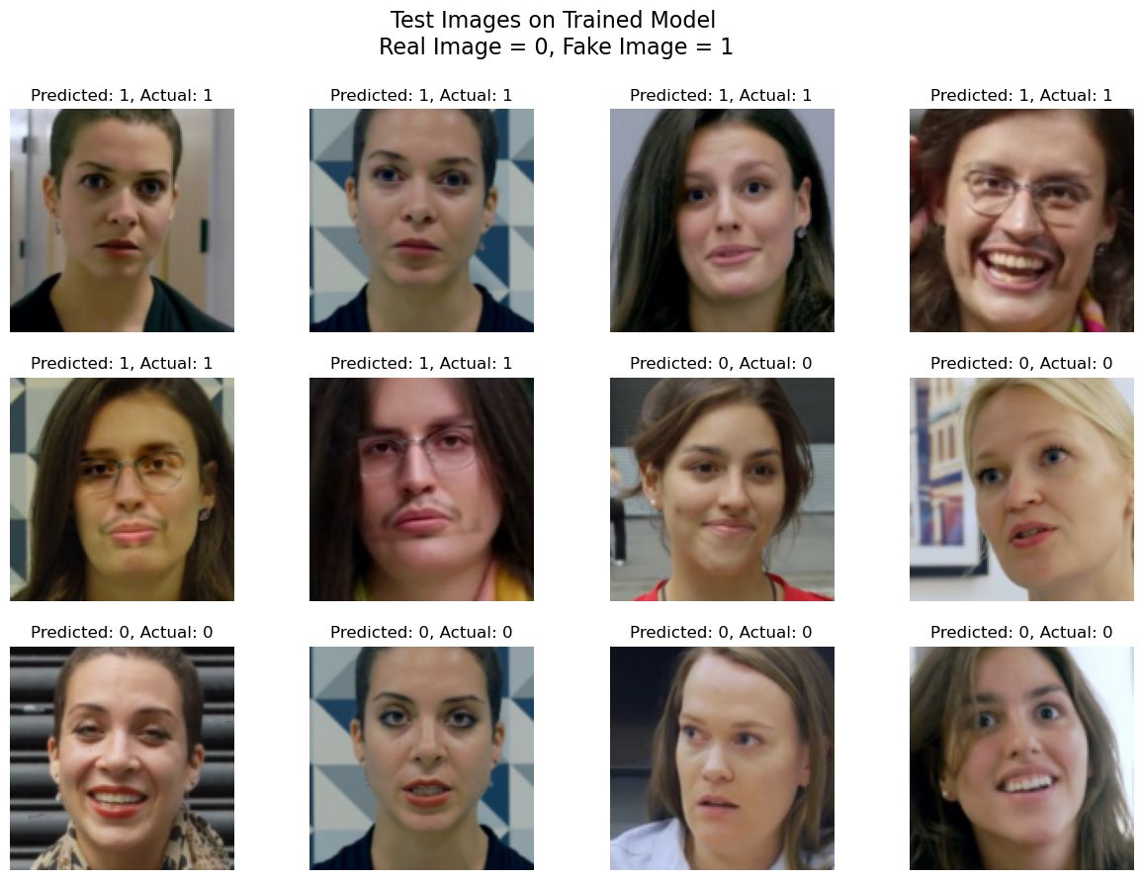
Fig. 8. Deepfake Prediction Result
Figure 8 presents representative prediction results of the proposed XceptionNet–BiLSTM framework on test images. For each sample, the predicted label is compared with the corresponding ground-truth label, where 0 denotes a real image and 1 denotes a fake image. The displayed examples show correct classification of both authentic and manipulated facial images, demonstrating the effectiveness of the proposed framework in accurately distinguishing deepfake content.

5.4 Discussion
The experimental results demonstrate that the proposed framework provides an effective balance between detection accuracy, generalization, and interpretability. Identity-based dataset partitioning and Explainable AI techniques improve the reliability of the system, while future work will focus on enhancing cross-dataset robustness and real-time deployment.

6. Limitations
Despite achieving promising performance, the proposed framework has certain limitations. The model is trained and evaluated primarily on the FaceForensics++ dataset, which may limit its generalization to deepfakes generated using unseen manipulation techniques or real-world social media content. In addition, the BiLSTM-based temporal modeling increases computational complexity during video inference compared with frame-level detection methods. The current framework also focuses on facial manipulation and does not consider audio-based or multimodal deepfake detection.

7. Conclusion and Future Work
This paper presented a hybrid deepfake detection framework that integrates XceptionNet and Bidirectional Long Short-Term Memory (BiLSTM) networks for accurate detection of manipulated images and videos. The framework employs MTCNN for face detection and preprocessing, XceptionNet for spatial feature extraction, and BiLSTM for learning temporal dependencies across consecutive video frames. Furthermore, Grad-CAM and LIME were incorporated to improve model interpretability by providing visual explanations of the prediction process.
Experimental evaluation on the FaceForensics++ dataset demonstrated that the proposed framework achieved a validation accuracy of 97.22% and a test accuracy of 95.37%, with an F1-score of 95.02% and an AUC of 99.19%, indicating robust and reliable deepfake detection performance. The adoption of identity-based dataset partitioning further improved the model's ability to generalize to previously unseen identities.
Future work will focus on evaluating the framework on additional benchmark datasets, improving robustness against emerging deepfake generation techniques and heavily compressed videos, reducing computational complexity for real-time deployment, and extending the framework to multimodal deepfake detection by incorporating audio and textual information.
Declarations
Competing interests
The authors declare that they have no competing interests.
Funding information
This research received no specific grant from any funding agency in the public, commercial, or not-for-profit sectors.
Authors' contributions
- Harshal More: Conceptualization, methodology, software development, model implementation, data preprocessing, experimentation, formal analysis and visualization.
- Purva Bangale: Contributed to methodology development, assisted with experimentation, data analysis, validation of results, manuscript writing (original draft), manuscript review, and editing.
- Ashwini Gavali: Supervision, research guidance, validation of the methodology, critical review of the manuscript, and overall project mentoring.
Availability of data and materials
The FaceForensics++ dataset used in this study is publicly available for research purposes through its official source. All data analyzed during this study were obtained from publicly accessible sources. The code and other supporting materials are available from the corresponding author upon reasonable request.
Research Involving Human and/or Animals
This study did not involve experiments on human participants or animals conducted by the authors. The research was performed using the publicly available FaceForensics++ dataset.

References
[1] Jugade, Y., Syed, Z., Dcosta, C. et al., "Deepfake Detection via Spatial–Temporal Deep Networks: Leveraging CNNs and LSTMs for Enhanced Accuracy", Discover Applied Sciences, 2026, Springer Nature, Volume 8, Article 179.
[2] Lal, K., Shiwani, S. and Gandhi, G.C., "Deepfake Video Deception Detection Using Visual Attention-Based Method", Scientific Reports, 2025, Nature Publishing Group, Volume 15, Article 40089.
[3] Kou, Y., Li, P., Ma, H., Zhou, J., Huang, Z. and Li, X., "SFIAD: Deepfake Detection through Spatial-Frequency Feature Integration and Dynamic Margin Optimization", Artificial Intelligence Review, 2025, Springer Nature, Volume 58, Issue 7.
[4] Balaji, V. et al., "A Gated Temporal Attention Based Intra Prediction Framework for Robust Deepfake Video Detection", Scientific Reports, 2025, Nature Publishing Group, Volume 15, Article 38540.
[5] Jin, X., Guan, W., Wang, W. and Dong, J., "Towards Reliable Deepfake Detection from Uncertainty Calibration Perspective", Visual Intelligence, 2025, Springer Nature, Volume 3, Article 28, pp. 1–11.
[6] Javiya, D., Jethava, G., Parmar, H. et al., "Enhancing Deepfake Detection with Adaptive-DCGAN and Lite-CNN: A Novel Approach to Image Classification", Discover Applied Sciences, 2025, Springer Nature, Volume 7, Article 1229.
[7] Chatterjee, S., "Optimal Transport-Guided Framework for Adversarial Robust Deepfake Detection", Discover Computing, 2026, Springer Nature, Volume 29, Article 40.
[8] Balafrej, I. and Dahmane, M., "Enhancing Practicality and Efficiency of Deepfake Detection", Scientific Reports, 2024, Nature Publishing Group, Volume 14, Issue 1, Article 31084.
[9] Sheng, Y., Zou, Z., Yu, Z., Pang, M., Ou, W. and Han, W., "ID-Insensitive Deepfake Detection Model Based on Multi-Attention Mechanism", Scientific Reports, 2025, Nature Publishing Group, Volume 15, Issue 1, Article 11168.
[10] Lai, C.-Y., Hsu, C.-T., Hsu, C.-C. and Lin, C.-W., "UMCL: Unimodal-Generated Multimodal Contrastive Learning for Cross-Compression-Rate Deepfake Detection", International Journal of Computer Vision, 2025, Springer Nature.
[11] Son, S. and Kim, W., "Advancing Generalization in Deepfake Detection: Supervised Contrastive Representation Learning With Dual Stream Spatio-Temporal Features", IEEE Access, 2025, IEEE, Volume 13, pp. 148646–148667.
[12] Xiong, D., Wen, Z., Zhang, C., Ren, D. and Li, W., "BMNet: Enhancing Deepfake Detection Through BiLSTM and Multi-Head Self-Attention Mechanism", IEEE Access, 2025, IEEE, Volume 13, pp. 21547–21556.
[13] Khormali, A. and Yuan, J.-S., "Self-Supervised Graph Transformer for Deepfake Detection", IEEE Access, 2024, IEEE, Volume 12, pp. 58114–58127.
[14] Shi, H., Wang, G., Li, Y. and Qi, R., "Full-Defense Framework: Multi-Level Deepfake Detection and Source Tracing", Frontiers of Information Technology & Electronic Engineering, 2025, Volume 26, Issue 9, pp. 1649–1661.
[15] Liu, Q., Xue, Z., Liu, H. and Liu, J., "Enhancing Deepfake Detection With Diversified Self-Blending Images and Residuals", IEEE Access, 2024, IEEE, Volume 12, pp. 46109–46117.
[16] Eutamene, H. B., Hamidouche, W., Keita, M., Taleb Ahmed, A. and Hadid, A., "Integrating Perceptual Quality Analysis and Caption-Based Features for Robust Deepfake Video Detection", Computers and Electrical Engineering, 2025, Elsevier, Volume 128, Article 110699.
[17] Zhang, Y., Wang, C. and Zhou, X., "MSER-Net: Multi-stage Edge Refinement Network for Deepfake Detection", Knowledge-Based Systems, 2025, Elsevier, Volume 328, Article 114280.
[18] Du, F., Yu, M., Li, B., Chow, K. P., Jiang, J., Zhang, Y., Liang, Y., Li, M. and Huang, W., "TAENet: Two-branch Autoencoder Network for Interpretable Deepfake Detection", Forensic Science International: Digital Investigation, 2024, Elsevier, Volume 50 (Supplement), Article 301808.
[19] Javed, M., Zhang, Z., Dahri, F. H., Laghari, A. A., Krajčík, M. and Almadhor, A., "Real-Time Deepfake Detection via Gaze and Blink Patterns: A Transformer Framework", Computers, Materials & Continua, 2025, Volume 85, Issue 1, pp. 1457–1493.
[20] Lu, T., Bao, Y. and Li, L., "Deepfake Video Detection Based on Improved CapsNet and Temporal–Spatial Features", Computers, Materials & Continua, 2023, Volume 75, Issue 1, pp. 715–740.

