**DESIGN DOCUMENT OF ELECTRONIC RECYCLING SYSTEM**

**Authors**

1. Bùi Nhựt Duy
2. Lương Viết Thanh
3. Hà Thị Phương Linh

**Table of contents**

**I. Introduction** 2

**II. Overall Architecture** 2

**III. Service Descriptions** 7

1. Quoting Service 7

2. Receiving Service 9

3. Assessment Service 10

4. Accounting Service 12

5. Item Status Service 12

6. Recycling Service 15

7. Reporting Service 16

**IV. Detailed Service Architecture** 18

**V. System Details** 20

1. External database 22

2. Internal database 23

3. Devide project 23

# **I. Introduction**

The electronic recycling system used to recycle old electronic devices (such as an iPhone or Galaxy cell phone).

The processing flow of recycling old electronic devices works as follows:

- First, the customer asks the company (via a website) how much money they can get for the old electronic device (called quoting). If satisfied, the customer will send the electronic device to the recycling company,

- The recycling company in turn will receive the physical device (called receiving).

- Once received, the recycling company will then assess the device to determine if the device is in good working condition or not (called assessment).

- If the device is in good working condition, the company will send the customer the money promised for the device (called accounting).

- Through this process, the customer can go to the website at any time to check on the status of the item (called item status).

- Based on the assessment, the device is then recycled by either safely destroying it or reselling it (called recycling).

- Finally, the company periodically runs ad hoc and scheduled financial and operational reports based on recycling activity (called reporting).

# **II. Overall Architecture**

We will deploy the electronic recycling system using a Service-Based Architecture because it provides many benefits that are suitable for the characteristics of this system.

We have a model of this architecture as follows:

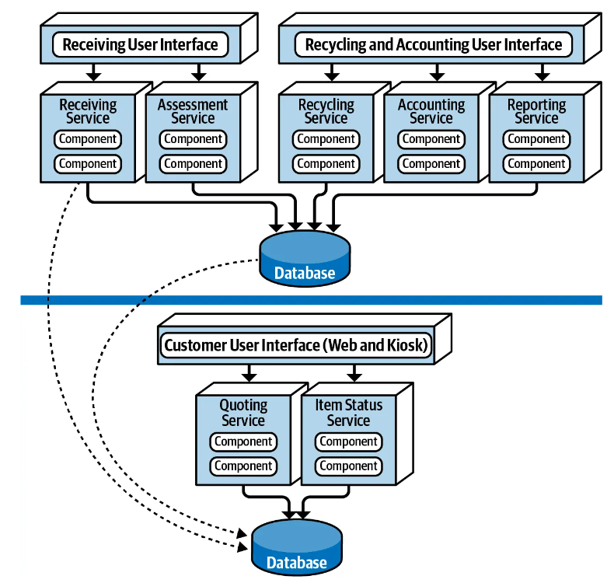

The recycling system comprises seven distinct services, organized into domain services, each catering to specific functionalities. These domain services are designed to efficiently address various tasks within the system.

Firstly, we have the Quoting and Item Status service, which operates as a domain service and is closely integrated with a dedicated database. This service handles tasks related to providing price quotations and managing item statuses, ensuring seamless communication and data management.

Following that, we have the Receiving and Assessment service, another domain service responsible for tasks associated with receiving recycled items and conducting assessments on them. This service streamlines the process of evaluating received materials and determining their suitability for recycling.

Lastly, we have a domain service encompassing Recycling, Accounting, and Reporting functionalities. These services are tightly integrated and share a common database. The Recycling service manages the actual recycling process, while the Accounting service handles financial transactions and records. Additionally, the Reporting service generates comprehensive reports based on recycling activities and financial data.

By dividing the system into domain services, each with its specific set of tasks and functionalities, we ensure modularity, scalability, and ease of maintenance. Furthermore, the integration of certain domain services with dedicated databases enhances data management and security, contributing to the overall efficiency and reliability of the recycling system.

In the electronics recycling, the system contains two quanta: one for the customer-facing portion of the application containing a separate customer user interface, database, and set of services (Quoting and Item Status); and one for the internal operations of receiving, assessing, and recycling the electronic device. Notice that even though the internal operations quantum contains separately deployed services and two separate user interfaces, they all share the same database, making the internal operations portion of the application a single quantum.

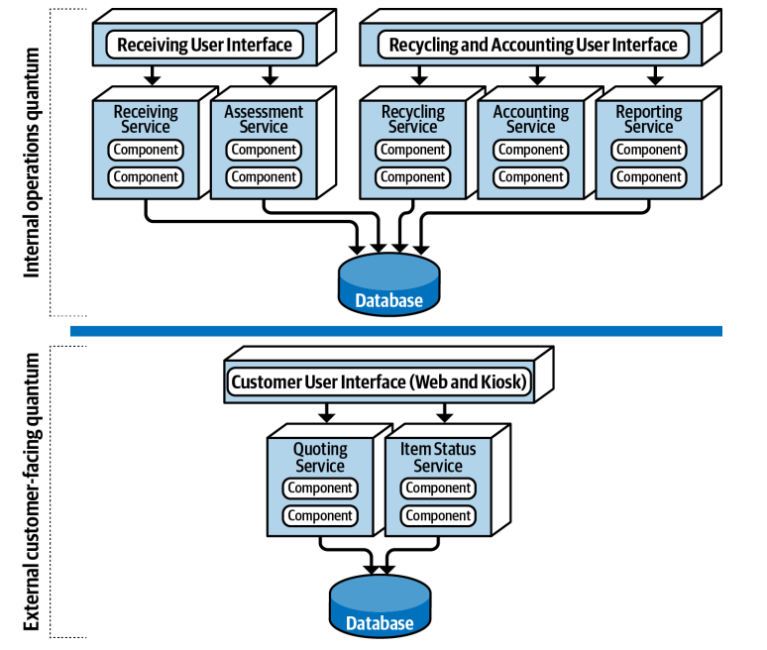

And here are some architecture characteristics for our system:

1. **Scalability**

The electronic recycling system may undergo different stages of operation. For example, services like Quoting and Item Status targeted at customers may require high scalability during promotional campaigns or peak periods. Service-Based Architecture allows us to simply scale these specific services to meet demand. Other services, such as Assessment or Accounting, may only require a single instance and do not need frequent scaling.

1. **Fault Tolerance**

Service-Based Architecture allows for the separation of functions into independent services. If one service encounters an issue, it will not affect other services. This improves the overall fault tolerance of the system. For example, if one domain service goes down (the Receiving service), it doesn’t impact any of the other six services.

1. **Security**

Service-Based Architecture allows for the separation of data into two separate databases: one for customer-facing operations and one for internal operations. This significantly enhances security by isolating sensitive company data from customer access. One-way access through a firewall ensures that internal services can update customer-facing information but not vice versa.

1. **Agility**

The electronic recycling system may require frequent updates to meet new assessment rules for new products or changes in business processes. Service-Based Architecture enables these changes to be implemented flexibly. For example, updating assessment rules only affects the Assessment service, separate from other services. This makes it easier to test and deploy changes, minimizing risks and downtime.

1. **Testability**

By isolating functions into independent services, Service-Based Architecture facilitates easy testing of each individual service. This improves the overall quality of the system and minimizes errors.

1. **Deployability**

Minimization of risks: Deploying each service independently minimizes the impact of incidents on the entire system. If an issue arises, only the related service is affected, while other services continue to operate normally.

Reduced downtime: The system can remain operational during the deployment of new services or updates to existing ones. This helps minimize disruptions and ensures the system is always ready to serve customers.

Flexible deployment: Services can be deployed in stages or according to practical needs. For example, the Quoting service could be deployed first, followed by the Item Status service, and so on. Flexible deployment allows for adjustments based on real-world needs and resource optimization.

# **III. Service Descriptions**

While we have a general architecture for this system, we also need to design the architecture for each small service. For each service, we will have descriptions and corresponding architectural characteristics. From here, we can determine the specific architecture for each service.

## **1. Quoting Service**

Currently, the phone retail industry is very developed, so the number of reselling users is increasing.

In this service, we employ a series of criteria to evaluate used phones. Phones failing to meet any of these criteria will have a corresponding percentage deducted from their offer price. The final offer price for such phones is determined by subtracting the accumulated percentage deductions from the market value of a new phone.

Note: The "original price" refers to the market value of a new, inactive iPhone, typically based on the average market price for such devices.

- Only buy old iPhones

- iPhone X or newer

In the case where the phone is in 'Unopened retail packaging (factory sealed)', we will purchase it at 90% of its original price. If the phone meets this criterion, the subsequent assessment criteria will be disregarded, and we will proceed with the purchase. However, if the phone does not meet this criterion, we will continue with the rest of the assessment process.

We don't care whether your phone is still under warranty or not; we only care about the criteria your phone can meet.

**Condition (Percentage deduction from original price)**

**1. Overall cosmetic condition**

- Damaged or Broken (Major Cosmetic Damage): Major cosmetic damage includes being bent, chipped, dented or sunbleached. (-40%)

- Scratched or Scuffed: There are noticeable scratches or scuffs on the front and back. (-25%)

- Lightly Used: There may be a few light scuffs or scratches that are smaller than the size of a pencil eraser. (-15%)

- Flawless or Like New: Looks almost new with very few minor blemishes. The best condition a used device can be in. (No deduction)

**2. Screen**

- Screen works and fully lights up (No deduction)

- Screen has flaws, flicker or is dim (-20%)

**3. Functional condition**

If criteria are not working normally, please tick the checkbox:

- Face ID (-15%)

- Battery that can hold a charge (-5%)

- Battery:

+ Battery > 85%: No deduction.

+ Battery 75-85%: -5%.

+ Battery < 75%: -7%.

- All peripheral buttons (-5%)

- Front camera (-8%)

- Back camera (-8%)

- Speaker and microphone (-4%)

- Mobile network, Wi-Fi, Bluetooth, and GPS connectivity (-6%)

Based on the description of the quoting service for used iPhones, here are some architectural characteristics it must have:

1. **Scalability**: The quoting service needs to handle varying loads efficiently, especially during peak periods or promotional campaigns when the volume of devices being quoted might increase significantly.
2. **Fault Tolerance**: The service must be robust enough to handle individual failures without affecting the overall system. If one part of the qupte process fails, it should not cause the entire service to fail.
3. **Performance**: Performance directly impacts user experience. A smooth and responsive quoting service portrays professionalism and inspires confidence in your brand. This can lead to higher customer satisfaction and loyalty.
4. **Security**: All customer data, including sensitive information and quoted product details, should be encrypted at rest and in transit. This means the data is scrambled into an unreadable format using encryption algorithms. Even if someone intercepts the data, they won't be able to access its contents without the decryption key.
5. **Deployability**: The service should allow for independent deployment to minimize risks and downtime. Updates to the quote logic should not disrupt other parts of the system.
6. **Agility**: The quoting criteria might need frequent updates to reflect changes in market values or quote rules for different iPhone models.
7. **Availability:** Should be highly available, meaning it should be accessible to users most of the time. Downtime could result in lost business opportunities.
8. **Usability**: The service should offer an intuitive and user-friendly interface for customer handling the quoting processes.

## **2. Receiving Service**

Upon customer satisfaction with the quoting process, the recycling company will send the customer documentation containing all relevant information and the status of the item as per the quoting agreement. The customer will send the electronic device to the recycling company attached to this documentation.

Once the package is received at the recycling company's facility, the device undergoes unboxing and an external inspection to assess its physical condition comprehensively. This inspection includes checking the overall cosmetic condition of the quoted condition. Following the unboxing and inspection process, detailed documentation is meticulously prepared for each received device. This documentation, which includes photographs and videos, meticulously captures the external condition of the device upon receipt, providing irrefutable evidence for future reference.

Then if the device's condition aligns with the customer's description during the quoting process, the recycling company proceeds with the assessment service. In cases where discrepancies arise, the company will reject the device and send it back to the customer.

Based on the description of the receiving service for used iPhones, here are some architectural characteristics it must have:

1. **Security**: The Receiving Service handles sensitive information related to customer devices and their conditions. It must implement robust security measures to protect this data, including encryption of documentation, secure storage of photographic and video evidence, and controlled access to this information. Security is crucial to protect customer data and maintain the integrity of the receiving process.
2. **Usability**: The Receiving Service should offer an intuitive and user-friendly interface for staff handling the unboxing and documentation processes. This includes easy-to-use tools for capturing and uploading photographs and videos, as well as streamlined workflows for updating the system with received device information. Good usability ensures that staff can perform their tasks efficiently and accurately.

## **3. Assessment Service**

Upon completion of the receiving process and confirmation that the device meets the overall cosmetic condition of the quoted condition, the recycling company proceeds with the assessment service.

The assessment service begins with a thorough inspection of the device's screen to ensure its functionality and condition. This inspection includes checking for any flaws, flickering, dimness, or other abnormalities that may affect the screen's usability.

After confirming the screen's condition, the assessment service proceeds to conduct functional testing to verify the device's operational capabilities. This testing encompasses various features and functionalities, including but not limited to:

* Testing Face ID functionality
* Assessing battery performance, including charging, discharging, and capacity
* Checking the operation of peripheral buttons such as volume, power, and home
* Evaluating camera quality for both front and back cameras
* Testing the functionality of speakers and microphones
* Verifying connectivity features, including mobile network, Wi-Fi, Bluetooth, and GPS

Throughout the assessment process, detailed documentation is meticulously maintained for each device, capturing both functional and cosmetic evaluations through a combination of photographs and videos. This comprehensive documentation serves as irrefutable evidence of the device's condition and assessment results, ensuring transparency and accountability throughout the process.

In cases where discrepancies or issues are identified during the assessment, the company will reject the device and send it back to the customer.

Based on the description of the assessment service for used iPhones, here are some architectural characteristics it must have (similar to receiving service):

1. **Security**: The Assessment Service handles sensitive information related to customer devices and their conditions. It must implement robust security measures to protect this data, including encryption of documentation, secure storage of photographic and video evidence, and controlled access to this information. Security is crucial to protect customer data and maintain the integrity of the assess process.
2. **Usability**: The Assessment Service should offer an intuitive and user-friendly interface for staff handling the unboxing and documentation processes. This includes easy-to-use tools for capturing and uploading photographs and videos, as well as streamlined workflows for updating the system with received device information. Good usability ensures that staff can perform their tasks efficiently and accurately.

## **4. Accounting Service**

Upon successful completion of the assessment process and confirmation that the device's condition aligns with the customer's description during the quoting process, the recycling company proceeds with the accounting service.

The payment amount is based on the agreed-upon value of the device during the quoting process. The payment is typically issued through bank transfer.

Upon completion of the payment process, the status of order will update to HAS_BEEN_PAID.

Based on the description of the accounting service for used iPhones, here are some architectural characteristics it must have:

1. **Security**: Given that the Accounting Service handles sensitive financial information, it must implement robust security measures. This includes encrypting financial data, secure handling of bank account details, and ensuring that transactions are protected against unauthorized access and fraud. Security is paramount to protect both customer information and the company's financial integrity.
2. **Auditability**: The Accounting Service should provide comprehensive audit trails for all transactions. This includes detailed logs of payment amounts, transaction timestamps, and status updates. Auditability is essential for regulatory compliance, financial accountability, and resolving any disputes or issues that may arise.
3. **Availability:** The service must be highly available to ensure that payments can be processed at any time without interruption. High availability is crucial to avoid delays in payment processing and ensure that customers receive their payments promptly.

## **5. Item Status Service**

The Item Status Service provides customers with real-time updates on the status of their electronic device throughout the entire recycling process. Through this service, customers can conveniently track the progress of their device via the company's website at any time.

Upon initiating the quoting process, customers receive a unique tracking identifier, which they can use to access the Item Status Service. This identifier serves as a secure link between the customer and their device throughout its journey within the recycling system.

Through the company's website, customers can use their tracking identifier to access and view detailed information regarding the current status of their device, including:

* INITIAL: The initial status when an order is created.
* RECEIVED: The status after the device is received by the company.
* EXTERNAL_EVALUATING: The status when the device is undergoing an external evaluation.
* EXTERNAL_EVALUATING_ACCEPTED: The status when the external evaluation confirms the device's condition as stated by the customer.
* INTERNAL_EVALUATING: The status when the device is undergoing an internal evaluation.
* INTERNAL_EVALUATING_ACCEPTED: The status when the internal evaluation confirms the device's condition as stated by the customer.
* HAS_BEEN_PAID: The status after the customer has been paid for the device.
* RESELL: The status when the device is marked for resale.
* RECYCLING: The status when the device is marked for recycling.
* EXTERNAL_EVALUATING_CONFLICT: The status when there is a conflict during the external evaluation.
* INTERNAL_EVALUATING_CONFLICT: The status when there is a conflict during the internal evaluation.
* WILL_BE_RETURN: The status when the device is to be returned to the customer.

**Process Flow**

1. **Order Creation**: When an order is created, the device's status is set to **INITIAL**.
2. **Receiving**: Upon receiving the device, the status is updated to **RECEIVED** and **EXTERNAL_EVALUATING**.
3. **External Evaluation**:
   * If the external evaluation confirms the device's condition as described by the customer, the status is updated to **EXTERNAL_EVALUATING_ACCEPTED** and then to **INTERNAL_EVALUATING**.
   * If there is a conflict during the external evaluation, the status is updated to **EXTERNAL_EVALUATING_CONFLICT** and **WILL_BE_RETURN**.
4. **Internal Evaluation**:
   * If the internal evaluation confirms the device's condition as described by the customer, the status is updated to **INTERNAL_EVALUATING_ACCEPTED**.
   * If there is a conflict during the internal evaluation, the status is updated to **INTERNAL_EVALUATING_CONFLICT** and **WILL_BE_RETURN**.
5. **Post-Evaluation**:
   * If both evaluations are accepted, the customer is paid, and the status is updated to **HAS_BEEN_PAID**.
   * Depending on the device's condition, it is then either marked for **RESELL** or **RECYCLING**.

Based on the description of the item status service for used iPhones, here are some architectural characteristics it must have:

1. **Scalability**: The item status service needs to handle varying loads efficiently, especially during peak periods or promotional campaigns when the volume of devices being processed may increase significantly.
2. **Fault Tolerance**: The service must be robust enough to handle individual failures without affecting the overall system.
3. **Performance**: Performance is critical for the Item Status Service as it directly impacts the user experience. The service must deliver real-time updates with minimal latency, ensuring that status information is promptly available whenever a customer requests it.
4. **Security**: The Item Status Service handles sensitive information related to customer devices and their statuses. Therefore, it must implement robust security measures to protect this data. This includes encrypting data at rest and in transit, ensuring secure authentication and authorization mechanisms, and protecting against common security threats such as data breaches and unauthorized access.
5. **Availability:** The Item Status Service must be highly available, ensuring that it is accessible to customers at all times. This involves designing the service to minimize downtime and quickly recover from failures. High availability is crucial to provide uninterrupted access to status updates, which is a key component of customer satisfaction and operational reliability.

## **6. Recycling Service**

After the assessment process is completed and the device's condition has been determined, the recycling company proceeds with the recycling service.

This service encompasses the final stage of the electronic device recycling process, where the device is either safely destroyed or prepared for resale based on the outcome of the assessment.

1. **Safe destruction**

Devices that are deemed unsuitable for resale due to irreparable damage, significant defects, or outdated technology undergo safe destruction.

This process involves environmentally responsible disposal methods to ensure compliance with regulations and minimize ecological impact.

Components that can be recycled are separated and processed through specialized recycling facilities to recover valuable materials, such as RAM, ROM, CAMERA, BATTERY.

Data wiping procedures are implemented to securely erase any remaining personal or sensitive information stored on the device, ensuring customer privacy and data security.

1. **Resale preparation**

Devices that meet the criteria for resale undergo refurbishment and preparation to maximize their value in the secondary market.

Cosmetic imperfections are addressed through cleaning, polishing, and, if necessary, minor repairs to restore the device to a like-new appearance.

Functional components are thoroughly tested and, if needed, replaced to ensure optimal performance and reliability.

Data wiping procedures are executed to erase any existing user data, restoring the device to its factory settings and safeguarding customer privacy.

Once refurbished, devices are carefully packaged and labeled for resale, including all necessary accessories and documentation.

Pricing strategies are implemented based on market demand, device condition, and competitive analysis to optimize resale value and profitability.

## **7. Reporting Service**

The Reporting Service plays a critical role in analyzing and utilizing data gathered throughout the electronic device recycling process to inform decision-making, identify trends, and optimize operational efficiency. This service involves several key business processes:

1. **Data collection**

The first step in the reporting process is to collect and aggregate data from various stages of the recycling system, including quoting, receiving, assessment, recycling, and accounting.

Data is gathered from multiple sources, such as online platforms, tracking systems, inspection records, customer interactions, and financial transactions.

This data encompasses a wide range of metrics, including device condition, customer demographics, recycling volumes, revenue streams, and operational costs.

1. **Data analysis**

Once the data is collected, it undergoes rigorous analysis to extract meaningful insights and identify patterns.

Statistical methods, data visualization techniques, and machine learning algorithms may be employed to analyze large datasets and uncover hidden trends.

Key performance indicators (KPIs) are established to measure the effectiveness and efficiency of the recycling system, such as recycling rates, customer satisfaction scores, revenue growth, and operational efficiency.

Comparative analysis may be conducted to benchmark performance against industry standards or previous periods, enabling stakeholders to assess progress and identify areas for improvement.

1. **Predictive analytics**

Building on the insights gained from historical data analysis, predictive analytics techniques are used to forecast future trends and outcomes.

Predictive models may be developed to anticipate device recycling volumes, market demand for refurbished devices, customer preferences, and technological advancements.

These predictive insights enable the recycling company to proactively adjust strategies, allocate resources effectively, and capitalize on emerging opportunities.

1. **Actionable recommendations**

Based on the findings from data analysis and predictive analytics, actionable recommendations are formulated to drive continuous improvement and strategic decision-making.

Recommendations may include adjustments to pricing strategies, optimization of refurbishment processes, enhancements to customer engagement initiatives, or investments in technology and infrastructure.

These recommendations are presented in detailed reports, accompanied by insights into the rationale behind each recommendation and potential outcomes.

# **IV. Detailed Service Architecture**

In our electronic recycling system, we have chosen to implement a layered architecture for each of the seven key services. While the overall system is service-based, each individual service leverages the layered architecture due to its simplicity, familiarity, and low cost.

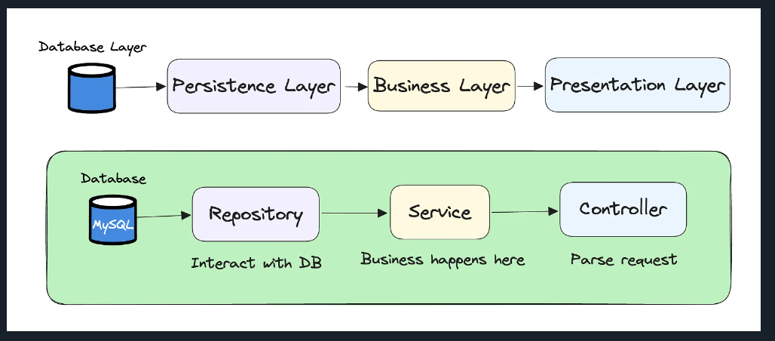

Here’s why this approach is beneficial for our specific context:

**1. Simplicity**

Layered architecture is inherently straightforward and easy to understand. By dividing each service into layers with distinct responsibilities—such as presentation, business logic, and data access—we simplify the development, maintenance, and troubleshooting processes. This clarity ensures that our development team can quickly grasp the system's structure, reducing the learning curve and accelerating the implementation of new features or bug fixes.

* **Ease of Understanding:** Developers can easily comprehend the flow of data and processes within a service, as each layer has a well-defined role.
* **Clear Separation of Concerns:** Each layer handles specific tasks, making the codebase more organized and easier to manage.

**2. Familiarity**

Layered architecture is one of the most widely adopted architectural styles in software development. This familiarity translates to a wealth of existing knowledge, best practices, and tools that our team can leverage.

* **Established Best Practices:** We can adopt proven design patterns and practices that have been honed over years of use in the industry.
* **Community Support:** There is extensive community and documentation support available, which aids in resolving issues and implementing features more effectively.

**3. Low Cost**

Layered architecture is cost-effective, both in terms of initial development and ongoing maintenance. It avoids the complexities and higher costs associated with distributed systems, making it a practical choice for each service within our system.

**4. Testing**

Testing is easier because of the separated components; each component can be tested individually.

However, layered architecture has inherent limitations in terms of deployability, fault tolerance, modularity, performance, reliability, scalability. Here’s a detailed analysis of these limitations and the technologies or practices we can adopt to mitigate them:

- Utilize **containerization technologies** like Docker to encapsulate each service into a standalone container. This approach allows for isolated deployment and testing, reducing the risk associated with large-scale redeployments. Implement **continuous integration and continuous deployment (CI/CD) pipelines** to automate the deployment process, ensuring frequent and reliable updates.

- Implement **horizontal scaling** with cloud platforms like AWS, Azure, or Google Cloud, allowing services to scale out by adding more instances.

- Enhance performance with **caching mechanisms** using tools like Redis or Memcached to store frequently accessed data. Optimize database queries and use **asynchronous processing** with messaging queues like RabbitMQ or Apache Kafka to handle tasks concurrently.

# **V. System Details**

There are two separate physical databases: one for external customer-facing operations, and one for internal operations. This allows the internal data and operations to reside in a separate network zone from the external operations (denoted by the vertical line), providing much better security access restrictions and data protection. One-way access through the firewall allows internal services to access and update the customer-facing information, but not vice versa. Alternatively, depending on the database being used, internal table mirroring and table synchronization could also be used.



## **1. External database**

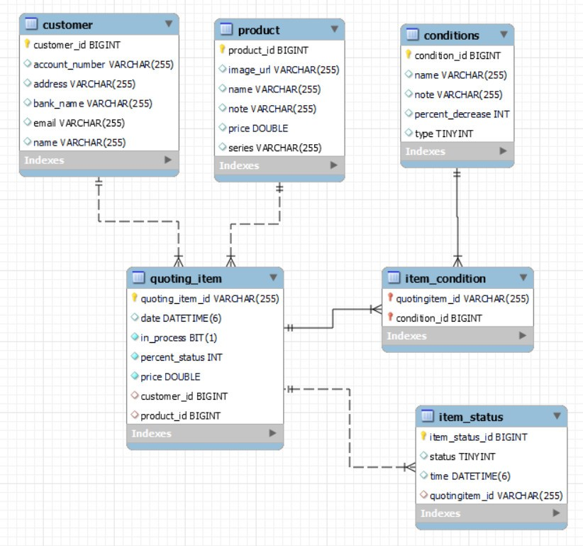

## **2. Internal database**

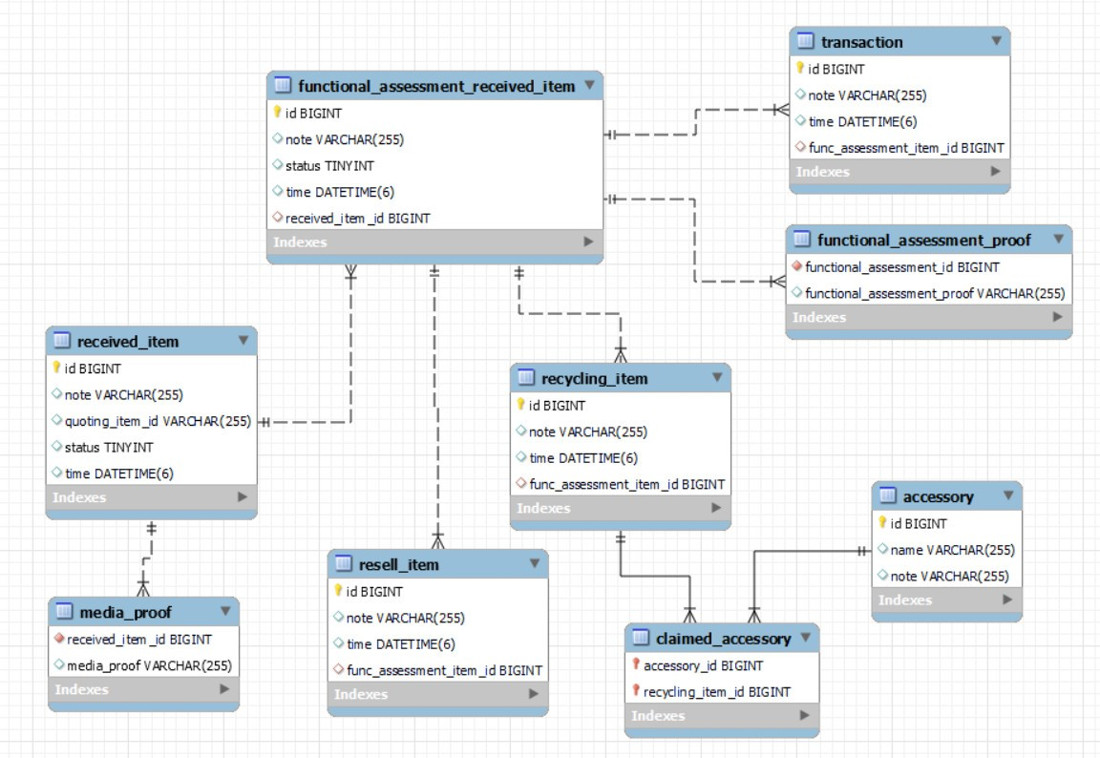

## **3. Devide project**

The system is divided into three backend projects, all sharing a common user interface. The user interface interacts with the services through APIs.

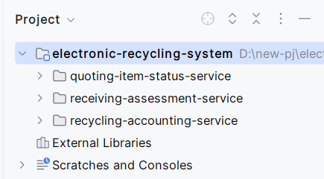

**Project 1: quoting-item-status-service**

This project includes the Quoting Service and the Item Status Service, divided into two modules. The Quoting Service is embedded within the Item Status Service to reuse its entities.

* **Quoting Service**
  + Port: 8081
  + Responsibilities: Handles the initial quoting process, providing customers with quotes based on the details of their electronic devices.
* **Item Status Service**
  + Port: 8082
  + Responsibilities: Tracks the status of the device throughout the recycling process, utilizing entities from the Quoting Service for consistent data management.

**Project 2: receiving-assessment-service**

This project includes both the Receiving Service and the Assessment Service as a single integrated project.

* **Receiving Service and Assessment Service**
  + Port: 8083
  + Responsibilities: Manages the receipt of devices, performs unboxing and external inspections, and conducts internal assessments to verify the device's condition.
  + Additional Features: Uses AWS S3 for storing images and videos documenting the device's condition.

**Project 3: recycling-accounting-service**

This project includes the Recycling Service, Accounting Service, and Reporting Service as a single integrated project. It also embeds Project 2 to reuse necessary entities.

* **Recycling Service, Accounting Service, and Reporting Service**
  + Port: 8084
  + Responsibilities:
    - **Recycling Service**: Handles the final stage of the process, including safe destruction or preparation for resale of the devices.
    - **Accounting Service**: Manages the financial transactions, ensuring payments are processed based on the agreed-upon quotes.
    - **Reporting Service**: Generates reports on various metrics and statuses throughout the recycling process.
  + Embedded Entities: Utilizes entities from Project 2 to maintain data consistency and integrity across the system.

Additionally, data between services is transmitted via queues using ActiveMQ.