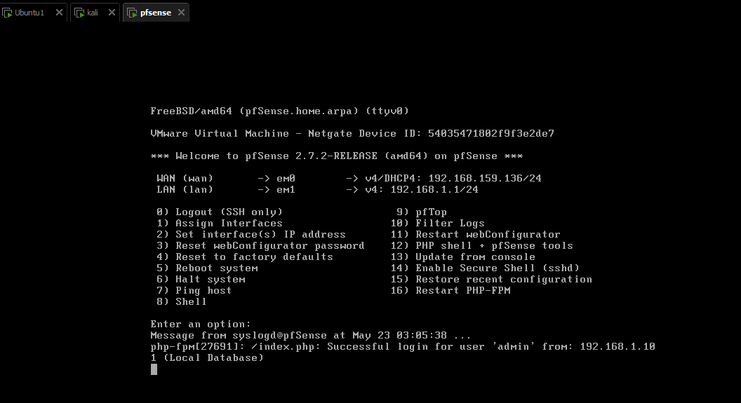

Tổng số lượng block traffic

source="udp:514" sourcetype="*" | stats count as "Total Blocked Traffic"

Block traffic theo thời gian

source="udp:514" sourcetype="*" | timechart span=1s count as "Blocked Traffic"

Block traffic theo IP nguồn

source="udp:514" sourcetype="*" | top limit=10 src_ip

Block traffic theo giao thức

source="udp:514" sourcetype="*" | stats count by protocol

Tổng số lượng block traffic theo thời gian:

source="udp:514" sourcetype="pfsense" action="block" | timechart span=1h count as "Blocked Traffic"

