Architecture Document
Layered Architecture for the Arduino LED Matrix System
Separating the platform and Bridge layer from the display, scrolling, and animation engines
Architectural Decision
The main file remains responsible only for Arduino and RouterBridge. Display state, text decoding, scrolling, animation, and matrix access are centralized in the LedMatrixDisplay class.

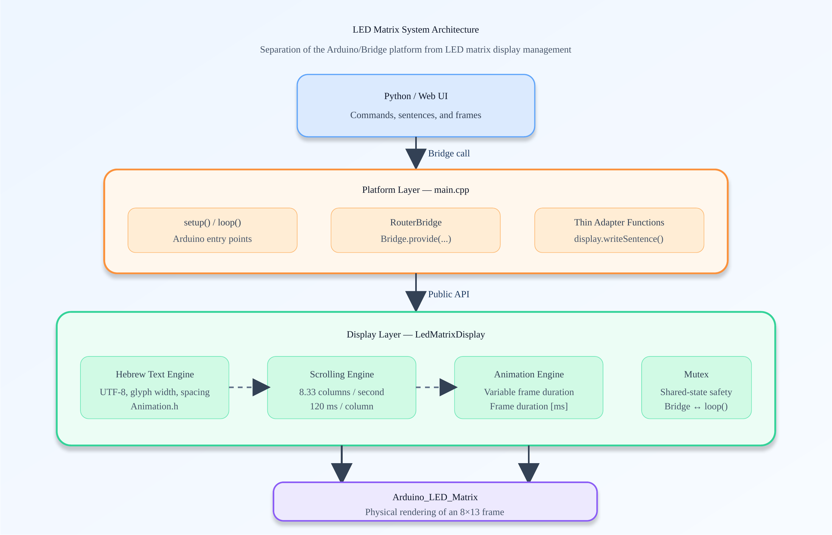
Figure 1 — Display system architecture and separation of responsibilities

1. Purpose of the Separation
The goal is to create code that is easy to understand, test, maintain, and extend. The platform layer knows how to receive external commands; the display layer knows how to convert them into pixels and schedule their presentation.
- Each layer handles a clearly defined area of responsibility.
- A change to the Bridge does not require a change to the scrolling algorithm.
- A change to text rendering does not require a change to the main Arduino code.
- A small public interface hides the internal implementation details.

2. Layer Responsibilities
Layer | Primary Responsibility | Not Responsible For
Python / Web UI | Sending commands, sentences, and frames | Pixel rendering and timing
main.cpp | Arduino, setup, loop, and provider registration | Glyph decoding and buffer management
LedMatrixDisplay | Text, scrolling, animation, mutex, and rendering | Web or Python communication
Animation.h | Font data and glyph-to-frame mapping | Display logic
Arduino_LED_Matrix | Transferring a frame to the matrix hardware | Sentence or animation construction

3. Proposed File Structure

main.cpp — Platform Layer
The main file contains only the application entry points and the RouterBridge integration:
- Create one LedMatrixDisplay instance.
- Initialize Arduino and the matrix through display.begin().
- Register the five Bridge providers.
- Call display.update() continuously from loop().
LedMatrixDisplay display;

void setup() {
display.begin();
Bridge.begin();
registerBridgeProviders();
}

void loop() {
display.update();
}

LedMatrixDisplay.h — Public Interface
The header exposes only the operations that the platform layer may request. State variables and helper functions remain private.
class LedMatrixDisplay {
public:
void begin();
void update();
void draw(const uint8_t* frame);
bool loadFrame(const uint32_t* frame);
void playAnimation();
void stopAnimation();
void writeSentence(const String& text);
};

LedMatrixDisplay.cpp — Display Engine
The implementation file contains:
- Decoding Hebrew UTF-8 characters and mapping them through Animation.h.
- Finding the first and last columns that contain pixels in each glyph.
- Building scrollBuffer with one blank column between letters and four between words.
- Building an 8×13 display window and moving it by one column per step.
- Managing animation frames and scheduling each frame duration.
- Protecting the complete display state with an internal mutex.

4. Function Call Flow

Writing a Sentence
When the Web UI sends a sentence, the Bridge invokes a thin adapter function in main.cpp. The adapter forwards the request to LedMatrixDisplay, where all processing takes place.
Step | Function | Action
1 | write_sentence() | Provider receives a String from the Bridge
2 | display.writeSentence() | Lock mutex and stop previous playback
3 | calculateSentenceWidth() | Calculate actual width without padding
4 | placeSentenceInScrollBuffer() | Copy glyphs and spaces into the buffer
5 | startScrolling() | Set the start position and next update time
6 | display.update() | Check time and render a frame when due

The update Function
void LedMatrixDisplay::update() {
updateAnimation();
updateScrollingText();
}
The function is called as quickly as loop() allows, but rendering occurs only when the next frame is due. Therefore, no delay blocks the system.

5. Rates and Timing
Action | Rate / Time | Meaning
loop() | As fast as possible | Enables fast Bridge response
Animation check | On every update() | Render only when the frame is due
Scroll check | On every update() | No blocking wait
Scroll step | Every 120 ms | Move by one column
Scroll speed | 8.33 columns/second | 1000 ÷ 120
Animation frame | Variable duration | Duration comes from the loaded frame
Bridge command | Asynchronous | May arrive while loop() is running
Checking Is Not Rendering
display.update() may be called thousands of times per second. Each call checks millis(), but matrix.draw() runs only after the configured interval has elapsed.

6. Timing Sequence
Time | loop() Action | Display Action
0 ms | Call update() | Render a frame and move the window
10 ms | Call update() | Check only — not due yet
50 ms | Call update() | Check only
119 ms | Call update() | Check only
120 ms | Call update() | Render the next frame and move again
240 ms | Call update() | Render the third frame

7. Concurrency and Mutex Management
RouterBridge runs providers on a thread separate from loop(). A new command may therefore arrive while the display engine is building or rendering a frame. The mutex prevents concurrent access to the same state.
- The mutex protects scrollBuffer and the animation buffer.
- It protects state variables such as scrollIsActive and animationIsRunning.
- It serializes access to matrix.draw() and matrix.clear().
- Its correct location is inside LedMatrixDisplay, alongside the state it protects.
Encapsulation Principle
main.cpp does not need to know that a mutex exists. It calls only the public functions. LedMatrixDisplay is responsible for ensuring that every internal operation is safe.

8. Benefits of the Structure
- Readability: the main file describes application flow without pixel-level details.
- Maintainability: scrolling-engine changes are isolated to one file.
- Testability: glyph-width calculation and character decoding can be tested independently of the Bridge.
- Extensibility: UART or another command source can be added without changing the display engine.
- Clear responsibility: each layer has one primary reason to change.

9. Conclusion
A two-layer separation is the right choice for this project: it significantly improves the structure without creating an overly complex architecture. main.cpp remains the platform and integration layer, while LedMatrixDisplay becomes a self-contained component that manages the complete display lifecycle.

