Write Up

- setting up the Docker environment locally was very hard due to numerous incompatbilities between TF, the OD API, the Waymo dataset, Google Cloud CLI and the graphics driver.
- I spend roughly 20 hours figuring everything out and therefor learned a lot about Docker.

Then I followed workflow in lesson 6 chapter 22:
Step 1: Become one with the data
Step 2: Define a baseline
Step 3: Build the pipeline
a Overfit a single batch (check that model is complex enough)
b Fit until the loss becomes zero
c visualize model predictions and ground truth
also visualize input to the network! Might be transformed
Step4: Iterate on model and hyperparameters
a start with base learning rate, no annealing
b no augmentation first then experiment (only if overfitting occurs)
c try smaller / larger models

Exploratory Data Analysis
Observations:
We have high density of labeled objects, even if they are barely visible in GT data (left).
Trailer are labeled as separate objects (right).

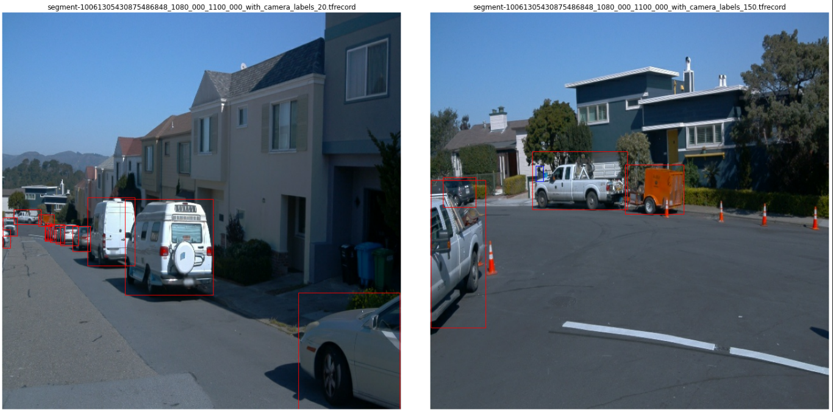
Glare and high dynamic range (sky vs. shadow areas) and high overlap of objects
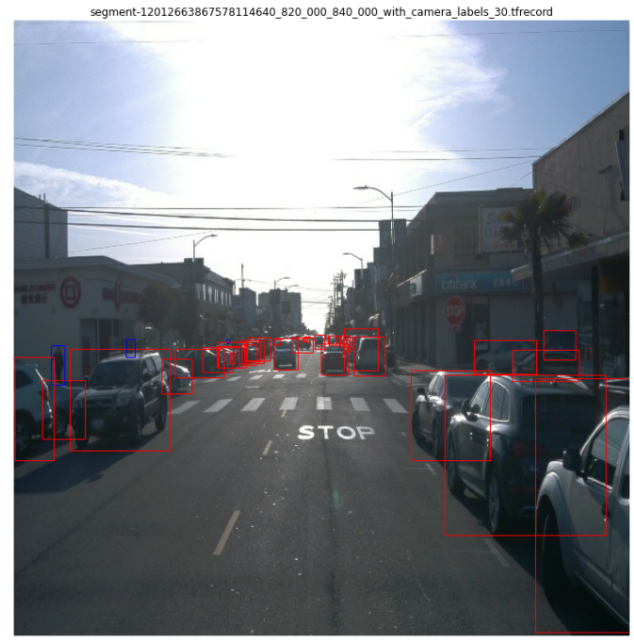
Most of the attributes are not filled with actual values
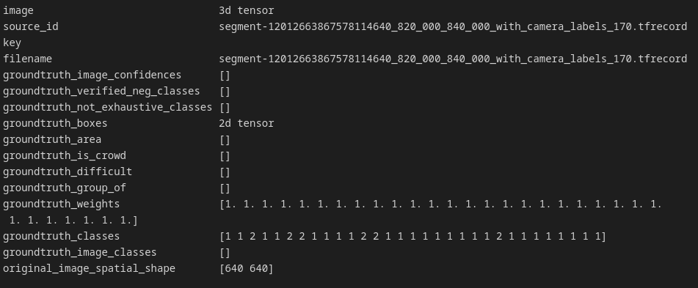
There are phantom annotations (big blue box = pedestrian)
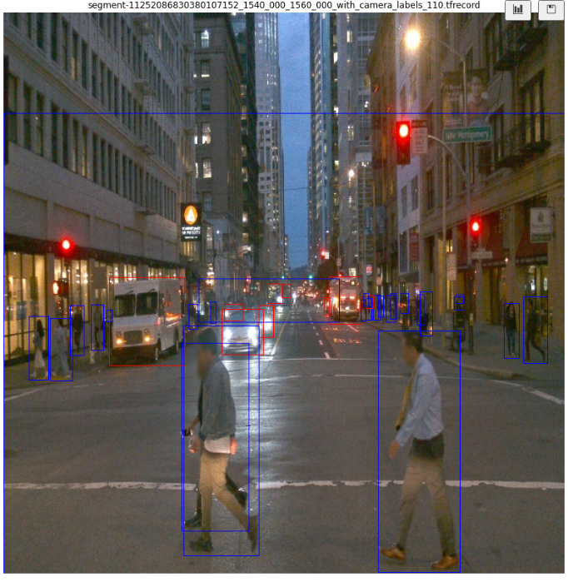
cyclists are very rare in the dataset

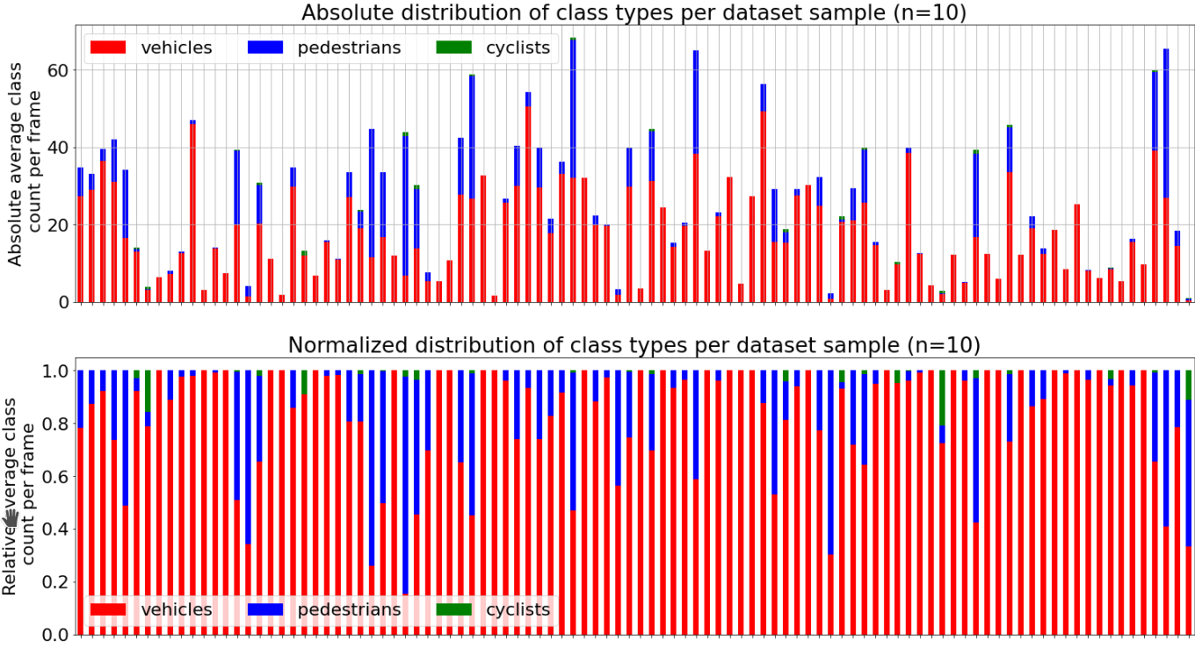

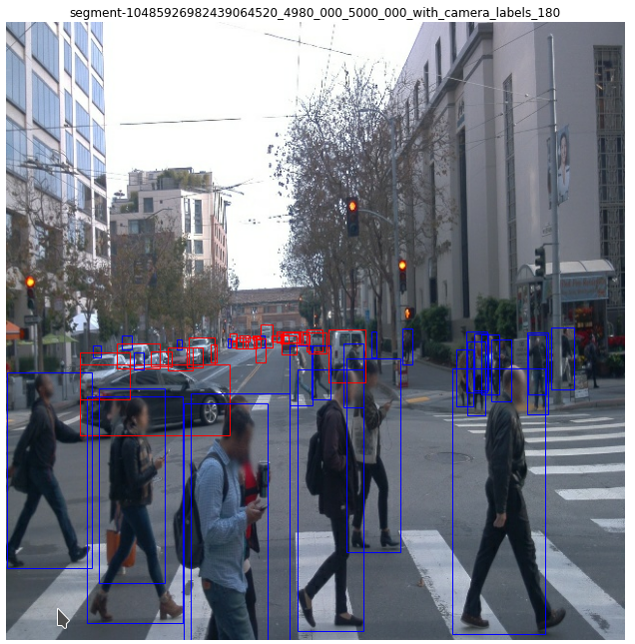
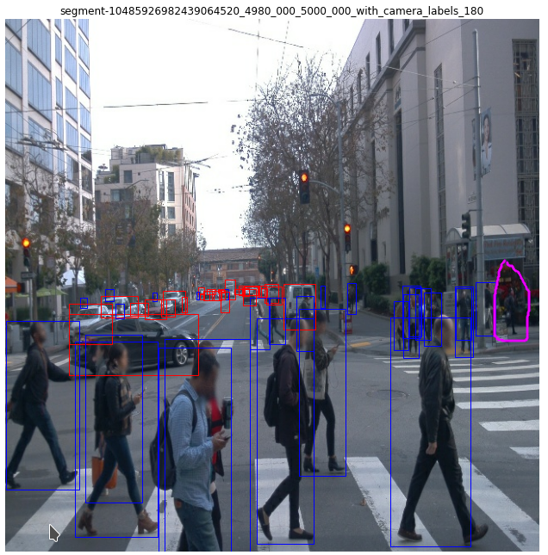
annotations can also be missing (pedestrian in the right)

