vim test.sh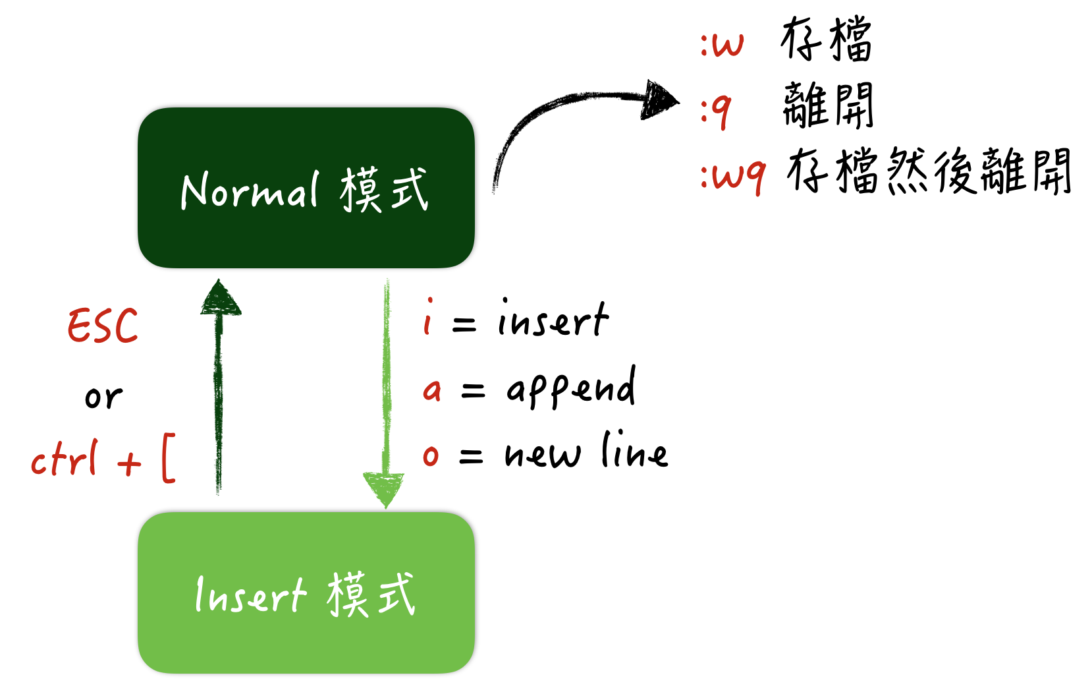

cat test.sh

touch test1.sh

chmod +x test1.sh

./test1.sh

|  |
| --- |
| #!/bin/bash mkdir permFiles cd permFiles **for** ((i=700;i<=777;i++)) **do**   mod=$[i%10]  **if** [ $mod == 0 -o $mod == 1 -o $mod == 4 -o $mod == 5 ]; then  file="p$i"  touch $file  chmod $i $file  **if** [$mod == 7]; then  i=$[i+2]  fi  fi done ls -l |

|  |
| --- |
| #!/bin/bash  read -p "Input here:" data **for**((i=1;i<$data;i++)) **do**  ans=`expr $data % $i`  **if** [ $ans != 0 ]; then  echo $i  fi done |