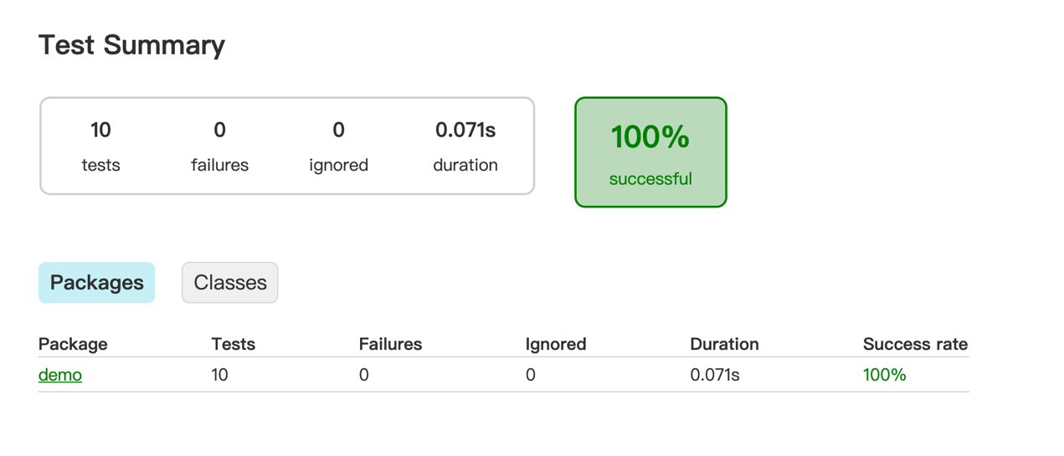

App.java

/*  
 * This Java source file was generated by the Gradle 'init' task.  
 */  
package demo;  
  
public class App {  
 private static final int *NORMAL_PRICE* = 200;  
 private static final int *WEEKEND_PRICE* = 250;  
 double getPrice (boolean is_member,boolean is_group,int time,int week,int age) throws Exception {  
 if(time>22 || time<5) throw new Exception("Not Open");  
 if(age<3 || age>75) throw new Exception("Not Open");  
 double discount = 1;  
 if (week == 6 || week == 7) {  
 discount = is_member ? 0.5 : 1;  
 return *WEEKEND_PRICE* * discount;  
 }  
 if (time < 7) discount = 0.8;  
 if (age <=12 || age>=60) discount = 0.8;  
 if (is_group) discount = 0.7;  
 if (is_member) discount = 0.5;  
  
 return *NORMAL_PRICE* * discount;  
 }  
  
 public static void main(String[] args) throws Exception {  
 var swimmer = new App();  
 swimmer.getPrice(false,false,10,3,25);  
 }  
}

AppTest.java

/*  
 * This Java source file was generated by the Gradle 'init' task.  
 */  
package demo;  
  
import org.junit.jupiter.api.BeforeAll;  
import org.junit.jupiter.api.BeforeEach;  
import org.junit.jupiter.api.Test;  
import static org.junit.jupiter.api.Assertions.*;  
  
class AppTest {  
 App app;  
  
 @BeforeEach  
 void set(){  
 app = new App();  
 }  
 @Test  
 void runTest() throws Exception {  
 App.*main*(null);  
 }  
 @Test  
 void priceTestWeak1() throws Exception {  
 *assertEquals*(100, app.getPrice(true,false,12,4,25));  
 *assertEquals*(200, app.getPrice(false,false,12,4,25));  
 }  
 @Test  
 void priceTestWeak2() throws Exception {  
 *assertEquals*(140, app.getPrice(false,true,12,4,25));  
 *assertEquals*(200, app.getPrice(false,false,12,4,25));  
 }  
 @Test  
 void priceTestWeak3() throws Exception {  
 *assertEquals*(160, app.getPrice(false,false,6,4,25));  
 *assertEquals*(200, app.getPrice(false,false,12,4,25));  
 }  
 @Test  
 void priceTestWeak4() throws Exception {  
 *assertEquals*(250, app.getPrice(false,false,12,6,25));  
 *assertEquals*(200, app.getPrice(false,false,12,4,25));  
 }  
 @Test  
 void priceTestWeak5() throws Exception {  
 *assertEquals*(160, app.getPrice(false,false,12,4,10));  
 *assertEquals*(200, app.getPrice(false,false,12,4,25));  
 }  
 @Test  
 void priceTestStrong1() {  
 *assertThrows*(Exception.class, ()-> {  
 app.getPrice(false, false, 4, 4, 25);  
 });  
 *assertThrows*(Exception.class, ()-> {  
 app.getPrice(false, false, 23, 4, 25);  
 });  
  
 }  
 @Test  
 void priceTestStrong2() {  
 *assertThrows*(Exception.class, ()-> {  
 app.getPrice(false, false, 12, 4, 2);  
 });  
 *assertThrows*(Exception.class, ()-> {  
 app.getPrice(false, false, 12, 4, 76);  
 });  
  
 }  
 @Test  
 void priceTestStrong3() throws Exception {  
 *assertEquals*(125, app.getPrice(true,false,12,6,25));  
 *assertEquals*(250, app.getPrice(false,true,12,6,25));  
 *assertEquals*(250, app.getPrice(false,false,6,7,25));  
 *assertEquals*(250, app.getPrice(false,false,12,7,10));  
 }  
 @Test  
 void priceTestStrong4() throws Exception {  
 *assertEquals*(160, app.getPrice(false,false,12,4,60));  
 }  
}