# GRAPHICAL USER INTERFACE DESIGN TEMPLATE

**User Interface/Report Number: 1**

**Related Use-Case: Customer Login**

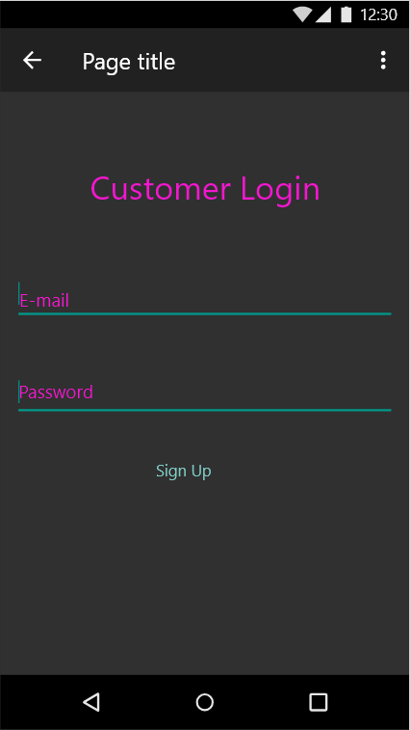

**User Interface/Report Number: 27**

**Related Use-Case: Seller Profile**

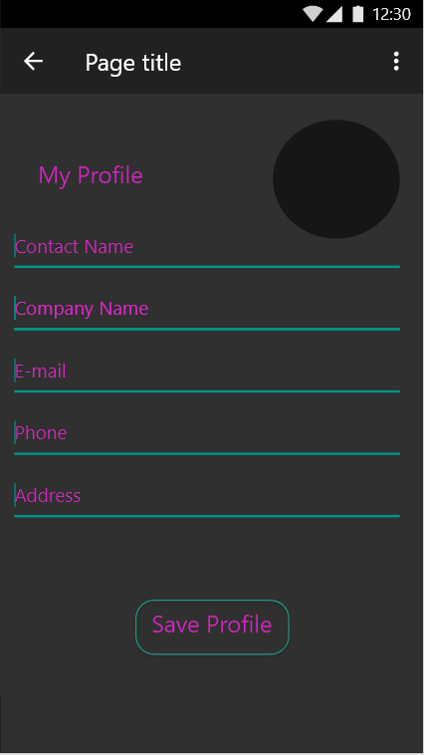

**User Interface/Report Number: 2**

**Related Use-Case: Sign Up**

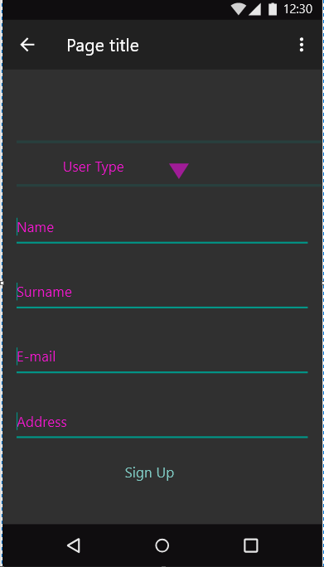

**User Interface/Report Number: 24**

**Related Use-Case: View & Manipulate Customers**

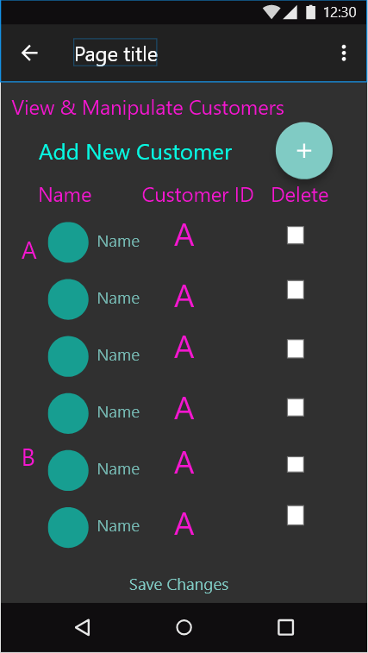

**User Interface/Report Number: 22**

**Related Use-Case: View & Manipulate Items**

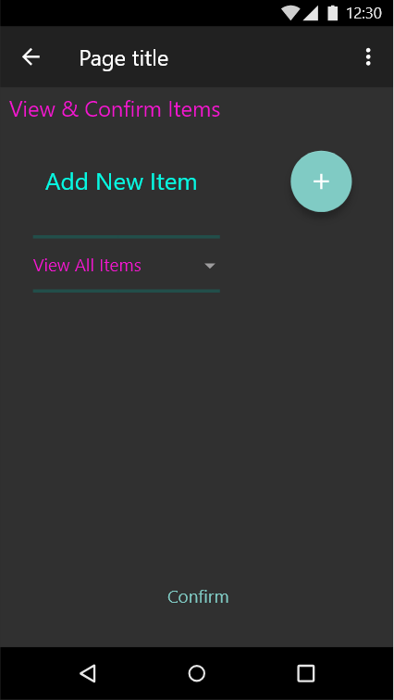

**User Interface/Report Number: 25**

**Related Use-Case: View & Manipulate Sales**

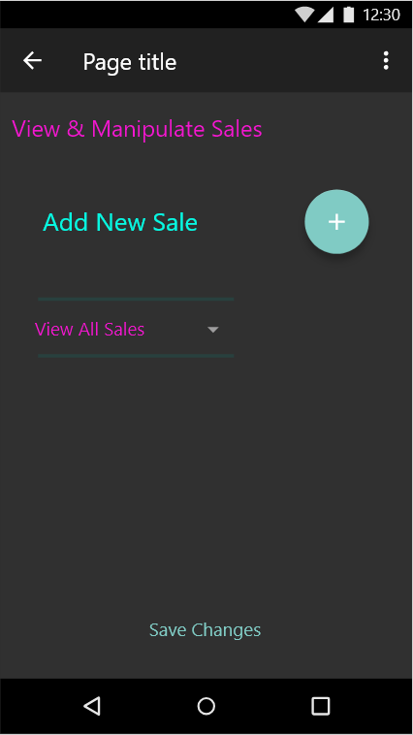

**User Interface/Report Number: 23**

**Related Use-Case: View & Manipulate Sellers**

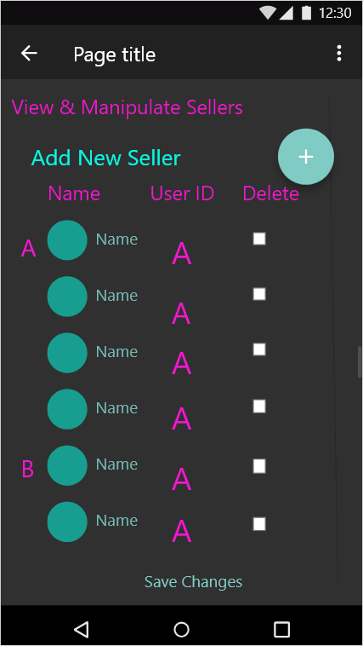

**User Interface/Report Number: 21**

**Related Use-Case: View & Supply Stock**

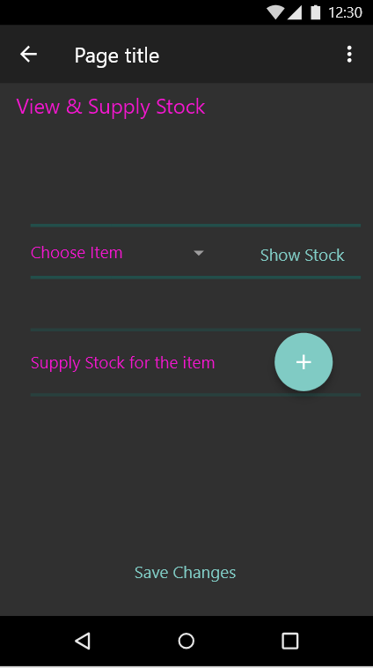

**User Interface/Report Number: 4**

**Related Use-Case: View Item**

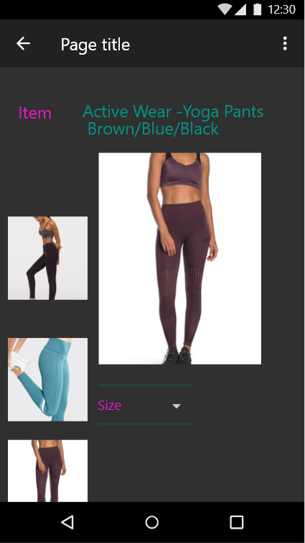

**User Interface/Report Number: 7**

**Related Use-Case: View Shopping Cart**

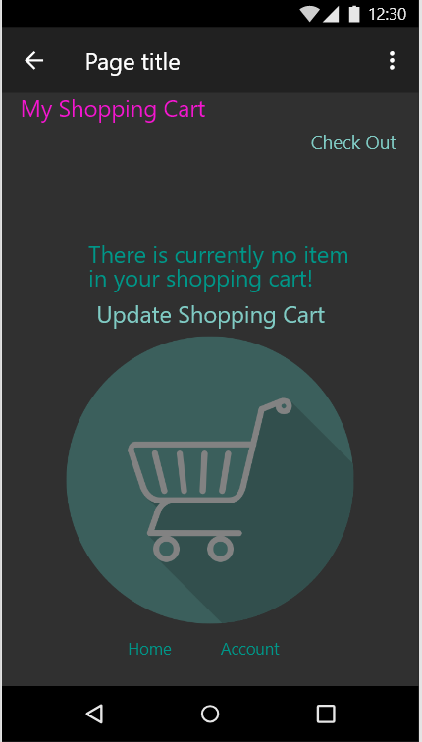

**User Interface/Report Number: 12**

**Related Use-Case: View Shopping History**

