Spor Çantam
Software Design Description

Revision History

Version | Date | Author | Change Description
1 | 14.05.2019 | Ayça Meriç Çelik
1 | 14.05.2019 | Batuhan Mete
1 | 14.05.2019 | Bilge Çimen
1 | 14.05.2019 | Nur Bengisu ÇAM
1 | 14.05.2019 | Okan Alan

INTRODUCTION

Purpose and Scope
SDD describes the goal of the project and describes the solutions of the problems. Alos specifies the detailed structure of the components to satisfiy the requirements in Software Requirements Specification (SRS).

Document Overview

In this document you can find the general overview of the system such as definitions, design constraints and decisions. Also there is a detailed version of the software description in the following chapters. These include software components, software behaviour, data model (E-R diagrams) and user interface design.

System Overview
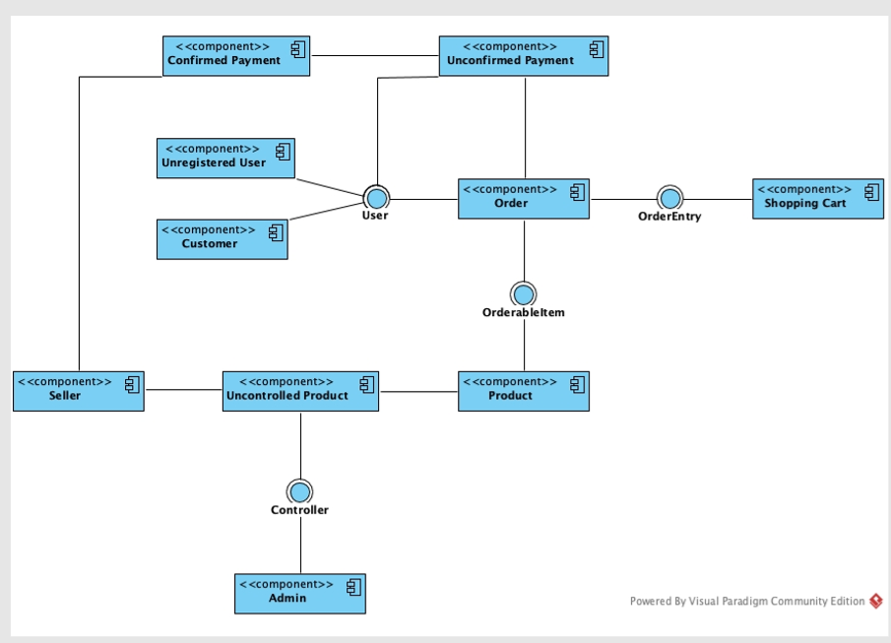
The software solution proposed here is Spor Çantam which allows the user to do online shopping for sport clothes and equipments. Main idea is to provide both second hand and first hand products and increase the variation for the user. This variation will allow user to choose the best product and price. There is the component diagram of the system which shows the interaction between system and user.

Definitions, Acronyms, and Abbreviations
SRS – System Requirements Specification

References
[Provide references for any pertinent document including reference number, version number, release date, and version name.]

Design Constraints and Decisions
This is an android project and we are using Android Studio. We are implementing the android with Kotlin. For the server we are using Spring Framework and Mysql.

Design Details

Software Components

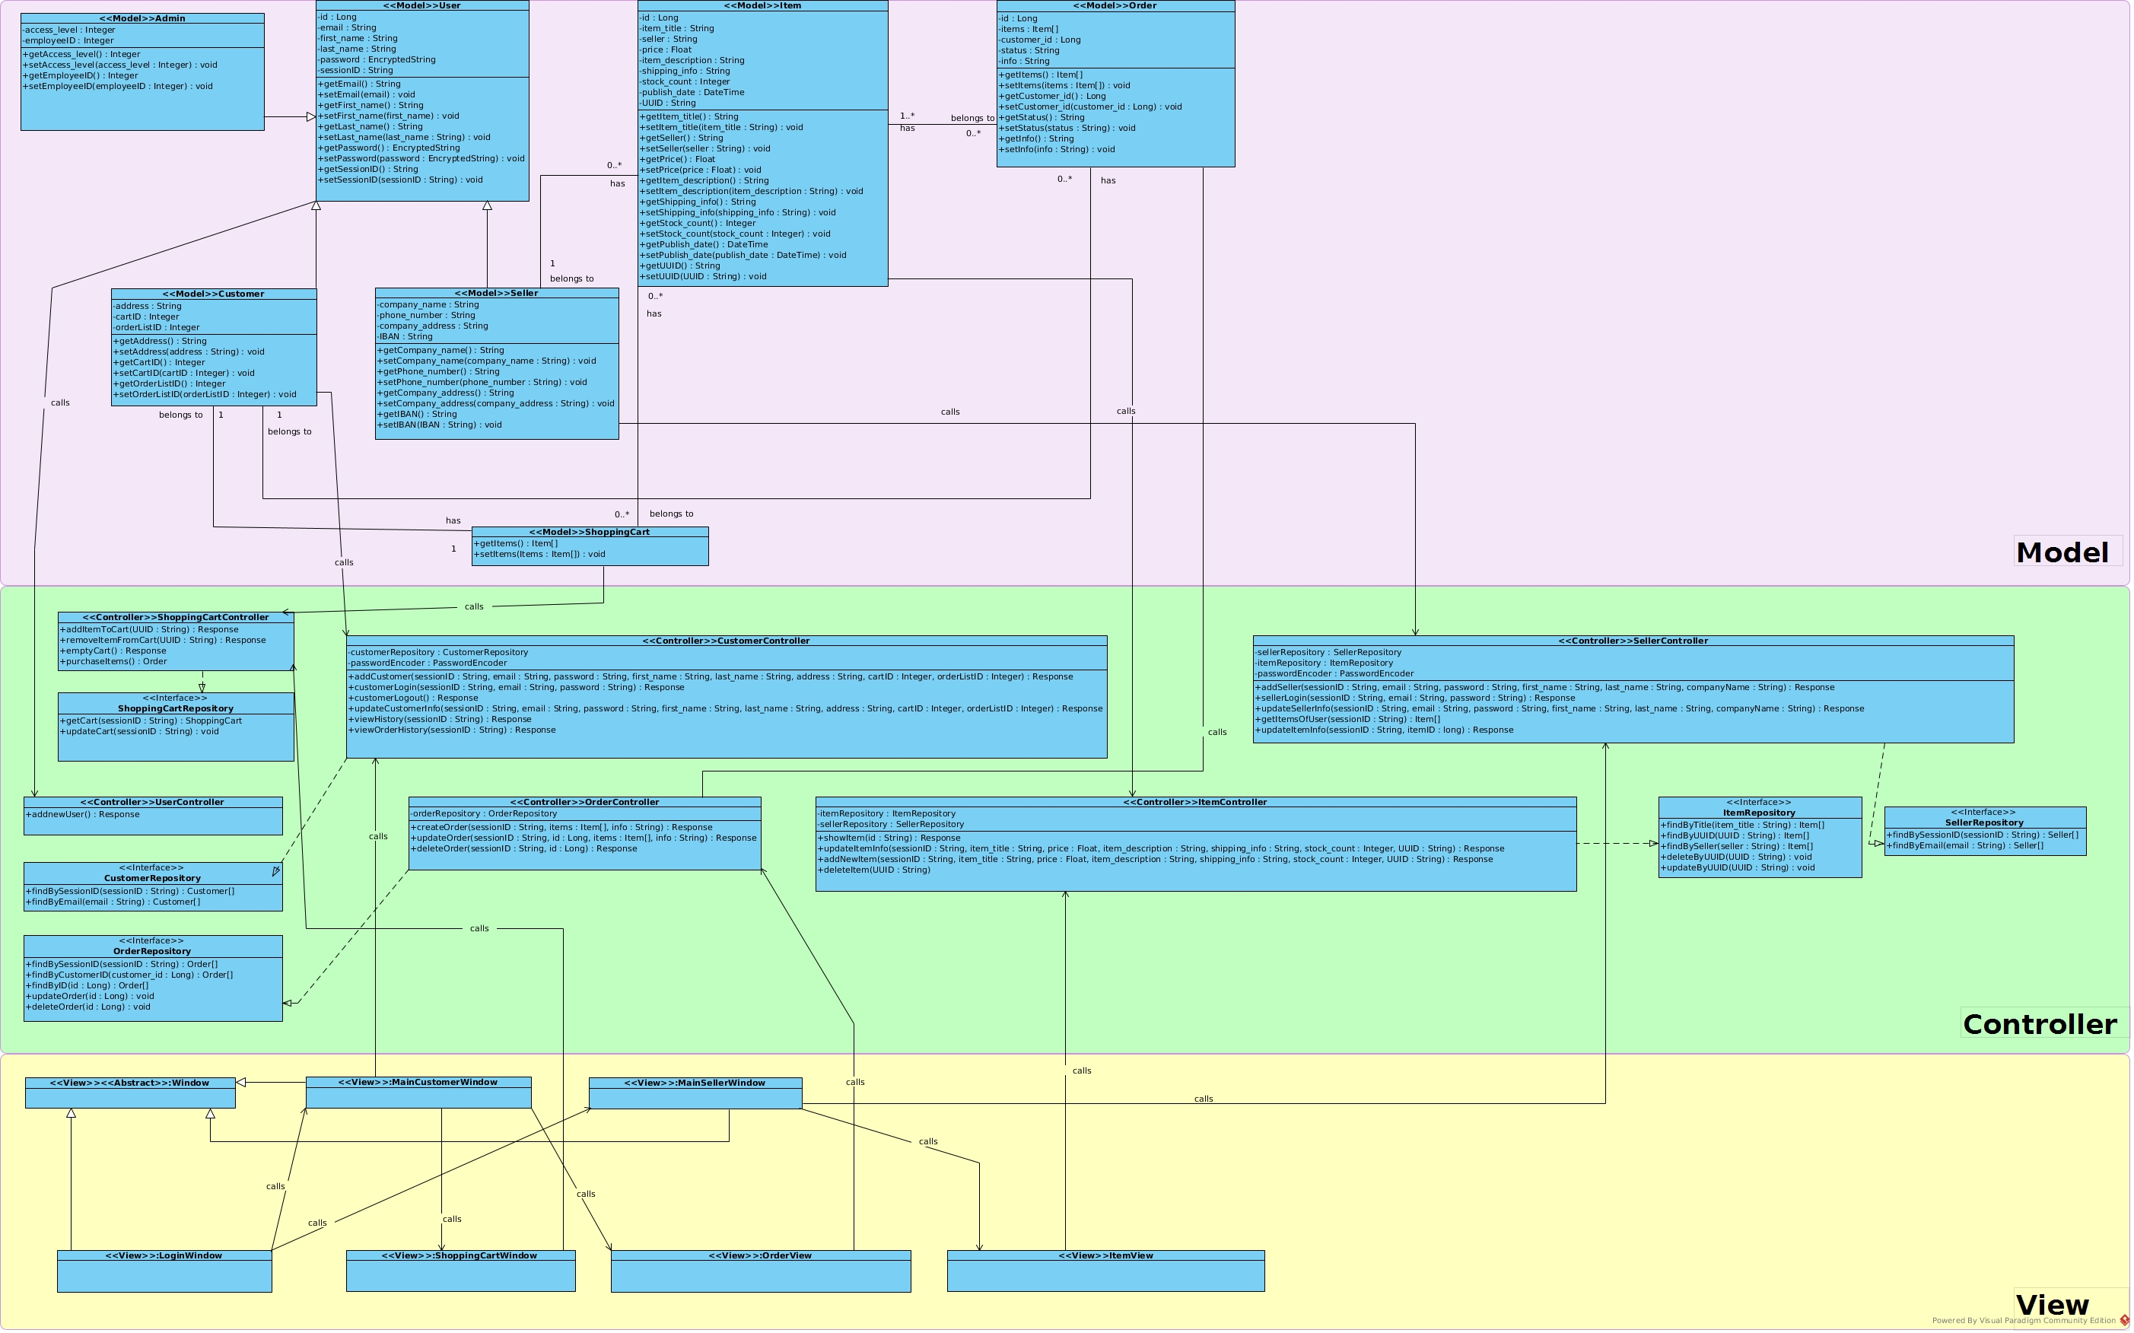

Software Behavior
1. Sequence diagram for changing user settings:
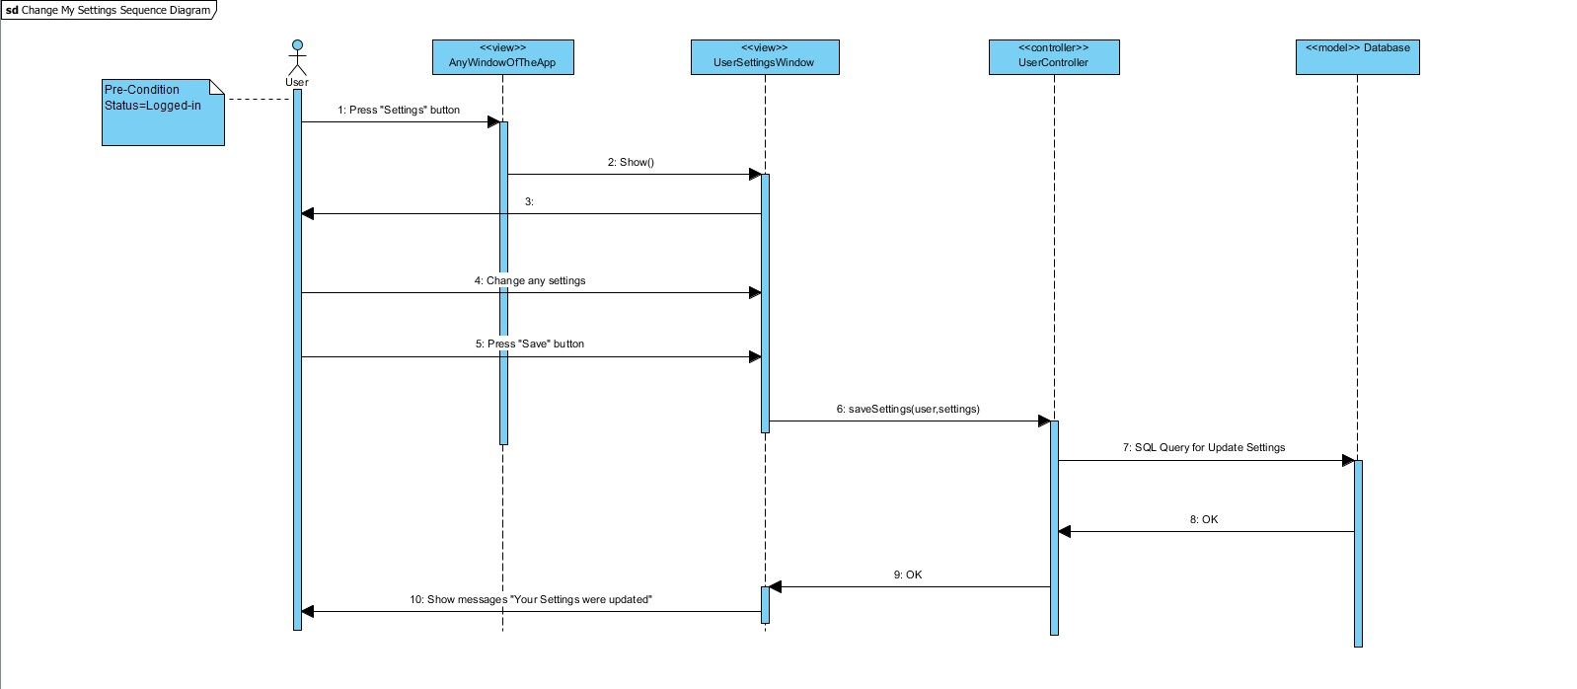
2. Sequence diagram for creating an item:
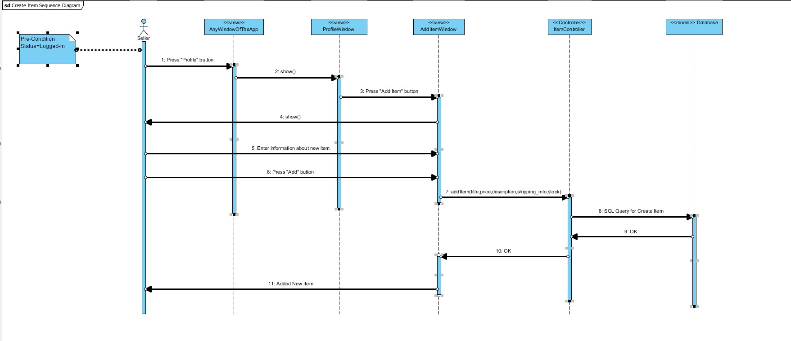
3. Sequence diagram for user log-in:
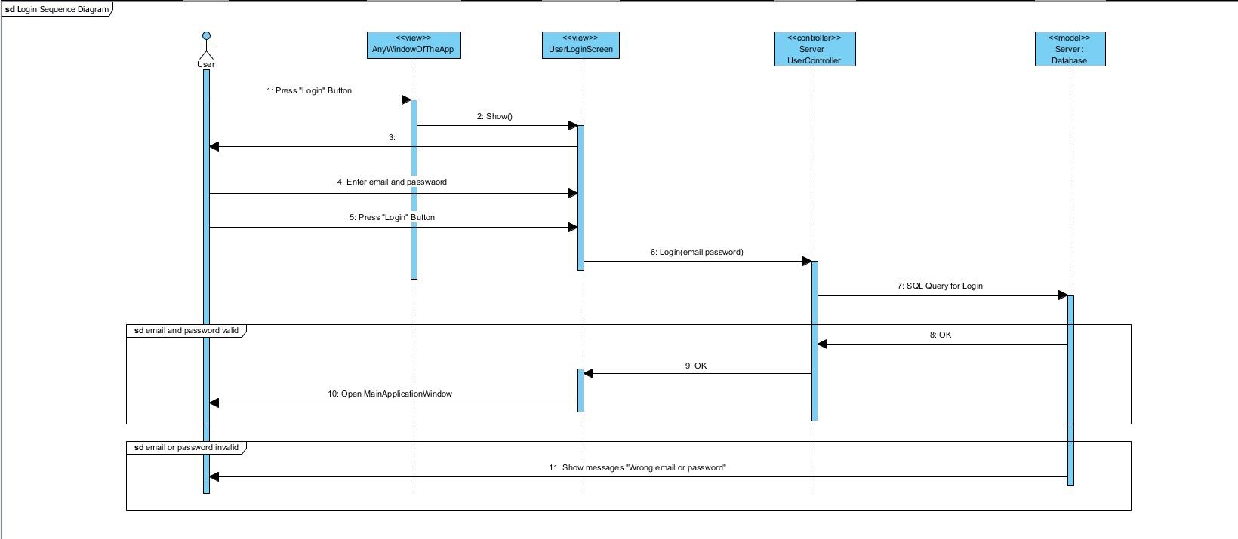
4. Sequence diagram for manipulating an item:

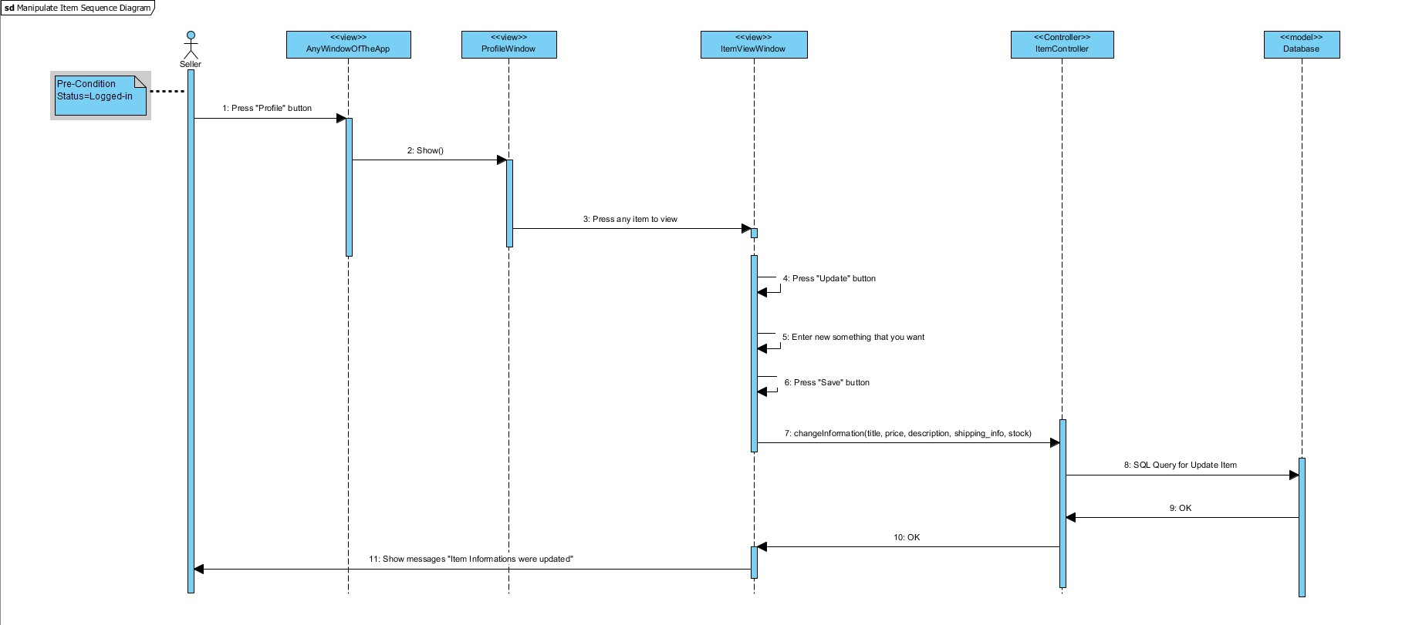
5. Sequence diagram for searching item:
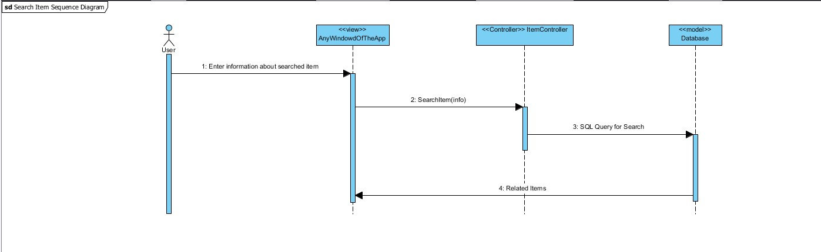

6. Sequence diagram for viewing history:

Data Model (E-R Diagram)
