# Computer Overview

## Define computer

Computer is an electronic device that receive input, stores and manipulate information and

provides output in useful format.

Or

A device which is capable of accepting data processing data, storing data, as required and

retrieves the desire results into output devices.

The terms computer is derived from Latin term “COMPUTE “this means to calculate; computer cannot do any things without a program.

# History of Computer

The history of computer development is often referred to in reference to the different generations of computing devices. Each generation of computer is characterized by a major technological development that fundamentally changed the way computers operate, resulting in increasingly smaller, cheaper, more powerful, more efficient and reliable devices.

**The evolution of computer technology is often divided into five generations:**

**First Generation (1940-1956) Vacuum Tubes;**

The first computers were using vacuum tubes(valves)as an electronic component. First generation computers were used machine language, the lowest-level programming language understood by computers, to perform operations, and they solve one problem at a time. Input was based on punched cards and paper tape, and output was displayed on printouts and cost was very high.



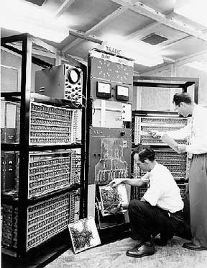

**Second Generation (1956-1963) Transistors;**

In the second generation of computers vacuum tubes were replaced by the Transistors. Size of transistors was much smaller than vacuum tubes, this generation assembly language was used, consumed less power, faster and reliable. The size of computers was come down and price of computers was also reduced. The computers used batch processing and multiprogramming operating system.



**Transistors**

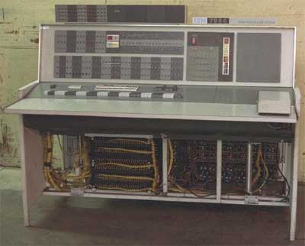

**Third Generation (1964-1971) Integrated Circuits;**

Third generation of computers used integrated circuits (IC's) in place of transistors made up of small crystal of silicon semiconductor were used. Structured programming language C and COBOL was used, speed and efficiency were increased. Input were given through keyboards and output through monitors, the size of computers, power of consumption, heat generation and cost were decreased in greater.



**Integrated Circuits**

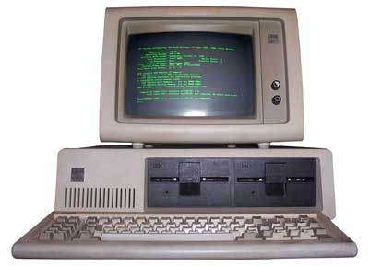

**Fourth Generation (1971-1990) Microprocessors;**

The microprocessor chip was used in the fourth generation of computers, made up of thousands of integrated circuits were built onto a single silicon chip. Objective oriented programming language like C, C++, and domain specifics languages SQL for database access and size, cost of computers were cut down. High processing speed, high reliability and low consumption.



**Microcircuits**

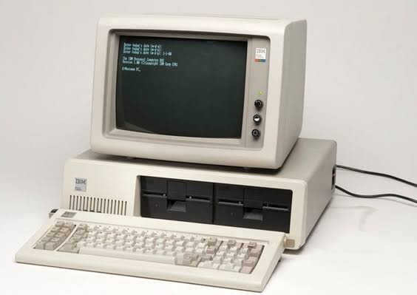

**Fifth Generation (Present and Beyond) Artificial Intelligence;**

Computers those are dealing with artificial intelligence (AI), expert system and robotics are in 5th generation. These computers are still in development phase, main goal is to respond to the natural language use of quantum, molecular and Nano technology is going to change the face of computer in coming year. All the high-level languages like C and C++, Java, .Net etc., are used in this generation.

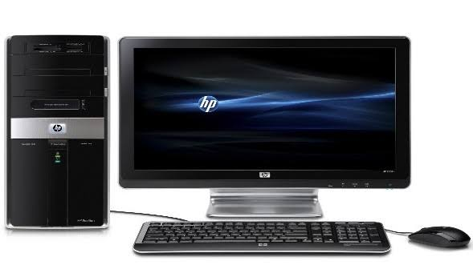

# Types of Computer

Now days, computer can be classified into for major categories depends on memory, size, processing, speed and numbers of users.

* Super computer
* Mainframe computer
* Mini computer
* Micro computer
* Micro controller

Super Computer;

The largest computer are super computers. They are most powerful, the most expensive fastest and also huge computer they are capable of processing trillions of instruction per second, the uses of super computers are in research and study energy nuclear weaps and designing the aircraft, airplane and flight.

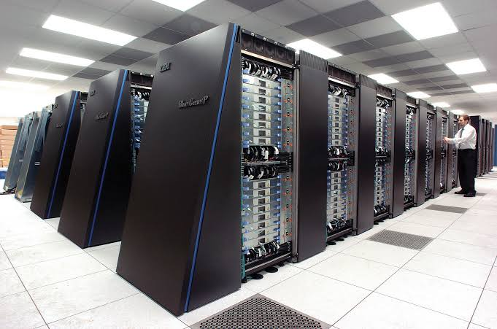

Mainframe Computer;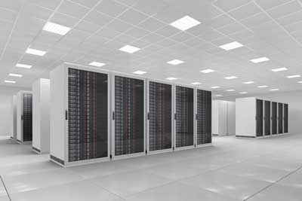The Large computer are called mainframe. Mainframe computers process data at very high rates of speed, measured in the millions of instruction per second. Mainframe are designed for multiple users and process vast amount of data quickly and highly efficient computer capable of simultaneously solving complex calculation and continuously for a longtime these have several microprocessors that have the ability to function the data at too high performance and speed. Mainframe are mainly used by a banks, insurance companies, mail orders companies and scientific research centers.

Mini Computer;

Mid-size computer in size and power. This type of computer performs data processing activities

in the same way as the mainframe but on a smaller scale. Generally capable of supporting from

10 to hundreds of users simultaneously these computers are currently used to store large

databases, multi-user applications and the automation industry and to perform scientific tasks

such as engineering calculation, banking, transportation, salaries records and tracking of

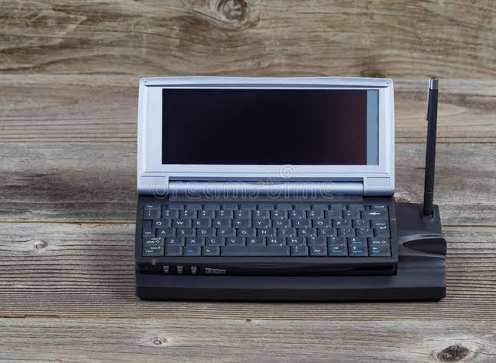financial account.

Micro Computer;

These are small desktop size that has become so widely used in resent year whose price. Size and capabilities make suitable for personal usage. Microcomputer used in many fields like home, office, data collection, education surfing the web, playing game or music, editing and many others

task you will find personal computers into two types; desktop and laptop.

Micro Controller;

Are complete computer systems on a chip typical combining an arithmetic logic unit (ALU), memory, timer counter serial port, input/output port. Microcontrollers are used in application requiring repetitive operation such as running traffic light at an intersection in this application sole

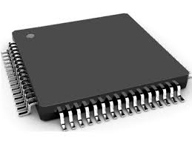function is to turning and off at predetermined time and another example analog to digital converters (ADCs), controller area network(CAN)and security functions.

# Hard ware parts of computers (input, output, processing and storage)

Data; is collection of number and letters which doesn’t have any meaning. It is just row facts

example a number, symbol and characters.

Information; is a set of data that has been meaning full form. Information depends on data example receipt, certificate and programing scripts.

Difference between data and information

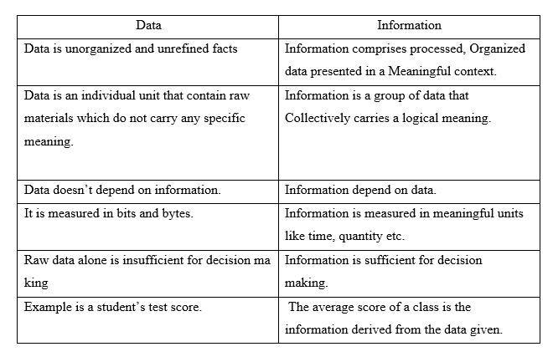

**Computer parts;**

Computer system consist two parts

* Computer hard ware
* Computer soft ware

Computer hard ware;

These are physical devices/parts found in computer that used to perform computing task i.e.

machinery and equipment such as CPU, disk, cable etc. Computer hard ware is classified

according to which of four operations its performs, and may therefore be classified into the

following.

1. Input devices - accept data or instruction by the way of input.
2. Processing and memory device – process data.
3. Storage device - store data.
4. Output device - to get the results in the form of output either softy copy and hard copy.
5. Input devices consist of device that allow computer users to put data into the computer in a form of computer can use. These input translate data into a form the computer can process; barcode, example of input device

* Keyboard; this is where you type and enter data into computer.
* Mouse; is a handheld device that is directs a pointer on the computer display screen.
* Scanner; this device which is use laser beams and reflected light to translate images of text, drawing, display on a monitor, stored on a storage device or communicate to another computer.
* Touch pad; is a device which is usually found on a laptop computer.
* Microphone; can be used to input sound.

1. Processing and memory device the brains of the computer are the processors and main memory device housed in the computer’s system unit, the computer system unit hours the electronic circuitry called the CPU (central processing unit) that does the actual processing and main memory, which supports processing.

The CPU this main brain of the computer follows the instruction of the software to manipulate data into information or it used to control the execution of programs and perform the required task and the speed of CPU Hz 2.0GHZand above also they have a cache

memory and architecture 32/64bit.

The CPU consists of two parts /section

* Arithmetic and logic unit (ALU)
* Control unit (CU)
* The control unit; this tells the rest of computer system how to carry out a programs instruction it supervises the implementation of all the activities in a computer.it is responsible for optimal utilization computer resources.
* The arithmetic logic unit; this responsible for performing arithmetic and logical operations and control the speed of those operation. The arithmetic and logic unit (ALU) contains the mill (adder and subtraction) the function of this unit is to perform suitable calculations such as addition multiplication and division.

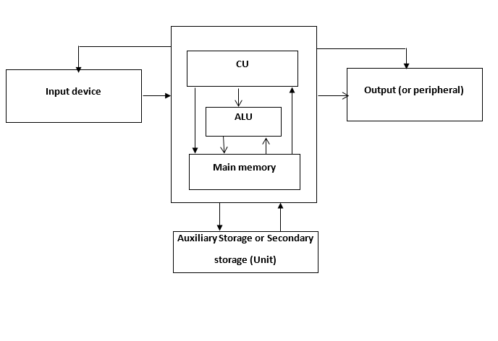A diagrammatic presentation of the CPU

Memory(storage) this is responsible for data storage before being processed and for storing

results. A computer memory is provided with location we the data can be stored. each memory

location is undefined by a unique address the location stores the data in the form of bits,

normally each can keep or store 8bits. The total capacity of memory is expressed in term of bytes

There are two types of storage memory

1. Primary memory (main memory, internal memory);

Also called random access memory (RAM) or temporary memory and any information stored in RAM is lost when the computer is turned off.

1. Secondary memory (read only memory(ROM));

This in the memory that etched on a chip has startup directions for your computer, it is permanent memory.

1. Storage device;

A storage device is a computer hardware used to store data, instruction and files that are not currently used which are transferred to the main memory, storage device can hold and store information either temporary or permanently.

Types of storage

* A primary storage
* Secondary storage

A primary storage device is a medium that holds memory for short term periods of time while a computer in running example RAM cache memory, also RAM is volatile and can divided into

two DRAM and SRAM allow the computer to read data quickly to run application and its allow

reading and writing. Secondary storage device is nonvolatile device that holds data until it is

deleted or over written, example hard drive, hard disk, floppy disk, optical disk, CD-ROM,

universal serial bus (USB), and compact disk (CD).

1. Output device;

Computer output device or hard ware translate the information processed by the computer into a form that humans can understand, the two principal kinds of output are softy copy such as the

material shown and display to the screen and hard copy which is printed.

## Characteristics of computer:

**Speed:** The computer can process data very fast, at the rate of millions of instructions per second. Some calculations that would have taken hours and days to complete otherwise, can be completed in a few seconds using the computer. For example, calculation and generation of salary slips of thousands of employees of an organization, weather forecasting that requires analysis of a large amount of data related to temperature, etc.

**Accuracy:** Computer provides a high degree of accuracy. For example, the computer can accurately give the result of division of any two numbers up to 10 decimal places.

**Diligence:** When used for a longer period of time, the computer does not get tired or fatigued. It can perform long and complex calculations with the same speed and accuracy from the start till the end.

**Storage Capability:** Large volumes of data and information can be stored in the computer and also retrieved whenever required. A limited amount of data can be stored, temporarily, in the primary memory. Secondary storage devices like floppy disk and compact disk can store a large amount of data permanently.

**Versatility:** Computer is versatile in nature. It can perform different types of tasks with the same ease. At one moment you can use the computer to prepare a letter document and in the next moment you may play music or print a document. Computers have several limitations too. Computer can only perform tasks that it has been programmed to do. Computer cannot do any work without instructions from the user. It executes instructions as specified by the user and does not take its own decisions.

# **Software parts of computer (system and application software)**

Is the programs used to direct the functions of computer system. Some of the computer

software is

* + - Application software
    - System software

A diagrammatic presentation of computer software;

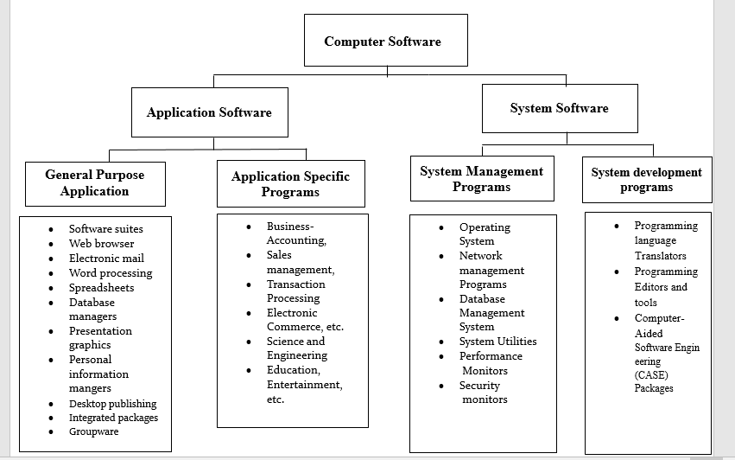

**Application software;** consists of programs designed to perform specific tasks for users.

Common types of Application Software Including General purpose application example Ms

Words, Ms Excel, Ms Access and Ms Power Point. Application specific programs include

business-accounting example oracle, business suite and Education application program example google classroom, LMS, Zoom and clubhouses, and others application program.

## Computer impacts and applications

Computers are commonly used in many areas. It is an important utility for people, especially those who run organizations, industry, etc. In today’s world almost everything you know runs or made by computers. Cars and jets were designed on computers, traffic signals are run by computers, most medical equipment use computers and space exploration was started with computers. Most of the jobs today require the use of computers. These „mechanical brains‟ made a huge impact on our society. It would be hard if we didn’t have the computers around.

The following are the application of computers in various fields.

Business

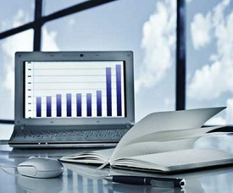

A computer has high speed of calculation, diligence, accuracy, reliability, or versatility which has made it an integrated part in all business organizations.

Computer is used in business organizations for

* Payroll calculations
* Budgeting
* Sales analysis

Banking

Today, banking is almost totally dependent on computers.

Banks provide the following facilities

* Online accounting facility, which includes checking current balance, making deposits and overdrafts, checking interest charges, shares, and trustee records.
* ATM machines which are completely automated are making it even easier for customers to deal with banks

Insurance

Insurance companies are keeping all records up-to-date with the help of computers. Insurance companies, finance houses, and stock broking firms are widely using computers for their concerns.

Insurance companies are maintaining a database of all clients with information showing

* Procedure to continue with policies
* Starting date of the policies
* Next due installment of a policy

Education

* The computer provides a tool in the education system known as CBE (Computer Based Education).
* CBE involves control, delivery, and evaluation of learning.
* Computer education is rapidly increasing the graph of number of computer students.
* There are a number of methods in which educational institutions can use a computer to educate the students.

Communication

Communication is a way to convey a message, an idea, a picture, or speech that is received and understood clearly and correctly by the person for whom it is meant. Some main areas in this category are



* E-mail
* Chatting
* Usenet
* FTP
* Telnet
* Video-conferencing