# Introduction to Microsoft Excel

**Microsoft excel** is a powerful spread sheet program used to record and stores various types of data. Also it used for calculation as well as all presentation tools you need for reporting. There are vertical columns and horizontal rows. A cell is where the column and row intersect. A cell can contain data and can be used in calculation of data within the spreadsheet. An excel spreadsheet can contain workbooks and worksheets. The workbook is the holder for related worksheets.

**Range** in excel is the group of highlighted cells that can span across rows and columns. Always use “:” for range.

How to open Microsoft excel;

Running the Microsoft excel is not different from running any other windows program.

The following are the steps to open excel

* click on start menu
* point all programs
* scroll down Microsoft office expand than point to Microsoft excel
* click on Microsoft excel
* than open and click blank workbook.
  + - search term Microsoft excel than you seen on the top of your interface can open than press blank workbook.
    - press widow flag and press latter r at the same than can opened a box is called run utility than write an excel on the box than press enter your excel can open by pressing blank workbook.

## Excel environment;

The Microsoft office button performs many functions that were located in the file menu of older versions of excel. This button allows you to create a new workbook, open and existing workbook, save and save as, print, send, exporting or close.

**Ribbon**

The ribbon is the panel at the top portion of the document it has seven tabs: home, insert, page layouts, formulas, data review and view. Each tab is divided into groups. The groups are logical collections of features designed to perform function that you will utilize in developing or editing your Excel spreadsheets.

Commonly utilized features are displayed on the ribbon. to view additional features within each group, click the arrow at the bottom right corner of each group.

**Home:** clipboard, fonts, alignment, number, styles, cells, editing.

**Insert:** tables, illustrations, charts, links, text.

**Page Layouts:** themes, page setup, scale to fit, sheet options, arrange.

**Formulas:** function library, defined names, formula auditing, calculation.

**Data:** get external data, connections, sort & filter, data tools, outline.

**Review:** proofing, comments, changes.

**View:** workbook views, show/hide, zoom, window, macros.

## Working with work book and worksheets.

**Workbook;** is the file in which you are working on and store your data. Or is a collection of one or more spreadsheets, also called worksheets in a single file.

Example of a Spreadsheet called “sheet 1”and in an excel workbook file called “book1” also has the “sheet2” and “sheet3” sheet tabs, which are also part of the same workbook.

**Worksheet;** is the primary document you use to store and work with data. Or Is a collection of cells organized in row and columns. Each worksheet contains 1048576 rows and 16384 columns and serves as a giant table that allows you to organize Information.

**Create a workbook**

To create a new workbook in 2007, excel:

* Click the Microsoft office toolbar
* Click new
* Choose blank document

**Save a workbook**

When you save a workbook, you have two choices: **Save** or **Save As.** To save a document.

**Open a workbook**

To open an existing workbook:

* Click the Microsoft office button
* Click open
* Browse to the workbook
* Click the title of the workbook
* Click open

**Insert and delete worksheets**

To insert a worksheet

* Open the workbook
* Click the insert button on the cells group of the home tab
* Click insert sheet

**To delete a worksheet**

* Open the workbook
* Click the delete button on the cells group of the home tab
* Click delete sheet

**Copy and paste worksheets**

To copy and paste a worksheet:

* Click the tab of the worksheet to be copied
* Right click and choose move or copy
* Choose the desired position of the sheet
* Click the check box next to create a copy
* Click ok

**Format worksheet tab**

You can rename a worksheet.

To rename a worksheet:

* Open the sheet to be renamed
* Click the **format** button on the **home** tab
* Click **rename** sheet
* Type in a new name
* Press **enter**

## Entering data (text, number).

There are different ways to center data in excel: in an active cell or in the formula bar. To enter in an active cell:

* Click in the cell where you want the data
* Begin type

To enter data into the formula bar

* Click the cell where you would like the data
* Place the cursor
* in the formula bar
* Type in the data

## Formatting (font, number) and customizing data

## **Formatting (font, number) and customizing data**

Data Formatting in excel is very useful, which allows us to format the data in any way we want. We can change the format of data to make it as per standards or our requirements. This brings uniformity in terms of the same type of fonts, shapes, alignment and font color. This is normally used in all types of work such as official, report creation, anything we want to print. This also allows other people to read and understand the meaning properly if everything is in the standard format.

**There are a lot of ways to format data in excel. Follow the below guidelines while formatting the data/report in excel:**

* The column heading/row heading is a very important part of the report. It describes the information about data. Thus, the heading should be in bold. The shortcut key is CTRL + B. It’s also available in the Font section in the toolbar.
* The header font size should be larger than the other content of the data.
* The header field background color should be other than white color so that it should be properly visible in the data.
* Make the outline border of the heading field. There are a lot of border styles. For border style, go to the Font section and click on an icon as per the below screenshot:

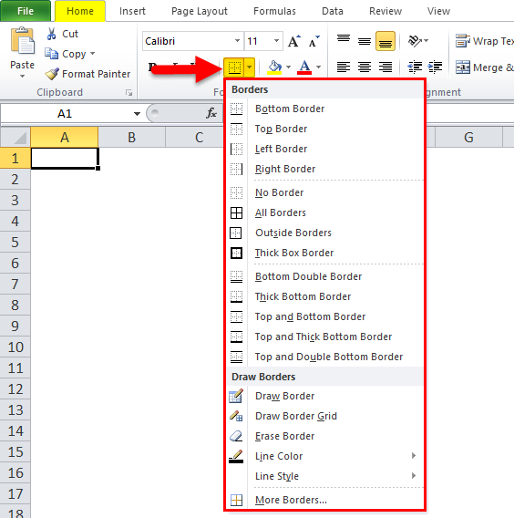

* Choose the appropriate border style. With this, we can add a border of the cells.
* The header font should be aligned in the center.
* To make the size of cells enough, so that the data written within the cell should be in a proper reading manner.
* For number formatting, there are a lot of styles available. For this, Go to the number section and click on the combo box like the below screenshot:

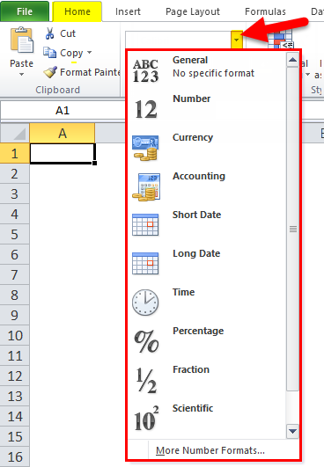

* Depending on the data, whether it should be in decimal, percentage, number, date, or formatting can be done.

In the below image, we have shown different font styles:

“B” is to make the font bold, “I” is for italic, “U” is for make underline, etc.

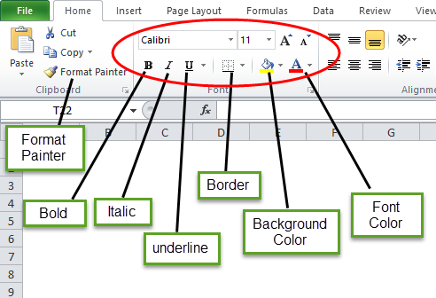

**How to Format Data in Excel**

Let’s take the below data and will understand the data formatting in excel one by one.

You can download this Data Formatting Excel Template here – [Data Formatting Excel Template](https://www.educba.com/excel-data-formatting/#popmake-167767)

#### Formatting in Excel – Example

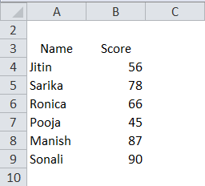

## Editing spreadsheets

In editing spreadsheets, the following areas are concerned

* [Cell Formatting](https://www.zoho.com/docs/help/editing-a-spreadsheet.html#edit-cell-formatting)
* [Format Painter](https://www.zoho.com/docs/help/editing-a-spreadsheet.html#edit-format-painter)
* [Clear Formatting](https://www.zoho.com/docs/help/editing-a-spreadsheet.html#edit-clear-formatting)
* [Conditional Formatting](https://www.zoho.com/docs/help/editing-a-spreadsheet.html#edit-conditional-formatting)
* [Insert & Delete](https://www.zoho.com/docs/help/editing-a-spreadsheet.html#insert-and-delete)
* [Insert Image](https://www.zoho.com/docs/help/editing-a-spreadsheet.html#insert-an-image)
* [Add Comment](https://www.zoho.com/docs/help/editing-a-spreadsheet.html#edit-add-comment)

The two ways to edit a spreadsheet are:

* Edit the data itself, such as the labels, numbers, and formulas that make up a spreadsheet.
* Edit the physical layout of the spreadsheet, such as adding or deleting rows and columns, or widening or shrinking the width or heights of rows and columns.

## Editing Data in a Cell

To edit data in a single cell, these steps are concerned:

1. Double-click the cell that contains the data you want to edit. Excel displays a cursor in your selected cell.
2. Edit your data by using the Backspace or Delete key, or by typing new data.
3. If you click a cell, Excel displays the contents of that cell in the Formula bar. You can click and edit data directly in the Formula bar, which can be more convenient for editing large amounts of data.

## Formula and functions

A function is a built in formula in excel. A function has a name and arguments (the mathematical function) in parentheses.

Three Principle to calculate

* Every formula in excel must start with equal (=)
* You don’t write the number of data value you write the cell name.
* Terminate the formula by press enter.

## Creating /copying formula

## **How to copy formula down a column**

## Microsoft Excel provides a really quick way to copy a formula down a column. You just do the following:

1. Enter a formula in the top cell.
2. Select the cell with the formula, and hover the mouse cursor over a small square at the lower right-hand corner of the cell, which is called the **Fill handle**. As you do this, the cursor will change to a thick black cross.
3. Hold and drag the fill handle down the column over the cells where you want to copy the formula.

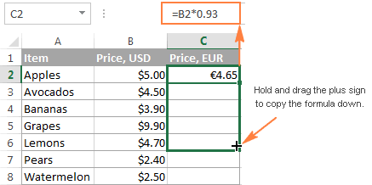

In a similar manner, you can **drag formula** into **adjacent cells** to the right, to the left or upwards.

## Cell referencing

Cell Reference in excel is the way to represent the identity and the location of any cell with the help of combining Column Name and Row Number on a worksheet. For example, if we say cell B10, then it expands as Column B and 10th Row. Similarly, we can define or declare cell references to any position in the worksheet. We can also activate R1C1 from Excel Options, another way for cell reference, where R1 is Row1 and C1 is Column1.

### Types of Cell Reference in Excel

We have three different types of Cell References in Excel –

1. Relative Cell Reference in Excel
2. Absolute Cell Reference in Excel
3. Mixed Cell Reference in Excel

Using the correct type of Cell Reference in a particular scenario will save a lot of time and effort and make the work much easier.

#### #1 – Relative Cell Reference in Excel

Relative cell references in excel refer to a cell or a range of cells in excel. Every time a value is entered into a formula, such as SUMIFS, it is possible to input into Excel a “cell reference” as a substitute for a hard-coded number. A cell reference may come in the form B2, where B corresponds to the cell column letter in question and 2 represents the row number. Whenever Excel comes across a cell reference, it visits the particular cell, extracts out its value, and uses that value in whichever formula that you’re writing. When this cell reference in excel is duplicated to a different location, the relative cell references in excel correspondingly also change automatically.

When we refer to cells like this, we can achieve it with any of the two cell reference types in excel: absolute and relative. The demarcation between these two distinct reference types is the different inherent behavior when you drag or copy and paste them to different cells. Relative Cell references can alter themselves and adjust as you copy and paste them; absolute references contrarily do not. Therefore, in order to successfully achieve results in Excel, it is critical to be able to use relative and absolute cell references in the right way.

**How to effectively use Relative cell reference in Excel?**

To comprehensively understand the versatility and usability of this amazing feature of Excel, we will need to look at a few practical examples to grasp its true value. Let us consider a simple example to explain the mechanics of Relative Cell Reference in Excel. If we wish to have the sum of two numbers in two different cells – A1 and A2, and have the result in a third cell A3.

So we apply the formula **=A1+A2**

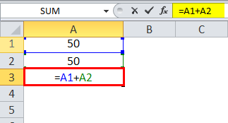

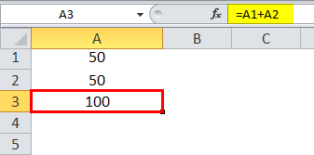Which would yield the result as 100 in A3.

Now suppose, we have a similar scenario in the next column (B). Cell B1 and B2 have two numbers, and we wish to have the sum in B3.

We can achieve this in two different ways:

Here we physically write the formula to add the two cells B1 and B2 in B3.

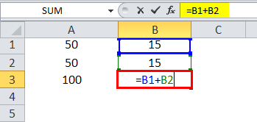

The result is 30.

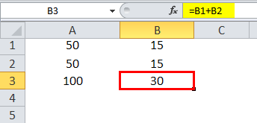

## Using insert function button

## Using the Insert Function Button

Excel provides more than 300 built-in functions. In order to use a function, however, you need to type its name in exactly.

To use the Insert Function feature, choose Formulas> Function Library> Insert Function. However, formula pros skip straight to the action by clicking the fix button that appears just to the left of the formula bar. (Or, they press the Shift+F3 shortcut key.)

No matter which approach you use, Excel displays the Insert Function dialog box, which offers three ways to search for and insert any of Excel's functions.  
  
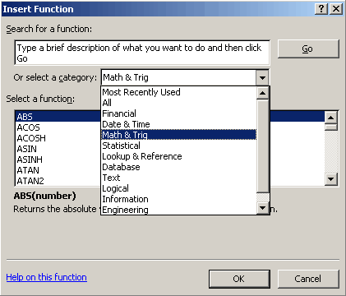

Sometimes displayed as **Ins**, the **Insert key** is a key on most computer keyboards near or next to the [backspace key](https://www.computerhope.com/jargon/b/backspac.htm). The Insert key toggles how letters, numbers, characters, or other text is inserted. By default, text is inserted in front of other text as you type but after pressing the Insert key text is [overwritten](https://www.computerhope.com/jargon/o/overwrit.htm) as you type.

## Using nested functions

Nested functionsUsing a function as one of the arguments in a formula that uses a function is called nesting, and we’ll refer to that function as a nested function. For example, by nesting the AVERAGE and SUM function in the arguments of the IF function, the following formula sums a set of numbers (G2:G5) only if the average of another set of numbers (F2:F5) is greater than 50. Otherwise, it returns 0.

The AVERAGE and SUM functions are nested within the IF function.

You can nest up to 64 levels of functions in a formula.

**How to do it**

1. Click the cell in which you want to enter the formula.
2. To start the formula with the function, click **Insert Function** Button image on the formula bar Button image.

Excel inserts the equal sign (**=**) for you.

1. In the **or select a category** box, select **All**.

If you are familiar with the function categories, you can also select a category.

If you're not sure which function to use, you can type a question that describes what you want to do in the **Search for a function** box (for example, "add numbers" returns the **SUM** function).

1. To enter another function as an argument, enter the function in the argument box that you want.

The parts of the formula displayed in the **Function Arguments** dialog box reflect the function that you selected in the previous step.

If you clicked **IF**, the **Function arguments** dialog box displays the arguments for the **IF** function. To nest another function, you can enter it into the argument box. For example, you could enter **SUM (G2:G5)** in the **Value_if_true** box of the **IF** function.

1. Enter any additional arguments that are needed to complete your formula.

Instead of typing cell references, you can also select the cells that you want to reference. Click Button image to minimize the dialog box, select the cells you want to reference, and then click Button image to expand the dialog box again.

1. After you complete the arguments for the formula, click **OK**.

## Using (SUM/COUNT/MAX/MIN/AVERAGE/RANK).

SUM: Adds all cells in the argument.

=SUM(B3+C3+D3+E3) PRESS ENTER OR =SUM (B3:E3) ENTER.

COUNTA: Finds the number of cells that contain a numerical value within a range of the argument.

= COUNTA (B3:E3) PRESS ENTER.

COUNTIF: To count cells in a range that meet a single condition.

= COUNTIF (B2:B11, “=FEMALE”) PRESS ENTER

MAXIMUM: Finds the maximum value.

=MAX (B3:E3) PRESS ENTER

MINIMUM: Find the minimum value.

=MIN (B3:E3) PRESS ENTER

AVERAGE: Calculates the averages of the cells in the argument

= AVERAGE (B3:E3) PRESS ENETR OR in traditional =F3/4 ENTER

RANK: To compares to a list of other numeric values, and rank can rank values from smallest to largest as well as largest to smallest.

= RANK (C2:C12, $C$2: $C$12) PRESS ENTER.

## IF STATEMENT AND NESTED IF

IF: IF function is one of the most popular functions in excel and it allows you to make logical comparisons between a value and what you expect. If you have two results, the first result is true and the second comparison is false.

= IF(I2>=40, “PASS”, “FAIL”) PRESS ENTER.

NESTED IF: The if function can be nested inside of itself to handle multiple conditions.

Example shown a nested if formula used to assign a grade score.

=IF(I2>=70, “A”, IF(I2>=60, “B+”, IF(I2>=50, “B”, IF(I2>=40, “C”, IF(I2>=35, “D”, “E”))))) PRESS ENTER.

## Working with charts

Charts allow you to present information contained in the worksheet in a graphic format.

How to create graph or chart

* High light the cells
* Click the insert menu
* Click the column chart
* Select the chart.

Example of graph and chart is.

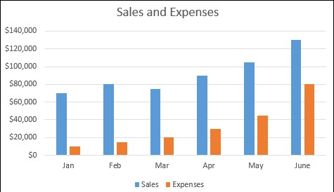

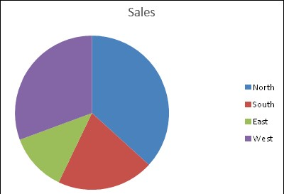Example pie chart

## Sorting and quearing data

**Basic sorts**

To execute a basic descending or ascending sort based on one column:

* Highlight the cells that will be sorted
* Click the sort & filter button on the home tab
* Click the sort ascending (A-Z) button or sort descending (Z-A) button.

**Custom sorts**

To sort on the basis of more than one column:

* Click the sort &filter button on the Home tab
* Choose which column you want to sort by first
* Click add level
* Choose the next column you want to sort
* Click OK.

**Filtering**

Filtering allows you to display only data that meets certain criteria. To filter:

* Click the column or columns that contain the data you wish to filter
* On the home tab click on sort &filter
* Click filter button
* Click arrow at the button of the first cell
* Click the text filter
* Click the words you wish to filter
* To clear the filter, click the sort & filter button
* Click clear.

## Freeze pane

You can select a particular portion of worksheet to stay static while you work on other parts of the sheet. This is accomplished through the freeze Rows and Columns function. To freeze a row or column:

* Click the freeze panes button on the view tab
* Either select a section to be frozen or click the defaults of top row or left column
* To unfreeze, click the freeze panes button
* Click unfreeze

## Data validation

Data validation is a feature in MS Excel used to control what a user can enter in a cell of an excel sheet. Like, restrict entries in a sheet, such as a date range or whole numbers only. We can even create dropdowns as well, which saves un-necessary space and shows the values in a single cell. Also, we can create a customized message which will appear user insert any incorrect value or an incorrect format.

* #####, Not enough space to display the value.
* #NAME?, the function does not exist.
* #DIV/0!, trying to divide by zero.
* # NULL!, there is syntax error
* #REF!, sum cells have different type of data.

## LINKING WORKHEETS

**STEPS**

1. 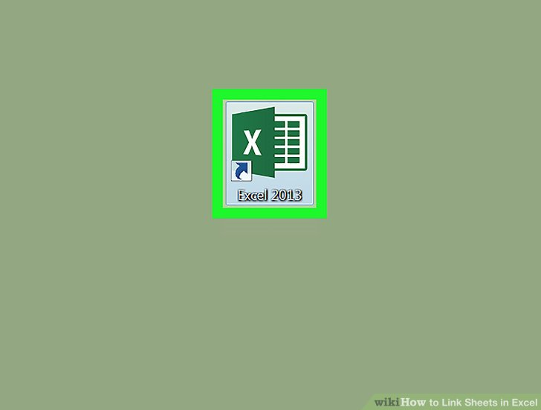**Open a Microsoft Excel workbook.** The Excel icon looks like a green-and-white "X" icon.
2. 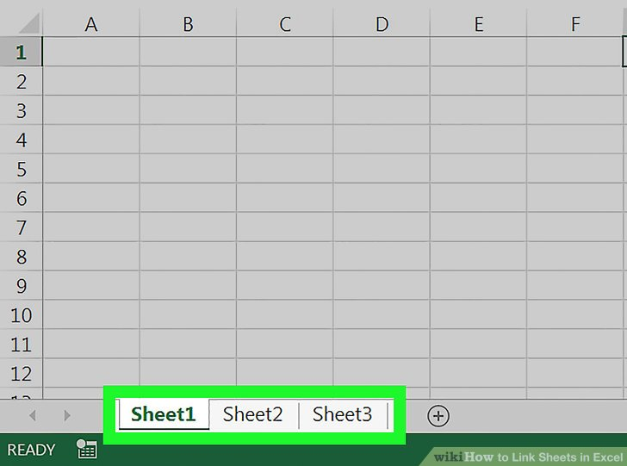**Click your destination sheet from the sheet tabs.** You will see a list of all your worksheets at the bottom of Excel. Click on the sheet you want to link to another worksheet.
3. **Click an empty cell in your destination sheet.** This will be your destination cell. When you link it to another sheet, the data in this cell will be automatically synchronized and updated whenever the data in your source cell changes.

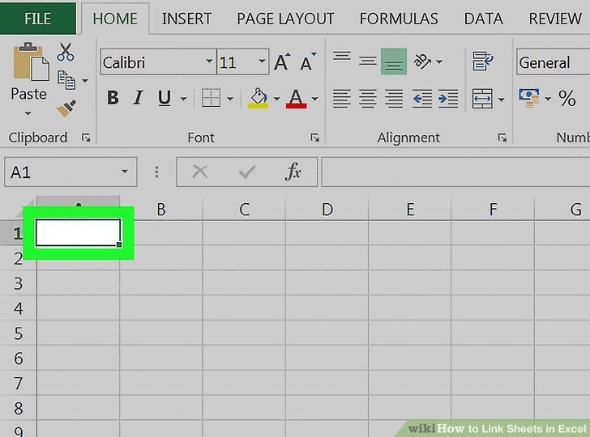

1. **Type = in the cell.** It will start a formula in your destination cell.

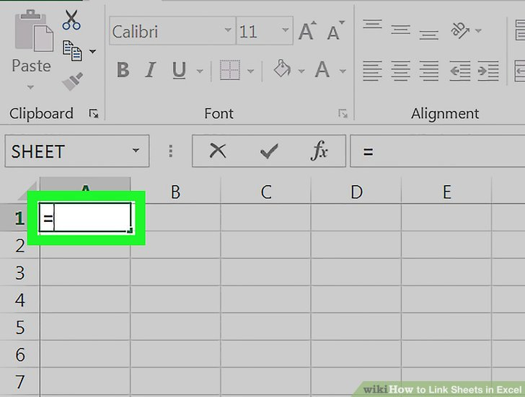

1. 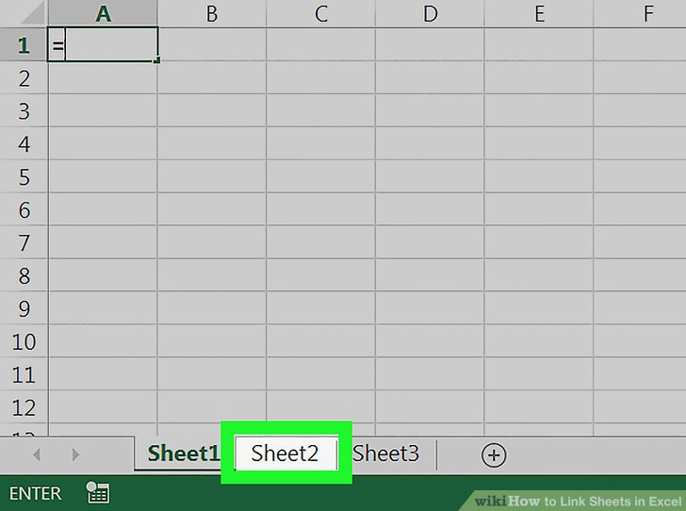**Click your source sheet from the sheet tabs.** Find the sheet where you want to pull data from, and click on the tab to open the worksheet.

## Importing and exporting data

Excel can import and export many different file types aside from the standard .xslx format. If your data is shared between other programs, like a database, you may need to save data as a different file type or bring in files of a different file type

### **Export Data**

When you have data that needs to be transferred to another system, export it from Excel in a format that can be interpreted by other programs, such as a text or CSV file.

1. 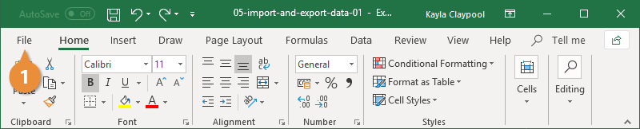Click the **File** tab.
2. At the left, click **Export**.
3. Click the **Change File Type**.
4. Under Other File Types, select a file type.
   * **Text (Tab delimited):** The cell data will be separated by a tab.
   * **CSV (Comma delimited):** The cell data will be separated by a comma.
   * **Formatted Text (space delimited):** The cell data will be separated by a space.
   * **Save as Another File Type:** Select a different file type when the Save As dialog box appears.

The file type you select will depend on what type of file is required by the program that will consume the exported data.

1. Click **Save As**.

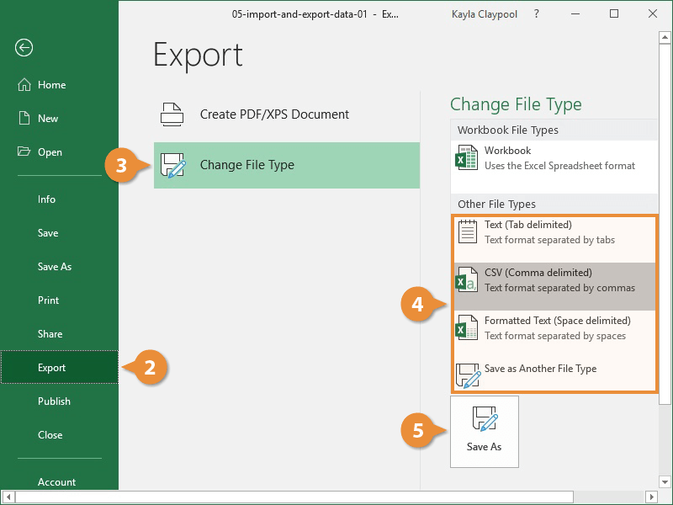

1. Specify where you want to save the file.
2. Click **Save**.

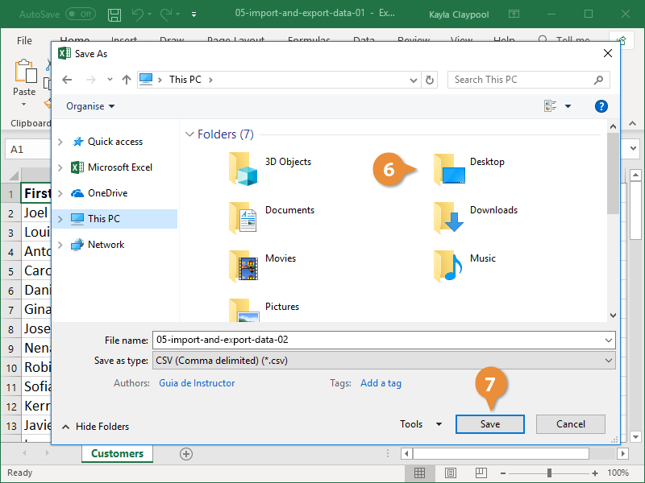

1. A dialog box appears stating that some of the workbook features may be lost.
2. Click **Yes**.

### **Import Data**

Excel can import data from external data sources including other files, databases, or web pages.

1. Click the **Data** tab on the Ribbon..
2. Click the **Get Data** button.

Some data sources may require special security access, and the connection process can often be very complex. Enlist the help of your organization’s technical support staff for assistance.

1. Select **from File**.
2. Select **from Text/CSV**.

If you have data to import from Access, the web, or another source, select one of those options in the Get External Data group instead.

1. Select the file you want to import.
2. Click **Import**.

If, while importing external data, a security notice appears saying that it is connecting to an external source that may not be safe, click **OK**.

1. Verify the preview looks correct.

Because we've specified the data is separated by commas, the delimiter is already set. If you need to change it, it can be done from this menu.

1. Click **Load**.

## Exporting to Ms word

1. **Copying and Pasting Excel Data into Word**

In Excel, click and drag to select the content you'd like to put in the Word document, and then press Ctrl + C.

* Press press Ctrl + A to select all the data in a chart, and then press press Ctrl + C.
* You can also click the Edit menu, and then click Copy.
* If you're on a Mac, press ⌘ Command + C to Copy.
* In addition to copying and pasting Excel data, you can also copy and paste Excel charts into Word.

1. **In Word, paste the Excel data.** In the Word document, move the cursor to the location you'd like your table, and then press Ctrl + V. The table is pasted into Word.

* You can also click the Edit menu, and then click Paste.
* If you're on a Mac, press ⌘ Command + V to Paste.

1. **Choose your paste option.** In the bottom right corner of the table, click the Paste Options button to see the different paste options. If you don't see the Paste Options button, you don't have it enabled. To enable it, go to Word Options, click Advanced. Under Cut, Copy, and Paste, click the Show Paste Options buttons check box to add a check.
2. Click Keep Source Formatting to use the Excel table style.
3. Click Match Destination Table Style to use the Word table style.
4. **Create a linked Excel table.** Word has a feature that allows it to create links to other Office files. This means that if you make a change to the Excel file, the copied table will be updated in Word. Click Keep Source Formatting and Link to Excel or Match Destination Table Style and Link to Excel to create a linked Excel table. These two options match the style sources for the other two paste options.

**Click Keep Text Only to paste the Excel content without any formatting.**

1. When you use this option, each row will be on its own paragraph, with tabs separating the column data.

## Importing a word table

This help page will show how to import data from Excel into a Microsoft Word table.

1. Open a new or existing document in **Microsoft Word**.
2. Click the "Insert" tab > Locate the "Tables" group.
3. Select the "Table" icon > Choose the "Insert Table..." option.
4. Set the "Number of columns," "Number of rows," and "AutoFit behavior" to your desired specifications > Click [OK].
5. Open the Excel file and use your mouse to select the data you wish to import.
6. Right-click on the range of cells you have highlighted and select "Copy."
7. Switch back to Word and highlight the table cells where you want to import the Excel data.
8. Right-click on the Word table and click the option you want under "Paste Options."

## Importing a text file

There are two ways to import data from a text file with Excel: you can open it in Excel, or you can import it as an external data range. To export data from Excel to a text file, use the **Save As** command and change the file type from the drop-down menu.

There are two commonly used text file formats:

* Delimited text files (.txt), in which the TAB character (ASCII character code 009) typically separates each field of text.
* Comma separated values text files (.csv), in which the comma character (,) typically separates each field of text.

You can change the separator character that is used in both delimited and .csv text files. This may be necessary to make sure that the import or export operation works the way that you want it to.

**Note:**You can import or export up to 1,048,576 rows and 16,384 columns.

## **Import a text file by opening it in Excel**

You can open a text file that you created in another program as an Excel workbook by using the **Open** command. Opening a text file in Excel does not change the format of the file — you can see this in the Excel title bar, where the name of the file retains the text file name extension (for example, .txt or .csv).

1. Go to **File** > **Open** and browse to the location that contains the text file.
2. Select **Text Files** in the file type dropdown list in the **Open**dialog box.
3. Locate and double-click the text file that you want to open.
   * If the file is a text file (.txt), Excel starts the Import Text Wizard. When you are done with the steps, click **Finish** to complete the import operation. See [Text Import Wizard](https://support.microsoft.com/en-gb/office/text-import-wizard-c5b02af6-fda1-4440-899f-f78bafe41857) for more information about delimiters and advanced options.
   * If the file is a .csv file, Excel automatically opens the text file and displays the data in a new workbook.

### **Import a text file by connecting to it (Power Query)**

You can import data from a text file into an existing worksheet.

1. On the **Data** tab, in the **Get & Transform Data** group, click **From Text/CSV**.
2. In the **Import Data** dialog box, locate and double-click the text file that you want to import, and click **Import**.
3. In the preview dialog box, you have several options:
   * Select **Load** if you want to load the data directly to a new worksheet.
   * Alternatively, select **Load to** if you want to load the data to a table, PivotTable/PivotChart, an existing/new Excel worksheet, or simply create a connection. You also have the choice of adding your data to the [Data Model](https://support.microsoft.com/en-gb/office/create-a-data-model-in-excel-87e7a54c-87dc-488e-9410-5c75dbcb0f7b).
   * Select [Transform Data](https://support.microsoft.com/en-gb/office/power-query-for-excel-help-2b433a85-ddfb-420b-9cda-fe0e60b82a94) if you want to load the data to Power Query, and edit it before bringing it to Excel.
4. If Excel doesn't convert a particular column of data to the format that you want, then you can convert the data after you import it. For more information, see [Convert numbers stored as text to numbers](https://support.microsoft.com/en-gb/office/convert-numbers-stored-as-text-to-numbers-40105f2a-fe79-4477-a171-c5bad0f0a885) and [Convert dates stored as text to dates](https://support.microsoft.com/en-gb/office/convert-dates-stored-as-text-to-dates-8df7663e-98e6-4295-96e4-32a67ec0a680).