# **Word processor**

## Introduction to Microsoft word

Microsoft Word is a word processor software developed by Microsoft 1983. it’s the most

commonly used word processor software. It is used to create professional quality documents,

letters, report, etc. and also allow you to edit or modify your new and existing document. The file saved in Ms. Word has. docs extension. Microsoft office this container that have different office

like out book, publisher, access, excel, word and power point.

**How to open Microsoft word;**

The following step shows how to open Ms. word

* + - search term word than you seen on the top of your interface than open.
    - start scrod down Microsoft office expand than click word than open
    - press widow flag and press latter r at the same than can opened a box write a win word on the box than press enter your word can open.
* Select a blank document and press create button.

Then you will get a window like in the image below you can write your content and perform different types of operations on that content, like font type, style, bold, italic, etc. you can also add images, tables, charts to your document.

## **Basic editing;**

The edit menu or toolbar in Microsoft word allows users to perform basic editing functions in their document such as copying, cutting and pasting. It also contains options for the undo and find/replace functions.

**Formatting;**

Add and format text

To add text place, the cursor where you want and start typing.

**Format text**

1. Select the text you want to format.

To select a single word, double-click it. To select a line of text, click to the left of it.

1. 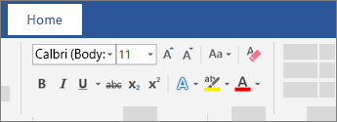Select an option to change the font, font size, font color, or make the text bold, italic, or underline.

**Copy formatting**

* Select the text with the formatting you want to copy
* Click the **format Painter** and then select the text you want to copy the formatting to.

Tip: double-click **format painter** if you want **to copy the formatting in more than one place.**

**Moving and copying;**

You can easily move and copy text in a document, and paste it wherever you want it to go, including into other documents. Using cut, copy and paste command, you can edit and rearrange text and other elements you insert into a document. You can drag and drop text to move it, or use the cut and paste technique. When copying text, you are making a duplicate of the original

**Steps that using;**

First; select the text or other item you want to move or copy.

Second; drag the selected text and drop it where you want it to appear.

Third; to copy the selection, press and hold the ctrl key while dragging.

Fourth; to move selected text with the cut command, click the cut button on the home tab of the ribbon.

Fifth; to copy selected text with the copy command, click the copy button.

Then; to paste the cut or copied text, click where you want it to go and click the paste button.

Lastly; to control paste options, click the paste menu button and choose an option.

**How to use a shortcut;**

Crtl + c = copy

Crtl + x = cut

Crtl + v = paste

Crtl + n = new blank document

## **More editing Features of Ms. Word;**

The features or component of the Ms word you can perform different operation like you can create, delete, style, modify or view the content of your document.

1. **File**

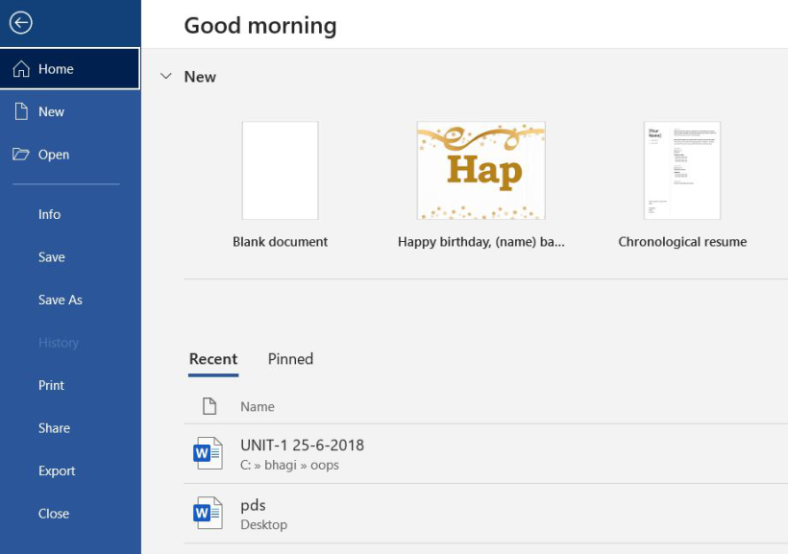It contains options related to the file, like new (used to create a new document), open (used to open an existing document), save (used to save documents), history, print, share, export, info, etc.

1. **Home**

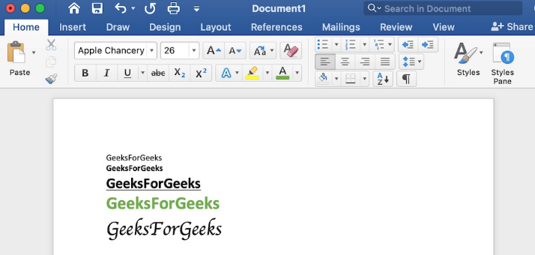It’s the default tab of ms word and its generally divided into five groups, clipboard, font, paragraph, style and edting.its allow you to select color, font, bullet, position of your text, it’s also contain options like cut, copy and paste.

1. **Insert**

It’s the second tab present on the menu bar or ribbon, it contains various item that you may want to insert into a Microsoft word, includes

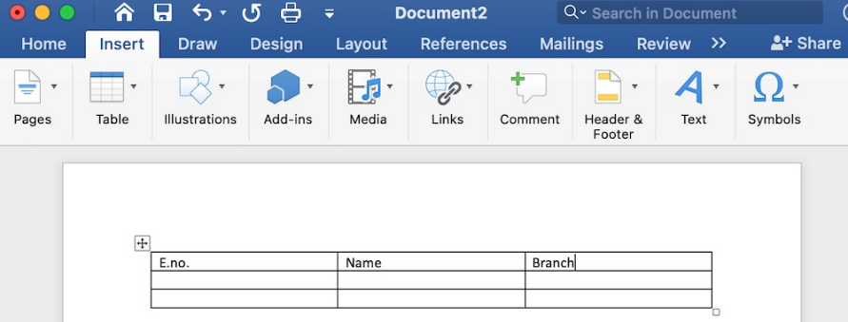tables, word art, hyperlink, symbols, charts, header, footer, shapes, page numbers, etc.

1. **Draw**

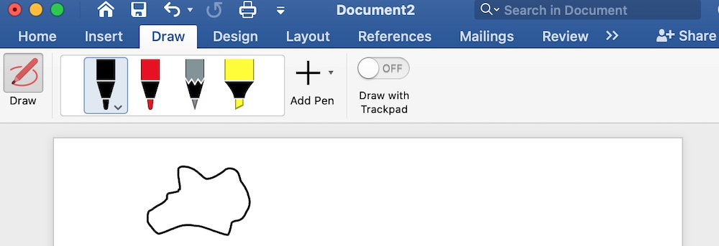It’s the third menu bar or ribbon its used for freehand drawing in ms word. Its provides different types of pens for drawing.

1. **Design**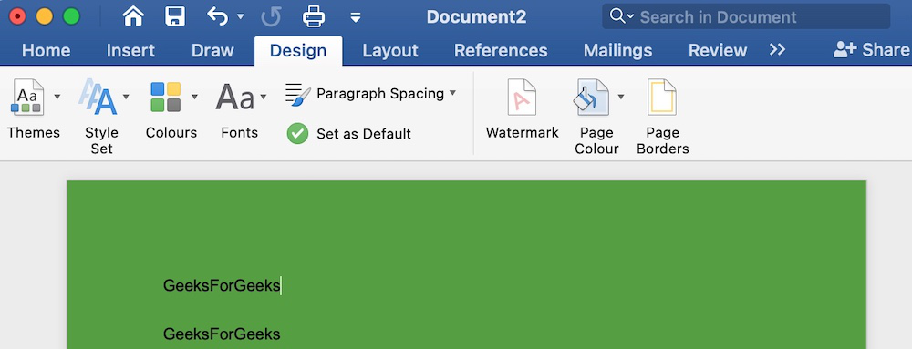The design tab contains document designs that you can select, such as documents with centered titles, offset headings, left justified text, pages border, watermarks, pages color, etc.
2. **Layout**

this options allow you to arrange your Microsoft word document pages the way you want include set margin, display line numbers, set paragraph indentation, control page

orientation and size, line breaks, etc.

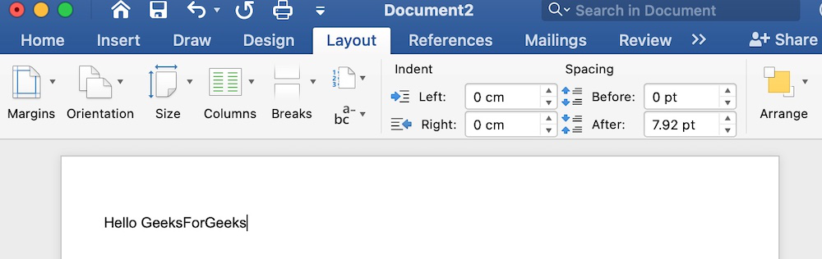

1. **References**

The reference tab lets you add references to a document, then create a bibliography at the end of the text, the references are generally stored in a master list, which is used to add

references to further documents. It includes options like, table of contents, footnotes,

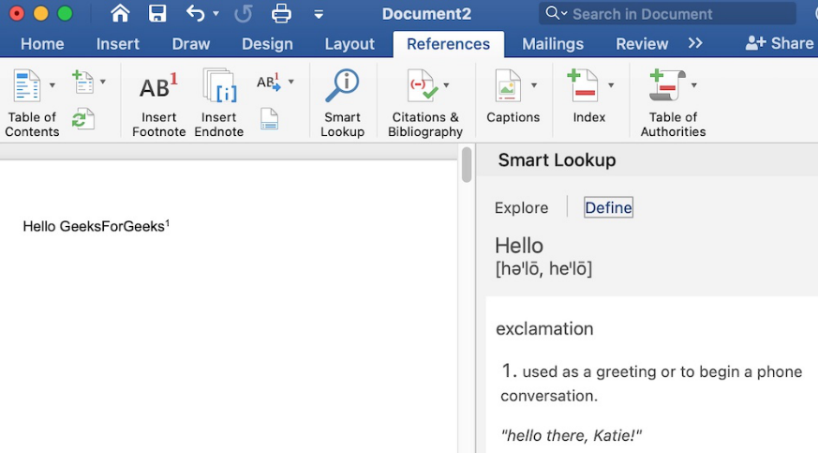 citations, bibliography, caption, index, table of authorities, smart look, etc.

1. **Mailings**

This tab is where you would create labels, print them on envelops, do mail merge, etc.

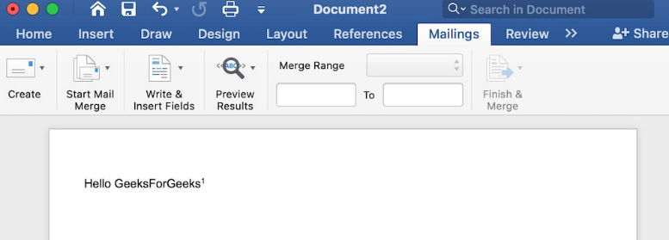

1. **Review**

The review tab contains, commenting, languages, translation, spell check, word count

tools. It is good for quickly locating and editing comments.

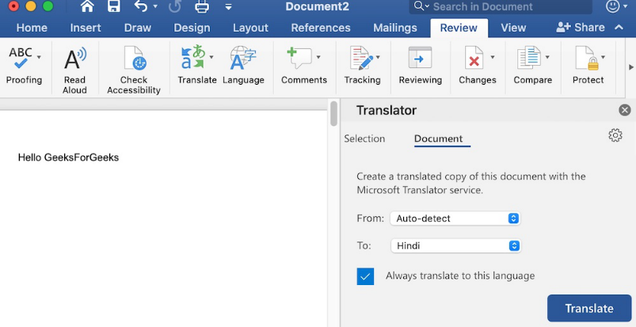

1. **View**

View tab allows you to switch between single page or double page and allows you to

control the layout tools it includes print layout, outline, web layout, task pane, toolbars,

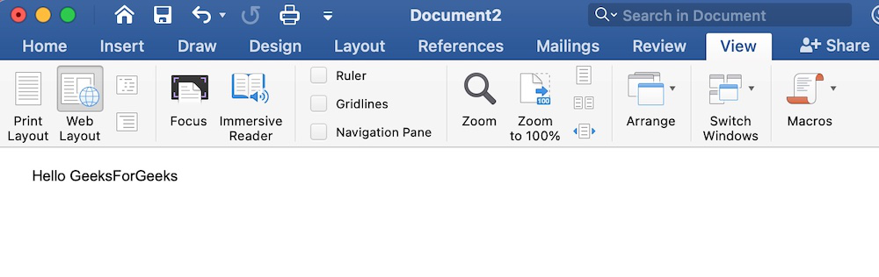ruler, multiple pages, page width, full-screen view, zoom, etc.

# Paragraph formatting;

Is a change in the format of text that affects an entire paragraph or is different from other paragraphs in a document. Paragraphs in a word processing document or on a web page can have paragraph formatting applied to them, including alignment, font type, font size, highlighting and indentation.

Example of paragraph formatting.

**Change font size;**

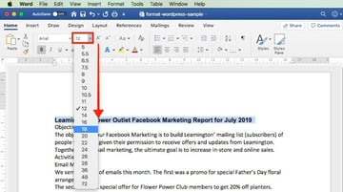

This paragraph uses a small font size.

This paragraph uses a large font size.

**Change font type;**

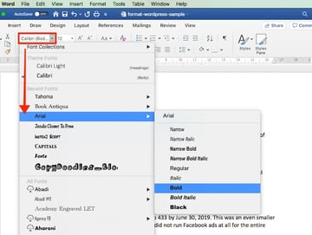

**This paragraph uses the “Arial” font type.**

**This paragraph uses the “comic sans MS” font type.**

**Change font color;**

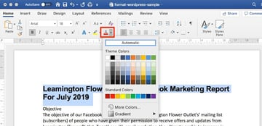

This paragraph uses the blue font color.

This paragraph uses the red font color.

**Change bold and italics formatting;**

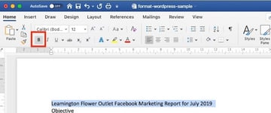

**This paragraph uses the bold text formatting.**

*This paragraph uses the italics text formatting.*

**Change color highlighting;**

This paragraph has no color highlighting.

This paragraph has yellow color highlighting.

Change color indentation;

This paragraph has no indentation.

This paragraph is indented by on-tab character.

## Insert table (merge cells, spilt cell, table properties);

A table is made up of rows and columns. The insert section of a row and column is called a cell. table are often used to organize and present information, but they have a variety of uses as well you can use table to align numbers and create inserting page layouts.

**Creating a table;**

1. Click the insert tab on the ribbon
2. Click on table
3. Highlighting the number of columns and rows you would like

Or

1. Click insert table
2. Click the arrows to select the desired number of columns.
3. Click the arrows to select the desired number of rows
4. Click ok

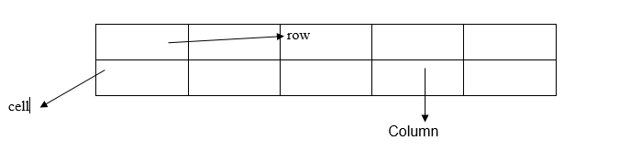

When working within a table, the **Table Tools** tab appears in the Ribbon, and includes the **Design** and **Layout** tabs

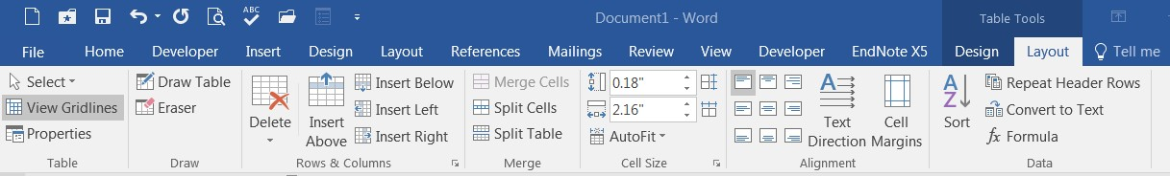

To Insert a Row:

1. Position the cursor in the table where you would like to insert a row
2. Select the Layout tab under Table Tools
3. Click either the Insert Above or Insert Below row buttons in the Rows & Columns group

To Insert a Column:

1. Position the cursor in the table where you would like to insert a column
2. Select the Layout tab under Table Tools
3. Click either the Insert Left or Insert Right column buttons in the Rows & Columns group

To Delete Columns or Rows:

1. Position your cursor in the row or column you would like to delete
2. Select the Layout tab under Table Tools
3. Click the Delete button in the Rows & Column group
4. Select either Delete Columns or Delete Rows

## Formatting a table;

Adding a Table Style:

1. Position your cursor in the table
2. Click the Design tab under table tools
3. Choose a style from the table styles group

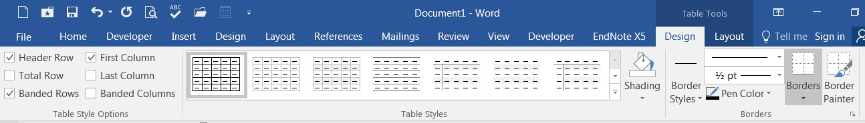

To Shade the Cells/Table:

1. Position your cursor in the table, column or row
2. Click the Design tab under Table Tools
3. Click the Shading button in the Table Styles group
4. Choose a color

To Add a Border to Cells/Table:

1. Position your cursor in the table, column or row
2. Click the Design tab under Table Tools
3. Click the arrow on the Borders button in the Borders group
4. Choose a border

To Merge Cells in a Table:

1. Select the cells that you would like to merge in the table
2. Click on the Layout tab under Table Tools
3. Click the Merge Cells button in the Merge group

# Sorting Data in a Table

You can easily sort data in a table in either ascending or descending order.

To Sort Data in a Table:

1. Position your cursor in the table
2. Select the Layout tab under Table Tools
3. Click the Sort button in the Data group
4. Select the field to sort by
5. Select the order (ascending, descending)
6. Choose if your table has a header row (in the example below, the table has a header row)

|  |  |
| --- | --- |
| **Name** | **Hours Worked** |
| Mike | 10 |
| Ann | 16 |
| Steve | 25 |
| Michele | 87 |

1. 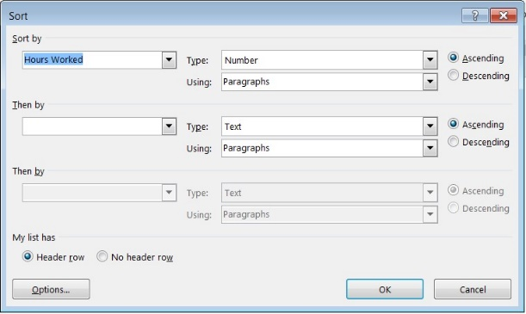Click OK.

# Split a Table

Once you have a table in Word, you might decide to split that table into two or more tables. This way, you can create smaller tables, or add text in between two tables.

1. Put your cursor on the row that you want as the first row of your second table. In the example table, it’s on the third row.

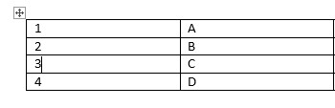

1. Select the Layout tab under Table Tools
2. Click Split Table in the Merge group

The table splits into two tables.

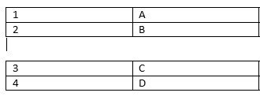

## Bullets/numbering;

When creating a list of text items, users can choose from several bullet or numbering system to add a small graphic icon or series of numbers before each item. To add bullets or numbering to a series of text click on the corresponding button formatting toolbar or choose ’bullets and numbering’ from the format menu.

Examples of bullet and numbering;

**Numbering**

1. Mango
2. Fish
3. cow

**Bullet**

* ali
* asha
* fatma

## Border and shading

Border and shading is always used to decorate a text, which makes a plain article seems highlighted and well organized. You can add borders, to any side of a paragraph, and you can add

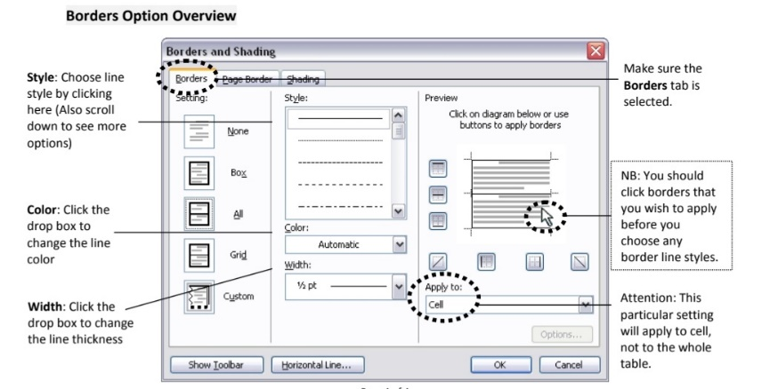background shading. You can also add borders and shading to ordinary text and to the paragraphs in table cells and frames. Choose **Home→ Paragraphs** sub task menu and click on the button to display **Border and Shading** submenu. The Borders and Shading dialog box appears. Click on the appropriate borders box after selecting Borders tab to select border, select **Paragraph** under **Apply to:** drop down submenu, click **OK.** To shade a paragraph, click on **Shading** tab in Borders and Shading dialog box, select appropriate shade under Fill, and select **Paragraph** under **Apply to:** drop down submenu, click **OK.**

## Inserting clipart and image

Inserting pictures (image)

1. Click on the **File** menu, and then the **Insert** Menu. Choose **Picture** and then **From File…**



2) Note the **Insert picture** dialogue box. Choose a location, and click on the picture you want to insert.



3) Click on the Insert button, and your picture will be inserted! Alternatively, you can simply double-click on a picture and it will be inserted into your word document.

4) The last step is to make it easier to edit and move your picture around.

Once the picture is in Word, simply double click on it. Note the picture dialogue box.

Click on the **Layout** tab and click **behind text**.

****Click **OK** and you are done.

**Inserting clipart**

Adding clip arts to Ms Word document makes it reader friendly and graphics also helps the idea clear and easy to understand. This tutorial is all about inserting clip arts in Ms Word and making word document readers friendly.

**Steps for inserting clip arts in Ms word:**

**1.**Open your desired word document in which you want to add a clip art.

**2.** Place your cursor in the area where the clip art is to be inserted.

**3.** Select the Insert Tab from the top menu bar.

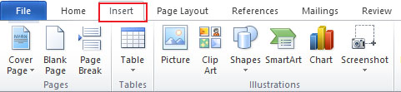

**4.** Select Clip Art from the Insert Menu, a small clip art window will appear at the right of word document.

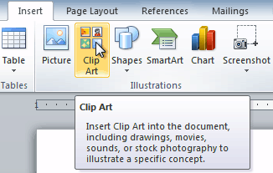

5. Enter any name or keyword related to your clip art to search for and press **Go** button.

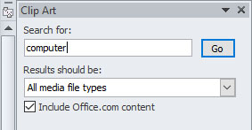

**Note:** From this menu you can insert or add any **Photographs**, **Illustration**, **Audio** and **Video** clip in word. By default, **All media file types** option is selected but if you want to display search results only for a specific file type such as **illustrations**, un-check all the boxes except **Illustrations** check box.

**6.**Click on your desired clip art from the search results and the clip art will be inserted at the position of cursor.

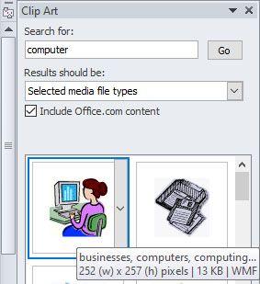

You can resize the clip art from the handles, if you cannot move your clip art freely, it is because of wrap text option.

**How to Change Wrap Text Settings in Word:**

The default **Wrap Text** option for clip arts and picture is **“In Line with Text”**, and when this option is selected you cannot move your clip art freely.

Right click on the newly added clip art or picture, select **Wrap Text** from the right click menu and then **Square**.

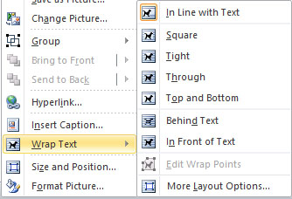

Now click and drag the clip art to any point you like.

## Drawing

Create a drawing on a digital canvas with Microsoft's predesigned shapes to help communicate your meaning. Word includes a Shapes gallery with time-saving drawing elements, such as lines, arrows, circles and stars, for quick insertion. Explore the Drawing Tools ribbon to customize each shape for your presentation. Your drawing can also include text to enhance your document with detailed content to grab the reader's attention. For example, your custom illustrations can add visual appeal to newsletters, reports and invitations for onscreen viewing and printouts.

Insert the Shape

Step 1: Click the "Insert" tab on the command ribbon and click the "Shapes" arrow button in the Illustrations group to open the chart of shapes.

Step 2: Select "New Drawing Canvas" to display a framed rectangle on your document. The canvas includes a border with sizing handles. Click the frame's sizing handle and then drag to the change the canvas dimensions to suit your document. Click the frame to change the cursor to a four-arrow icon and then move the canvas to the preferred location on your document.

Step 3: Click inside the drawing canvas to bring up the Drawing Tools ribbon and the Format Tab. Click the "Format" tab to display editing tools arranged in the Insert Shapes and Shape Styles groups, for example.

Step 4: Click the "More" button in the Shapes gallery in the Insert Shapes group to display the chart of shapes organized in sections, such as Basic Shapes, Block Arrows and Stars and Banners. Select the preferred shape icon. The cursor changes to a "+" symbol.

Step 5: Click and drag on the drawing canvas to insert the shape. Press and hold "Shift" and then drag the cursor to help maintain a perfect shape, such as a square or circle. A frame with sizing handles surrounds each inserted shape. Select a sizing handle, drag and release to change the configuration. For example, insert the "Triangle" shape and then select and drag a sizing handle to change the angles.

## Page break and creating section

use sections breaks to divide and format document of all size. For example, you can break down sections into chapters and add formatting such as columns, headers and footers, page borders to each.

**Add a section break**

1. select where you want a new section begin.
2. Go to layout break.

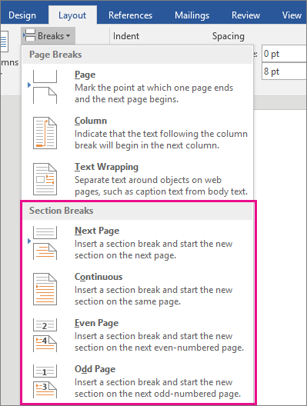

1. Choose the type of section break you want:

* Next page Section break starts the new section on the following page.



* Continuous Section break starts the new section on the same page. This type of section is often used to change the number of column without starting a new page.



* Even page Section break starts a new section on the next even-numbered page.



* Odd page Section break starts a new section on the next odd-numbered page.



## Using templates to create documents

Templates are like a blueprint for a document, it determines the basic structure of the document. It contains setting such as margins, tabs, columns, line spacing, fonts etc.

Templates let you configure all the relevant settings you want pre-applied to documents—page layout, styles, formatting, tabs, boilerplate text, and so on. You can then easily create a new document based on that template.

When you save a document as a template, you can then use that template to create new documents. Those new documents contain all the text (and images, and other content) that the template contains. They also have all the same page layout settings, sections, and styles as the template. Templates can save you a lot of time when you’re creating multiple documents that need to have a consistent layout, format, and some boilerplate text.

Once you have saved your custom template, you can then create new documents based on it. The easiest way to do this is to just fire up Word.

Its opening splash screen shows a bunch of featured templates that are either built-in or downloadable. At the top of the window, click the “PERSONAL” link to show your custom templates. Then, all you have to do is click the template you want, and Word creates a new document based on it.

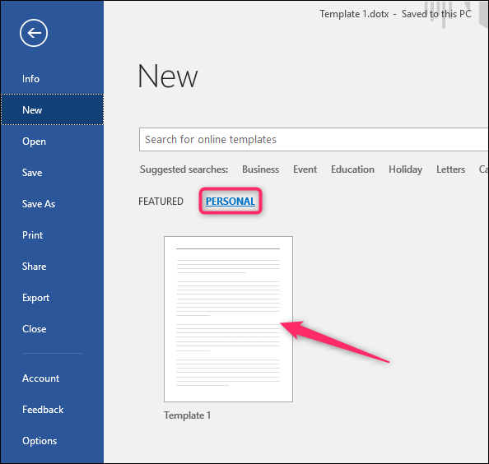

By default, Word likes to save templates to Documents\Custom Office Templates, where they’ll show up alongside templates you create in any other Office app.

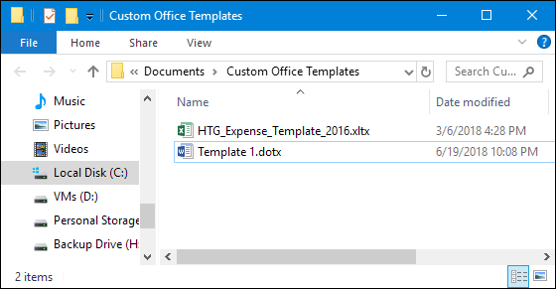

When you save a template, you can choose a different location if you want. The trouble is that if you save it in a different location, Word may not be able to pick it up and display it on the splash screen as an option. If that’s not a big deal to you, then save them anywhere you like. You can still create a new document based on the template by just double-clicking the file.

You can also open the template in Word so that you can edit it by right-clicking the file, and then choosing the “Open” command from the context menu.

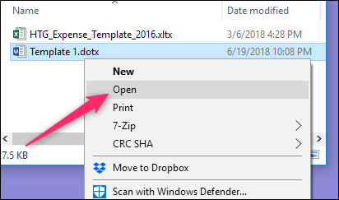

If you want an even more organized approach, you can change the default location where Excel saves templates. This lets you save templates where you want (though they still need to all be in the same location) and be able to access them on Word’s splash screen.

On the “File” menu, click the “Options” command. In the “Word Options” window, slick the “Save” category on the left. On the right, type the path where you want to save templates in the “Default personal templates location” box. Click “OK” when you’re done.

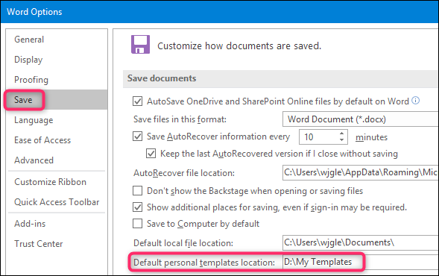

## **Mail merge;**

**Start mailing,** step by step mail merge wizard, select document type (letters, e-mail messages,

envelops, labels, directory), next: starting document+ next type new list+ create than you can set what you want to use (customize, rename, delete and add) than ok you enter a name by click a new entry than Ok.

**Step 2** after that you can save your list anywhere you want like desktop or document than save

Ok.

**Step 3** you can write your latter than address block, greeting line than ok.

**Step 4** complete if you connect with printer you can print.

## Page set up and printing;

**Page set**; Is a set of specific parameters involving the display and layout of a printed page. This type of resource is part of many modern word processing applications and other document processing software, for instance, in Microsoft office applications. Aspects of page setup include the setting of margins a portrait or landscape page orientation and other features. Page setup menus can help users to set these attributes in order to ensure a print project is done correctly. Word processing may or may not have dedicated page setup menus. Other aspects of page setup include header and footer elements, color, paper

sizes, various alignments and use a ruler to help set margins for a document.

**Printing;**

Printing is a computer transferring data to a computer printer and generating a hard copy of the electronic data being printed.

**Step for printing**

1. Click the Office button and then click Print. Word displays the Print dialog box. (You can also display the dialog box by simply pressing **Ctrl+P**.)
2. Using the Name drop-down list, select the printer you want to use. (It is common to have more than one printer available if you are working in a networked environment.)
3. Click on the Properties button. Word displays the Properties dialog box for the printer you selected in step 2. The exact appearance of the dialog box, and the controls it contains, depends on the printer driver you have installed for your printer.
4. Using the tabs and other controls in the dialog box, specify the printer settings you want to use.
5. Click on OK to close the Properties dialog box.
6. Click on OK from the Print dialog box. Your document will be printed.

## Document protection;

Document Protection secures your important documents against unauthorized access. Only users who have a valid CRYPTO-BOX connected to their computer can read the encrypted documents. Additionally, an Expiration Date can be added to the documents and licenses can be renewed via the Remote Update Management System.