Invitation to Participate in an Immersive Modeling Session for a Water Bank
IRB Protocol # 14064
DATE
Overview
This document lays out the different methods—those already approved and new—that we are using to invite collaborators to join immersive modeling sessions. The methods are:
- Email to invite people (Approved).

- Meet in-person, such as at a conference (Submitted as an amendment to this protocol).
  - Step 1. Initial in-person encounter.
  - Step 2. Share flier and exchange contact information.
  - Step 3. Follow up email to people who expressed interest in joining a session.

- Invite as part of a technical presentation, poster, field trip, etc. (Submitted as an amendment to this protocol)
  - Step 1. Present/Describe the work.
  - Step 2. Share flier/power point slide, etc.
  - Step 3. Ask people if they want to join a session. If yes, obtain their contact information.
  - Step 4. Follow up email to people who expressed interest in joining a session.
All of the methods share the same ½ page poster board with full study information so potential collaborators can make an informed decision about whether to join a model session. We provide a copy of this poster board at the end of this document for reference. We also provide a copy of the flier for Methods #2 and #3.

Method 1. Recruitment email to people (Approved).
Recruitment email
Dear ______,
We invite you to collaborate in an immersive online collaborative model session for [[Describe the model in 1 or a few sentences]]. Your perspectives are important and we want to include them! During a model session, you will have opportunities to consume water, bank water, share rationales for choices, observe other collaborators’ choices, and listen to rationales for their choices. The attached ½ page poster board provides more information about the study including goals, what we request of collaborators, data to collect, how stored, risks, and possible benefits.
We are planning 2-hour model sessions on the following dates:
- LIST OF SESSIONS
If you wish to collaborate in this study, please indicate your availability for any of these dates by response to this email.
We hope you are available for at least one model session. If you have questions, please reach out to Principal Investigator Dr. David Rosenberg and Hadia Akbar at david.rosenberg@usu.edu and hadia.akbar@usu.edu.
This letter is sent as part of Utah State University Institutional Review Board protocol #14064.
We look forward to hear from you.

Regards,

Hadia Akbar
PhD researcher

David Rosenberg
Professor
Utah Water Research Lab
Utah State University

Method 2. Meet in-person, such as at a conference (Submitted as an amendment to this protocol).
Step 1. The in-person encounter.

[Introductions]

[Ask them to discuss their work]

[Follow up with questions such as “Why are you ...”, "Can you talk more about ....?"]

[Describe our project, such as the Why and How. For example, we are working on a cross-state water bank for Bear River Basin to explore how to get more water to Great Salt Lake. We are wanting to learn about the possibilities and constraints of using this approach. We are using an immersive modeling method. During a model session, you will have opportunities to consume water, bank water, share rationales for choices, observe other collaborators’ choices, and listen to rationales for their choices. We will ask a few follow-up questions at the end … ]

[What] Would you be interested to join a 2-hour model session?

[Wait. Let them think and/or ask follow-up questions]

[If No]. Thank them for their time.

[A. If Yes].

[Share a flier] (see end of this document for a copy)

[Ask for their contact information, e.g. share a business card or write down their email address, phone, etc.].

I will send an email with more information about the project. [This email will be the short version of our original one that includes the ½ page poster board and the step where informed consent will occur.]

I will send an email with more information about the project. [This email will be the short version of our original one that includes the ½ page poster board and the step where informed consent will occur. See step 2B just below]
Step 2A. Follow up email to people who said yes in-person to join a model session and scheduled a time.

____,

Thank you for your interest to participate in an immersive model session! We have upcoming model sessions scheduled on:

- LIST OF SESSIONS

If none work, can you please suggest 1 or 2 alternative days/times?

This ½ page online poster board provides more information about the study -- link [[HERE]].

You are welcome to invite someone you think who would be relevant to this work, In fact an immersive model session goes better with 2 to 4 collaborators.
If you have questions, please reach out to me at hadia.akbar@usu.edu or Dr. David Rosenberg at david.rosenberg@usu.edu or 435.797.8689. Please reach out to the Utah State University Institutional Review Board (IRB) if you have questions or concerns and want to speak to someone outside of the research team (irb@usu.edu). This letter is sent as part of Utah State University IRB protocol # 14064.

We look forward to see you on ______!

Method 3. Invite as part of a technical presentation, poster, field trip, et (Submitted as an amendment to this protocol).
Step 1. Present and share about the work.
[Presentation – Title, technical information such as methods and results to date. For example, see 2-page summary of prior results on page immediately after informed consent ½ page poster board].
[Share a flier/presentation slide, or similar] (see final page of this document for a copy)
[What] Would you be interested in joining a 2-hour model session?
[If yes], ask fornontact information.

I will send an email with more information about the project. [This email will be the short version of our original one that includes the ½ page poster board and the step where informed consent will occur]
Step 2. Follow up email to the ones who signed up to join a model session.
____,

Thank you for your interest to participate in an immersive model session! We have upcoming model sessions scheduled on:

- LIST OF SESSIONS

If none work, can you please suggest 1 or 2 alternative days/times?

This ½ page online poster board provides more information about the study -- link [[HERE]].

You are welcome to invite someone you think who would be relevant to this work, In fact an immersive model session goes better with 2 to 4 collaborators.
If you have questions, please reach out to me at hadia.akbar@usu.edu or Dr. David Rosenberg at david.rosenberg@usu.edu or 435.797.8689. Please reach out to the Utah State University Institutional Review Board (IRB) if you have questions or concerns and want to speak to someone outside of the research team (irb@usu.edu). This letter is sent as part of Utah State University IRB protocol # 14064.

We look forward to schedule a model session!
For Reference: ½ page poster board with full study information so potential collaborators can make an informed decision about whether to join a model session (Approved)

Summary/Results of prior work to share in a technical presentation, poster, field trip, etc. ahead of inviting people to join a new model session (p. 1 of 2).
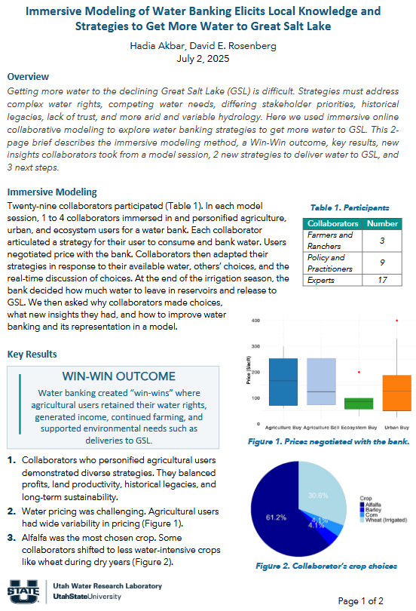

Summary/Results of prior work to share in a technical presentation, poster, field trip, etc. ahead of inviting people to join a new model session (p. 2 of 2).
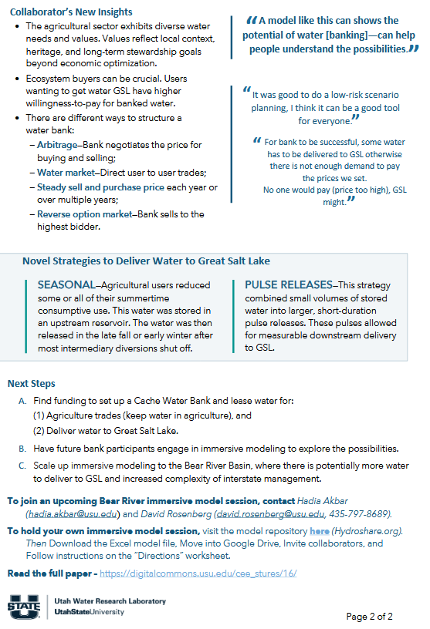

Flyer to hand out during in-person encounters or technical presentations, or similar activities.
