We would like to design a propulsion system for a Toy Boat. Your task is to design a demo illustrating magneto hydrodynamic propulsion. You need to use electricity, magnetism, and a create propulsion system. So, you need to modify/design your system on a toy boat.

Here is what you know 𝐹⃗=𝑖𝑑𝑙'''⃗𝑥𝐵'⃗ that is the same as𝐹⃗=𝑞𝑣⃗𝑥𝐵'⃗. Need to create a current in a magnetic field to get the boat to be pushed forward.

So, think of a Toy Boat and having available salt water (good conductivity). You need to create current in water as the presence of a magnetic field. Assume that you have access to Batteries, and strong magnets.

a) “Design” the system. This will be a sketch of the system.

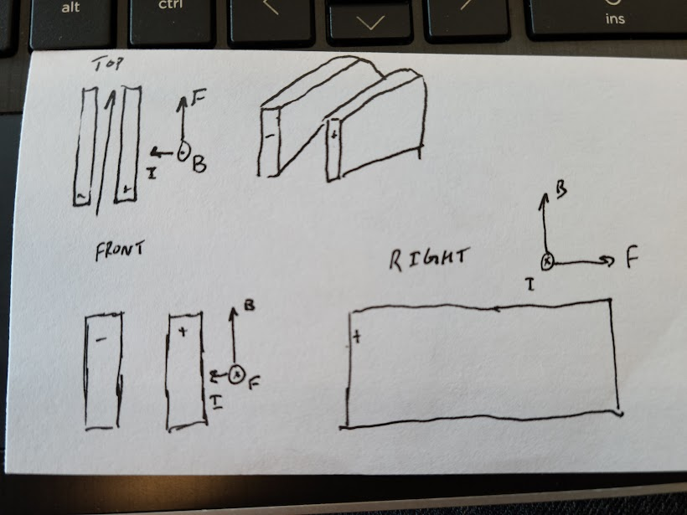  
b) Describe how it works in words and with your equations/pictures

The two plates will be submerged within the salt water and have charges respectively as shown. The two magnets would be placed in parallel statically attached to the boat (if you want the ability to reverse, I suppose you could make them electromagnets and swap their charges to do so). To go faster you would be a very large current going through the system to create a large B and F values.

c) The idea if for us to think about the process, not to really think about all values etc.   
d) However, think about what kinds of values do you need for Current etc?????

You would need quite large values for current if you wanted to go at a high speed, taking the formula into consideration, we know that 𝐹⃗=𝑖𝑑𝑙'''⃗𝑥𝐵'⃗ that is the same as 𝐹⃗=𝑞𝑣⃗𝑥𝐵'⃗ and we can see that the current does directly play into the speed of the boat.  
  
  
  
  
  
  
  
  
  
  
  
  
  
  
  
  
  
Compare and contrast this vs. the rail gun that you thought about in the last meeting?

?  
  
  
  
  
What type of challenges do you see in this process?

It seems slowish and possibly a bad idea to have that powerful electronics that close to water, that feels like its asking for an accident to occur.