Setting up your first Linux machine on your own computer

By Haadi Majeed

# Introduction

Linux is an operating system alternative to Windows and MacOS. There are countless types and versions of it, each has its own unique quirks and differences, most are free to download and use at your leisure. On top of it all, for people who are more technologically oriented, you can modify these as much or little as you would like as the developers leave them to be open-sourced.

Linux offers as much security as Windows and MacOS, and even more for versions that are open source, as when developers find and fix issues, the patches roll almost instantly, there is no true need to get antimalware software. There is also a significant more customizability you can do with the operating system, the combinations and options are limitless. For this set of instructions, we will be setting up Ubuntu 20.04.

You can get your own Linux system through the following steps:

**Step 1:** Downloading Ubuntu 20.04

**Step 2:** Setting up to load Into Ubuntu.

**Step 3:** Navigating Ubuntu.

**Step 4:** Running Updates and terminal basics.

**Step 5:** Pre-installed and open-source software that parallels paid-software.

# Before you get started

Make sure you have an empty flash drive that is 8GB or larger to download the iso onto. Creating a Linux subsystem is completely free and only needs about 20GB of storage if you want to keep your original OS in parallel to Linux. This guide is based off Windows 10 Education/Home edition.

# 1. Downloading Ubuntu

To begin the process of setting up your first Ubuntu system/subsystem, you will want to visit Ubuntu’s Homepage at <https://ubuntu.com/> and click the downloads dropdown to see the following.

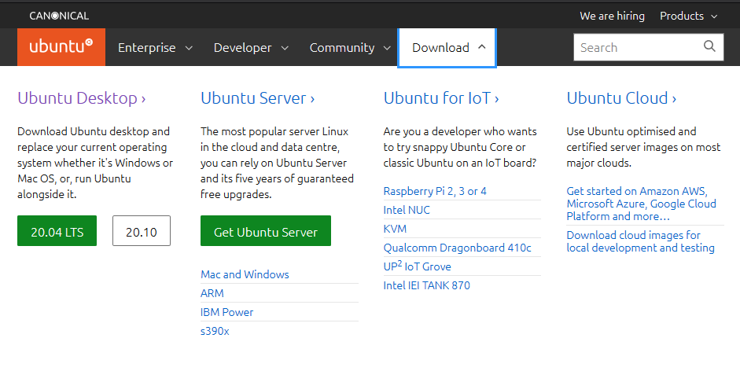

*Figure 1: Downloading Ubuntu*

From here, you want to click 20.04 LTS under Ubuntu Desktop which will begin the download of a .iso file. The file installed should be the following:

ubuntu-20.04.2.0-desktop-amd64.iso

Next you want to plug in a flash drive of your choice that is at least 8GB in size and move the file from your downloads into the flash drive.

## Important:

Make sure you download Ubuntu Desktop and not Server. Server will not have a Graphical User Interface (GUI), and everything will in there will have to be done exclusively via terminals. Ubuntu Desktop will look somewhat like Windows.

# 2. Booting from the Flash Drive

This step is a bit more on the technical side of computers, as we must check the BIOS (Basic Input/Output System) of the computer to check to see if the computer is permitted to boot from a flash drive, and if not then we are going to enable it.

# 3. Welcome to Ubuntu- The First Boot

Now that we have booted into Ubuntu for the first time, it is time to configure it to work. You may see a screen like this:

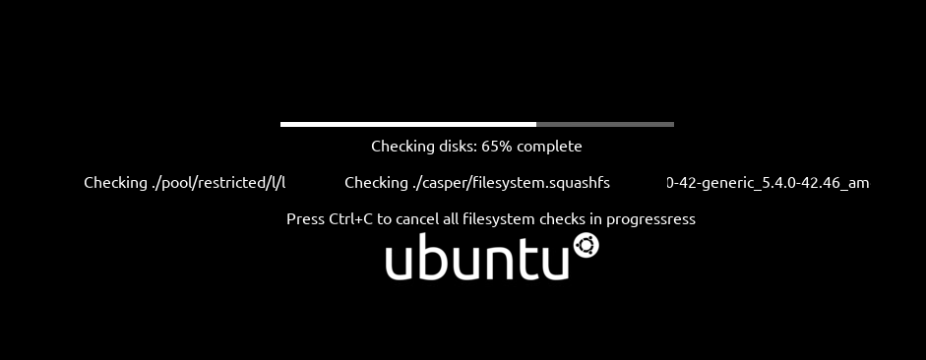

*Figure 2: First Boot*

Just allow it to run the system checks and do not touch the keyboard during this stage. There is also a chance you may not see this screen, which is perfectly alright.

Upon successful boot, you will be greeted with the following screen: 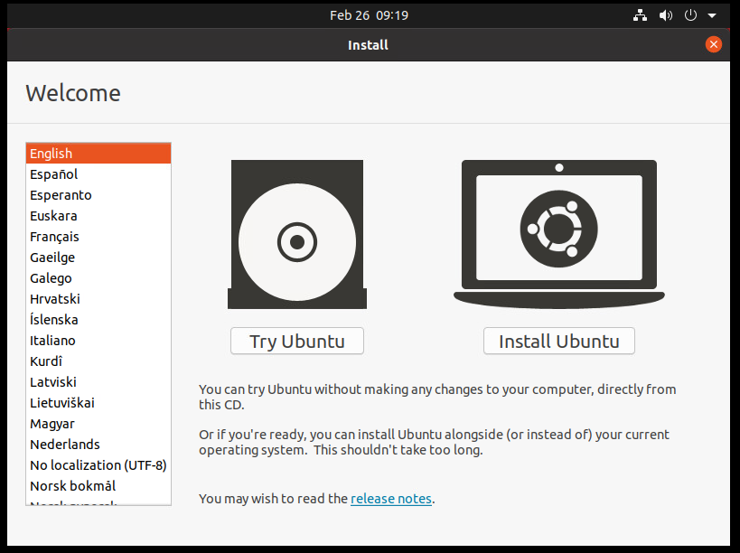

*Figure 3: Landing page*

## Important:

If you click “Try Ubuntu” you can play around in a temporary environment which will be purged from existence upon restarting the computer. If you do not want to have a persistent Ubuntu version, this option is fine, and the guide effectively ends here.

If you wish to create a more permanent Ubuntu environment, click on Install Ubuntu, where it will prompt you for what type of keyboard and language you are using, upon selection, you will next be prompted with an update page.

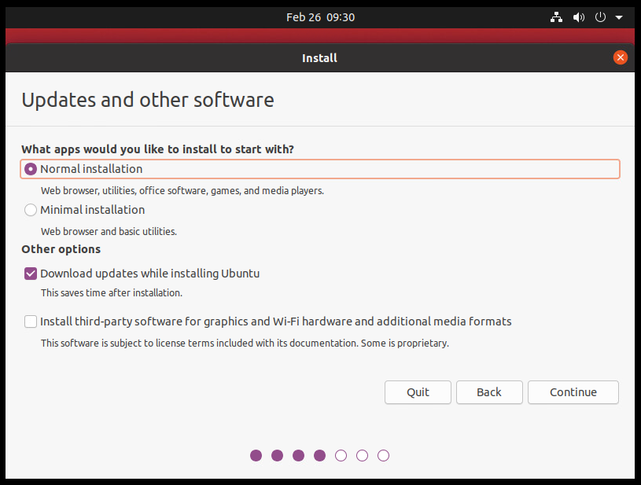

If you wish for an environment most like Windows, “Normal Installation” would be the option you should pick. Minimal installation installs only core functions and the default web browser. Depending on your hardware, you may also want to select to install third party software for additional drivers for the system, however this can be done later as well.

WARNING

The following screen can possibly ERASE all existing data on your computer proceed with caution!

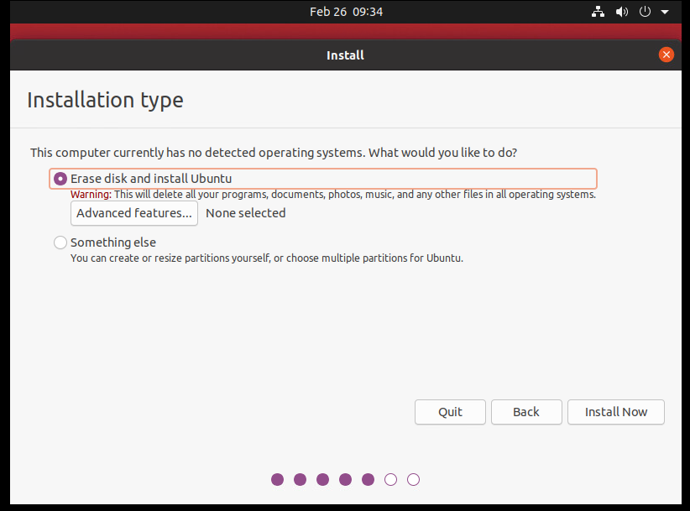

The first option does a full wipe of your entire computer’s storage and installs just Ubuntu in its place. It is not recommended to do this if this is your first-time using Linux, as it can be frustrating and needing to go back to Windows for some things may be necessary in the future. Instead, you should select “Something Else” then click continue. This screen will show you your current disk’s partitions and how much free space it has so you can reallocate some of it for Ubuntu to sit within. Anything around 20 to 30 GB of storage should be sufficient, however this comes down to your jurisdiction how much you wish to allocate. This can be adjusted in the future, however not as easily.

//TODO ADD PIC

It will then prompt for what time zone you are in to set the system clock correctly. Following that screen, it will ask you for some account-building information.

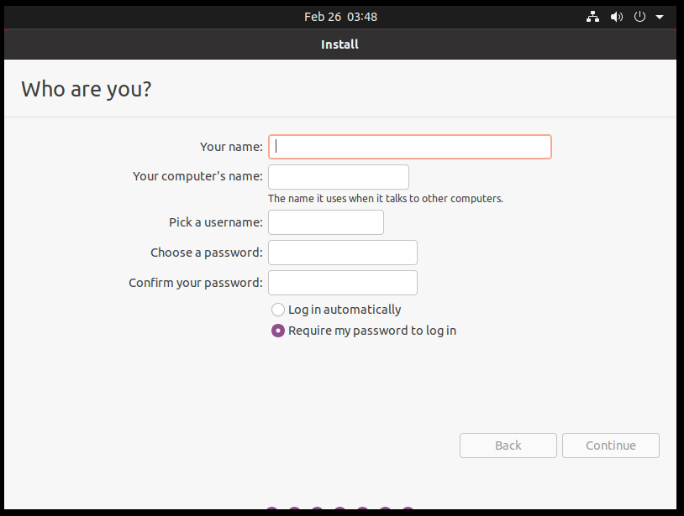

Finally, it will begin to set up your new desktop environment. This process can take a few minutes.

Upon successful setup, Ubuntu will prompt for a system restart, before accepting the prompt to do so, remove the flash drive plugged into the computer in step 2.

# 4. Welcome Back to Ubuntu- The Second Boot

Upon restarting the device and login using the account created at the end of step 3, You will next be welcomed with a prompt asking if you would like to link some other accounts to the device, however these are non-vital and can skipped or done at another time if desired, if you wish to skip, the button for such is in the top right.

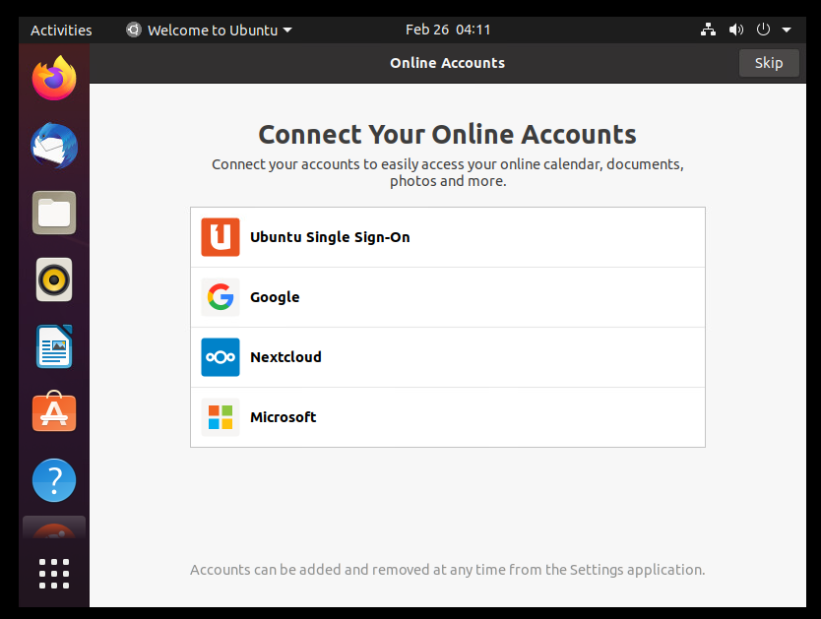

The following screen prompts you about Ubuntu’s Livepatch service, this automatically applies security updates without requiring system restarts allowing continuous work during updates without breaking workflow. To enable it you must create an Ubuntu Account, however these are not critical and can be done manually, thus we shall skip Livepatch. We will cover how to manually do such shortly. Sending data to Ubuntu is optional and can be skipped along with locational services. Finally, it asks about software you would like to install at this time and will open an application most like an App Store from other devices. Finally, it will ask once more for system update information asking for a download, it is recommended to do so as it provides security updates. Upon completion it will once again ask for a restart and doing so will allow the updates to be applied.

Next, we will be making sure everything has updated nicely, if you click on the 3x3 grid in the bottom left of the screen, it will show all applications installed.

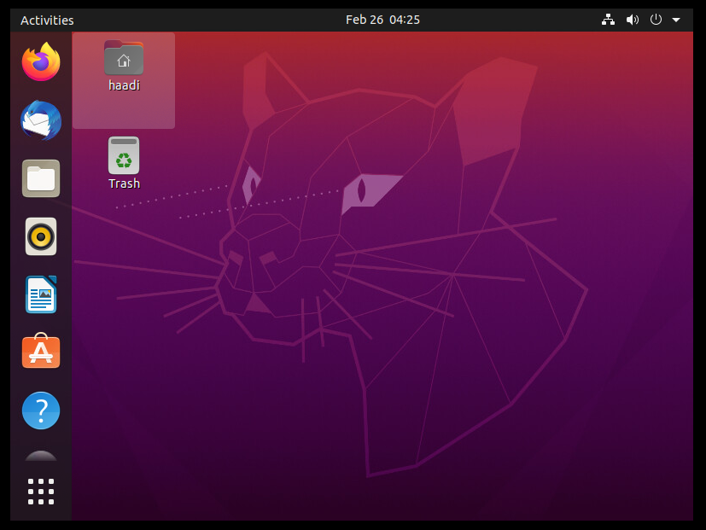

From there, you want to search for “Terminal” and open that application, you should be welcomed to a blank looking window: 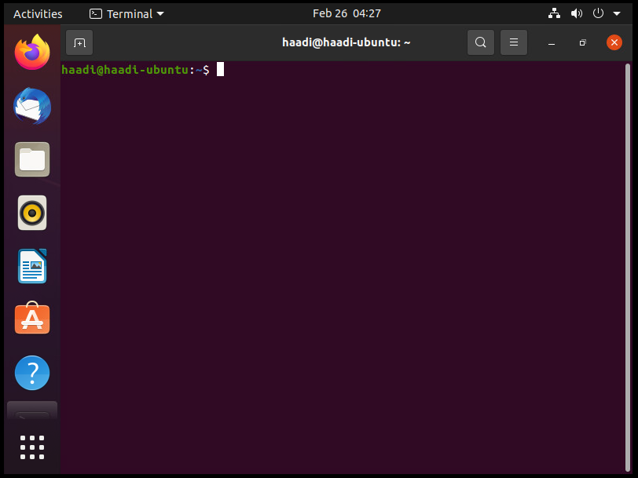

Terminals were what preceded GUIs and you can enter commands straight here for the computer to process. The commands we want to run are the following in order, one after another. You can either copy paste these in or type them in, once in the terminal, hit enter to run the command.



The term “sudo” means Super User DO (pronounced sue doe) and is the equivalent of running something as administrator in Windows. Upon running a command with sudo out front, the system will normally ask you for the password for your user. 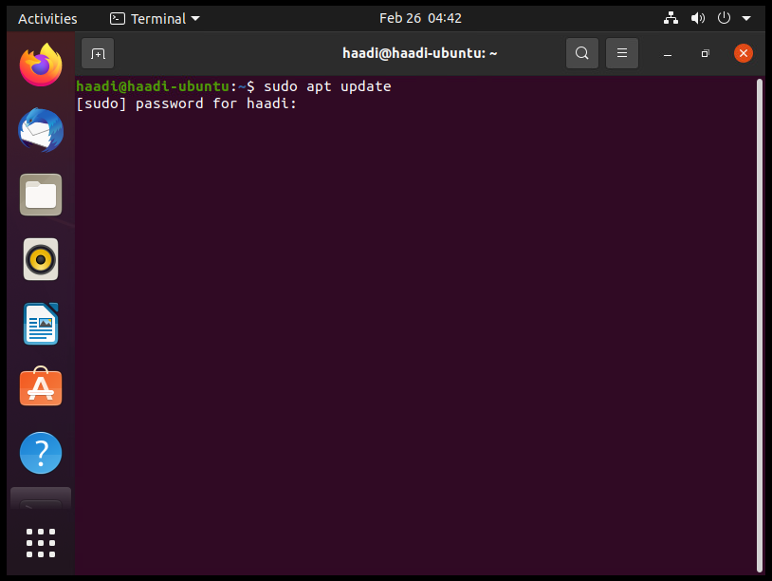

## NOTE:

This specific line will not show any input, but it DOES record it, for example, my password is fully typed out here, however for security, it does not show it nor any symbols for length of it. If you get it incorrect it will simply re-prompt for the password twice more before cancelling the command. To re-run the command, hit the up-arrow key, then enter.

In order of what each command does, “apt update” has your system connect online and check versions of files and drivers on your computer with those online and returns a list of what all can be updated. “apt full-upgrade -y” tells the system that, using the list from “apt update” to install the newer versions for the system. Finally, “apt auto-remove” just deletes old and obsolete software that was not done via the upgrade.