**Improve Dietary Accommodations for Students and Faculty at Iowa State University**

**Haadi Majeed**

**1. Introduction**

*1.1 Purpose:*

This document is intended for the administration of Iowa State Universities dining services for existing dining services on campus. The proposal is for a revamp of the current configuration of the kitchens to accommodate those with dietary restrictions in a more proper fashion.

*1.2 Background*

Iowa State University has reported that there are 31,825 students this last fall semester (Enrollment Statistics). Along with this, approximately 20% of Americans having some form of food allergy be it to nuts, gluten, or any other assortment of combinations to foods (Facts and Statistics). There are also many students who have dietary restrictions due to religious reasons and must avoid certain or all animal products, however due to either carelessness or ignorance cross contamination occurs rendering the meal unsuitable for the persons. The situation at non-dining centres is a bit different as most of them are optimised to have one or two workstations per entre type; ex: anything that needs to be grilled is done in one area, anything fried in another, etc.

*1.3 Scope*

This proposal only goes into modifying the current physical infrastructure that exists within dining’s meal preparation areas and does not account for the negligence of the workers and/or training for it. It will not be addressing the lack of meal diversity the university may have on any given day, nor the availability of such.

**2. Discussion**

***2.1 Approach***

I am proposing a change to modification in the kitchen areas that dining is equipped to work with when meal prep is occurring. In this proposal, I will address issues with the current design and/or workflow that occurs in a few of the dining facilities here on campus. With the current direction the university, Storms Dining Centre will be omitted for modifications due to current plans for its closure beginning next fall semester.

*2.1.1 Hawthorn and Clyde’s*

These two facilities are oriented around speed and static menus. They consistently have the same options regardless of the days along with some seasonal specials. The issue here is that they have little kitchen workspace to function with, so everything tends to be done in the same spot. This includes vegetarian options at both locations, and halal at Hawthorn, expected protocol would state that the workspace is cleaned when ordering the vegetarian when requested as to accommodate, and halal is automatically a clean request. The problem with this is that is causes all food production at these locations to grind to a halt, as they must stop all production for all other orders, to clean the area, make that single order, then continue. In casual hours, this is not as big of an issue as there are less people, however during the hours of 11 AM to 1 PM and again from 5 PM to 7 PM, common mealtimes, they are forced to put the special requested order on hold until others can be completed. I have experienced this first-hand on multiple occasions, waiting multiple hours to get my order, with and without using the online ordering system. I propose in this situation the purchases of two, one for each facility, Vevor’s Electric Grill (see works cited). Marked for commercial use, it is small enough to be relocated as necessary in the facility and would be left for only the special accommodations. Due to the size of the product, it would be easier to move it out of the way when not needed and easy to clean between uses. This would permit the workflow of the facility to continue just as fast as before since production would no longer need to be stopped, nor would the person ordering have to wait significantly longer.

*2.1.2 Seasons and Union Drive Community Centre*

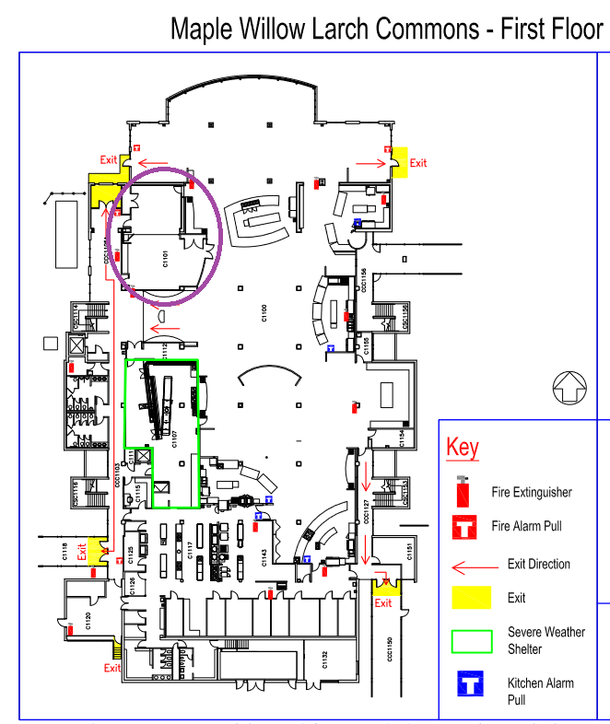 These two dining centres are the two largest on campus, in both seating and options, however they also have their share in problems. Due to the nature of some of the stations there, cross contamination is just an expected occurrence, as the process has the employee putting the proteins onto the sandwich first, then proceeds with the same gloves to reach into the other toppings’ containers. The issue arises if somebody wishes to avoid animal-based proteins for whatever reason, but all other components are already contaminated, then it becomes invalidated either way. The proposed solution to this problem would be a simple re-arrangement of the ordering of the service, with the proteins being put on last and a glove change between every order. Additionally, a feature that UDCC has is the special dietary kitchen for those people who have extremely inhibiting allergies and allows for a sterile place for them to get and eat food. Seasons should also adopt this idea, and this could be easily achieved by reallocating part of the Harvest Room and some renovations to transform it into such a facility.

*Floor plan of Seasons Dining Centre and the proposed effected area to transform into a critical allergy room. Reallocating the north half for such.*

(Building Information)

*2.2 Result*

These changes to the current infrastructure would remove very little from the current setup, with the largest change being in Season’s current Harvest Room losing 2 tables (12 seats) for the critical allergen room. Considering these modifications, people who have allergies or other dietary restrictions can be served food with ease of mind. It would also improve time performance for facilities that have to come to a stop to clean when a special request comes in.

**3. Resources**

*3.1 Personnel*

Iowa State University’s Facilities and Planning Management (FP&M) would be directly involved along with the university’s Dining team to properly coordinate what needs to be completed. FP&M has previously worked on projects similar during the Hub’s rework and other facility upgrades involving dining services.

*3.2 Fiscal*

I have identified the following resources satisfactory to complete the project. While I cannot identify everything needed for a renovation in the Harvest Room, I can attempt to plan out roughly what all is needed for the task. The following prices come from Vevor’s official website and Amazon.com:

* Electric Grill Grooved and Flat Top Grill Combo 30-inch Commercial Griddle Grill
  + $224.99 USD each
  + Quick to clean and store/deploy as needed
  + Large enough for multiple similar orders
  + Small enough for countertop use
  + One for Hawthorn, one for Clyde’s
* Commercial grade kitchen equipment
  + Stovetop ~ $3000 USD
  + Work surface & Sink ~ $1000 USD
  + Fridge & Freezer ~ $1500 USD
  + Estimated total: ~ $5500 USD
* Commercial grade hypoallergenic disposable gloves3
  + ~ $10 USD / 1000 Units
* Commercial Vinyl Tile
  + ~ $45 Sq. ft. sterile tiles
* Commercial fire extinguisher
  + ~ $50 USD

*3.3 Timing and Scheduling*

The Clyde’s and Hawthorn modifications could be completed as soon as the order for the grills has arrived and a space allocated for storage and usage is designated, allowing for a very quick turnaround for the two and an immediate and noticeable change for those involved and affected. The change for Seasons and UDCC’s sandwich bar is also immediate, just requiring the station to change the order of process and more frequent glove changes at the station. Finally, the renovation within Seasons for a Critical Allergy room would be a longer project, however, should be able to be completed during the summer months when the facility is closed. Minimal infrastructure changes would be necessary, with the largest one being a connection to the water systems for a sink, and redoing the flooring to no longer be carpet, but a sterile tile for kitchen use. I believe that the price of the renovation is appropriate and can be done with relative ease, as the commercial grade kitchen equipment alone is just over half of a single student’s in-state tuition.

*3.4 Gantt Chart of Project*

|  |  |  |  |  |  |
| --- | --- | --- | --- | --- | --- |
| Tasks | Week 1 | Week 2 | Week 3 | Week 4 | Week 5+ |
| Ordering Grills |  |  |  |  |  |
| Installing Grills |  |  |  |  |  |
| Change sandwich bars |  |  |  |  |  |
| Order Renovation Materials |  |  |  |  |  |
| Renovations |  |  |  |  |  |

**4. Conclusion**

*4.1 Summary*

The proposed modifications to the current infrastructure set up within ISU’s dining services will allow for people who have allergies, religious reasons, or anything else, and to have a better experience when using a service they pay for. These new modifications will also allow workflow to progress at a constant rate without having to stop for every special request, nor will the person trying to get food have to wait longer than anyone else as a clean environment will be ready almost instantly for them.

*4.2 Contact*

For more information, please contact Haadi Majeed via email at hmajeed@iastate.edu.

Works Cited

“Building Information.” *Iowa State University Building Information*, www.fpm.iastate.edu/maps/buildings/.

“Enrollment Statistics.” *Enrollment Statistics | The Office of the Registrar | Iowa State University*, 2021, www.registrar.iastate.edu/resources/enrollment-statistics.

“Facts and Statistics.” *Food Allergy Research & Education*, 2021, www.foodallergy.org/resources/facts-and-statistics.