Create a new project in MyCSC portal
  - Log in to the CSC environment, https://my.csc.fi/.
  - Navigate to the Projects tab in MyCSC portal management view and click + New Project.
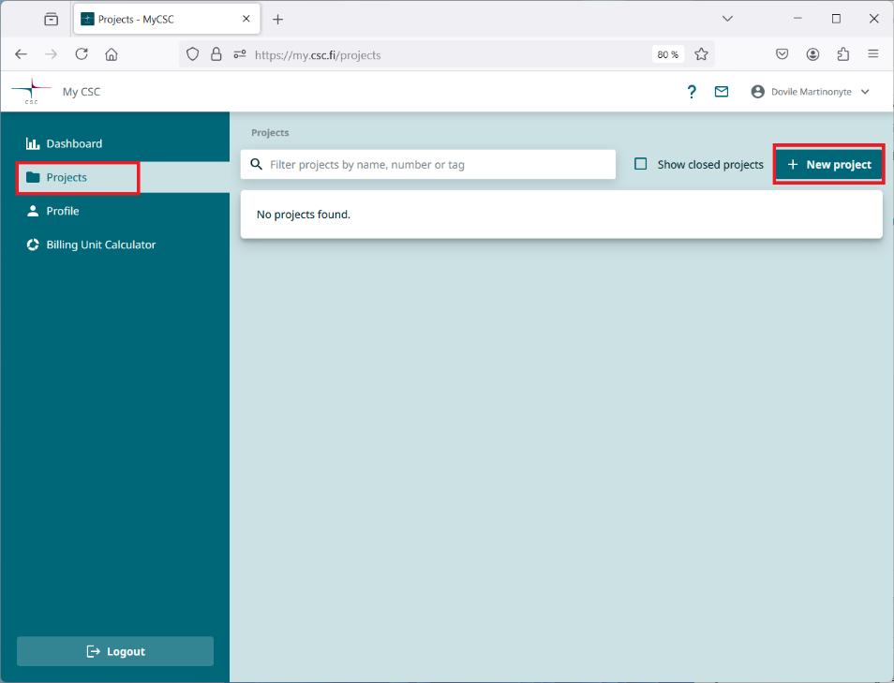
  - Enter the required project details:
- Project name and description
- Course end date: can be at most six months from the creation date.
- Project resources:
  - Primary science area: Engineering and technology
  - Secondary science area: Other engineering and technologies
- Review the Terms of Use and READ CAREFULLY documentation about CSC services for students
Click the Create Project button.
* A course project is single-use. It cannot be extended, copied, or allocated additional resources. The default resource allocation for the project is 100 000 BU (billing units).
* The project and all its resources will be automatically deleted after the end date.
Note: Personal data must not be stored in course project services.

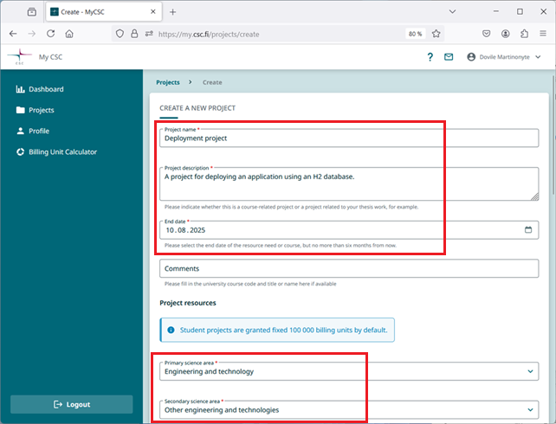

  - Add services to your project. In this course, you will need the Rahti service from CSC’s offerings. You will also need the project number later for the actual application deployment.
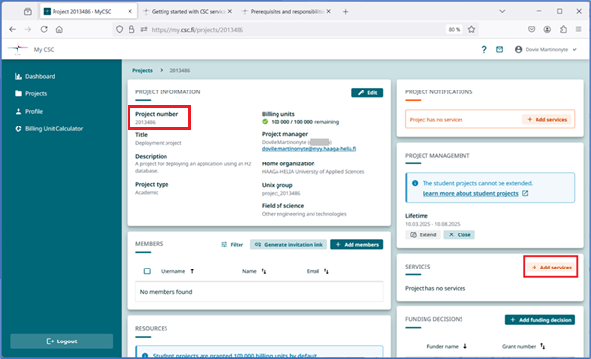

  - Click on the + Add services button. A new view with services listed will appear.
Select Rahti, accept the terms of use for the Rahti and click Add selected services button.
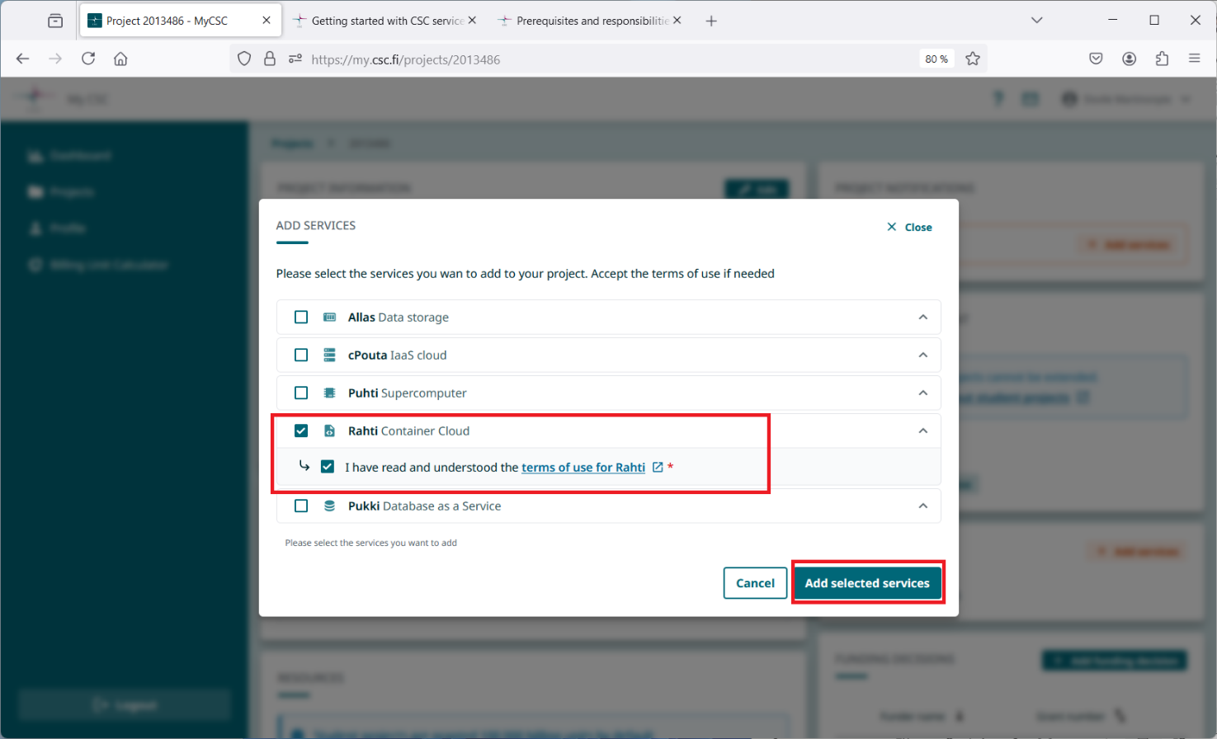

  - In the Services card, you will now see Rahti Container Cloud service. Log in to the Rahti service by clicking the Login button.
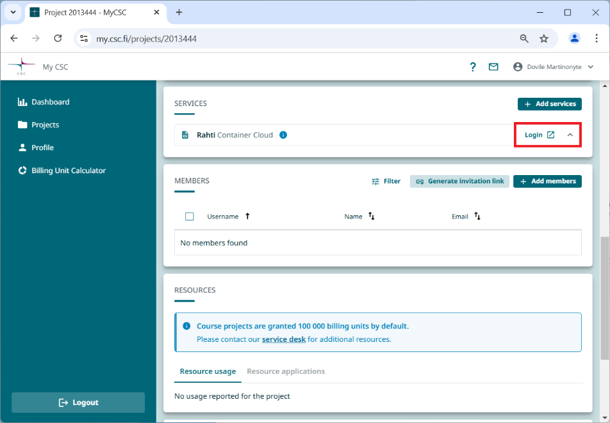

A new tab https://rahti.csc.fi/ will open in your browser. Click the Login button.
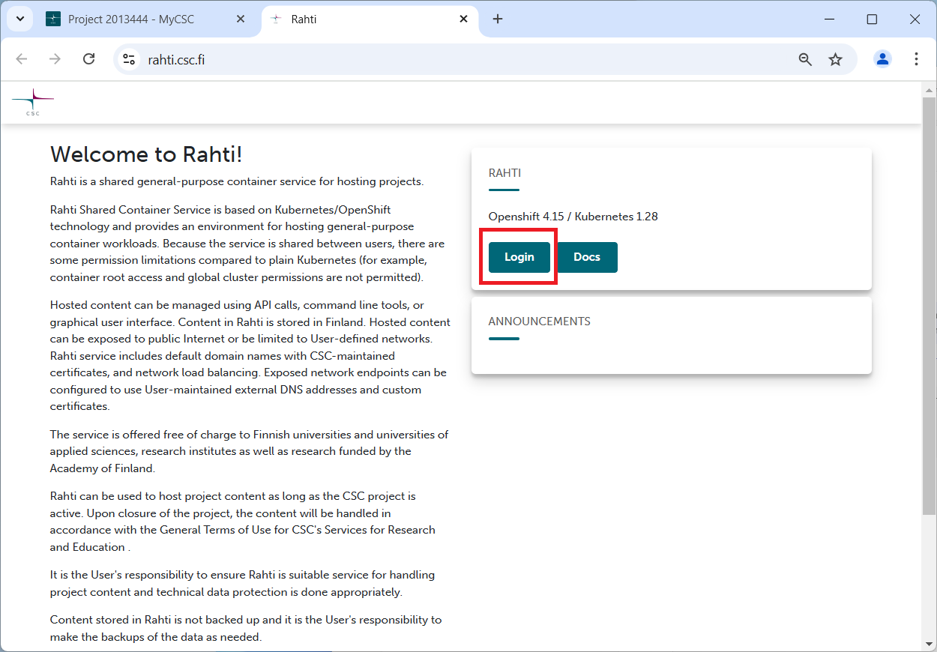
Click Login and sign in using your CSC or Haka credentials.
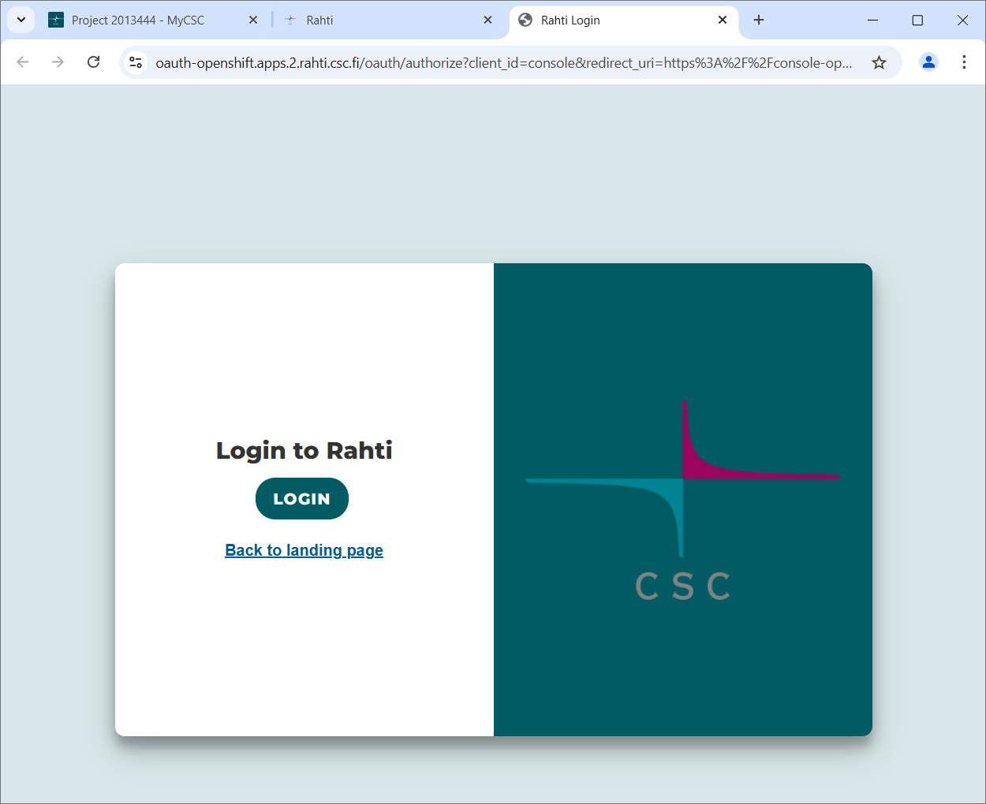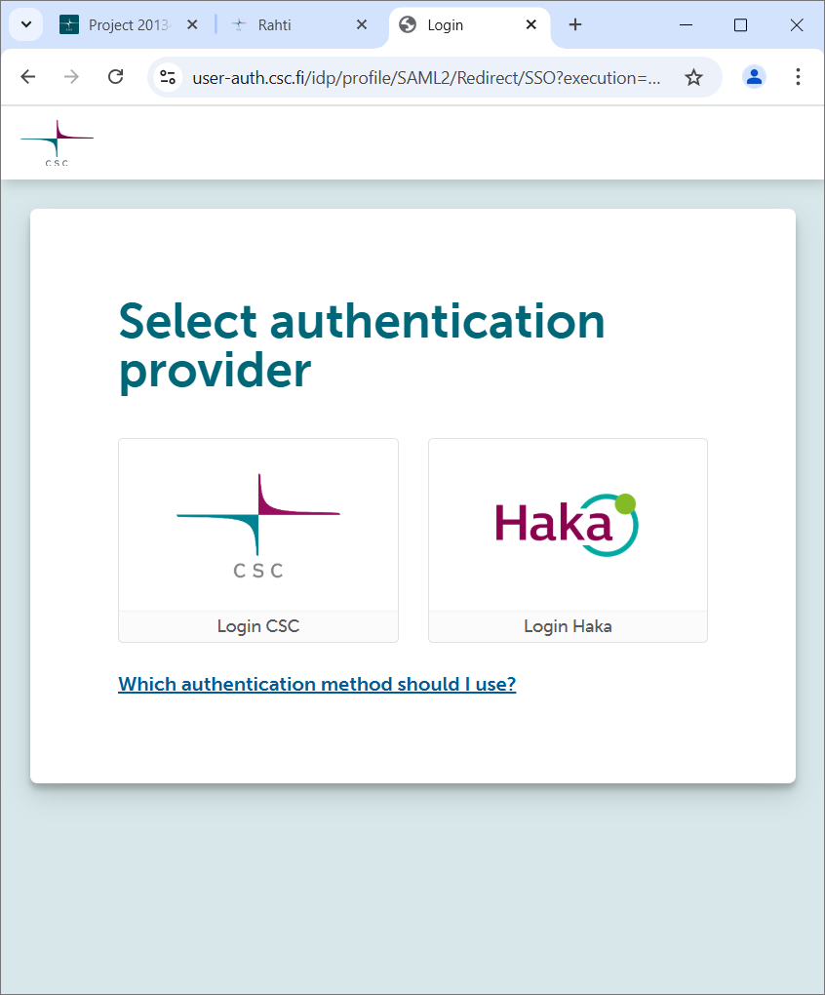

Note: if you have registered to my.csc.fi just before following these instructions, it may take some time for your account to activate, so you might see an error message: “Could not find user”. Try going back to the Rahti service login step after a while.
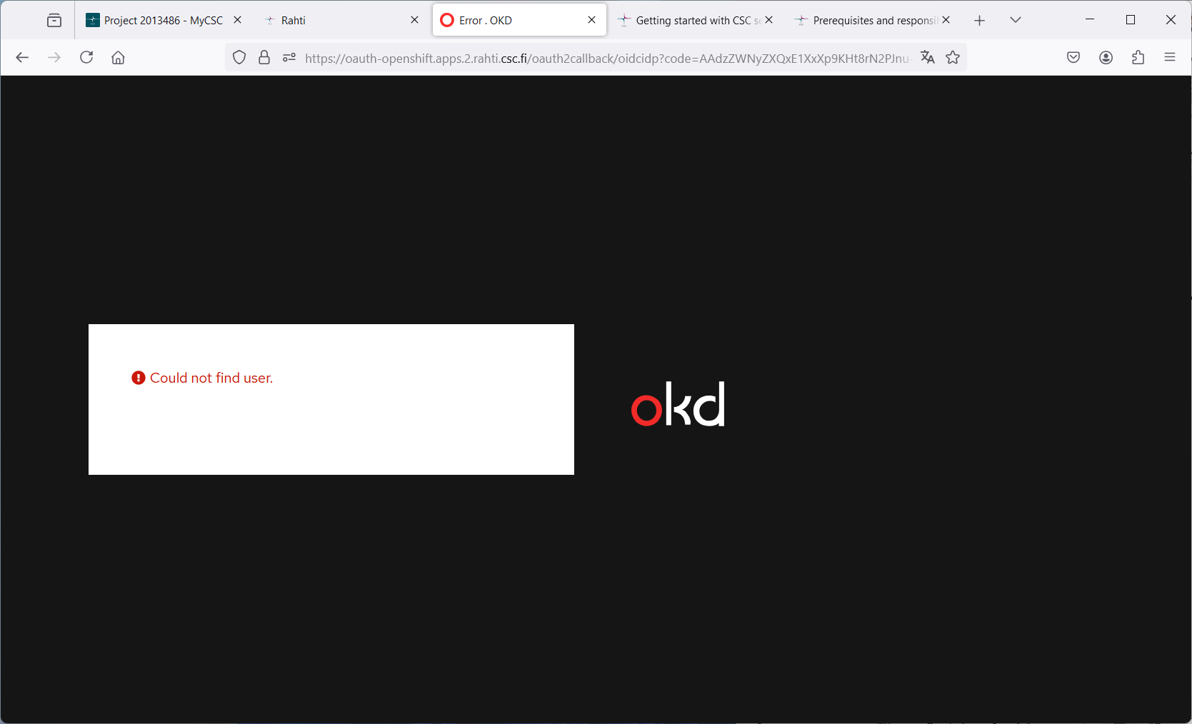

Once your login is successful, you can get started with a tour to improve your workflow or skip it.

Deploy a Spring Boot Application with an H2 database on Rahti

Prepare your Spring Boot Application
    - Create a new file in the root directory of your Spring Boot application and name it Dockerfile (without a file extension).
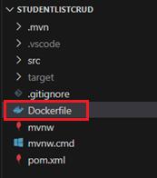
    - Copy the following content into the Dockerfile (this can also be found in the course’s Moodle page):
FROM eclipse-temurin:17-jdk-focal as builder
WORKDIR /opt/app
COPY .mvn/ .mvn
COPY mvnw pom.xml ./
RUN chmod +x ./mvnw
RUN ./mvnw dependency:go-offline
COPY ./src ./src
RUN ./mvnw clean install -DskipTests
RUN find ./target -type f -name '*.jar' -exec cp {} /opt/app/app.jar \; -quit
FROM eclipse-temurin:17-jre-alpine
COPY --from=builder /opt/app/*.jar /opt/app/
EXPOSE 8080
ENTRYPOINT ["java", "-jar", "/opt/app/app.jar"]

    - Push your updated application to GitHub.
Note: These instructions assume you GitHub repository is public. (If needed, you can make it public temporarily during deployment and switch it back to private later.)
Private repositories can also be used, but this document does not cover that method.

Spring Boot application deployment
- Navigate to the top left menu. Choose your role Administrator Home Projects.
The deployment is done by creating a new project in the Rahti service, click the Create Project button.
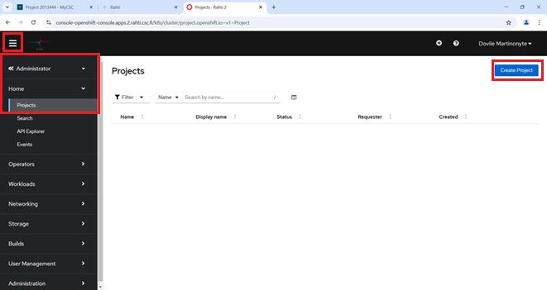
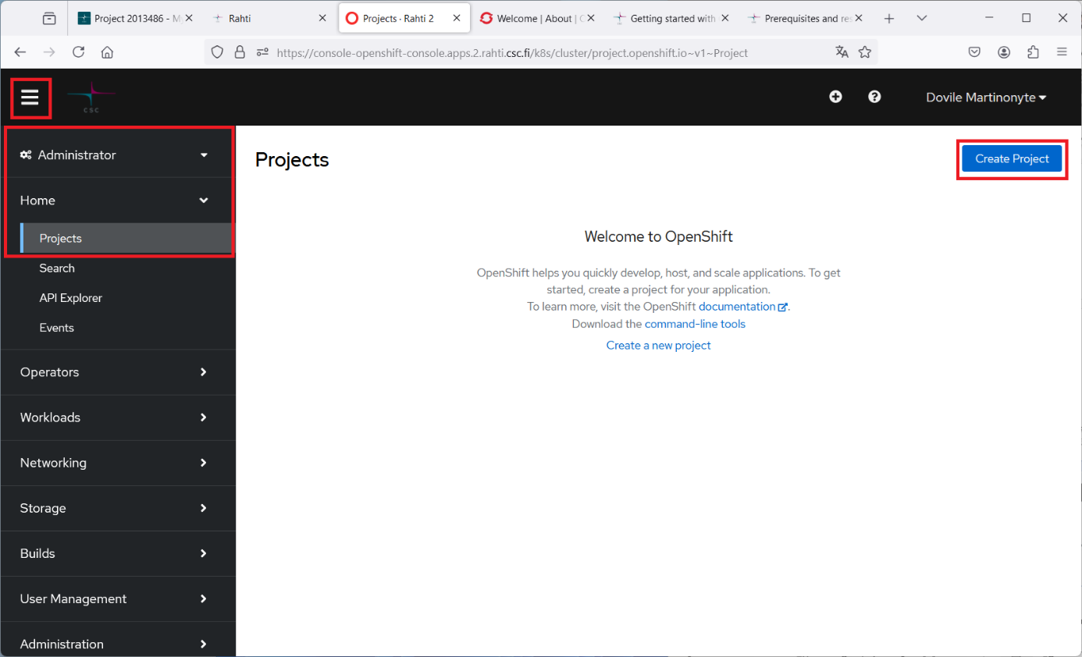
- Enter the required details. Name must be unique and it is case sensitive.
Click Create button.
Note: To successfully create the project, you must enter the CSC project number (e.g. csc_project:<project number>) in the Description field.
If you don’t know project number, see step 1.4.
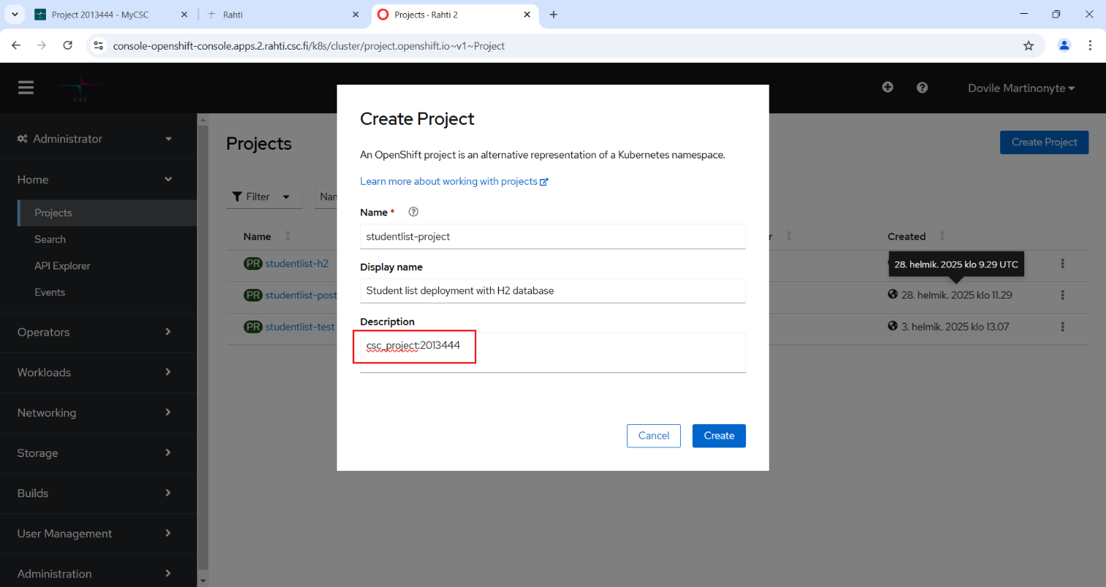

- Now you can deploy your Spring Boot application inside the newly created project in the Rahti service. Navigate to Developer mode. If your project name is not visible, select it from the Project drop-down menu.
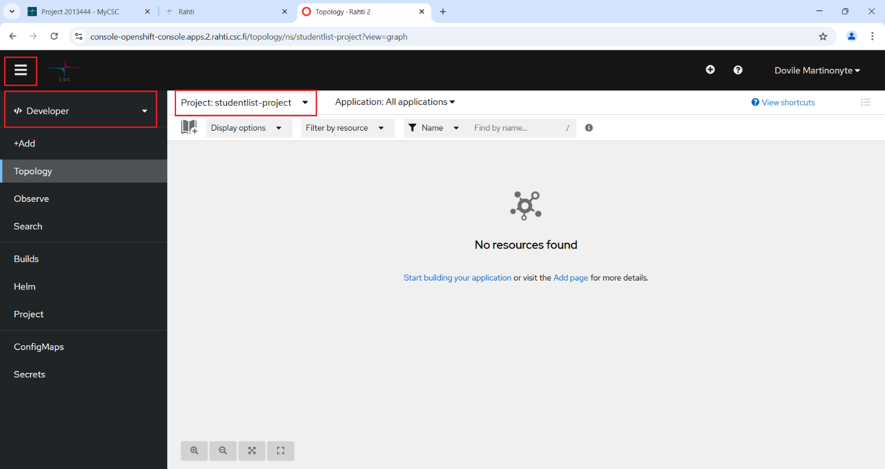
- Click +Add and from the available resources select Git Repository Import from Git.
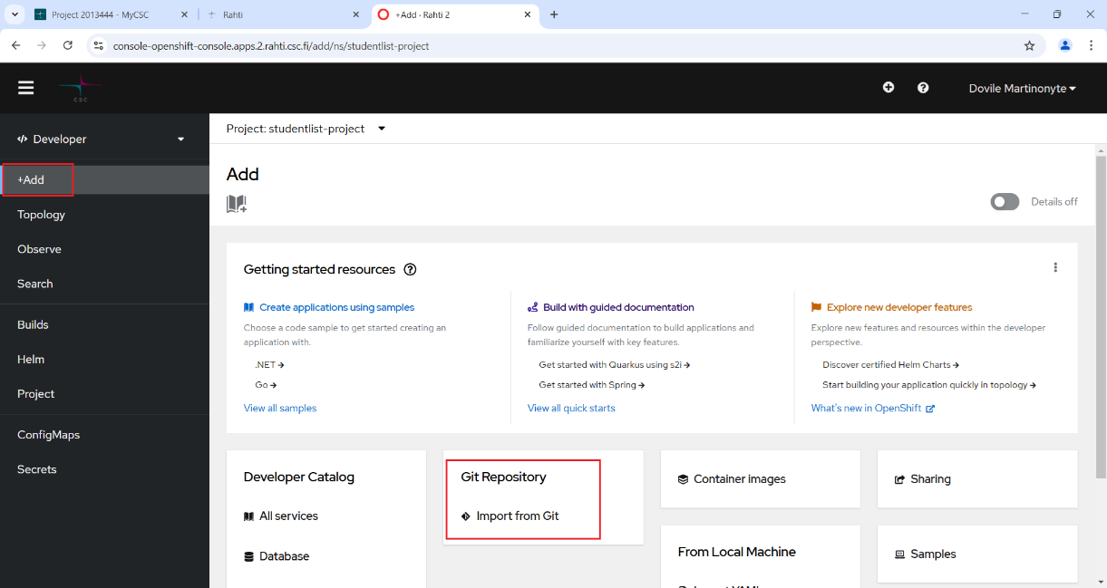

- Fill in the Import from Git form by entering the Git Repo URL.
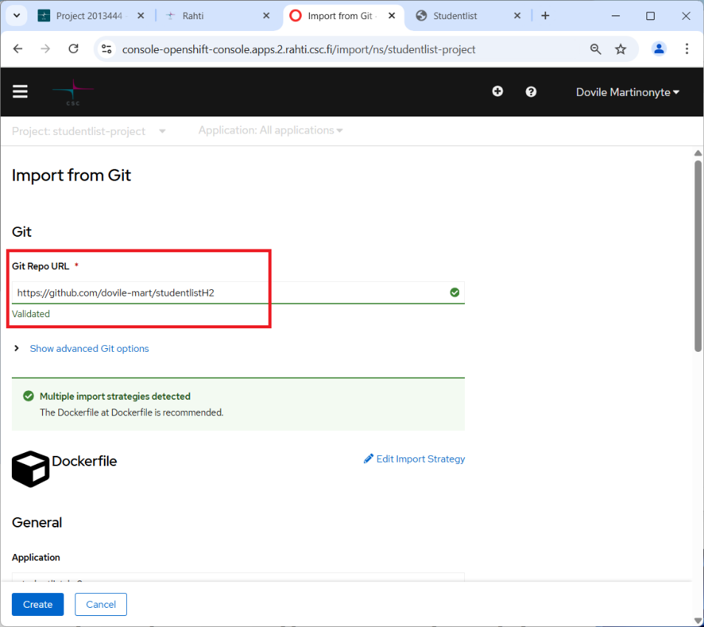
If your repository contains multiple projects, open Advanced Git options and specify the path to the root folder in the Content dir field:
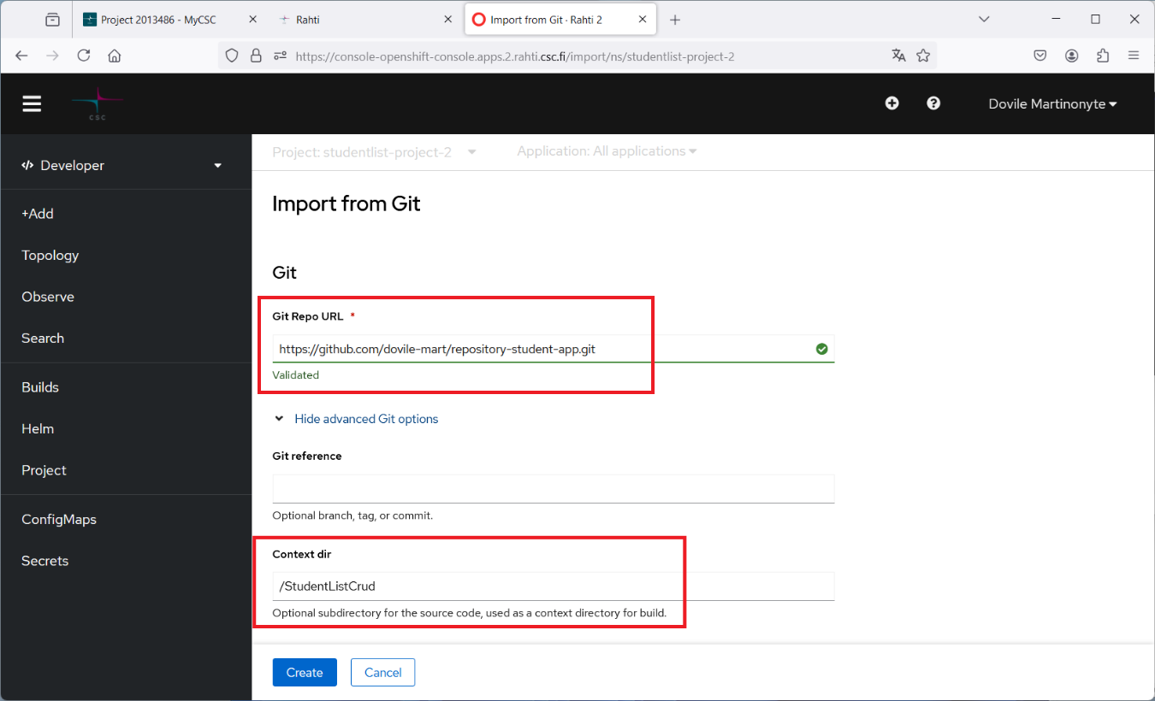
A name for your application component in Name field is be generated automatically but you can also create your own unique name. This component will be used to name associated resources.
Then click the Create button.
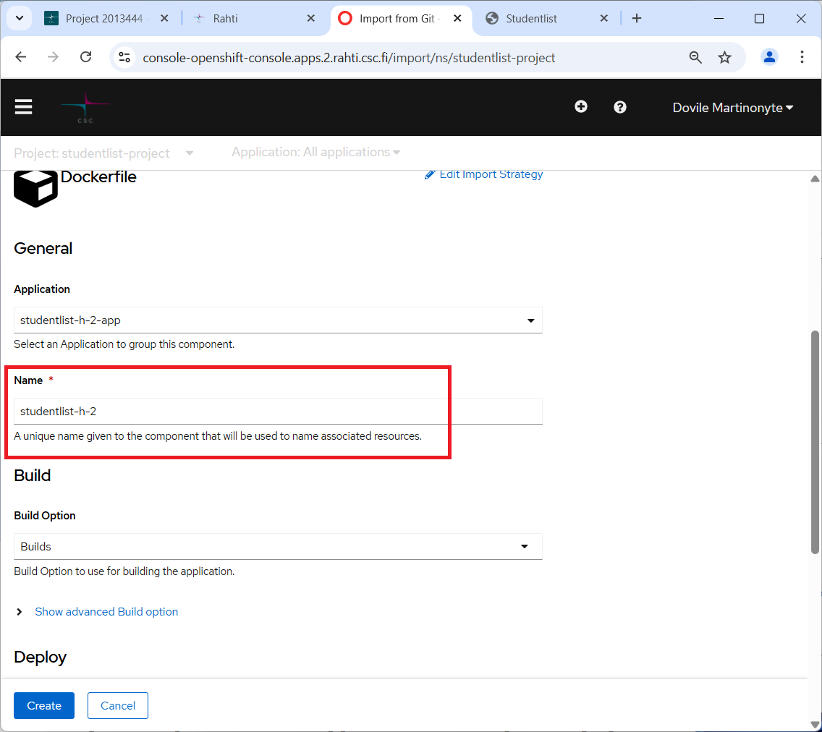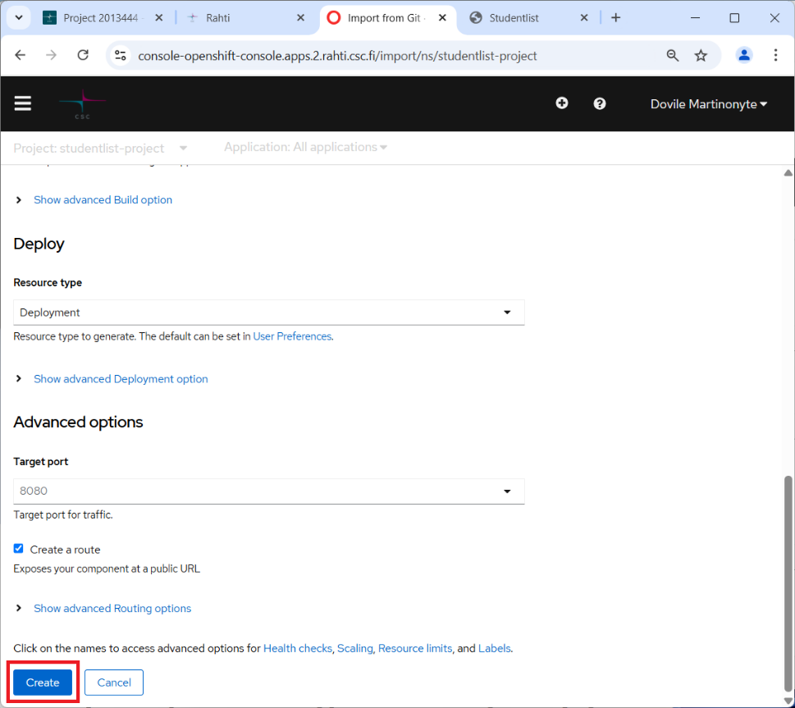
- The build process will start and may take a few minutes. You can find application component under Developer mode Topology view:
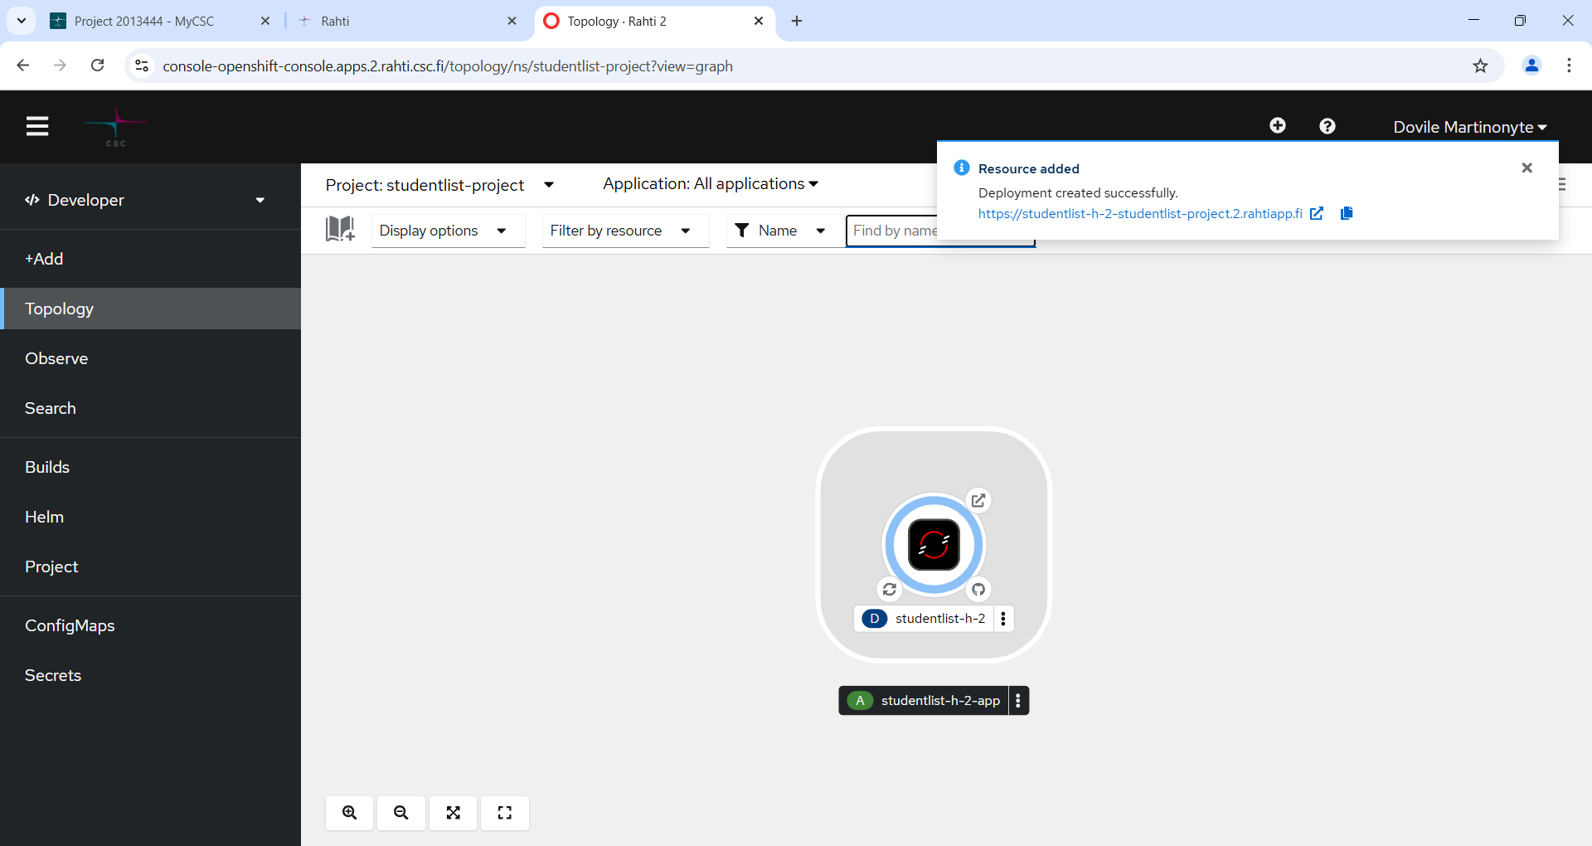
- Follow the build progress in the Developer mode Builds view.
While application is being built, its status will be Running.
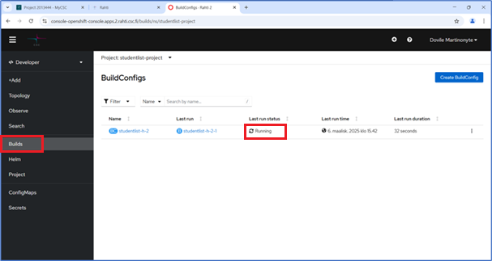
- Once the build is complete, the status will change to Complete.
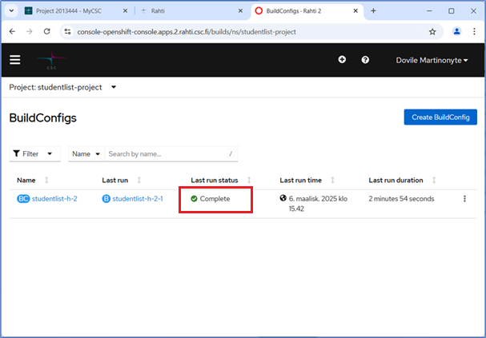
- You can find your application’s URL, by navigating to the Topology view selecting the component when the sidebar on the right opens, navigate to the Resources tab the application’s URL will be under Routes. Click the link, and the application will open in your web browser.
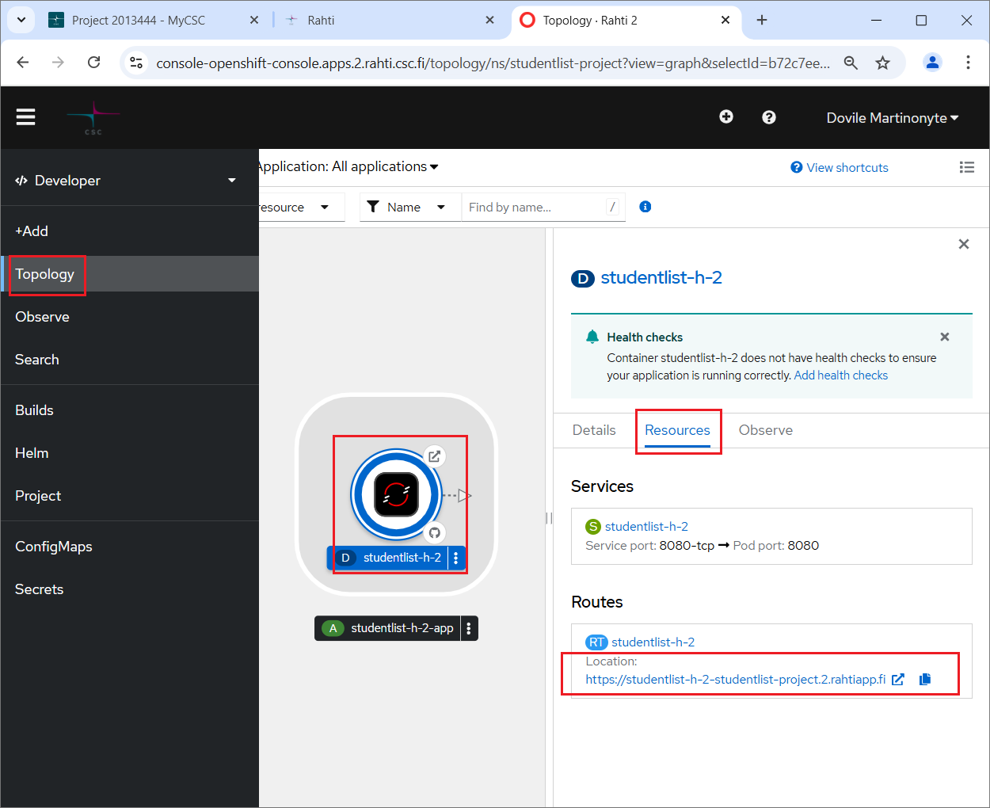
- Congratulations, your application is deployed!
