Deployment: Spring Boot application with Postgresql database

Configuring Java + Maven + Spring project for deployment
Add PostgreSQL driver as dependency in your project’s pom.xml. Copy and paste the below snippet, place it as a child element of <dependencies> element.

<dependency>
<groupId>org.postgresql</groupId>
<artifactId>postgresql</artifactId>
<scope>runtime</scope>
</dependency>

Create a file named Dockerfile (no file extension) in your coding project’s root. Content of the Dockerfile for a Java + Maven project is (use Copy + Paste):

FROM eclipse-temurin:17-jdk-focal as builder
WORKDIR /opt/app
COPY .mvn/ .mvn
COPY mvnw pom.xml ./
RUN chmod +x ./mvnw
RUN ./mvnw dependency:go-offline
COPY ./src ./src
RUN ./mvnw clean install -DskipTests
RUN find ./target -type f -name '*.jar' -exec cp {} /opt/app/app.jar \; -quit
FROM eclipse-temurin:17-jre-alpine
COPY --from=builder /opt/app/*.jar /opt/app/
EXPOSE 8080
ENTRYPOINT ["java", "-jar", "/opt/app/app.jar" ]

The above content is a generalized Dockerfile configuration and can be used for other Spring Boot projects.

Create a new deployment profile for your application. You need to create a new file in the
<your app>/src/main/resources/ directory.

Name the new file application-rahti.properties.

Content of the application-rahti.properties is (use Copy + Paste):

spring.datasource.url=jdbc:postgresql://${POSTGRESQL_SERVICE_HOST}:${POSTGRESQL_SERVICE_PORT}/${DB_NAME}
spring.datasource.username=${DB_USER}
spring.datasource.password=${DB_PASSWORD}
spring.jpa.show-sql=true
spring.jpa.generate-ddl=true
spring.jpa.hibernate.ddl-auto=update

Commit the above changes and push them to your GitHub repository.

Creating a project in CSC
NOTE! If you already have created a project in CSC, you are unable to create another one. In that case proceed to chapter 3 of these instructions.

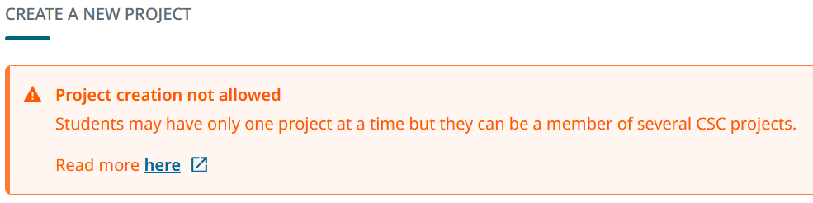

Login to CSC at https://my.csc.fi/login using you Haka user account (Haaga-Helia credentials) or your CSC user account (username sent to your email). Navigate to Projects view and start creating a new project.

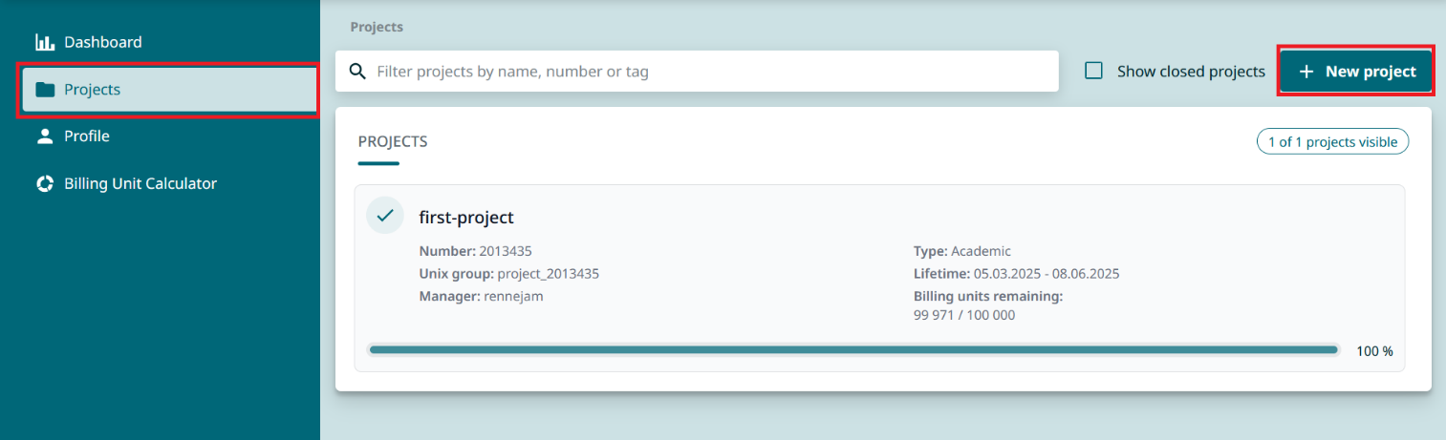

Fill in your project’s information as instructed in the form. Read and accept all terms of use and privacy notice. Choose Create project to continue.

You have now created your CSC project. Within this project you can start adding CSC’s services. For your deployment you only need Rahti – Container Cloud. Click Add services and select Rahti.

NOTE: check your project number. You will need it later!

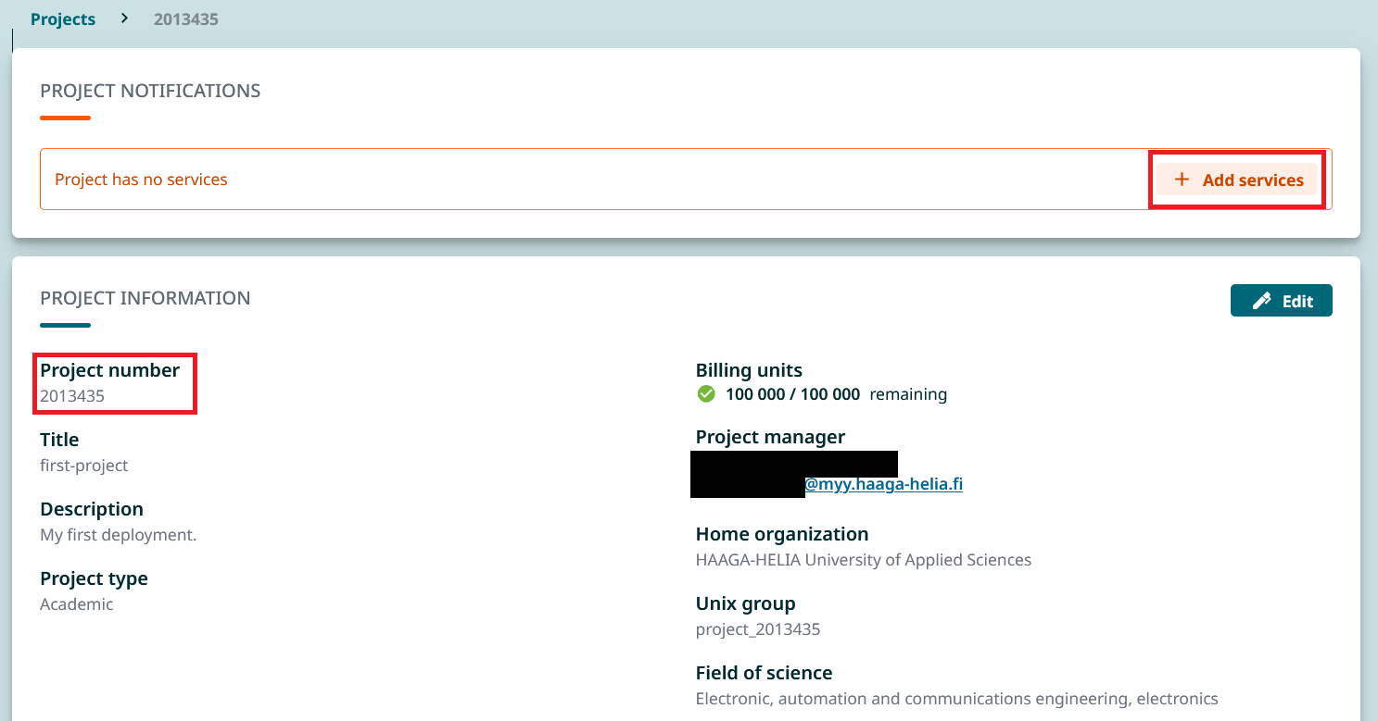

Once you have added the Rahti service you might have to wait up to 60 mins for you to gain access after activation. So be patient!

Creating a project in Rahti
After you have gained access to Rahti service, you can login to Rahti at your CSC project’s Projects view. Choose your (only) project and scroll down to Services. Clicking Login will take you to Rahti landing page.

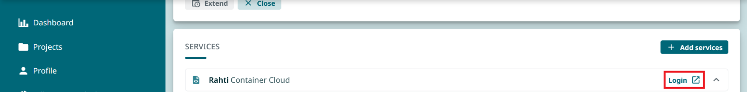

Proceed the login process, you need to click Login buttons a few times in different pages. Use either Haka or CSC as your authentication method when prompted.

Successfully logging in directs you to Rahti console. When starting the console for the first time take the site’s tour showing important navigation options. After the tour you are ready to create your Rahti project.

Click the Project: All projects dropdown menu and choose Create Project or click the text Create a Project. If you don’t have these options visible in your page, make sure you are in Developer view (marked with yellow).

NOTE! You can have more than one Rahti projects in one CSC Project.

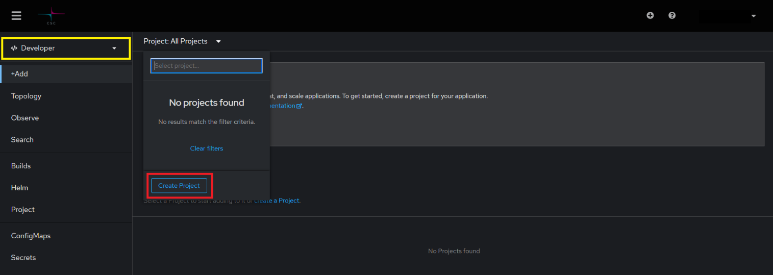

Give your project a name and a display name. In the description write csc_project:<your CSC project number>. You will find your CSC project number in your CSC Project’s Project information view. Proceed by clicking Create.

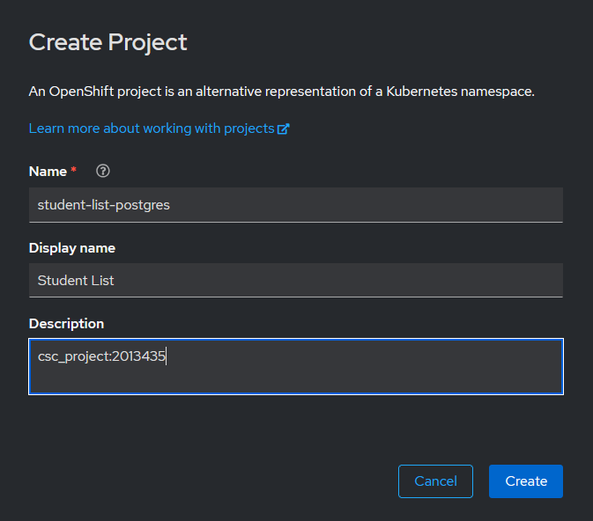

Creating a Postgresql database instance
After creating a project in Rahti it’s time to create a new database instance for your application.

In Developer view, go to +Add page and start creating a database for your project. Choose PostgreSQL. Make sure you don’t select the Ephemeral version! Click Instantiate Template to continue the process.

You can leave all the default values in the form where you create your database. Leaving PostgreSQL Connection Username and Password empty will make the system generate random credentials for you. This is fine within the scope of Haaga-Helia UAS course work.

If you want to specify PostgreSQL Connection Username and Password, don’t use weak a password! Always use strong passwords even when practicing!

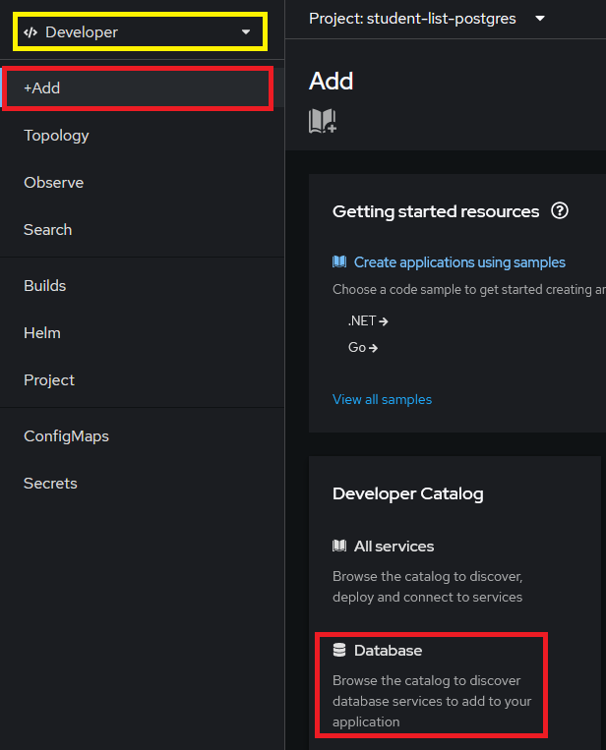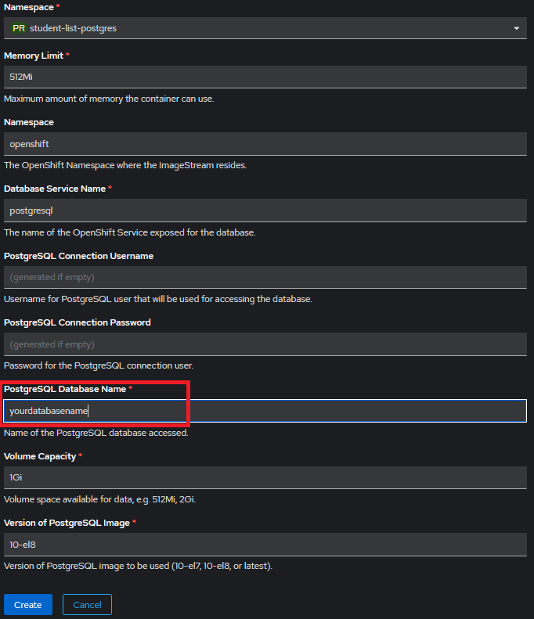

Successful creation of a database will show as a new DeploymentConfig object in your Topology view.

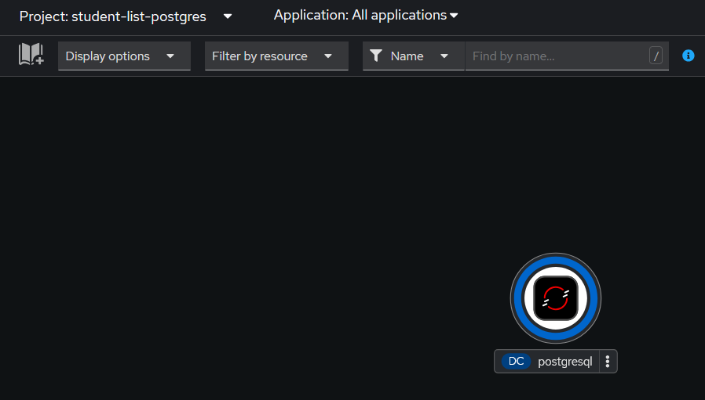

The next step is to include your SpringBoot application into your Rahti project.

Including SpringBoot application into Rahti
You will need to have your SpringBoot application in GitHub before continuing these instructions. The following instructions assume that you have set your GitHub repository Public.

In Rahti dashboard make sure you are in Developer view: go to +Add page and choose Import from Git.

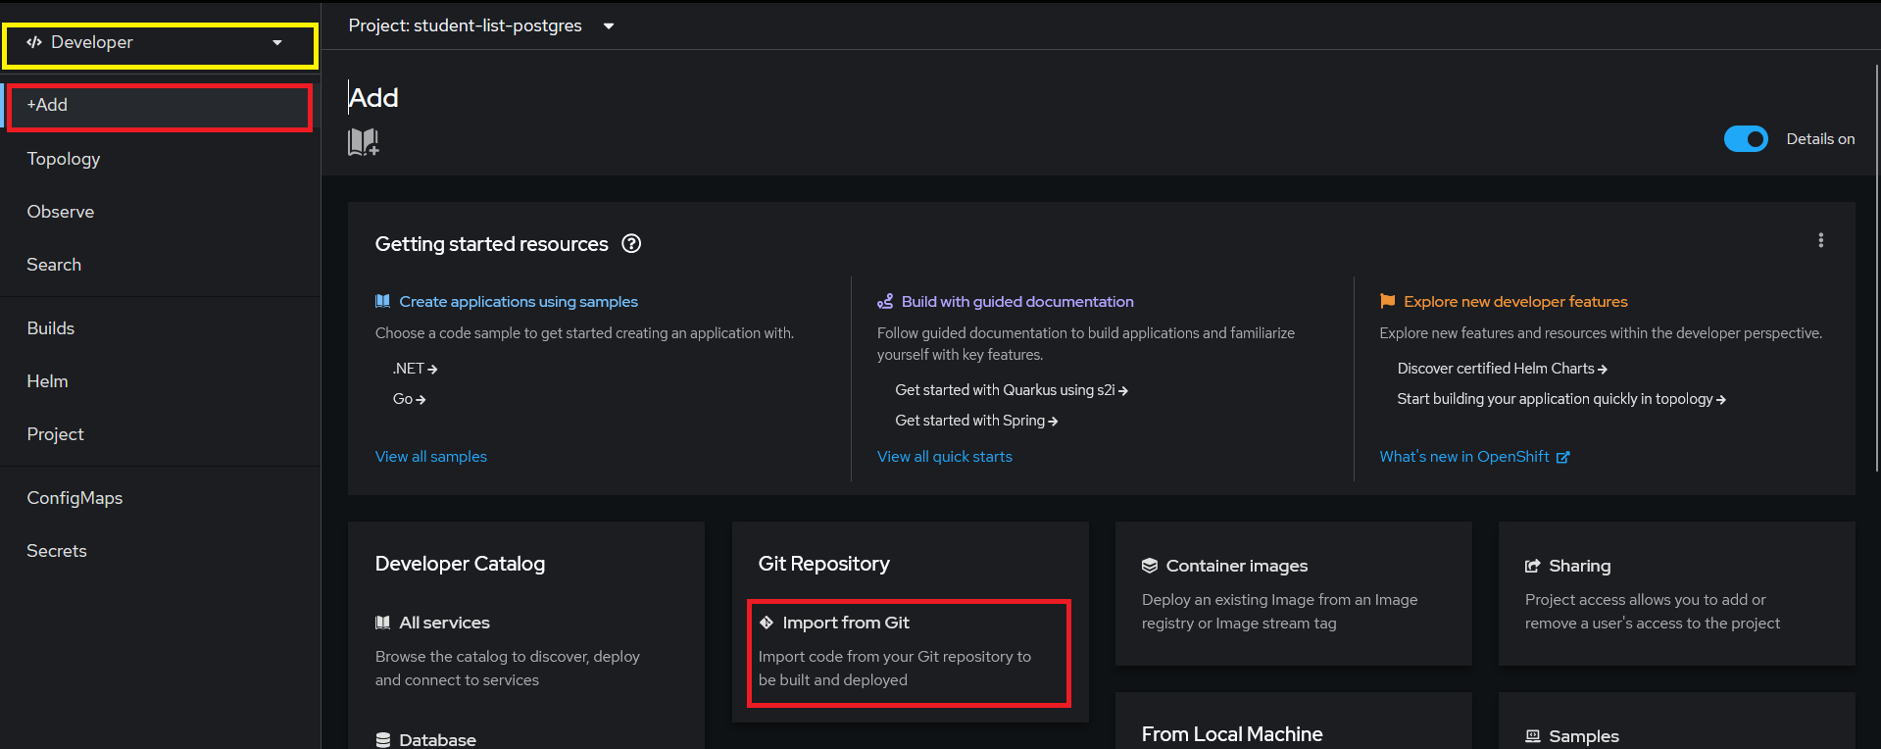

Copy and paste your GitHub repository’s URL into the corresponding form field and choose Dockerfile as your Import Strategy if it is not the suggested one. You can leave rest of the form fields to their default values. Move on to Create.

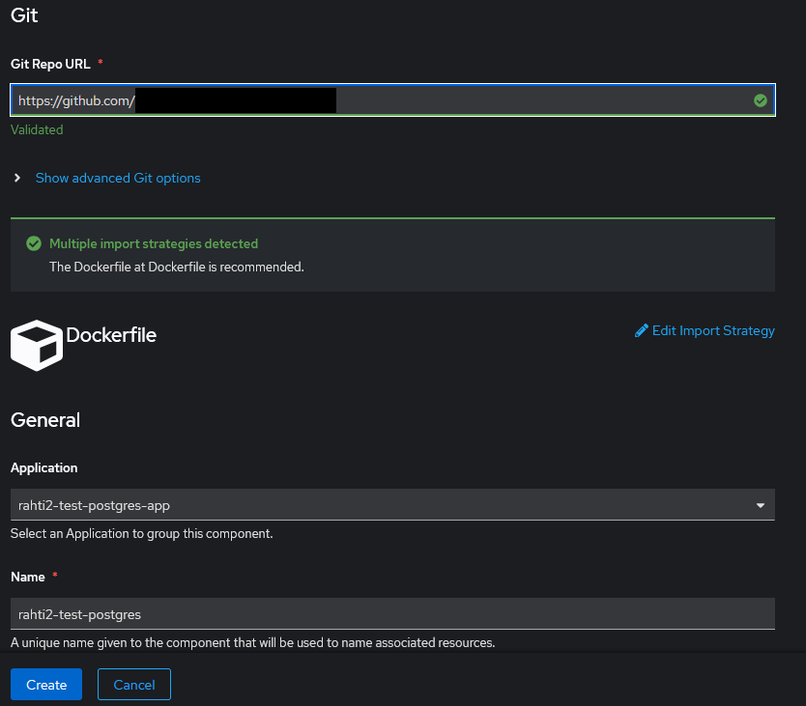

NOTE! Rahti might not detect the Dockerfile if it is not in your GitHub project’s root. In this case open Show advanced Git options under Git Repo URL form field. In Context dir form field update the value to the name of the subdirectory that contains pom.xml and Dockerfile.

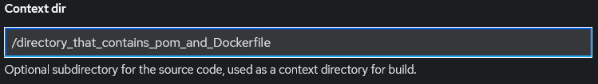

Successful creation will take you to your project’s Topology view. Click the graphical representation of your deployment to open your deployment controls.

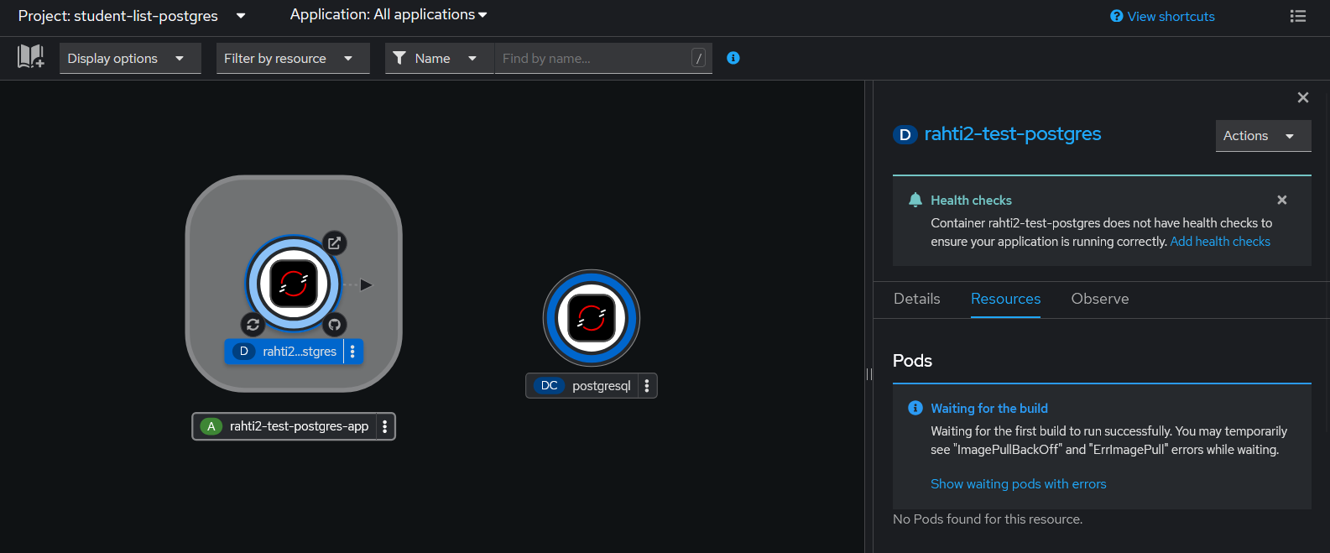

You have now deployed your application into Rahti. But it is not in working condition yet. You still need to configure the environment variables for the JDBC connection.

Configuring environment variables
In Administrator view: Workloads Deployments <your deployment> Environment.

Set your environment variables as shown below. Click the circled Add from ConfigMap or Secret to get more form fields. Click Save at the bottom of the page to activate your changes.

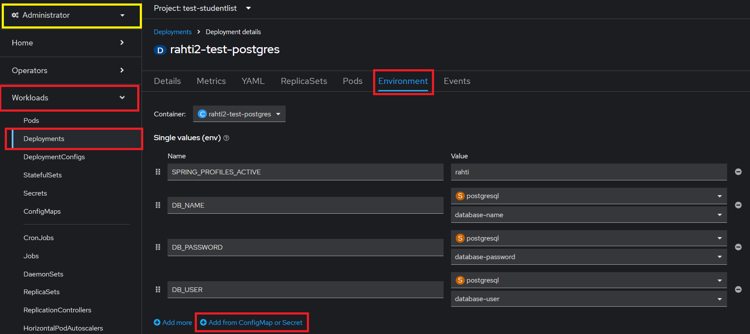

Congratulations! You have now deployed your Spring application with a proper database to CSC/Rahti!

To get the URL for your app go back to Developer view Topology. Click your application’s Open URL shortcut or navigate to deployment’s quick controls (navigation pane on the right) and scroll down to Routes. It might take few minutes before you are able to access your deployment’s URL in browser.

