# Create a new project in MyCSC portal

* 1. Log in to the CSC environment, <https://my.csc.fi/>.
  2. Navigate to the **Projects** tab in MyCSC portal management view and click **+ New Project**.

* 1. Enter the required project details:
* **Project name** and **description**
* **Project category**: select **Course**. If the Course option is not available, choose **Academic** instead.
* **Course start date**: today or future date.
* **Course end date**: can be at most six months from the creation date.
* **Project resources**:
  + Primary science area: Engineering and technology
  + Secondary science area: Other engineering and technologies

- Review the Terms of Use and click the **Create Project** button.

* A course project is single-use. It cannot be extended, copied, or allocated additional resources. The default resource allocation for the project is 100 000 BU (billing units).

* The project and all its resources will be automatically deleted after the end date.

**Note: Personal data must not be stored in course project services.**

* 1. Add services to your project. In this course, you will need the Rahti service from CSC’s offerings. You will also need the **project number** later for the actual application deployment.*A screenshot of a computer

     AI-generated content may be incorrect.*
  2. Click on the **+ Add services** button. A new view with services listed will appear.   
     Select **Rahti**, accept the terms of use for the Rahti and click **Add selected services** button.

* 1. In the **Services** card, you will now see **Rahti Container Cloud** service. Log in to the Rahti service by clicking the **Login** button.  
     A screenshot of a computer

     AI-generated content may be incorrect.

A new tab <https://rahti.csc.fi/> will open in your browser. Click the **Login** button.

Click **Login** and sign in using your **CSC** or **Haka credentials**.

# Deploy a Spring Boot Application with an H2 database on Rahti

## Prepare your Spring Boot Application

* + 1. Create a new file in the **root** directory of your Spring Boot application and name it **Dockerfile** (without a file extension).   
       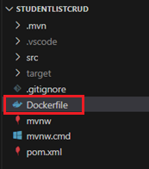
    2. Copy the following content into the **Dockerfile** (this can also be found in the course’s Moodle page):  
       FROM eclipse-temurin:17-jdk-focal as builder

WORKDIR /opt/app

COPY .mvn/ .mvn

COPY mvnw pom.xml ./

RUN chmod +x ./mvnw

RUN ./mvnw dependency:go-offline

COPY ./src ./src

RUN ./mvnw clean install -DskipTests

RUN find ./target -type f -name '*.jar' -exec cp {} /opt/app/app.jar \; -quit

FROM eclipse-temurin:17-jre-alpine

COPY --from=builder /opt/app/*.jar /opt/app/

EXPOSE 8080

ENTRYPOINT ["java", "-jar", "/opt/app/app.jar"]

* + 1. Push your updated application to GitHub.   
       **Note:** These instructions assume you GitHub repository is **public.** *(If needed, you can make it public temporarily during deployment and switch it back to private later.)*  
       Private repositories can also be used, but this document does not cover that method.

## Spring Boot application deployment

1. Navigate to the top left menu. Choose your role **Administrator** 🡪 **Home** 🡪 **Projects**.  
   The deployment is done by creating a new project in the Rahti service, click the **Create Project** button.

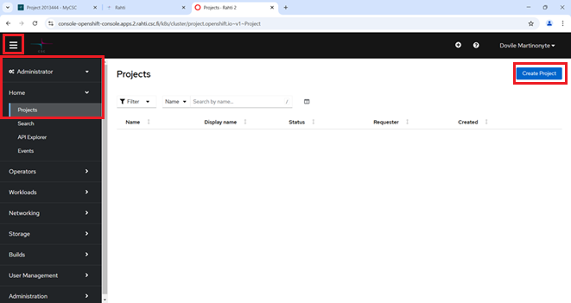

1. Enter the required details and click **Create** button.   
   **Note:** To successfully create the project, you must enter the **CSC project number** (e.g. **csc_project:<project number>**) in the **Description** field.   
   If you don’t know project number, see step 1.4.  
   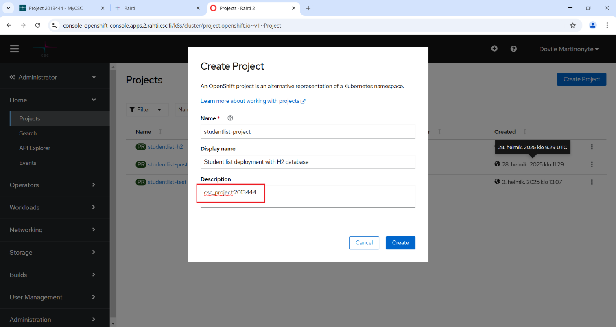
2. Now you can deploy your Spring Boot application inside the newly created project in the Rahti service. Navigate to **Developer** mode. If your project name is not visible, select it from the **Project:** drop-down menu.  
   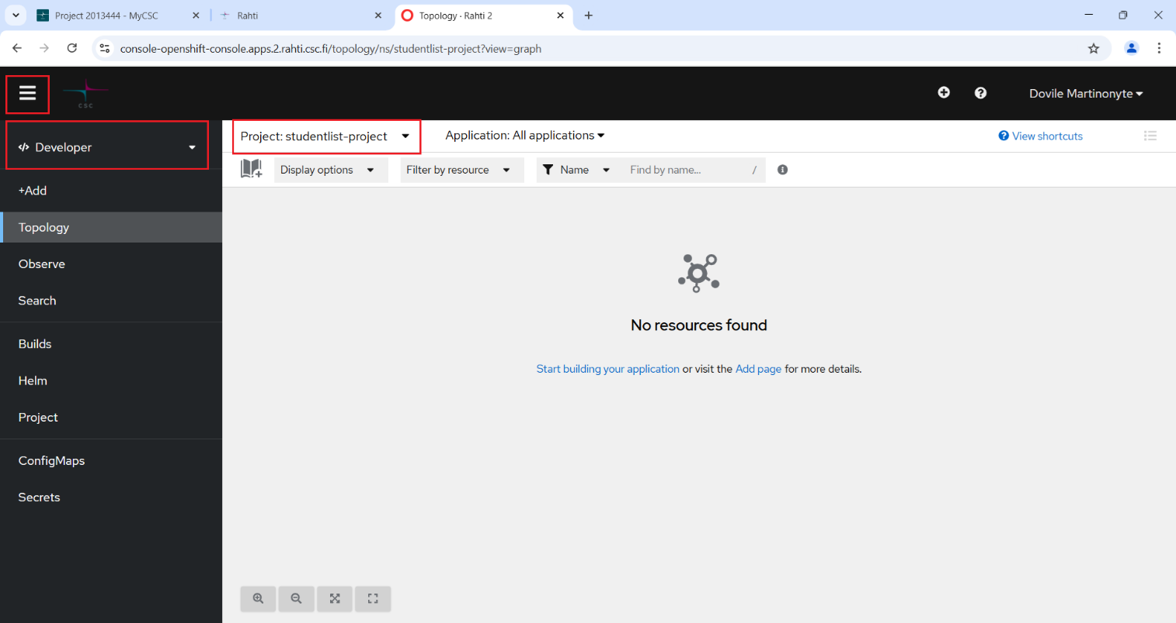
3. Click **+Add** and from the available resources select **Git Repository** 🡪 **Import from Git**.   
   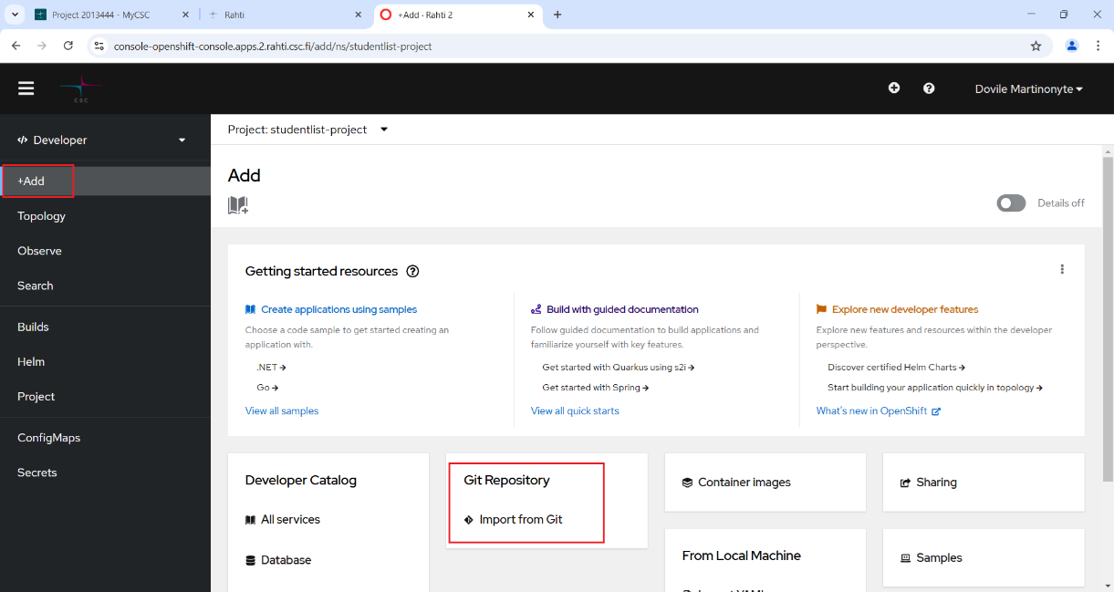
4. Fill in the **Import from Git** form by entering the **Git Repo URL**.  
   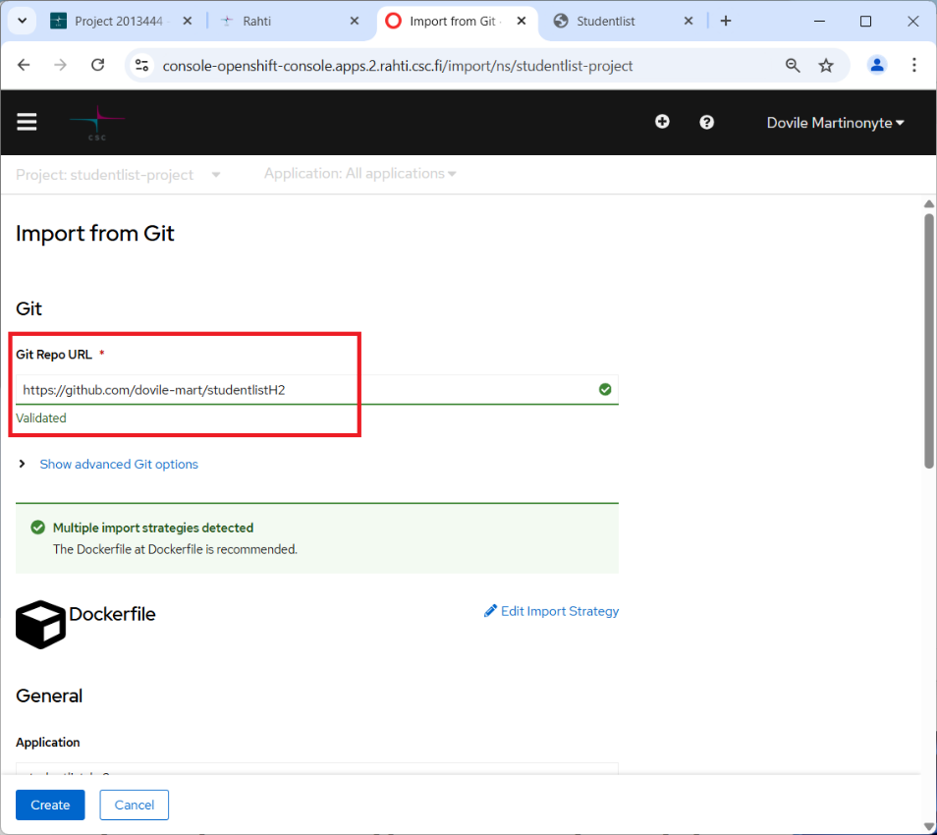  
     
   A name for your application component in **Name** field is be generated automatically but you can also create your own **unique name**. This component will be used to name associated resources.  
   Then click the **Create** button.

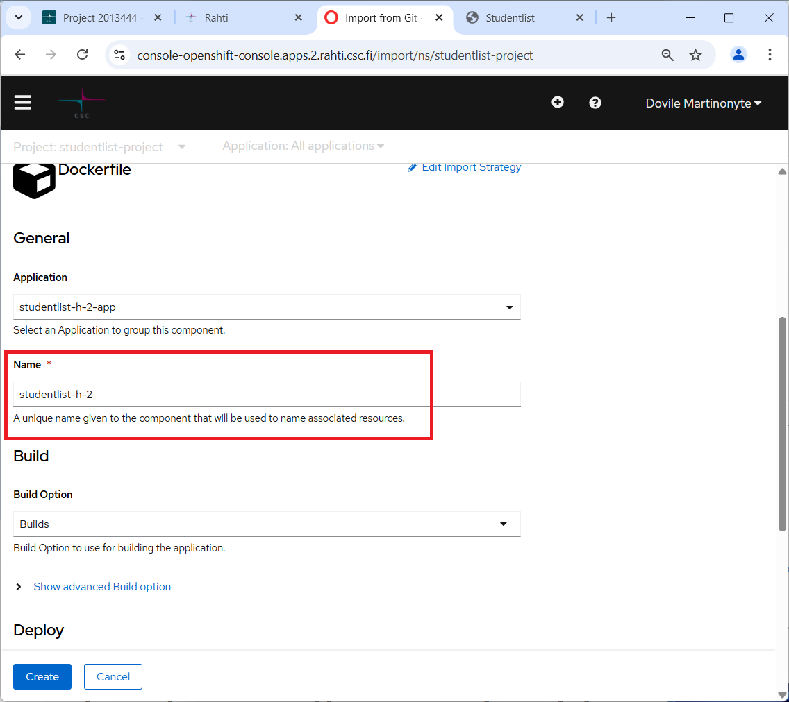🡪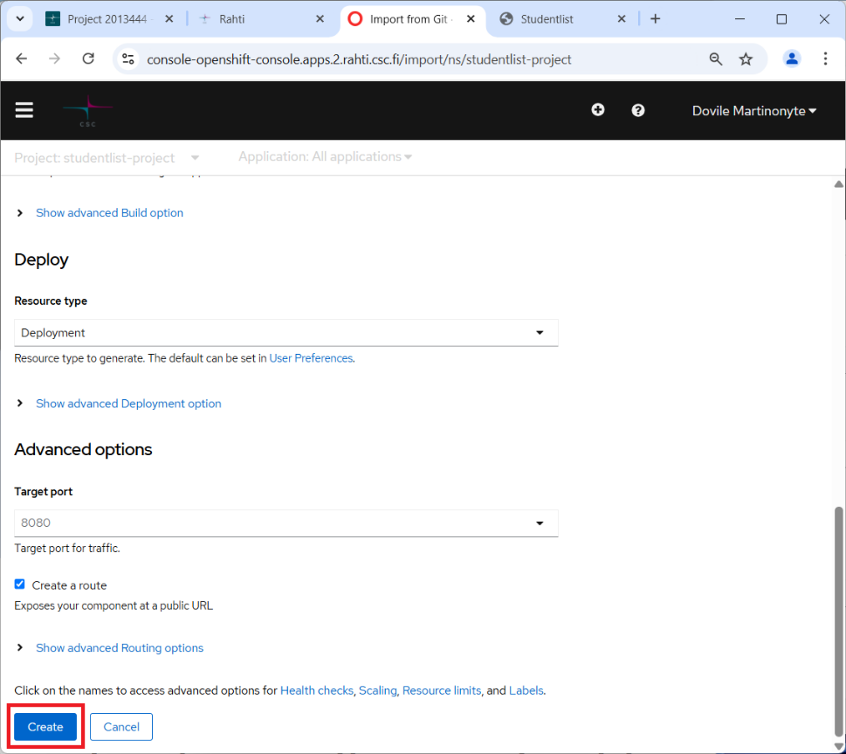

1. The build process will start and may take a few minutes. You can find application component under **Developer** mode 🡪 **Topology** view**:**A screenshot of a computer

   AI-generated content may be incorrect.
2. Follow the build progress in the **Developer** mode 🡪 **Builds** view.   
   While application is being built, its status will be **Running**.

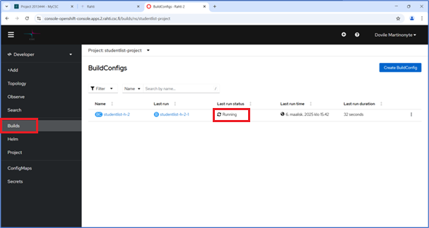

1. Once the build is complete, the status will change to **Complete**.  
   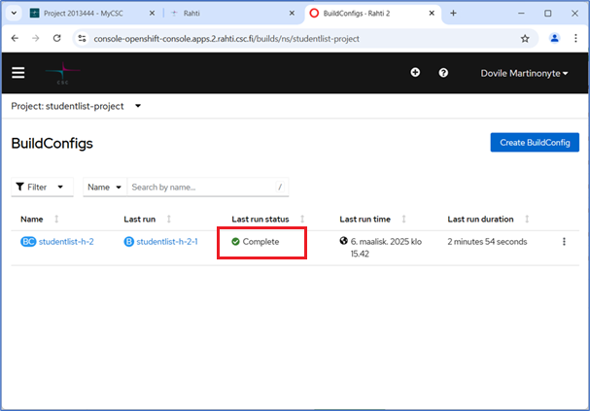
2. You can find your application’s URL, by navigating to the **Topology** view 🡪 selecting the component 🡪 when the sidebar on the right opens, navigate to the **Resources** tab 🡪 the application’s URL will be under **Routes**. Click the link, and the application will open in your web browser.  
   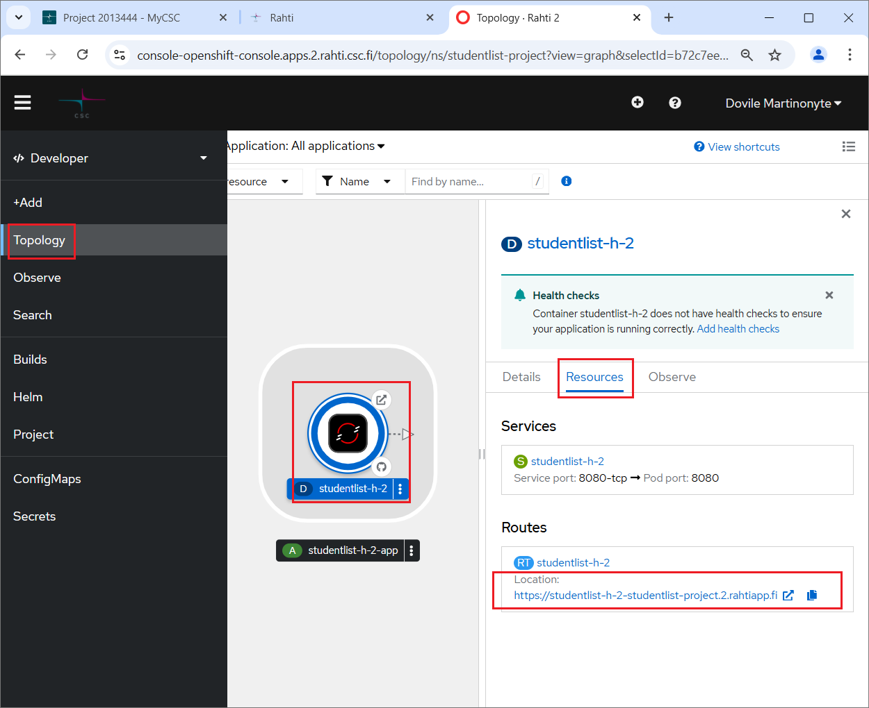
3. Congratulations, your application is deployed!  
   