Kramer Johnson

5042_02 Seattle University Spring 2021

Homework 3

1. 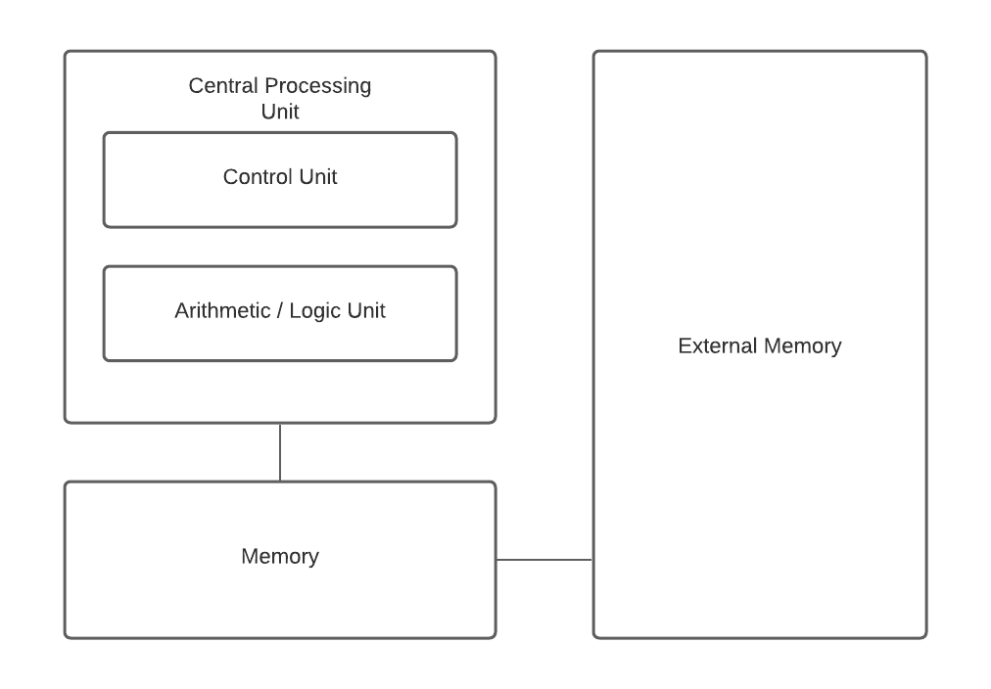

4. The control of system hardware and management of memory

7. Virtualization is a subclass of emulation. Emulation takes place whenever instructions need to be translated from one CPU to another. Virtualization is specifically when one operating system is run as an application on another operating system.

11. Asymmetric multiprocessors have a single boss processor that assigns tasks to the other processors. In symmetric multiprocessing each processor in the system can perform all tasks in the system.

25. hit rate + miss rate * miss penalty = AMAT

50 = 2 + x * 100

48/100 = x

X = 48% the maximum miss rate would be 48%

37. Programs that use a small amount of their code very often but most of it not often benefit most from dynamic relocation because the entirety of the code does not need to be addressed all at once, only the code being used needs to be addressed. The 20-80 rule states that 20 percent of your code is used 80 percent of the time and 80 percent of your code is used 20 percent of the time.

44. The three strategies for placement policy are first fit where a process is allocated to the first hole that fits, best fit where the process is allocated to the smallest hole, and worst fit where the process is fit to the largest hole.

52. size of logical address is 2^24. The page size is 2^12 page number is 24-12 = 12 bits of logical address the 20 low order bits designate the page offset. Physical memory is 2^20 bytes

Page number = m – n = 24 - 12 = 12

Page offset = n = 12

Number of pages = space of logical address / size of a page = (2^24 / 2^12) = 2^12 pages = 4096 pages

Total size of page table = num pages * page size = 2^12 * 2^12 = 2^24 = 4MB

F = 8 bits

ABCDEF is mapped to F5DEF

53.

from random import randint

from statistics import mean

blockSize = 2048

iterations = 10000

maxInt = 20000

minInt = 1

results = []

for i in range(0, iterations):

p = randint(minInt, maxInt)

internalFrag = blockSize - (p % blockSize)

results.append(internalFrag)

mean = mean(results)

print("The mean internal fragmentation is " + str(mean))

The mean is ~1051

55.

logical address = 32 bits; p = 20; d = 12

page size = 4kb = 2^12

page table = 2^32 – 2^12 = 2^20 lines

physical address = 24 bits; f = 12; d = 12

EAT = .5 * .9 + 1 * .1 = .55 cycles

D00EF123 = 56F123

12345F05 = 567F05