DA5402 MACHINE LEARNING OPERATIONS MLOPs

PROJECT REPORT

ID24S800

HAAMBAYI MUDENDA

Introduction
This project presents DiaSense, a production-oriented AI application for predicting diabetes risk from clinical and demographic measurements such as glucose, blood pressure, BMI, insulin, age, skin thickness, pregnancies, and diabetes pedigree function. The objective of the project is to build a web-based system that can be used by both patients and healthcare professionals through an intuitive interface while also demonstrating a complete MLOps lifecycle. The solution combines a machine learning pipeline, a model-serving API, a modern web frontend, experiment tracking, data versioning, orchestration, monitoring, and containerized deployment. The system is designed to align with MLOps best practices by automating data ingestion, preprocessing, model training, evaluation, deployment, and monitoring. It also emphasizes reproducibility, observability, documentation, testing, and environment parity through Docker and Docker Compose.

The application uses the Pima Indians Diabetes dataset as the initial training source and implements an end-to-end workflow using Python, FastAPI, Next.js, Apache Airflow, DVC, MLflow, PostgreSQL, Prometheus, Grafana, and Docker Compose. In addition to prediction, the system supports operational health checks, pipeline visibility, and a feedback loop for future monitoring of real-world model performance.

Problem Statement
Diabetes is a major public health challenge, and delayed detection can lead to serious complications. Many people remain undiagnosed until symptoms become severe. Because of this, there is strong value in developing assistive systems that can estimate diabetes risk early from readily available health indicators.

The objective of DiaSense is therefore to build a system that:
- accepts structured health input data from a web interface,
- predicts diabetes risk using a trained machine learning model,
- exposes the model through REST APIs,
- tracks model experiments and artifacts,
- versions data and pipeline steps,
- monitors infrastructure and application health,
- supports future retraining and drift detection.

Project Objectives
The objectives of this project are as follows:
- To build a machine learning model that predicts diabetes risk from structured tabular health data.
- To expose the model through a FastAPI backend for real-time inference.
- To develop a user-friendly web frontend for patients and healthcare professionals.
- To automate data ingestion, preprocessing, training, evaluation, and registration using Airflow and DVC.
- To track experiments, parameters, metrics, artifacts, and model versions using MLflow.
- To monitor application performance, pipeline health, and data drift using Prometheus and Grafana.
- To package the full system using Docker Compose for consistent local deployment.
- To produce the required software engineering artifacts such as architecture diagrams, HLD, LLD, test plan, test cases, and user manual.
4.Project scope
This project focuses on a tabular-data-based diabetes risk prediction system built for local or on-premise deployment. The implemented scope includes:
ingestion of the diabetes dataset,
- validation and preprocessing of data,
- EDA and drift baseline calculation,
- training and comparison of candidate ML models,
- registration of the selected model,
- model serving via REST APIs,
- web application frontend,
- pipeline orchestration with Airflow,
- experiment tracking with MLflow,
- data versioning with DVC,
- monitoring with Prometheus and Grafana,
- Docker Compose packaging,
- documentation and testing.
The system is a decision-support tool and not a medical diagnosis system. All prediction results are presented with a disclaimer advising users that the result should not replace clinical judgement.
5.Dataset Description
The dataset used in this project is the Pima Indians Diabetes dataset, loaded from the provided CSV source. It contains the following main input features:
- Pregnancies
- Glucose
- Blood Pressure
- Skin Thickness
- Insulin
- BMI
- Diabetes Pedigree Function
- Age
The target variable is the diabetes outcome class. This dataset is suitable for the project because it is small enough for local experimentation, structured for tabular modeling, and relevant to the medical-risk prediction problem.
A limitation of the dataset is that it represents a specific population and may not generalize perfectly to all users. Another limitation is that some fields contain values such as zeros in medically unrealistic places, which need to be handled during preprocessing.
6. Methodology

6.1 Data Ingestion
The first step in the workflow is data ingestion. The raw CSV is downloaded from the configured source URL and stored in the raw data directory. The ingestion process is version-controlled and incorporated into the reproducible pipeline, in line with the guideline’s requirement to automate data ingestion and validation.

6.2 Data Validation
During ingestion, the system performs schema and quality checks. These include:
- expected column verification,
- type validation,
- missing value checks,
- duplicate checks,
- range checks,
- basic data quality reporting.

6.3 Exploratory Data Analysis and Drift Baselines
EDA is performed to understand feature distributions, identify anomalies, and prepare for preprocessing. Statistical baselines such as mean, variance, and distribution summaries are computed and saved for later drift detection.

6.4 Data Preprocessing and Feature Engineering
The preprocessing step handles missing or invalid values and prepares the data for training. In this project, zero values in medically unrealistic fields such as glucose, insulin, blood pressure, skin thickness, and BMI are treated as missing and imputed appropriately. Numerical preprocessing is applied consistently so that the same transformation logic can be reused at inference time. The preprocessing logic is versioned separately from the model logic.

6.5 Model Development and Selection
Multiple candidate models are trained and compared. The selection strategy is based primarily on F1-score, with recall, precision, ROC-AUC, calibration, inference speed, and interpretability used as supporting criteria.
The candidate models considered include:
- Logistic Regression
- Random Forest
- XGBoost

6.6 Experiment Tracking
All experiments are tracked using MLflow. The system records:
- model parameters,
- training metrics,
- evaluation metrics,
- artifacts,
- model versions,
- selected run IDs,
- model registration details.

6.7 Data and Pipeline Versioning
DVC is used to version datasets, intermediate artifacts, and pipeline stages. The DVC DAG provides traceability over ingestion, validation, preprocessing, training, evaluation, and registration.

6.8 Model Deployment
The deployment uses a multi-container setup managed by Docker Compose.
In this project:
- the frontend provides the user interface,
- the FastAPI backend exposes application APIs,
- the MLflow model server serves the trained model,
- PostgreSQL stores metadata and prediction records,
- Airflow orchestrates pipelines,
- Prometheus collects metrics,
- Grafana visualizes the monitored data.

6.9 Monitoring and Maintenance
Prometheus and Grafana are used for exporter-based instrumentation and real-time visualization. The system monitors:
- API request counts,
- request latency,
- prediction counts,
- prediction errors,
- pipeline successes and failures,
- service health,
- drift signals.
7. System Architecture
The architecture follows a loosely coupled design in which the frontend and backend are independent components connected only through configurable REST APIs.
At a high level, the architecture consists of the following blocks:
- Next.js Frontend
Provides the user interface for entering patient information, viewing results, and accessing the operations dashboard.
- FastAPI Backend API
Handles request validation, communication with the model server, persistence of prediction requests and outputs, health checks, operational APIs, and metrics exposure.
- MLflow Model Server
Serves the selected trained model for real-time inference.
- PostgreSQL Database
Stores prediction requests, prediction outputs, model version metadata, pipeline run metadata, and feedback labels.
- Airflow
Orchestrates the training pipeline and monitoring pipeline.
- DVC
Versions data, artifacts, and reproducible stages.
- Prometheus and Grafana
Monitor the application and pipeline in near real time.
- Minio
for object storage
8. High-Level Design
The high-level design of DiaSense is based on a service-oriented monorepo architecture. The user interacts only with the web frontend. The frontend never calls the database or model server directly; instead, it sends requests to the FastAPI backend over REST. The backend validates requests, forwards inference payloads to the MLflow model server, stores the request and response in PostgreSQL, and returns a structured prediction result to the frontend.
In parallel, the MLOps pipeline is orchestrated by Airflow. The pipeline downloads the dataset, validates it, preprocesses it, trains multiple models, evaluates them, and registers the best model. DVC ensures that each stage is reproducible, while MLflow tracks all experiments and artifacts. Prometheus and Grafana then monitor the live system and its metrics.
This design was chosen because it supports loose coupling, maintainability, reproducibility, observability, and deployment consistency.
Below is a visual representation of the high level design.
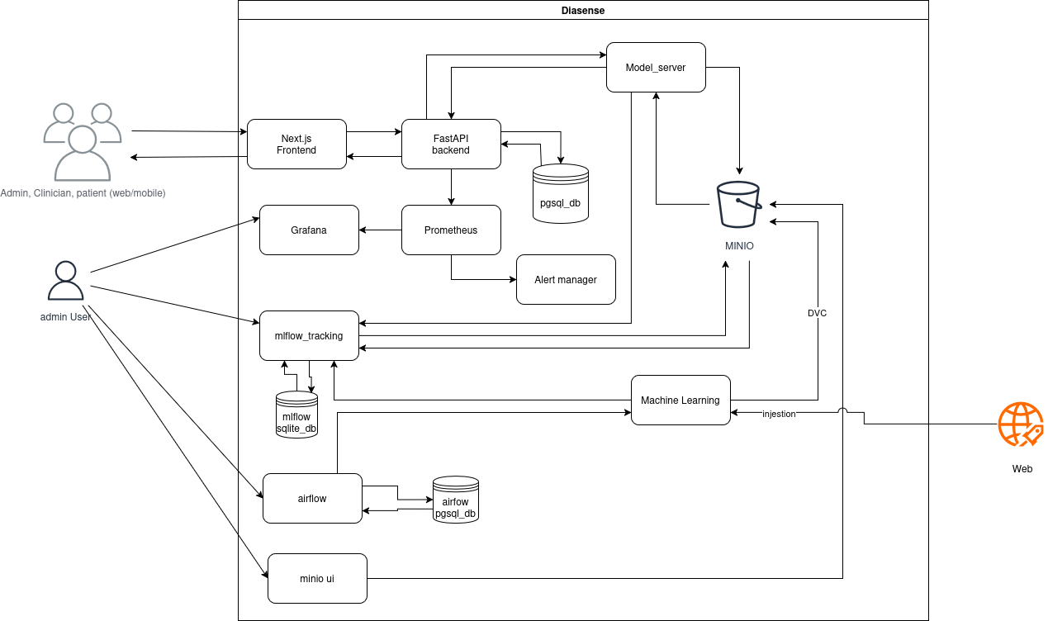Figure 1: Diasense High Level Design

9.Low-Level Design

9.1 Key API Endpoints
The backend API exposes the following main endpoints:

Endpoint | Method | Purpose
/api/v1/health | GET | Basic service health check
/api/v1/ready | GET | Dependency readiness check
/api/v1/predict | POST | Submit a diabetes risk prediction request
/api/v1/model/info | GET | Return active model metadata
/api/v1/predictions/{request_id} | GET | Fetch a saved prediction result
/api/v1/predictions/{request_id} | DELETE | Remove a past prediction
/api/v1/signup | POST | Create a user account
/api/v1/login | POST | User login to the system
/api/v1/logout | POST | Logout authenticated user
/api/v1/reset-password | POST | Change user password
/api/v1/users | GET | Return a list of users
/api/v1/patients | GET | Return a list of patients
/api/v1/patients | POST | Create a new patient
/api/v1/patients/{patient_id} | DELETE | Remove a patient record
/api/v1/user | POST | Create a new user
/api/v1/feedback | POST | Record ground-truth feedback
/api/v1/drift/latest | GET | Return latest drift report
/api/v1/pipeline/runs | GET | Show recent pipeline runs
/api/v1/ops/summary | GET | Operations summary for UI
/metrics | GET | Prometheus metrics endpoint

9.2 Database Design
The main database tables are:
- auth_users
- model_versions
- prediction_requests
- prediction_results
- feedback_labels
- drift_reports
- pipeline_runs
- system_events

These tables were chosen so the application can support not only inference, but also experiment traceability, operational monitoring, and long-term maintenance.
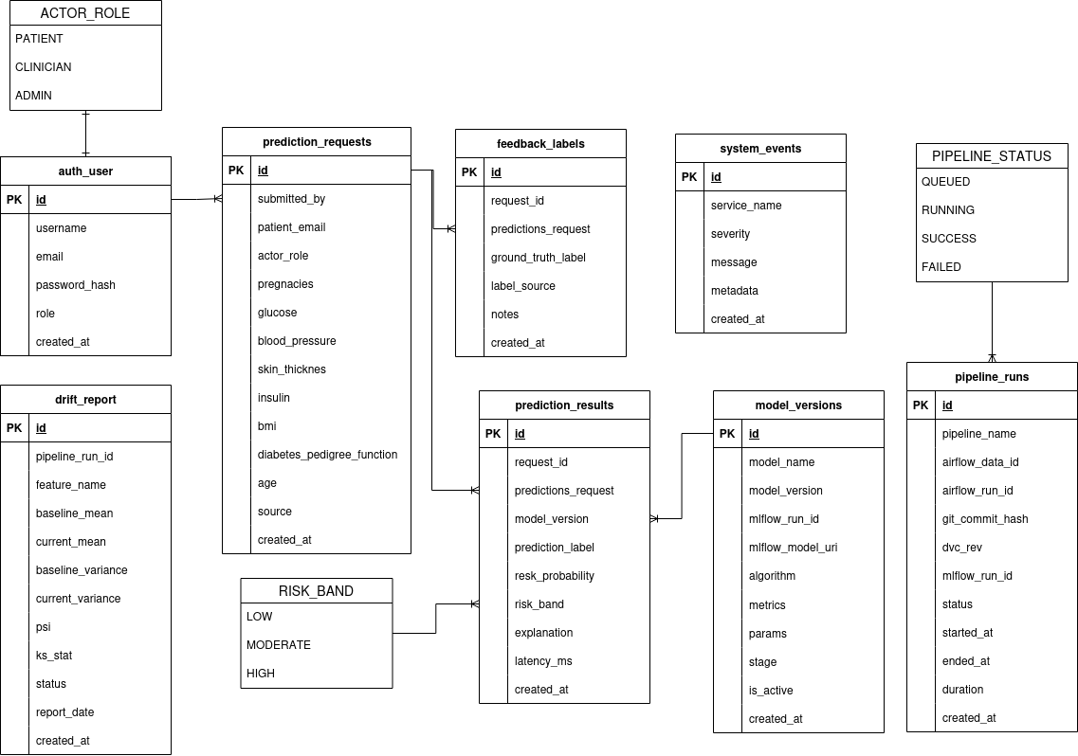Figure 2: Diasense Database Design

9.3 Prediction Flow
The runtime prediction flow is:
- User enters health values in the frontend.
- Frontend sends a POST request to /api/v1/predict.
- Backend validates the payload.
- Backend stores the input in prediction_requests.
- Backend calls the MLflow model server for inference.
- Backend stores the output in prediction_results.
- Backend returns the prediction result to the frontend.
- Frontend displays risk band, probability, and explanation.
This flow keeps the architecture modular and easy to maintain.

10. MLOps Implementation

10.1 Orchestration
Apache Airflow is used to automate the ML lifecycle. A typical training DAG includes:
- ingest,
- validate,
- preprocess,
- train,
- evaluate,
- register.

10.2 Version Control and CI
Git is used for source control, while DVC is used for data and artifact versioning. The CI pipeline is designed to run automated checks, tests, and build steps when code changes are introduced. This supports the guideline’s emphasis on reproducibility, CI, and version control across code, data, models, and configuration.

10.3 Experiment Tracking
MLflow is used for:
- experiment tracking,
- artifact storage,
- model metadata capture,
- model registration,
- model serving.
Tracked information includes hyperparameters, model metrics, confusion matrices, feature importance outputs, classification reports, and the run ID used for reproducibility.

10.4 Monitoring and Alerting
Prometheus collects infrastructure and application metrics, while Grafana visualizes them in dashboards. The project includes monitoring for:
- API latency,
- request counts,
- error rates,
- pipeline run outcomes,
- system health,
- drift metrics.
11. Testing Strategy
The testing strategy includes:
- unit tests for data validation and preprocessing,
- unit tests for risk band mapping,
- API tests for health, ready, predict, and feedback endpoints,
- integration tests for backend to model-server communication,
- pipeline tests for DVC/Airflow steps,
- frontend validation tests,
- manual acceptance tests for UI and end-to-end flow.

11.1 Acceptance Criteria
The solution is considered acceptable if:
- the frontend accepts valid input and rejects invalid input,
- the backend returns predictions correctly,
- /health and /ready work,
- the ML pipeline runs end-to-end,
- experiments are logged to MLflow,
- data and artifacts are versioned with DVC,
- monitoring dashboards display expected metrics,
- the application runs through Docker Compose,
- documentation and user guidance are provided.

12. Challenges Faced and Mitigation
Several practical challenges were encountered during the design and implementation of the project.
The first challenge was handling noisy or medically unrealistic values in the dataset. This was addressed through validation rules and preprocessing steps that detect suspicious zeros and apply controlled imputation.
The second challenge was maintaining reproducibility across data, training, and deployment. This was mitigated through Git, DVC, MLflow, and Docker Compose, making it possible to trace an experiment through code revision, data version, and run metadata.
The third challenge was integrating multiple MLOps tools into one coherent workflow. This was addressed by assigning clear roles: Airflow for orchestration, DVC for pipeline versioning, MLflow for tracking and serving, Prometheus for instrumentation, and Grafana for visualization.
Another challenge was designing the UI for both technical and non-technical users. This was mitigated by keeping the input form simple, validating user input early, and presenting results with plain-language interpretation rather than overly technical output.
13. Security, Reliability, and Maintainability
The project follows the guideline’s recommendation to implement security measures and maintain clean, testable, well-documented code. Sensitive configuration is stored through environment variables rather than hardcoded values. Input validation is enforced at the API layer. Logging and exception handling are included to improve debugging and operational reliability.
14. Limitations
Despite its strengths, the project has several limitations.
First, the dataset is relatively small and may not generalize broadly. Second, the prediction is based only on the available tabular features and does not include richer medical context such as laboratory history, medications, lifestyle patterns, or physician notes. Third, the system is a prototype for academic and demonstration purposes and should not be used as a standalone clinical decision-maker. Finally, drift monitoring and feedback logging are implemented as infrastructure capabilities, but their full value depends on collecting new real-world data over time.
15. Future Work
Future improvements may include:
- training on larger and more diverse datasets,
- better calibration of predicted probabilities,
- stronger explainability dashboards,
- clinician-specific workflows,
- user authentication and role-based access,
- retraining triggers based on drift thresholds,
- better alert routing and automated rollback,
- richer historical analytics for repeated patient use.

16.Conclusion
This project successfully demonstrates how a diabetes risk prediction application can be designed as a complete MLOps-enabled system rather than just a machine learning notebook. DiaSense combines data engineering, preprocessing, model training, evaluation, experiment tracking, deployment, monitoring, frontend usability, testing, and documentation into one integrated solution. The architecture follows good software engineering practice by separating the frontend from the backend inference engine through REST APIs, while the MLOps pipeline supports reproducibility, automation, observability, and future retraining.
Overall, the project meets the spirit of the assignment by showing not only how to build a predictive model, but how to manage the full lifecycle of an AI application in a disciplined and production-oriented way. With further data and iterative refinement, the system can be extended into an even more useful decision-support platform for healthcare settings.

DIASENSE USER MANUAL

1. INTRODUCTIONS
This guide is written fo clinic user and not-technical reviewers.
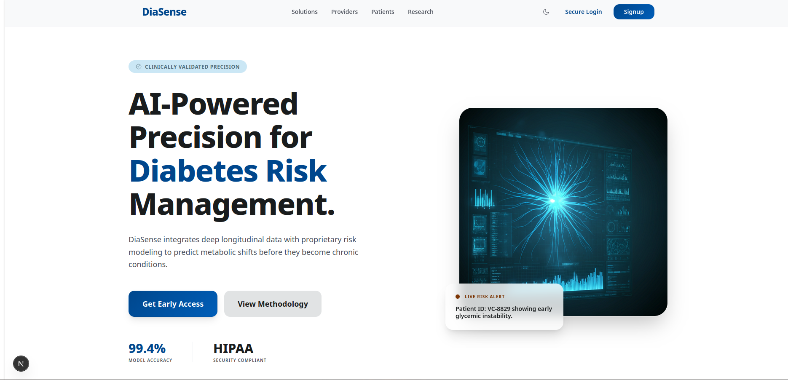Figure 3: Landing Page

2.What DiaSense Does
DiaSense lets you:
- create an account or sign in
- enter diabetes-related assessment values
- receive a risk score and explanation
- review past prediction results
- reset your password
If you are a clinician or admin, you can also:
- assess another patient account
- create patient accounts
- review patient history

3.Important Medical Disclaimer
DiaSense does not provide a diagnosis.
It is a screening and decision-support tool that estimates diabetes risk from the values entered. Always use a licensed healthcare professional for diagnosis and treatment decisions.

How it works

- How to sign up
  - open diasense frontend in your web browser
  - open the signup page
    - Enter a username and an email
    - Enter a password with at least 8 characters
    - select create account
What happense next:
Your account is created as a patient account by default
you are signed in automatically after successful signup
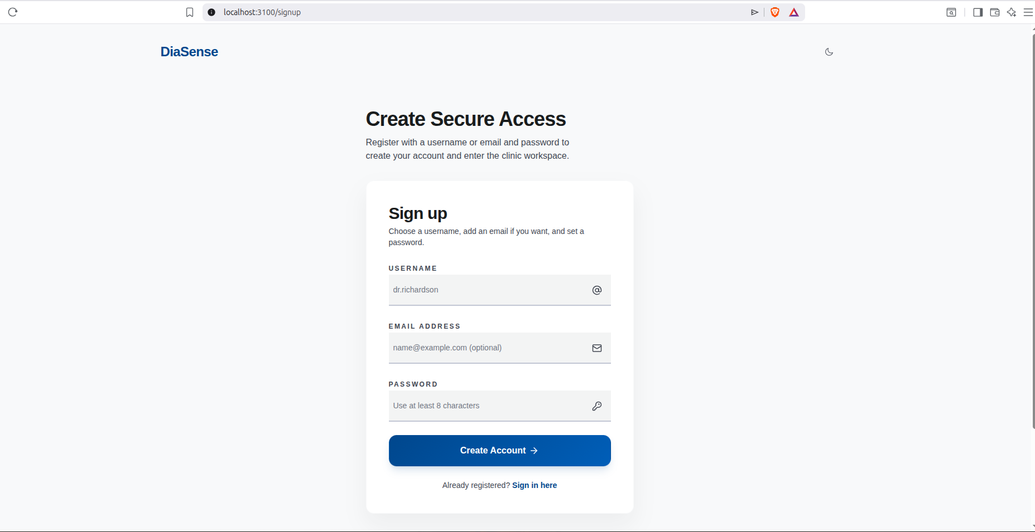Figure 4: Signup Page

- How to login
  - open the login page
  - Enter your username or email
  - enter your password
  - select Sign in to clinic

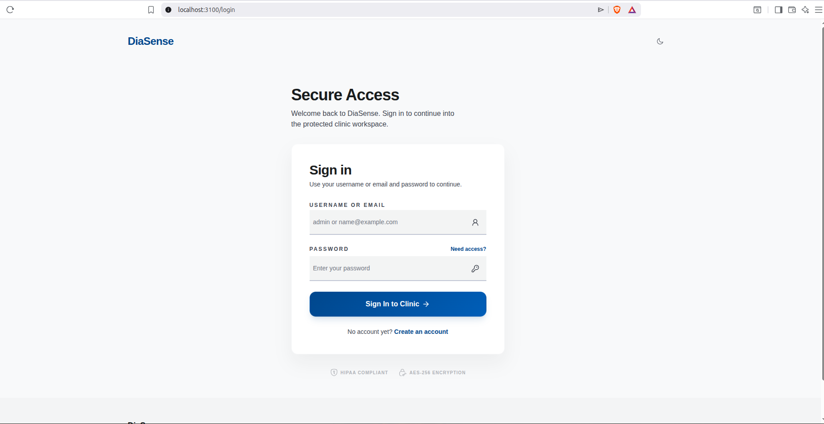Figure 5: Login Page
- How To Enter Assessment Values
  - Open Assesment page from the clinic menu
  - Enter these values
    - pregnancies
    - Glucose
    - Blood Pressure
    - Skin thickness
    - Insulin
    - BMI
    - Diabetes Pedigree Function
    - Age
  - NOTE:
    - Use numbers only
    - double-check decimal point where needed
    - clinicians and admins can choose a patient account before submitting
  - Accepted Value Ranges in the current system:
    - Pregnancies: 0 to 30
    - Glucose: 0 to 300
    - Blood Pressure: 0 to 200
    - Skin Thickness: 0 to 100
    - Insulin: 0 to 1000
    - BMI: 0 to 100
    - Diabetes Pedigree Function: 0 to 10
    - Age: 1 to 120
Patient self Assessment
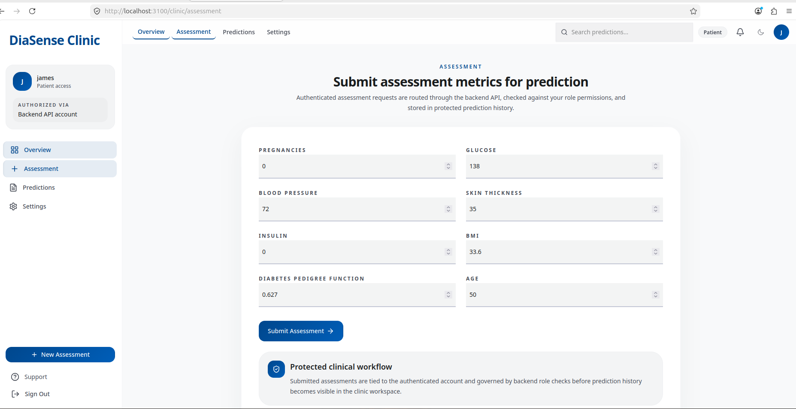Figure 6: Patient Self Assessment
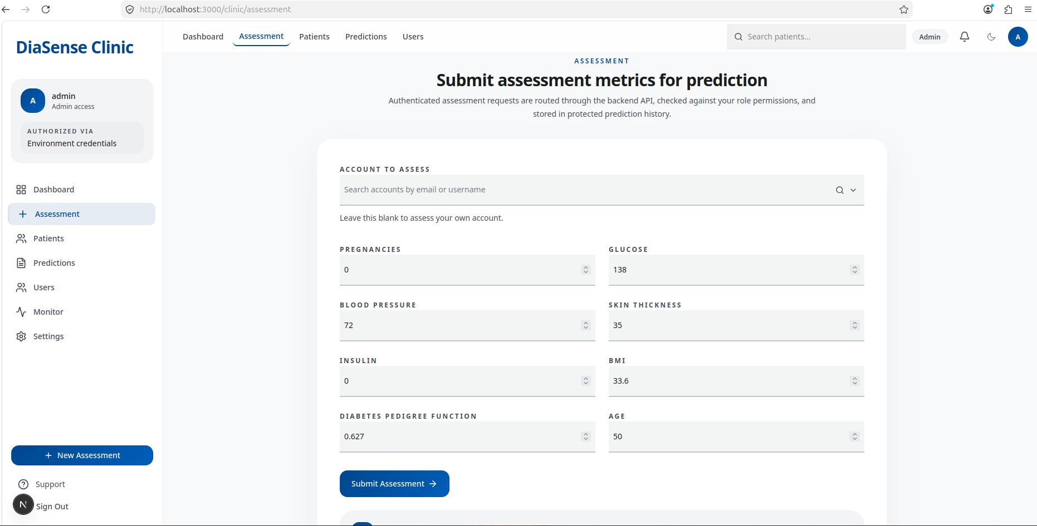Figure 7: Clinician and Admin Assessment
- How To Submit An Assessment
  - Enter the values.
  - Select Submit Assessment.
  - Wait for the result card to appear.
After a successful submission, the screen shows:
    - risk band
    - probability percentage
    - interpretation text
    - patient account used
    - submitter identity
    - latency
    - top contributing factors, if available
- How To Interpret The Result
DiaSense groups the prediction into one of three risk bands:
  - Low: probability below 0.33
  - Moderate: probability from 0.33 up to but not including 0.66
  - High: probability 0.66 or higher
What the result means:
  - Low means the model saw a relatively lower predicted risk from the provided values
  - Moderate means the model saw a meaningful risk signal and the result should be reviewed carefully
  - High means the model saw a strong risk signal and follow-up is strongly recommended
Again, this is not a diagnosis.

- How To View Prediction History
  - Open Predictions from the clinic menu.
  - Review the list of saved assessments
  - The page shows:
    - creation time
    - patient account
    - submitter
    - risk band
    - probability
    - interpretation
Patients will normally see only their own history.
Clinicians and admins can view broader clinic history and filter by patient.
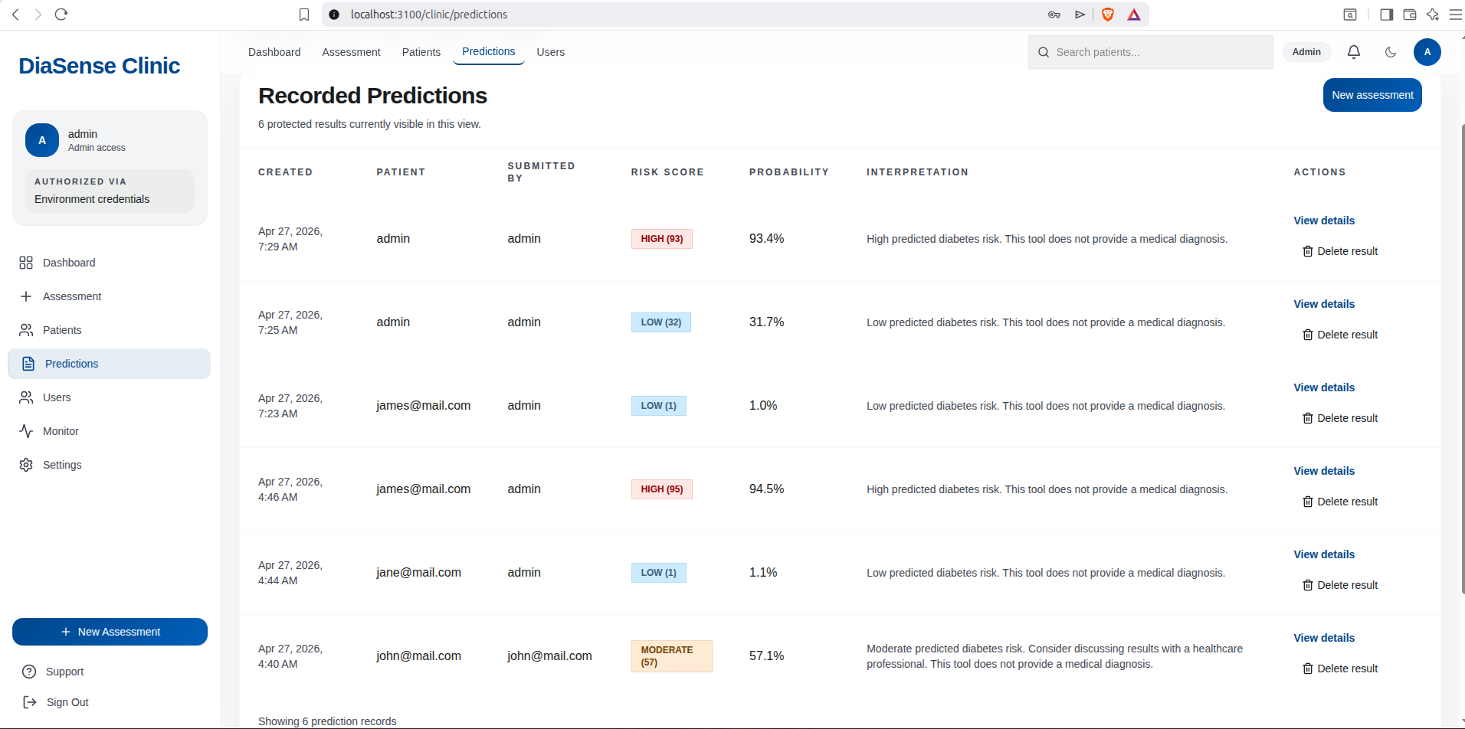Figure 8: Assesment Predictions
- How To View Prediction Details
  - Open the Predictions page.
  - Select View details for any record.
The detail page shows:
    - all submitted assessment values
    - patient and submitter information
    - the calculated risk band
    - probability
    - interpretation
    - top factors, when available
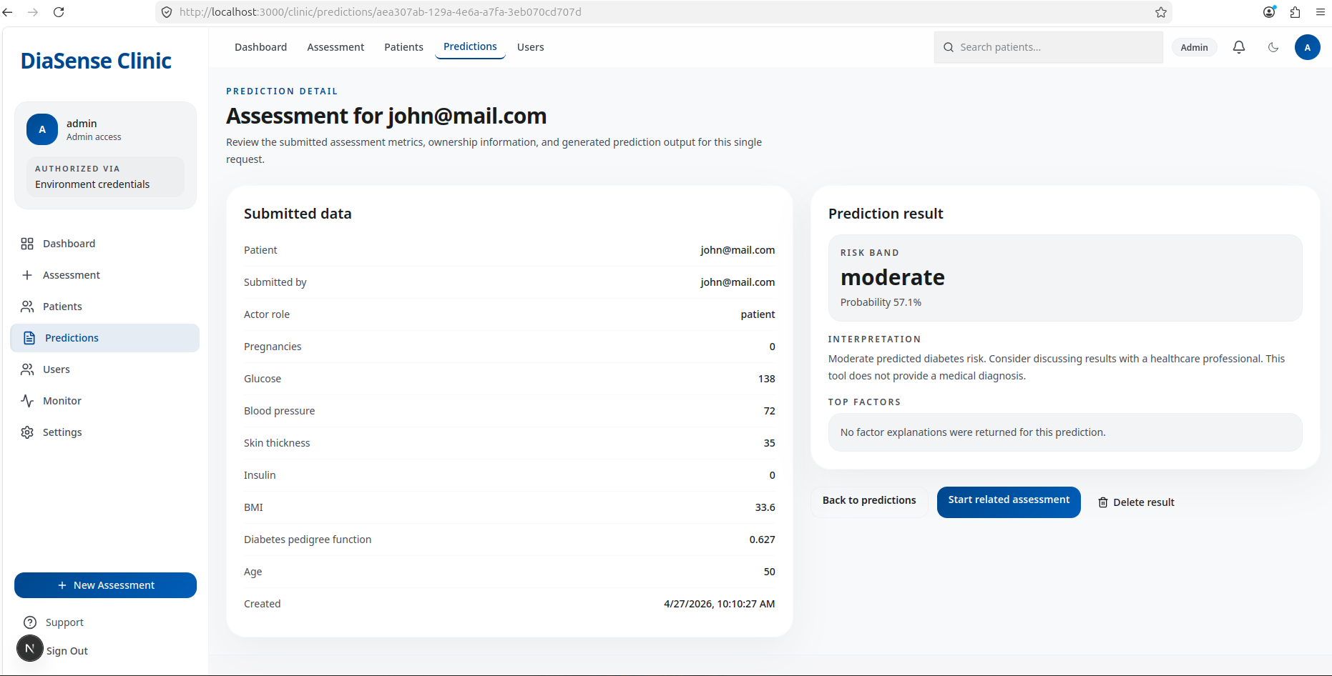Figure 9: Prediction Details

- How To Add New Patients
This option is available to clinicians and admins.
  - Open Patients.
  - Select Add patient.
  - Enter:
    - username,
    - email,
  - Enter a temporary password.
  - Select Create patient.
The new patient can then sign in with the provided username/email and password.
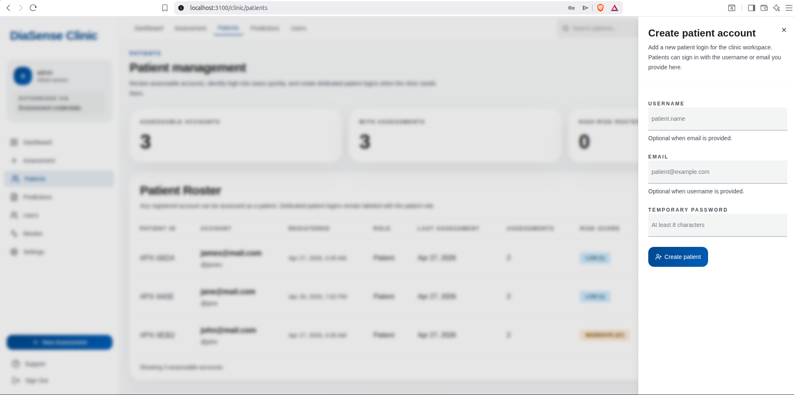Figure 10: Create a patient
- How To Reset Your Password
  - Open Settings.
  - Enter your current password.
  - Enter a new password.
  - Enter the same new password again in the confirmation field.
  - Select Update password.
If the update succeeds, a confirmation message appears.
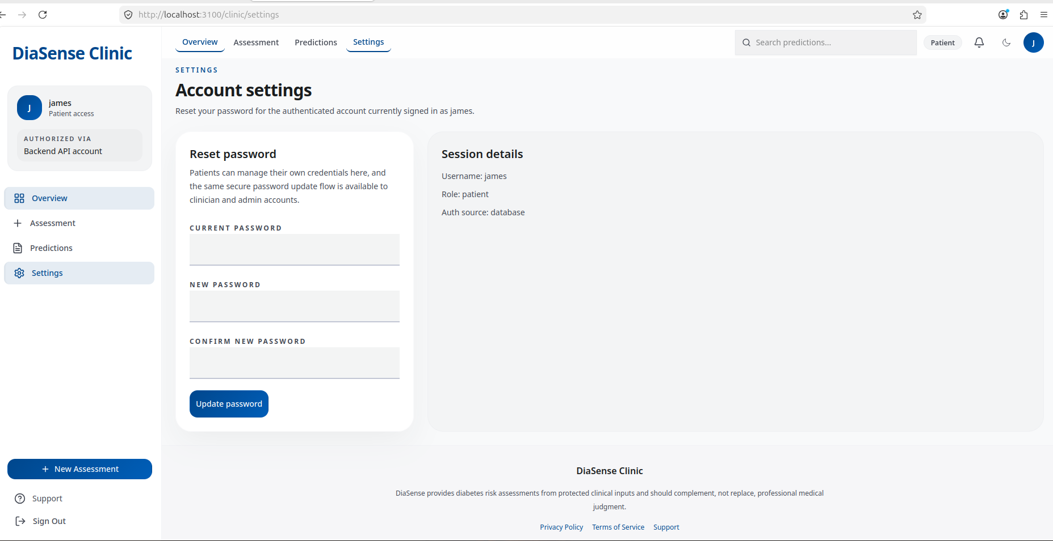Figure 11: Reset Password

- What To Do If Something Goes Wrong
If you see an error:
- retry the action once
- make sure all required fields are filled
- check that numeric values are within the expected ranges
- if the page says the backend is unavailable, contact the technical operator
- if you cannot sign in, ask the admin to confirm your account exists and your role is correct

- Role Summary
  - Patient
    - run self-assessments
    - view own predictions
    - reset own password
  - Clinician
    - all patient capabilities
    - assess patient accounts
    - create and remove patient accounts
    - view patient prediction history
  - Admin
    - all clinician capabilities
    - manage user roles
    - open the monitor page
    - inspect operational status

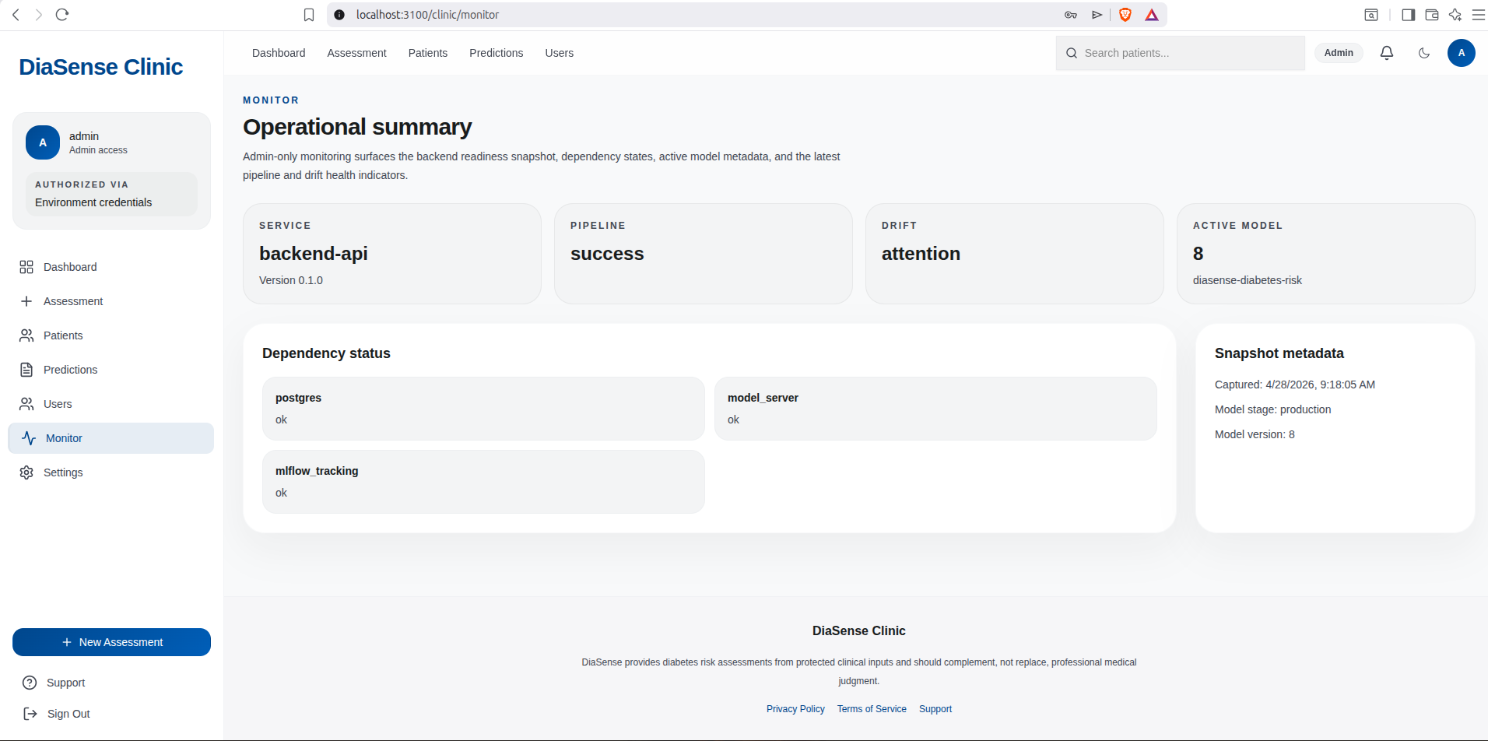Figure 12: Monitor Page

