DIASENSE USER MANUAL

INTRODUCTIONS
This guide is written fo clinic user and not-technical reviewers.
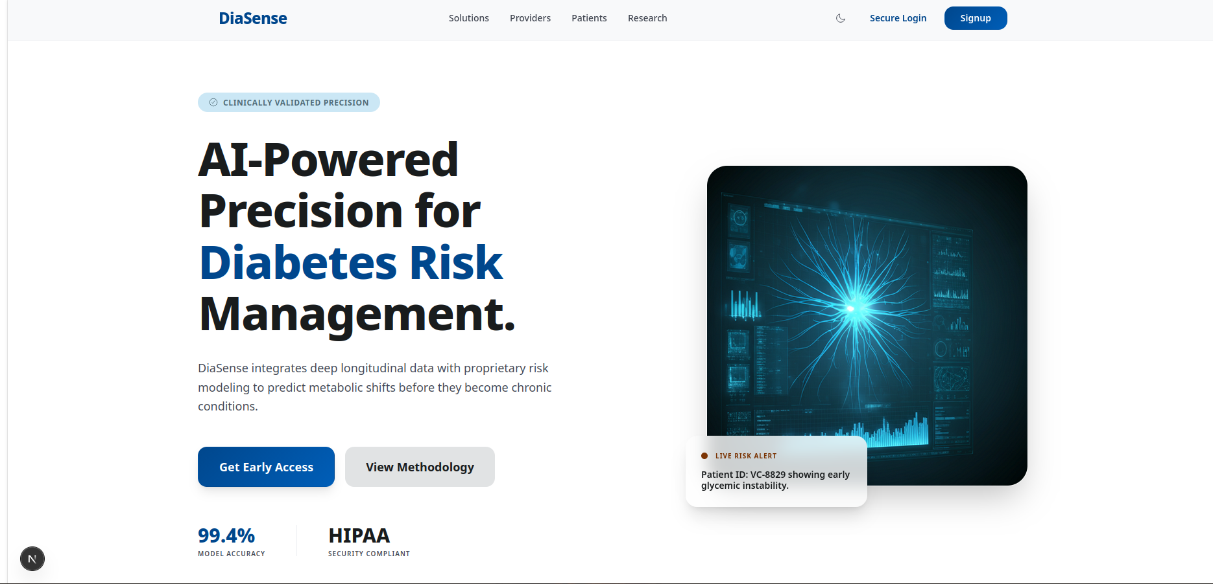Figure 1: Landing Page

What DiaSense Does
DiaSense lets you:
- create an account or sign in
- enter diabetes-related assessment values
- receive a risk score and explanation
- review past prediction results
- reset your password
If you are a clinician or admin, you can also:
- assess another patient account
- create patient accounts
- review patient history

Important Medical Disclaimer
DiaSense does not provide a diagnosis.
It is a screening and decision-support tool that estimates diabetes risk from the values entered. Always use a licensed healthcare professional for diagnosis and treatment decisions.

How it works

- How to sign up
  - open diasense frontend in your web browser
  - open the signup page
    - Enter a username and an email
    - Enter a password with at least 8 characters
    - select create account
What happense next:
Your account is created as a patient account by default
you are signed in automatically after successful signup
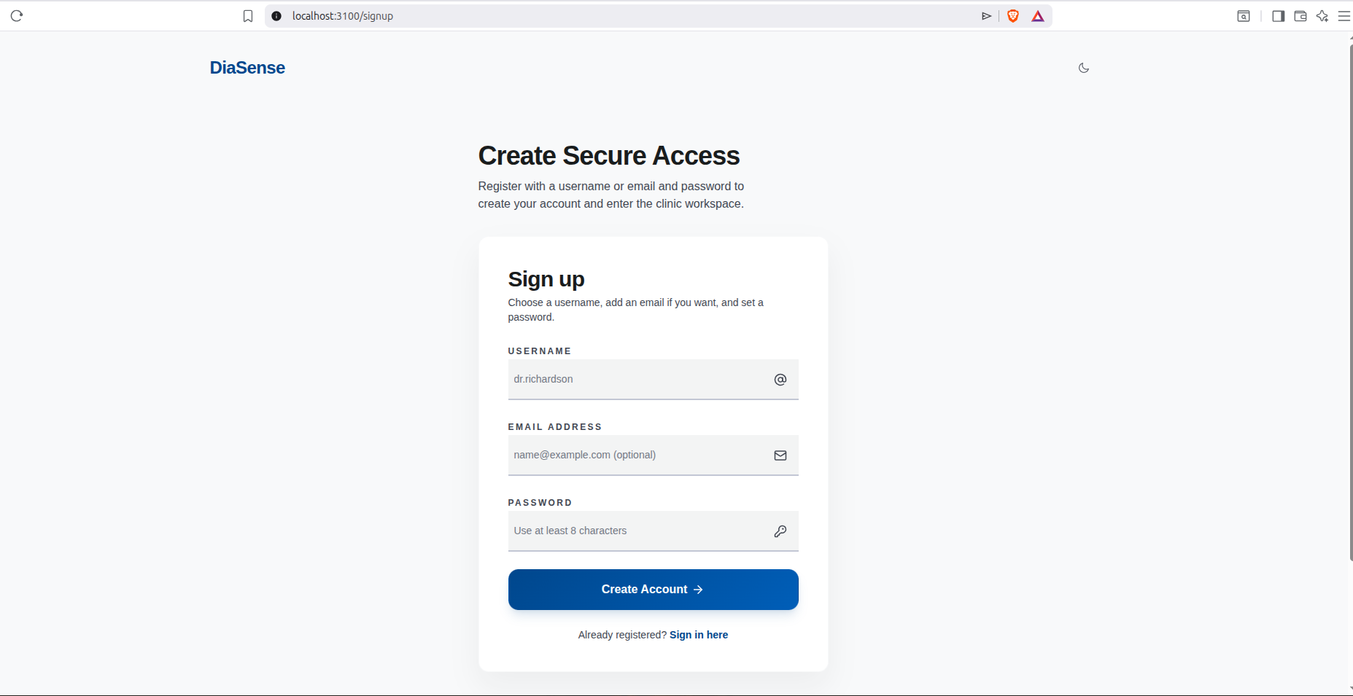Figure 2: Signup Page

- How to login
  - open the login page
  - Enter your username or email
  - enter your password
  - select Sign in to clinic

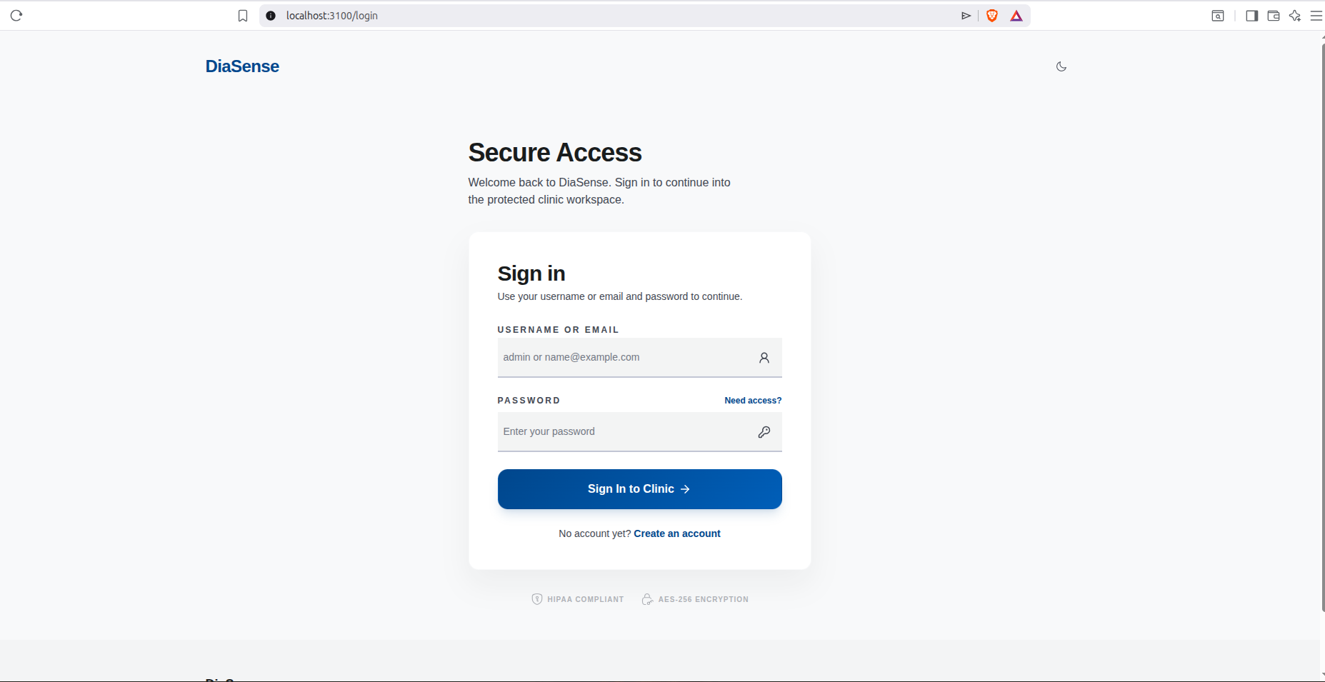Figure 3: Login Page
- How To Enter Assessment Values
  - Open Assesment page from the clinic menu
  - Enter these values
    - pregnancies
    - Glucose
    - Blood Pressure
    - Skin thickness
    - Insulin
    - BMI
    - Diabetes Pedigree Function
    - Age
  - NOTE:
    - Use numbers only
    - double-check decimal point where needed
    - clinicians and admins can choose a patient account before submitting
  - Accepted Value Ranges in the current system:
    - Pregnancies: 0 to 30
    - Glucose: 0 to 300
    - Blood Pressure: 0 to 200
    - Skin Thickness: 0 to 100
    - Insulin: 0 to 1000
    - BMI: 0 to 100
    - Diabetes Pedigree Function: 0 to 10
    - Age: 1 to 120
Patient self Assessment
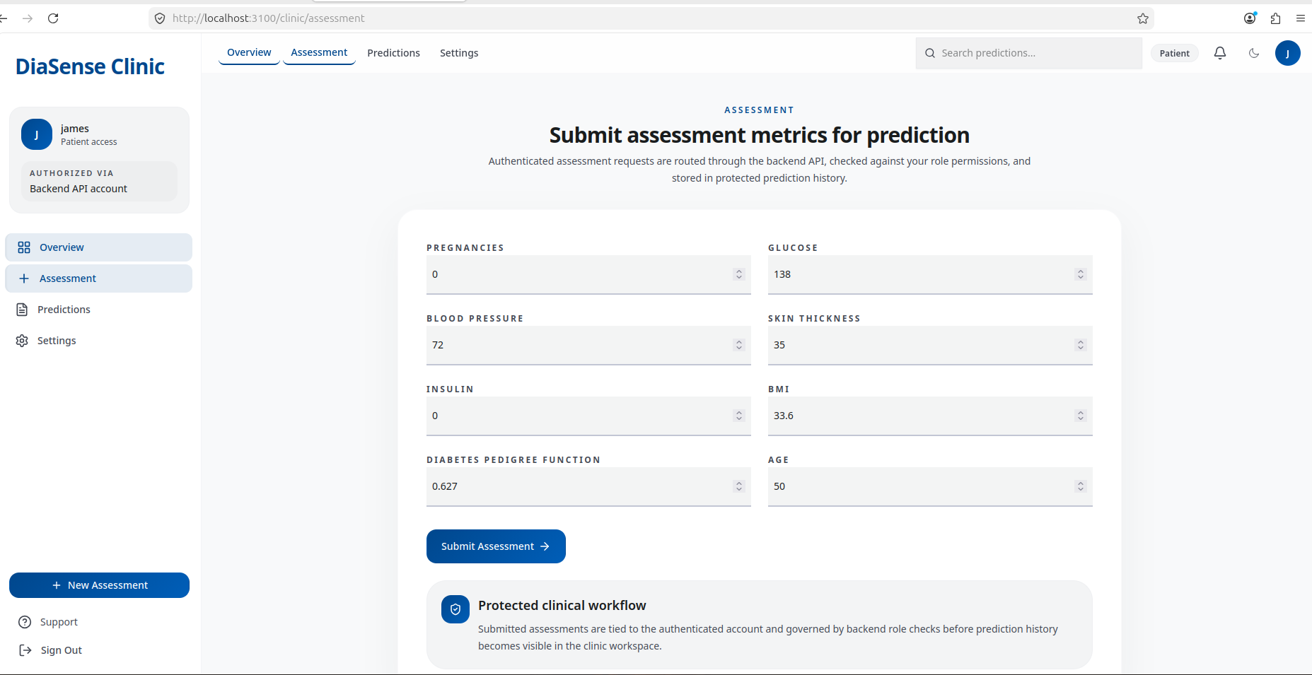Figure 4: Patient Self Assessment
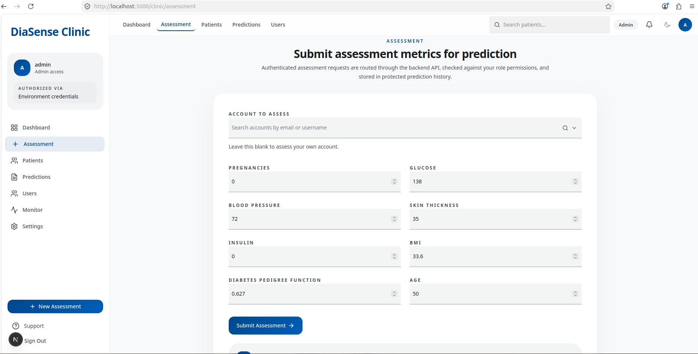Figure 5: Clinician and Admin Assessment
- How To Submit An Assessment
  - Enter the values.
  - Select Submit Assessment.
  - Wait for the result card to appear.
After a successful submission, the screen shows:
    - risk band
    - probability percentage
    - interpretation text
    - patient account used
    - submitter identity
    - latency
    - top contributing factors, if available
- How To Interpret The Result
DiaSense groups the prediction into one of three risk bands:
  - Low: probability below 0.33
  - Moderate: probability from 0.33 up to but not including 0.66
  - High: probability 0.66 or higher
What the result means:
  - Low means the model saw a relatively lower predicted risk from the provided values
  - Moderate means the model saw a meaningful risk signal and the result should be reviewed carefully
  - High means the model saw a strong risk signal and follow-up is strongly recommended
Again, this is not a diagnosis.

- How To View Prediction History
  - Open Predictions from the clinic menu.
  - Review the list of saved assessments
  - The page shows:
    - creation time
    - patient account
    - submitter
    - risk band
    - probability
    - interpretation
Patients will normally see only their own history.
Clinicians and admins can view broader clinic history and filter by patient.
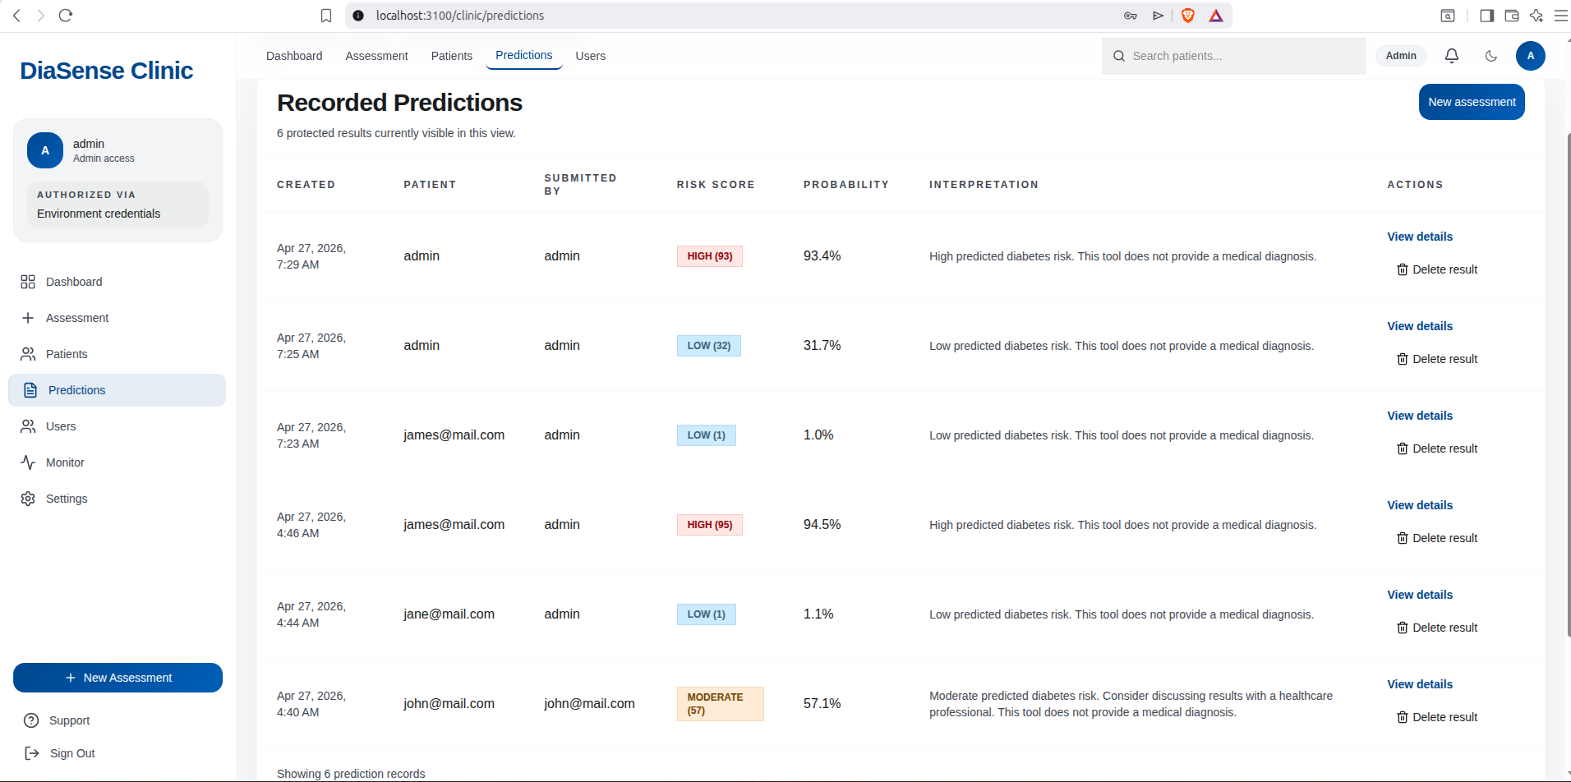Figure 6: Assesment Predictions
- How To View Prediction Details
  - Open the Predictions page.
  - Select View details for any record.
The detail page shows:
    - all submitted assessment values
    - patient and submitter information
    - the calculated risk band
    - probability
    - interpretation
    - top factors, when available
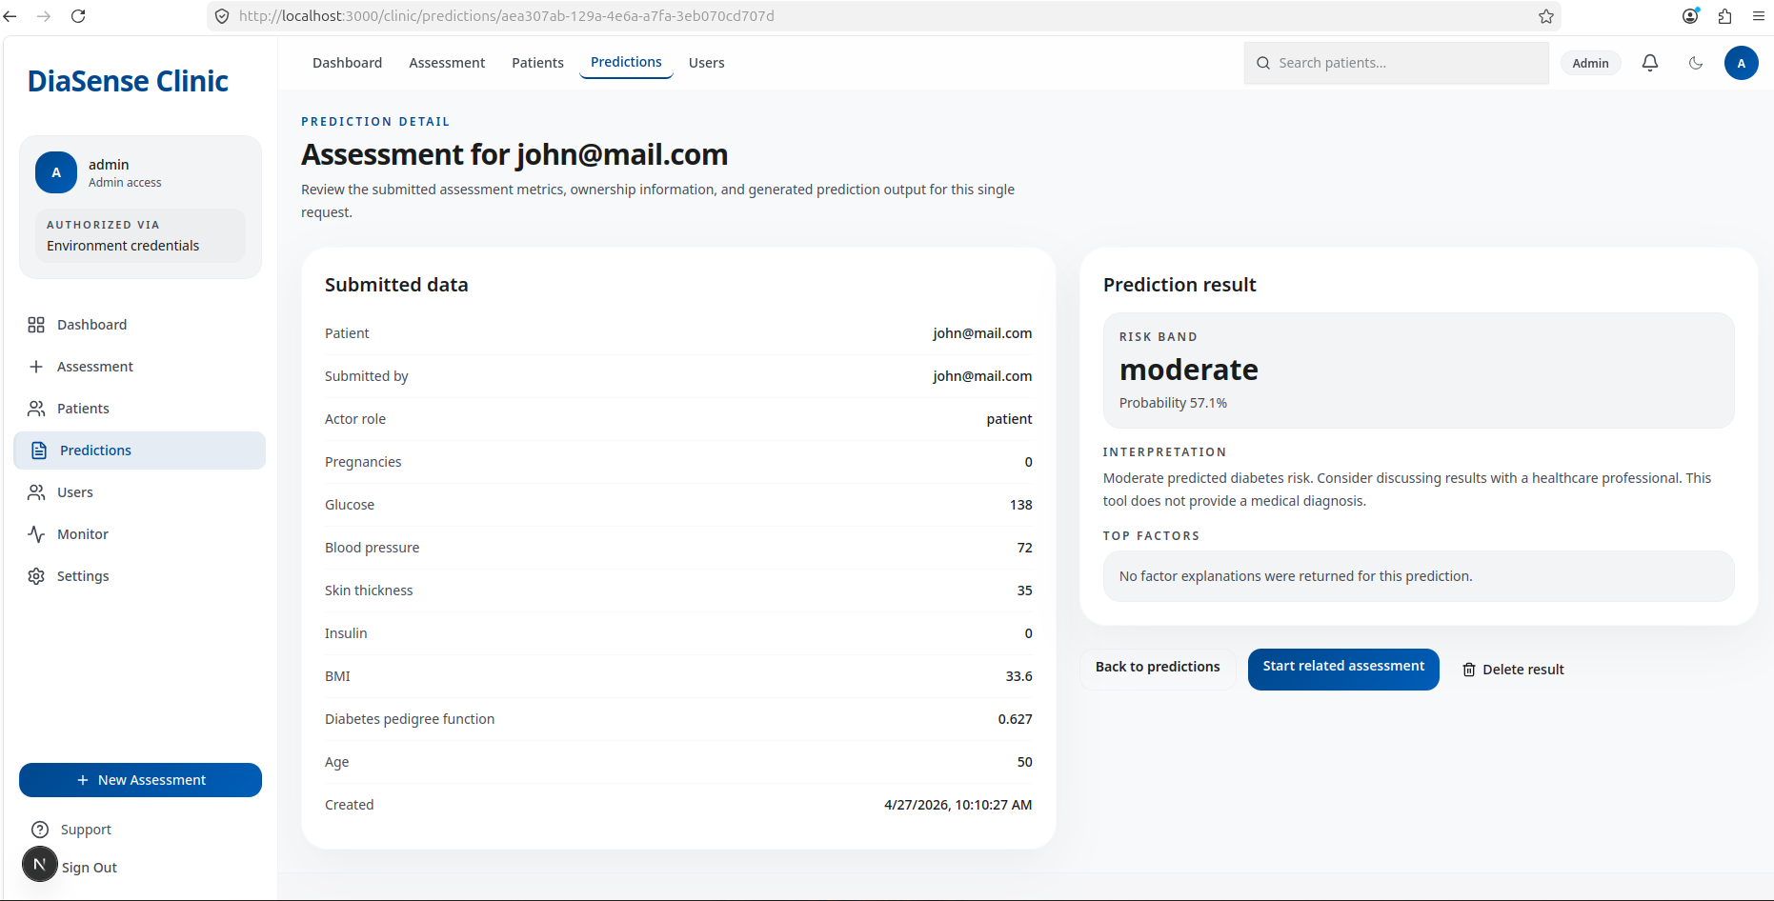Figure 7: Prediction Details

- How To Add New Patients
This option is available to clinicians and admins.
  - Open Patients.
  - Select Add patient.
  - Enter:
    - username,
    - email,
  - Enter a temporary password.
  - Select Create patient.
The new patient can then sign in with the provided username/email and password.
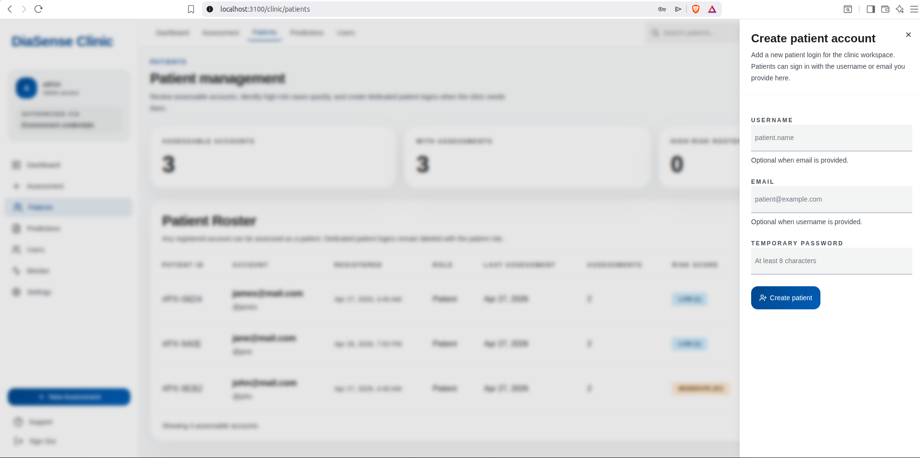Figure 8: Create a patient
- How To Reset Your Password
  - Open Settings.
  - Enter your current password.
  - Enter a new password.
  - Enter the same new password again in the confirmation field.
  - Select Update password.
If the update succeeds, a confirmation message appears.
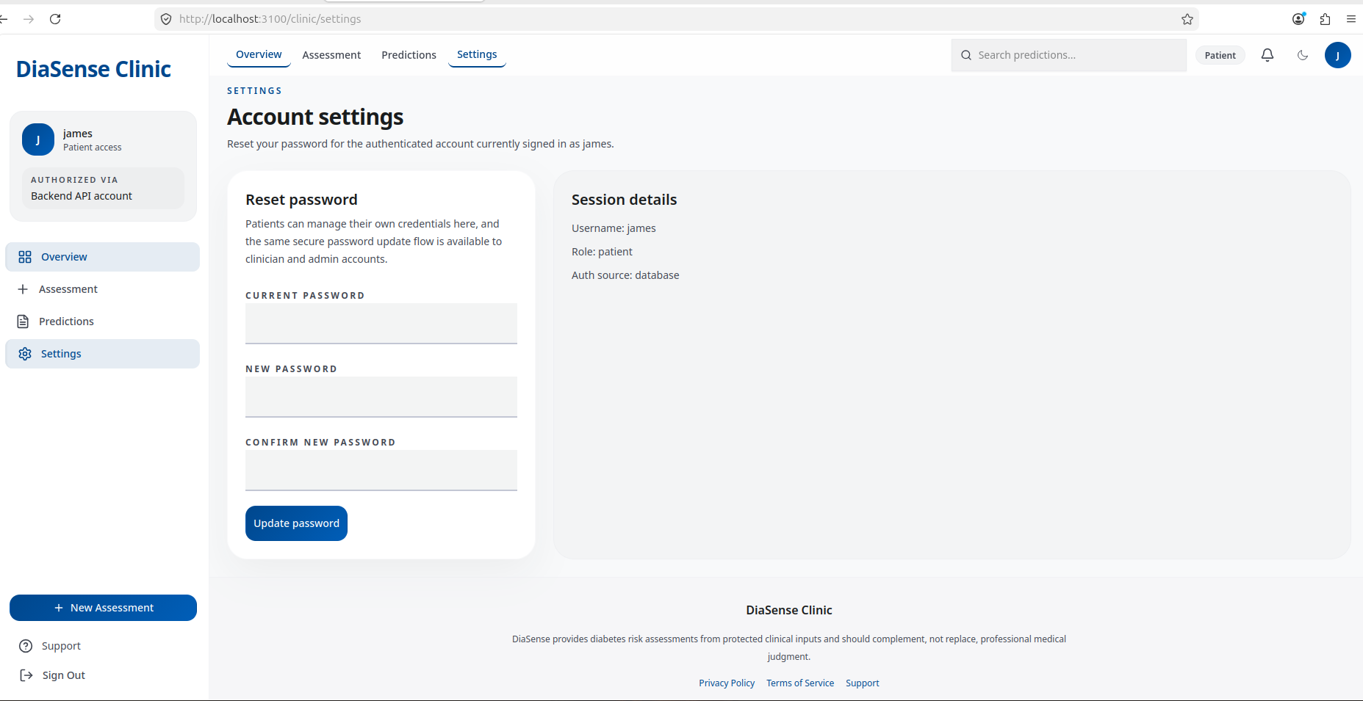Figure 9: Reset Password

- What To Do If Something Goes Wrong
If you see an error:
- retry the action once
- make sure all required fields are filled
- check that numeric values are within the expected ranges
- if the page says the backend is unavailable, contact the technical operator
- if you cannot sign in, ask the admin to confirm your account exists and your role is correct

- Role Summary
  - Patient
    - run self-assessments
    - view own predictions
    - reset own password
  - Clinician
    - all patient capabilities
    - assess patient accounts
    - create and remove patient accounts
    - view patient prediction history
  - Admin
    - all clinician capabilities
    - manage user roles
    - open the monitor page
    - inspect operational status

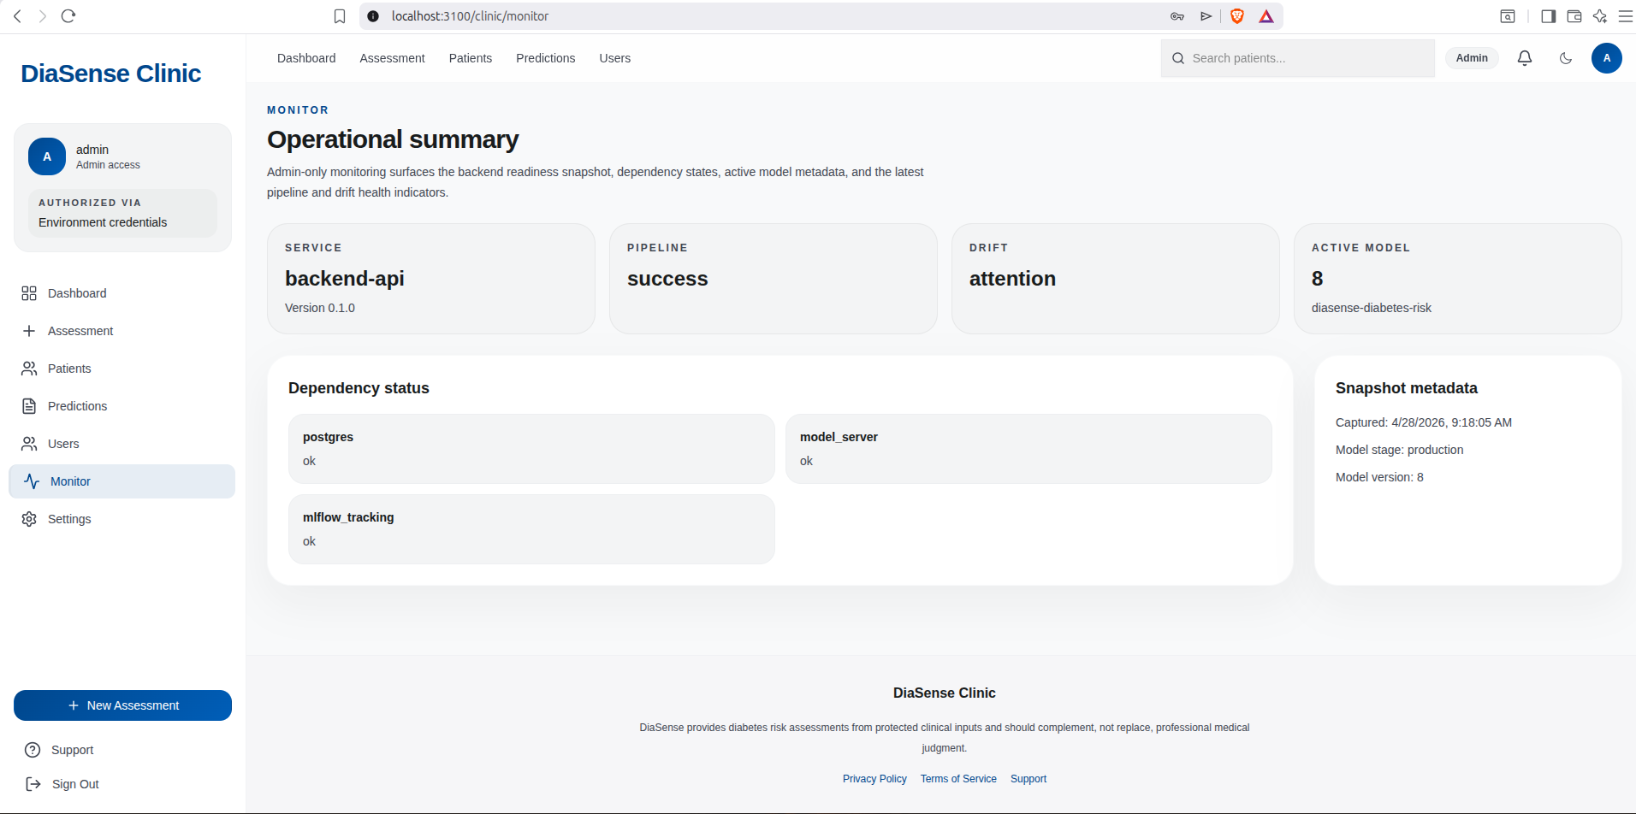Figure 10: Monitor Page

