VIVEKANANDA INSTITUTE OF PROFESSIONAL STUDIES-TC
VIVEKANANDA SCHOOL OF INFORMATION TECHNOLOGY

MASTER OF COMPUTER APPLICATIONS
MediAssist: Smart Prescription Scanner and Medicine Reminder System
Minor Project Synopsis Report
Guru Gobind Singh Indraprastha University

SUBMITTED TO:  Dr. Cosmina  Project Mentor  VSIT, VIPS-TC | SUBMITTED BY:  Haardik Goel  Enroll. no.: 09417704426  MCA 1 (B)

DECLARATION
I, Haardik Goel, a student of Master of Computer Applications, MCA 1 (B), Enrollment No. 09417704426, hereby declare that the synopsis entitled “MediAssist: Smart Prescription Scanner and Medicine Reminder System”, submitted to Vivekananda Institute of Professional Studies-TC (VIPS-TC), affiliated to Guru Gobind Singh Indraprastha University, Delhi, is a record of my own work carried out under the guidance of Dr. Cosmina. To the best of my knowledge, the contents of this synopsis have not been submitted elsewhere for any other degree or diploma.
Haardik Goel
Enroll. No.: 09417704426
MCA 1 (B)
Place: Delhi

ACKNOWLEDGEMENT
I express my sincere gratitude to my project mentor, Dr. Cosmina, for her valuable guidance, encouragement and constructive feedback during the preparation of this synopsis. I also thank Vivekananda School of Information Technology, VIPS-TC, for providing the opportunity and the academic environment to undertake this project, and my peers and family for their continued support.
Haardik Goel

ABSTRACT
Medication non-adherence, caused in part by prescriptions that are difficult to read, remember and act upon, reduces the effectiveness of treatment, particularly among elderly patients. This synopsis proposes MediAssist, a web-based medical assistant that converts a photographed or uploaded prescription into a structured, personalised medicine schedule. The system applies image preprocessing and Optical Character Recognition (OCR) to extract text, uses natural language processing, rule-based parsing and fuzzy matching to identify medicine names, strengths, frequencies and durations, and interprets notations such as OD, BD, TDS and 1-0-1 into clear daily dose times. After the user confirms or corrects the extracted data, prescriptions are stored in a secure personal vault, real-time browser push reminders are scheduled with taken, snooze and skip actions, and a medicine locator guides the user to online pharmacies and nearby stores using the browser’s geolocation. The system is to be implemented with HTML, CSS and JavaScript on the client, Python (Flask or FastAPI) on the server, OpenCV with Tesseract or EasyOCR for text extraction, spaCy and RapidFuzz for parsing, and SQLite or PostgreSQL for storage. This report presents the ideology, objectives, scope, system design including data flow and entity-relationship diagrams, methodology, workflow, testing plan, expected outcomes and limitations of the project.
Index Terms—Prescription digitization, optical character recognition, medication adherence, natural language processing, push notifications, geolocation, web application.

CONTENTS
DECLARATION i
ACKNOWLEDGEMENT i
ABSTRACT ii
I. INTRODUCTION 1
A. Background 1
B. Motivation 1
C. Ideology and Vision 1
D. Organization of this Report 2
II. PROBLEM STATEMENT 2
A. Problem Description 2
B. Limitations of Existing Approaches 2
C. Gap Analysis 2
III. OBJECTIVES 3
A. Primary Objectives 3
B. Secondary Objectives 3
IV. SCOPE OF THE PROJECT 3
A. In Scope 3
B. Out of Scope 4
C. Assumptions and Constraints 4
V. LITERATURE REVIEW AND RELATED TECHNOLOGIES 4
A. Optical Character Recognition 4
B. Image Preprocessing 4
C. Natural Language Processing and Fuzzy Matching 4
D. Notifications and Scheduling 4
E. Geolocation and Maps 5
F. Data Modelling 5
VI. PROPOSED SYSTEM AND MODULES 5
A. System Overview 5
B. Module Description 5
VII. SYSTEM REQUIREMENTS 6
A. Functional Requirements 6
B. Non-Functional Requirements 6
C. Technology Stack 7
D. Hardware and Software Requirements 7
VIII. SYSTEM DESIGN 8
A. System Architecture 8
B. Data Flow Diagram 8
C. Entity-Relationship Diagram 9
D. Data Dictionary 11
E. Security and Privacy Design 11
IX. METHODOLOGY 12
A. Development Model 12
B. Processing Pipeline 12
C. Image Preprocessing 12
D. Prescription Parsing and Frequency Interpretation 12
E. Reminder Scheduling 13
F. Medicine Locator 13
X. WORKFLOW 14
A. Overall Workflow 14
B. Reminder Lifecycle 15
XI. TESTING AND EVALUATION PLAN 15
A. Testing Levels 15
B. Evaluation Metrics 15
C. Sample Test Cases 16
XII. PROJECT TIMELINE 16
XIII. EXPECTED OUTCOMES 16
XIV. LIMITATIONS AND FUTURE SCOPE 17
A. Limitations 17
B. Future Scope 17
XV. CONCLUSION 17
REFERENCES 17

LIST OF FIGURES
Fig. 1. Layered system architecture of MediAssist. 8
Fig. 2. Level-1 data flow diagram of MediAssist. 9
Fig. 3. Entity-relationship diagram of the MediAssist database. 10
Fig. 4. Workflow of the MediAssist system. 14

LIST OF TABLES
TABLE I Comparison of the Manual Approach and MediAssist 3
TABLE II Summary of System Modules 5
TABLE III Functional Requirements 6
TABLE IV Technology Stack 7
TABLE V Recommended Hardware and Software Requirements 7
TABLE VI Relationships Between Entities 11
TABLE VII Entities and Their Attributes 11
TABLE VIII Interpretation of Frequency Notations 13
TABLE IX States in the Reminder Lifecycle 15
TABLE X Sample Test Cases 16
TABLE XI Proposed Project Timeline 16

I. INTRODUCTION

A. Background
A prescription is the primary written instruction through which a doctor communicates a treatment plan to a patient. It carries the medicine names, strengths, dosage frequencies and durations that the patient must follow exactly. In practice, prescriptions are often handwritten, compressed into clinical abbreviations such as OD, BD, TDS and numeric patterns such as 1-0-1, and are easily misread by patients, especially the elderly and first-time users of long-term medication.
Following a prescription correctly is a well-recognised public-health concern. The World Health Organization identifies poor adherence to long-term therapy as a major obstacle to treatment effectiveness and reports that in developed countries adherence among patients with chronic illness averages only about 50% [1]. Missed or wrongly timed doses therefore directly reduce the benefit of the treatment that the patient has already paid for and the doctor has already planned.

B. Motivation
Patients repeatedly face three practical problems after leaving the clinic: reading what has been written, remembering when each medicine must be taken, and finding where the medicines can be bought. Each problem is currently solved separately and manually. At the same time, the technology needed to solve all three together is now widely available: smartphones with cameras, mature open-source Optical Character Recognition (OCR) and Natural Language Processing (NLP) libraries, browser push notifications and location services. This project is motivated by the opportunity to join these capabilities into a single, simple web application.

C. Ideology and Vision
MediAssist is built on a set of guiding principles that shape every design decision in this report:
- Assistive, not prescriptive. The system helps the patient understand and follow the doctor’s instructions; it never diagnoses, changes a dose or replaces the advice of a doctor or pharmacist.
- Human-in-the-loop verification. Automatic extraction can be wrong, particularly on handwriting. Every extracted medicine must be confirmed or corrected by the user before any reminder is created.
- Simplicity and accessibility. The interface is designed so that an elderly user or a caregiver can scan a prescription and receive a clear schedule with a minimum number of steps.
- Privacy by design. Prescriptions are sensitive personal health information. The system stores data per user account, secures it with authentication, and follows the principles of lawful and limited processing of personal data reflected in India’s Digital Personal Data Protection Act, 2023 [2].
- Open, low-cost and platform independent. The solution relies on open-source tools and runs in a standard web browser, so no special hardware or app installation is required.
- End-to-end continuity. The project covers the whole journey of a prescription: scan, understand, remember and procure.
The vision of the project is a dependable digital companion that turns a piece of paper into a clear daily routine, so that no patient has to guess what to take, when to take it, or where to get it.

D. Organization of this Report
Section II defines the problem and Section III lists the objectives. Section IV sets the scope, and Section V reviews the related technologies. Sections VI and VII describe the proposed system, its modules and requirements, while Section VIII presents the system design with the architecture, data flow and entity-relationship diagrams. Sections IX and X explain the methodology and workflow. Section XI gives the testing plan, Section XII the project timeline, Sections XIII and XIV the expected outcomes, limitations and future scope, and Section XV concludes the report.

II. PROBLEM STATEMENT

A. Problem Description
Prescriptions are often handwritten, use abbreviations (OD, BD, TDS, 1-0-1) and are easily misunderstood. Missed or wrong doses reduce treatment effectiveness. Patients also lose time searching for medicine availability across stores and websites. There is no single, simple tool that reads a prescription, converts it into a verified schedule, reminds the patient at the right time and helps the patient locate the medicines.

B. Limitations of Existing Approaches
- Patients or relatives read the prescription manually and may misinterpret handwriting or abbreviations.
- General-purpose alarm and reminder applications require the user to type every medicine name and dose time by hand, which is error-prone and tedious for elderly users.
- Reminders from such tools are not linked to the prescription, so there is no record of what was prescribed, for how long, or whether a dose was taken.
- Finding a medicine requires separate manual searches on pharmacy websites and maps, repeated for each medicine.

C. Gap Analysis
Table I compares the manual approach with the proposed system and highlights the gap that MediAssist is intended to fill.
TABLE I
Comparison of the Manual Approach and MediAssist
Capability | Manual approach / generic alarms | Proposed MediAssist system
Reading the prescription | Done by the patient; prone to misreading | Automatic OCR followed by user confirmation
Interpreting OD, BD, TDS, 1-0-1 | Depends on the patient’s knowledge | Rule-based conversion into a daily schedule
Creating the schedule | Manual entry of each medicine and time | Generated automatically from the confirmed data
Reminders | Plain alarms without dose context | Dose-aware push alerts with taken / snooze / skip
Record keeping | Paper or none | Prescriptions and dose history stored in a personal vault
Finding medicines | Separate searches on websites and maps | Online pharmacy links and nearby store map in one place

III. OBJECTIVES

A. Primary Objectives
- Extract medicine names, dosage and frequency from prescription images using OCR.
- Interpret frequency notations into a clear daily schedule (for example, “1-0-1” means morning and night).
- Store prescriptions and schedules in a personal user account.
- Send real-time reminders at the correct dose times.
- Recommend online pharmacies and detect the user’s location to list nearby medical stores.

B. Secondary Objectives
- Provide a mandatory confirmation and editing step so that the user always verifies extracted data.
- Protect user data through authentication, per-user data isolation and secure storage.
- Offer a responsive, easy-to-use interface that works on both mobile and desktop browsers.
- Design the system as independent modules that can be tested and improved separately.
- Evaluate extraction accuracy and reminder reliability using a defined testing plan.

IV. SCOPE OF THE PROJECT

A. In Scope
- Upload of a prescription image or capture through the device camera.
- Image preprocessing, OCR, parsing of medicine name, strength, frequency and duration.
- User registration, secure login, and storage of prescriptions and history.
- Scheduling and delivery of browser push reminders with taken, snooze and skip actions.
- Online pharmacy search links and a map of nearby stores based on browser geolocation.

B. Out of Scope
- Medical diagnosis, dose recommendation or any substitute for professional medical advice.
- Online ordering, payment and delivery of medicines.
- A native mobile application, drug-interaction checking and price comparison (listed as future scope).

C. Assumptions and Constraints
- The prescription image is reasonably clear, well lit and in focus.
- The user has an internet connection and a modern browser that supports Service Workers, push notifications and geolocation.
- The user grants notification and location permissions when requested.
- The medicine reference database covers the commonly prescribed medicines used for matching.

V. LITERATURE REVIEW AND RELATED TECHNOLOGIES

A. Optical Character Recognition
OCR converts text in an image into machine-readable characters. Tesseract is an open-source OCR engine whose architecture was described by Smith [3] and is widely used for printed text. EasyOCR is an open-source, deep-learning-based OCR library that supports many languages [4]. Both perform well on clean printed text, but accuracy falls on handwriting, low-resolution images and unusual layouts, which is why MediAssist treats OCR output as a draft that the user must confirm.

B. Image Preprocessing
The quality of OCR strongly depends on the input image. Common preprocessing steps are grayscale conversion, noise removal and binarisation. Otsu’s method [5] selects a global threshold automatically from the grey-level histogram, and adaptive thresholding handles uneven lighting. The OpenCV library [6] provides efficient implementations of these operations and is used in the Scanner module.

C. Natural Language Processing and Fuzzy Matching
After OCR, the raw text must be converted into structured fields. The spaCy library [7] provides tokenisation and rule-based matching, which can be combined with regular expressions to detect strengths (for example, 500 mg), frequencies (OD, BD, 1-0-1) and durations (for example, 5 days). Because OCR may misspell a medicine name, approximate string matching based on edit distance is used to match the extracted name against a reference database; the RapidFuzz library [8] offers fast implementations for this purpose.

D. Notifications and Scheduling
The Push API and Service Workers allow a web application to receive messages from a server and display notifications even when the page is not in the foreground [9]. A server-side scheduler such as APScheduler or Celery triggers the push messages at the computed dose times.

E. Geolocation and Maps
The HTML5 Geolocation API lets a web page obtain the user’s position after explicit permission [10]. The position can be used to query OpenStreetMap data through the Overpass API [11] for nearby pharmacies, and the results can be displayed using the Leaflet mapping library [12]. Google Places is an alternative data source.

F. Data Modelling
The entity-relationship model proposed by Chen [13] describes data in terms of entities, attributes and relationships and remains the standard way to design relational databases. It is used in Section VIII to model the MediAssist database.

VI. PROPOSED SYSTEM AND MODULES

A. System Overview
MediAssist is a web-based medical assistant that scans a prescription image, extracts the medicines and their dosage frequency, stores them, reminds the user in real time and guides the user to online and nearby stores. The system is organised into five cooperating modules, summarised in Table II.
TABLE II
Summary of System Modules
Module | Input | Core technique | Output
Prescription Scanner | Uploaded or camera image | Preprocessing and OCR | Raw extracted text
Medicine Parser | Raw text | NLP, regular expressions, fuzzy matching | Medicine, strength, frequency, duration
Prescription Vault | Confirmed data, credentials | Authentication and database storage | Saved prescriptions and history
Reminder Engine | Dose schedule | Scheduler and Web Push | Notifications and dose log
Medicine Locator | Medicine name, location | Search links, Geolocation, map API | Pharmacy links and nearby store map

B. Module Description

1) Prescription Scanner
The user uploads an image or captures one with the device camera. The module validates the file type and size, applies preprocessing (grayscale conversion, denoising and thresholding) and passes the cleaned image to the OCR engine, which returns the extracted text.

2) Medicine Parser
This module applies NLP and rule-based extraction to identify the drug name, strength, frequency and duration from the OCR text. Names are matched against a medicine database, and low-confidence matches are flagged so that the user can review them. Frequency notations are converted into explicit dose times (Section IX-D).

3) Prescription Vault
The vault provides secure registration and login and stores each user’s prescriptions, schedules and dose history. Passwords are stored only as salted hashes, and every query is restricted to the authenticated user’s own records.

4) Reminder Engine
A scheduler creates a job for every dose time and triggers browser push notifications. Each notification offers three actions: taken, snooze and skip, and the chosen action is recorded in the dose log.

5) Medicine Locator
For each medicine, the module provides online pharmacy search links and, using the browser’s geolocation, shows a map of nearby medical stores so that the user can decide where to buy.

VII. SYSTEM REQUIREMENTS

A. Functional Requirements
TABLE III
Functional Requirements
ID | Requirement
FR1 | The system shall allow a user to register and log in with secure credentials.
FR2 | The system shall accept a prescription image by file upload or camera capture.
FR3 | The system shall preprocess the image (grayscale, denoising, thresholding) before OCR.
FR4 | The system shall extract text from the image using OCR.
FR5 | The system shall identify medicine name, strength, frequency and duration from the text.
FR6 | The system shall interpret frequency notations (OD, BD, TDS, 1-0-1, etc.) into a daily schedule.
FR7 | The system shall show the extracted data for confirmation and allow the user to edit it before saving.
FR8 | The system shall store prescriptions, schedules and history in the user’s personal account.
FR9 | The system shall send push reminders at the scheduled dose times.
FR10 | The system shall allow the user to mark a dose as taken, snoozed or skipped and shall log the action.
FR11 | The system shall provide online pharmacy search links for each medicine.
FR12 | The system shall detect the user’s location, with permission, and display nearby medical stores on a map.
FR13 | The system shall allow the user to view and delete saved prescriptions and history.

B. Non-Functional Requirements
- Security: salted password hashing, HTTPS for all communication, session or token-based authentication and validation of uploaded files.
- Privacy: per-user data isolation, collection of only the data needed for the service, and the ability for users to delete their data.
- Usability: a simple, responsive interface with readable text and a small number of steps, suitable for elderly users and caregivers.
- Performance: image processing and extraction should complete within a short, acceptable waiting time, and reminders should be delivered close to the scheduled time.
- Reliability: the scheduler must not lose reminders after a server restart; schedules are persisted in the database.
- Portability and maintainability: the application runs in standard browsers and is organised into independent modules.

C. Technology Stack
Table IV lists the tools selected for each layer. Python web frameworks such as Flask [14] or FastAPI [15] expose the REST API used by the browser client.
TABLE IV
Technology Stack
Layer | Tools
Frontend | HTML, CSS, JavaScript (optional React), Service Workers for notifications
Backend | Python with Flask or FastAPI
OCR and Image Processing | Tesseract or EasyOCR, OpenCV
NLP and Parsing | spaCy, regular expressions, fuzzy matching (RapidFuzz)
Database | SQLite / PostgreSQL
Scheduling | APScheduler or Celery, Web Push API
Location and Maps | HTML5 Geolocation API, Google Places API or OpenStreetMap (Overpass) with Leaflet

D. Hardware and Software Requirements
TABLE V
Recommended Hardware and Software Requirements
Item | Requirement
Client device | Smartphone, tablet or computer with a camera and a stable internet connection
Client browser | Modern browser supporting Service Workers, Push notifications and Geolocation (for example, Chrome, Edge or Firefox)
Development machine | Processor equivalent to Intel Core i5, 8 GB RAM or more, and sufficient free disk space
Operating system | Windows, Linux or macOS
Languages and runtimes | Python 3, JavaScript
Libraries and engines | Tesseract OCR engine or EasyOCR, OpenCV, spaCy, RapidFuzz, Flask or FastAPI, APScheduler
Database | SQLite for development, PostgreSQL for deployment
Tools | Code editor (for example, Visual Studio Code), Git for version control

VIII. SYSTEM DESIGN

A. System Architecture
MediAssist follows a three-layer architecture, shown in Fig. 1. The presentation layer runs in the user’s browser and contains the upload and camera interface, the review and edit screen, the dashboard, a Service Worker for push alerts and the Geolocation API. The application layer is a REST API built with Flask or FastAPI and contains the authentication, scanner, parser, reminder and locator modules. The data and external services layer contains the relational database, image storage, the medicine reference database and the external Web Push and map services.
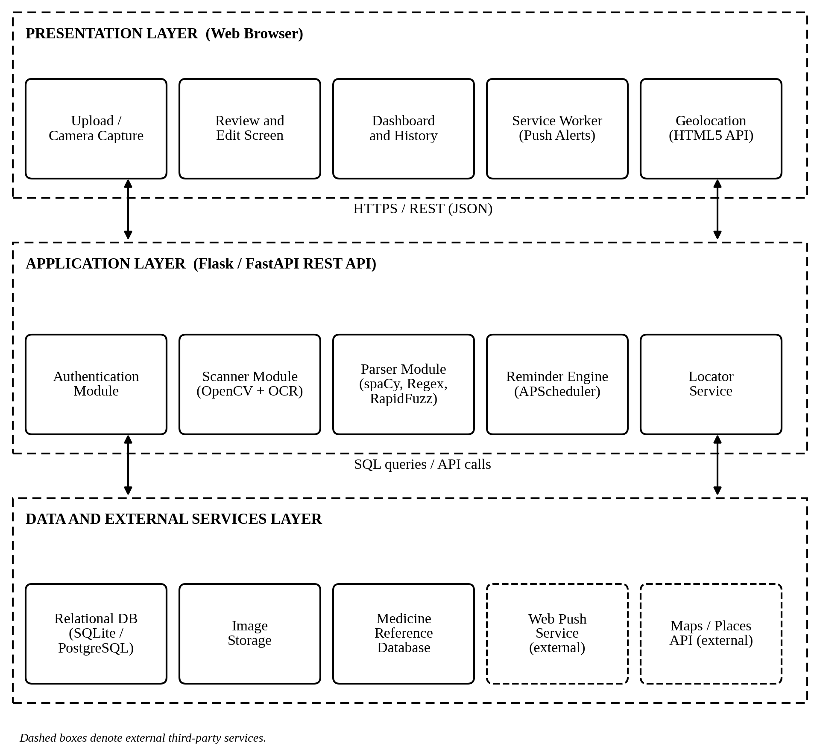
Fig. 1. Layered system architecture of MediAssist.

B. Data Flow Diagram
Fig. 2 shows the Level-1 data flow diagram. The user interacts with five processes: authentication (1.0), scanning and text extraction (2.0), parsing and verification (3.0), scheduling and reminders (4.0) and medicine location (5.0). Processes read and write four data stores: users (D1), prescriptions (D2), the medicine database (D3) and reminders with the dose log (D4). The Web Push service delivers notifications, and the maps and places service supplies nearby store data.
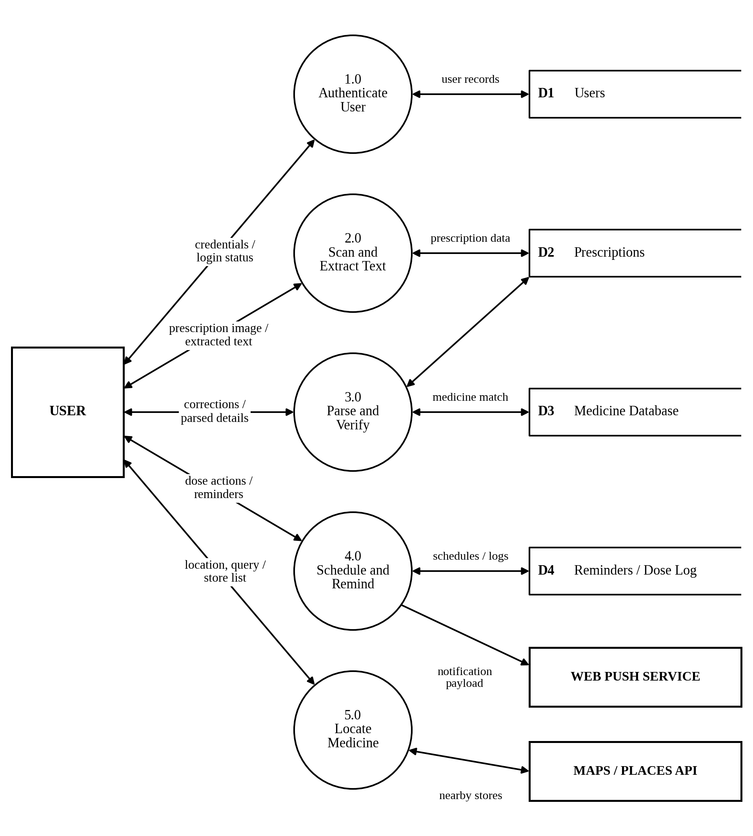
Fig. 2. Level-1 data flow diagram of MediAssist.

C. Entity-Relationship Diagram
The database is modelled using the entity-relationship approach [13] and is shown in Fig. 3. A user uploads many prescriptions; each prescription contains many prescription items, and each item refers to one entry in the medicine reference table. Every item can have many reminders, and every reminder records many dose log entries. A user can also register many push subscriptions for receiving notifications on different devices. Primary keys are marked [PK] and foreign keys [FK].
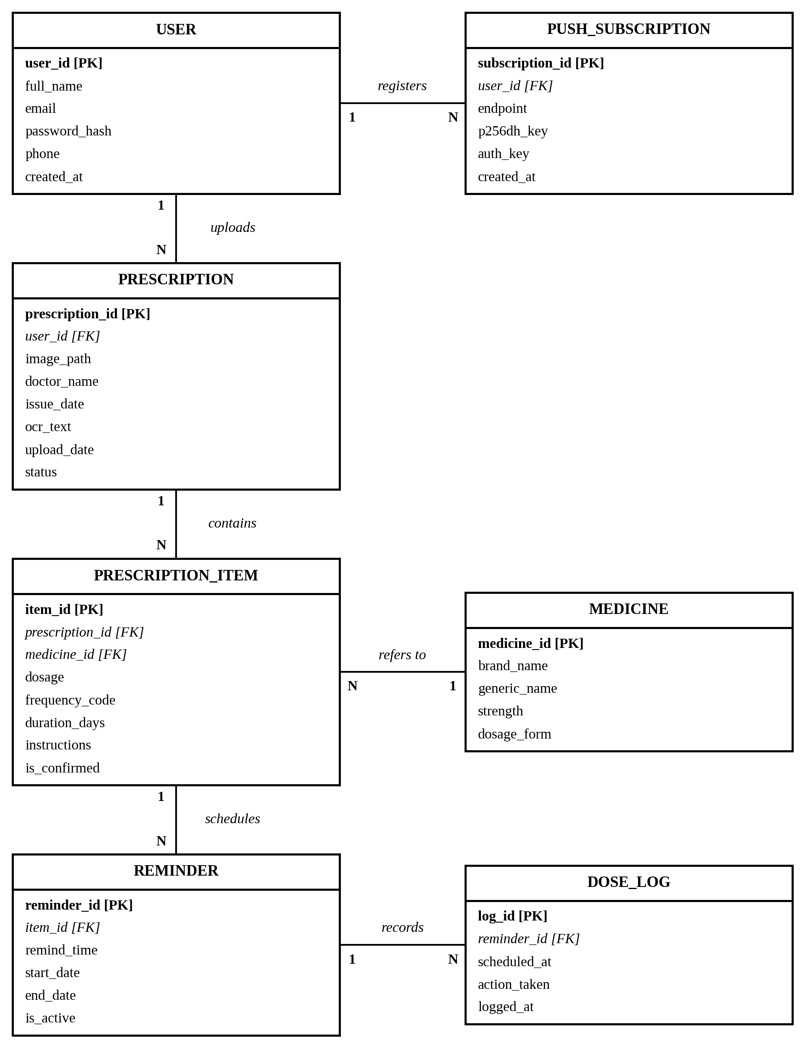
Fig. 3. Entity-relationship diagram of the MediAssist database.
TABLE VI
Relationships Between Entities
Relationship | Entities | Cardinality | Description
uploads | USER – PRESCRIPTION | 1 : N | A user uploads many prescriptions
contains | PRESCRIPTION – PRESCRIPTION_ITEM | 1 : N | A prescription lists many medicine items
refers to | PRESCRIPTION_ITEM – MEDICINE | N : 1 | Many items refer to one reference medicine
schedules | PRESCRIPTION_ITEM – REMINDER | 1 : N | An item has one or more dose reminders
records | REMINDER – DOSE_LOG | 1 : N | A reminder has many logged dose actions
registers | USER – PUSH_SUBSCRIPTION | 1 : N | A user registers devices for push alerts

D. Data Dictionary
TABLE VII
Entities and Their Attributes
Entity | Attributes | Purpose
USER | user_id (PK), full_name, email, password_hash, phone, created_at | Account holder
PRESCRIPTION | prescription_id (PK), user_id (FK), image_path, doctor_name, issue_date, ocr_text, upload_date, status | Uploaded prescription
PRESCRIPTION_ITEM | item_id (PK), prescription_id (FK), medicine_id (FK), dosage, frequency_code, duration_days, instructions, is_confirmed | One medicine line
MEDICINE | medicine_id (PK), brand_name, generic_name, strength, dosage_form | Reference database
REMINDER | reminder_id (PK), item_id (FK), remind_time, start_date, end_date, is_active | Scheduled dose time
DOSE_LOG | log_id (PK), reminder_id (FK), scheduled_at, action_taken, logged_at | Taken / snoozed / skipped
PUSH_SUBSCRIPTION | subscription_id (PK), user_id (FK), endpoint, p256dh_key, auth_key, created_at | Device for push alerts

E. Security and Privacy Design
- Passwords are stored only as salted hashes (for example, using bcrypt); plain-text passwords are never saved.
- All traffic between the browser and server uses HTTPS, and sessions or tokens expire after a period of inactivity.
- Each database query is filtered by the authenticated user’s identifier so that one user can never read another user’s prescriptions.
- Uploaded files are checked for type and size, stored outside the public web directory and served only to their owner.
- Users can delete a prescription and its related schedules and history at any time.

IX. METHODOLOGY

A. Development Model
The project follows an iterative and incremental development model. The work is divided into phases of requirement analysis, design, module-wise implementation, integration, testing and documentation. Modules are built in a logical order (vault, scanner, parser, reminder engine and locator) so that each increment can be tested independently before it is integrated with the others.

B. Processing Pipeline
The overall methodology follows the pipeline described below. The user uploads a prescription, the image is preprocessed, OCR extracts text, the parser identifies medicines and schedules, the user confirms or corrects the results, data is saved, reminders are scheduled and the locator suggests where to buy each medicine.
- Acquisition: the user uploads an image or captures it with the camera.
- Preprocessing: the image is converted to grayscale, denoised and thresholded.
- Text extraction: the OCR engine returns the text of the prescription.
- Parsing: medicine name, strength, frequency and duration are identified and matched with the medicine database.
- Confirmation: the user reviews, corrects and approves the extracted data.
- Storage: the confirmed prescription and schedule are saved to the user’s vault.
- Scheduling: dose times are computed and reminder jobs are created.
- Notification: a push reminder is sent at each dose time and the user’s action is logged.
- Location: the locator shows online pharmacy links and nearby stores for each medicine.

C. Image Preprocessing
Preprocessing improves OCR accuracy. The image is first converted to grayscale to remove colour information. Noise is then reduced using filtering or denoising functions of OpenCV [6]. Finally, thresholding converts the image to black text on a white background, using Otsu’s method [5] for evenly lit images and adaptive thresholding for uneven lighting. Where required, the image is also resized and straightened (deskewed) before OCR.

D. Prescription Parsing and Frequency Interpretation
The parser splits the OCR text into lines and processes each line to extract the medicine name, strength, frequency and duration using regular expressions and spaCy rules [7]. The extracted name is compared with the medicine database using fuzzy matching [8]; if the similarity is below a threshold, the entry is marked for mandatory review. Frequency notations are then converted into dose slots according to Table VIII.
TABLE VIII
Interpretation of Frequency Notations
Notation | Meaning | Daily dose slots
OD | Once a day | Morning
BD / BID | Twice a day | Morning and night
TDS / TID | Three times a day | Morning, afternoon and night
QID / QDS | Four times a day | Four slots spread across waking hours
HS | At bedtime | Night
SOS / PRN | Only when needed | No fixed reminder
1-0-1 | Morning, none, night | Morning and night
1-1-1 | Morning, afternoon, night | Morning, afternoon and night
1-0-0 | Morning only | Morning
0-0-1 | Night only | Night
AC / PC | Before meals / after meals | Timing note attached to the dose

The clock time of each slot (for example, morning or night) is set to a default and can be changed by the user. Algorithm 1 summarises the parsing procedure.
Algorithm 1. Prescription parsing and schedule generation.
Input : prescription image I, medicine database D
Output: list S of (medicine, strength, slots, days)
1 G := denoise(grayscale(I)); B := threshold(G)
2 T := OCR(B)
3 for each line L in split_lines(normalize(T)) do
4 name := fuzzy_match(extract_name(L), D)
5 strength := regex_strength(L)
6 freq := regex_frequency(L) // OD, BD, TDS, 1-0-1
7 days := regex_duration(L)
8 if name is found then
9 slots := map_frequency(freq) // Table VIII
10 add (name, strength, slots, days) to S
11 else mark L for manual review
12 return S for user confirmation

E. Reminder Scheduling
After the user confirms the data, the scheduler creates a reminder job for every dose slot from the start date until the end of the prescribed duration. At the dose time the server sends a Web Push message [9] that the Service Worker displays as a notification. The user can respond with taken, snooze or skip. A taken or skipped dose is written to the dose log, while a snoozed dose is rescheduled after a short, configurable interval. Reminder jobs are stored in the database so that they survive a server restart.

F. Medicine Locator
For each confirmed medicine, the locator builds search links for online pharmacies using the medicine name. With the user’s permission, the browser’s Geolocation API [10] supplies the current coordinates. The server queries a map data source, such as the OpenStreetMap Overpass API [11] or Google Places, for pharmacies within a chosen radius, and the results are displayed as markers on a Leaflet map [12]. If the user denies location access, the online links remain available and the user may search for an area manually.

X. WORKFLOW

A. Overall Workflow
Fig. 4 illustrates the complete workflow of MediAssist. After login, the user uploads or captures a prescription. The image is preprocessed and passed to OCR, and the parser extracts and matches the medicines. At the decision point “Details correct?”, the user either approves the data or returns to edit it; this loop repeats until the data is correct. Once approved, the prescription is saved, the dose schedule is generated and reminders are registered. In parallel, the Medicine Locator offers pharmacy links and a nearby store map. At every dose time a push notification is sent, the user responds, and the dose is logged.
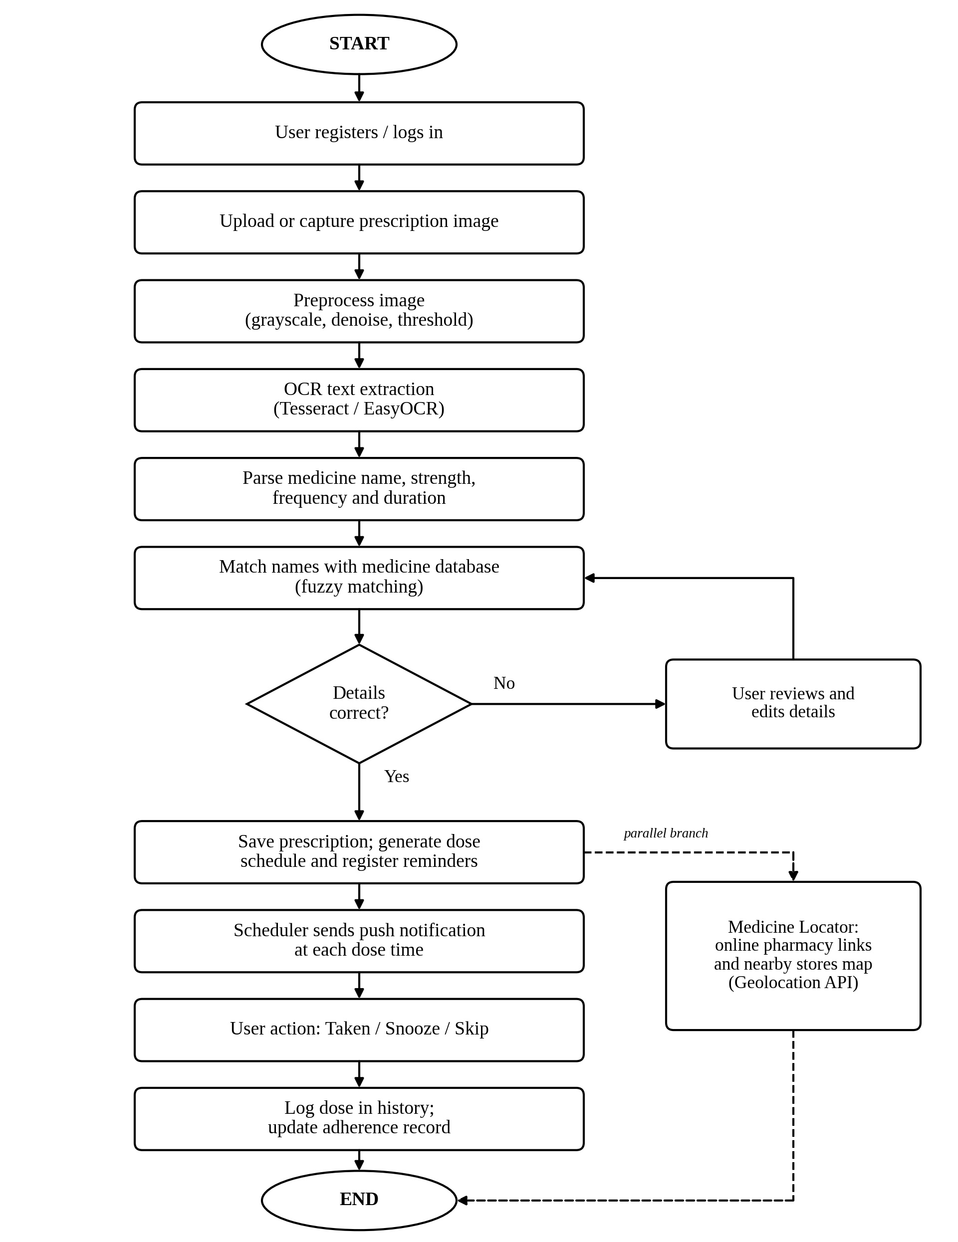
Fig. 4. Workflow of the MediAssist system.

B. Reminder Lifecycle
Each reminder moves through the states described in Table IX.
TABLE IX
States in the Reminder Lifecycle
State | Description | Next state
Scheduled | The reminder job exists and is waiting for the dose time | Triggered
Triggered | The push notification has been sent to the user’s device | Taken, Snoozed, Skipped or Missed
Snoozed | The user postponed the dose by a short interval | Triggered (again)
Taken | The user confirmed that the dose was taken | Logged (final)
Skipped | The user chose to skip the dose | Logged (final)
Missed | No response was received within the allowed time | Logged (final)

XI. TESTING AND EVALUATION PLAN

A. Testing Levels
- Unit testing of individual functions such as preprocessing, regular expressions, frequency mapping and schedule generation.
- Integration testing of the pipeline from image upload to saved schedule and from schedule to notification.
- System testing of the complete application on different browsers and devices.
- Security testing of authentication, file upload validation and access control between users.
- User acceptance testing with a small group of sample users, including elderly users, to assess usability.

B. Evaluation Metrics
- OCR quality measured by character and word accuracy on a set of sample prescriptions.
- Information extraction measured by precision, recall and F1-score for medicine name, strength, frequency and duration.
- Reminder reliability measured by the delay between the scheduled time and the time the notification is delivered.
- Usability measured through feedback from sample users on ease of use and clarity.

C. Sample Test Cases
TABLE X
Sample Test Cases
ID | Scenario | Expected result
TC1 | Clear printed prescription is uploaded | Medicines, strengths and frequencies are extracted correctly
TC2 | Blurred or poorly lit image is uploaded | User is warned and can retake or edit the data
TC3 | OCR misspells a medicine name | Fuzzy matching suggests the nearest name for confirmation
TC4 | Frequency “1-0-1” is detected | Two reminders are created: morning and night
TC5 | Scheduled dose time is reached | Push notification with taken, snooze and skip actions is delivered
TC6 | User selects snooze | The reminder is triggered again after the snooze interval
TC7 | Location permission is denied | Online pharmacy links remain available; manual area search is offered
TC8 | A user requests another user’s prescription | Access is denied
TC9 | A file of an invalid type is uploaded | The file is rejected with an error message

XII. PROJECT TIMELINE
The proposed schedule for the project is shown in Table XI. The durations are planned estimates and may be adjusted according to the academic calendar.
TABLE XI
Proposed Project Timeline
No. | Phase and activities | Duration
1 | Requirement analysis and literature survey | Weeks 1 – 2
2 | System design: architecture, DFD, ER diagram and interface layouts | Weeks 3 – 4
3 | Implementation of the Scanner and Parser modules | Weeks 5 – 6
4 | Implementation of the Vault and Reminder Engine | Weeks 7 – 8
5 | Implementation of the Medicine Locator | Week 9
6 | Integration, testing and bug fixing | Weeks 10 – 11
7 | Documentation, final review and presentation | Week 12

XIII. EXPECTED OUTCOMES
The expected outcome is a working web application that reduces missed doses, makes prescriptions easy to understand and shortens the time needed to find medicines. The project is expected to deliver:
- a prescription scanner that converts an image into structured medicine data;
- a verified, personalised dose schedule stored in a secure personal vault;
- real-time push reminders with taken, snooze and skip actions and a dose history;
- a medicine locator with online pharmacy links and a nearby store map; and
- complete project documentation, including design diagrams and test results.

XIV. LIMITATIONS AND FUTURE SCOPE

A. Limitations
- OCR accuracy on handwritten prescriptions is limited, so a user confirmation step is mandatory.
- The system is an assistive tool and not a substitute for a doctor’s or pharmacist’s advice.
- Reminder delivery depends on browser support, device settings and the permissions granted by the user.
- The quality of medicine matching depends on the coverage of the medicine reference database.

B. Future Scope
- Drug interaction warnings.
- Multilingual support for prescriptions and the user interface.
- Caregiver alerts so that a family member is informed about missed doses.
- A dedicated mobile application.
- Price comparison across pharmacies.

XV. CONCLUSION
MediAssist addresses a practical everyday problem: patients find prescriptions hard to read, hard to remember and hard to fulfil. By combining image preprocessing, OCR, NLP-based parsing, a secure personal vault, real-time reminders and a medicine locator in one web application, the proposed system supports the patient from the moment the prescription is issued until the medicines are obtained and taken. The human-in-the-loop confirmation step, privacy-focused design and open-source technology stack make the solution safe, affordable and practical. The detailed design, methodology and testing plan presented in this synopsis provide a clear foundation for the implementation of the project.

REFERENCES
[1] E. Sabaté, Ed., Adherence to Long-Term Therapies: Evidence for Action. Geneva, Switzerland: World Health Organization, 2003.
[2] The Digital Personal Data Protection Act, 2023, Act No. 22 of 2023, Government of India, 2023.
[3] R. Smith, “An overview of the Tesseract OCR engine,” in Proc. 9th Int. Conf. Document Anal. Recognit. (ICDAR), Curitiba, Brazil, Sep. 2007, pp. 629–633.
[4] JaidedAI, “EasyOCR,” GitHub repository. [Online]. Available: https://github.com/JaidedAI/EasyOCR
[5] N. Otsu, “A threshold selection method from gray-level histograms,” IEEE Trans. Syst., Man, Cybern., vol. SMC-9, no. 1, pp. 62–66, Jan. 1979.
[6] G. Bradski, “The OpenCV library,” Dr. Dobb’s J. Softw. Tools, 2000.
[7] Explosion, “spaCy: Industrial-strength natural language processing in Python.” [Online]. Available: https://spacy.io
[8] M. Bachmann, “RapidFuzz: Rapid fuzzy string matching in Python and C++,” GitHub repository. [Online]. Available: https://github.com/rapidfuzz/RapidFuzz
[9] MDN Web Docs, “Push API.” [Online]. Available: https://developer.mozilla.org/en-US/docs/Web/API/Push_API
[10] MDN Web Docs, “Geolocation API.” [Online]. Available: https://developer.mozilla.org/en-US/docs/Web/API/Geolocation_API
[11] OpenStreetMap Wiki, “Overpass API.” [Online]. Available: https://wiki.openstreetmap.org/wiki/Overpass_API
[12] V. Agafonkin, “Leaflet: An open-source JavaScript library for interactive maps.” [Online]. Available: https://leafletjs.com
[13] P. P.-S. Chen, “The entity-relationship model—Toward a unified view of data,” ACM Trans. Database Syst., vol. 1, no. 1, pp. 9–36, Mar. 1976.
[14] Pallets Projects, “Flask documentation.” [Online]. Available: https://flask.palletsprojects.com
[15] S. Ramírez, “FastAPI.” [Online]. Available: https://fastapi.tiangolo.com

