**Analyze the problem and come with the entities in it. Identify what data has to be persisted in the databases. (E-R Model)**

The Following are the entities and relationships:

1. Bus

2. Ticket

3. Passenger

Attributes in entities:

**Bus:(Entity)**

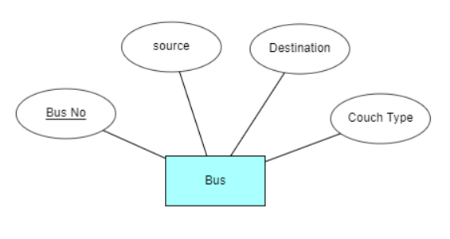

**Ticket :(Entity)**

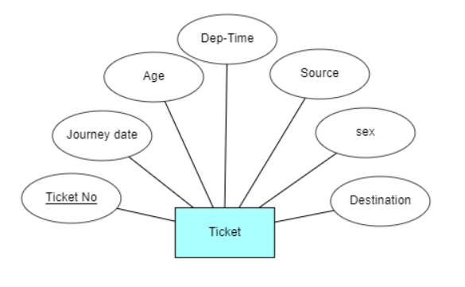

**Passenger:( Entity)**

