**Experiment - 6**

**Applying DML commands on Road Way Travels Tables. Data Manipulation Command**

**• Insert**

**• Update**

**• Delete**

**• Select**

create database emp;

use emp;

CREATE TABLE emp(emp_id numeric(10) primary key, DOB date,f_name varchar(20), l_name varchar(20), date_of_join date,salary numeric,gender varchar(10),age varchar(10));

desc emp;

insert into emp values(103,'2002-06-03','haasini','choudhary','2019-08-06',80000,'Female',18), (116,'1999-05-03','akshay','choudhary','2018-02-01',75000,'Male',21), (105,'2000-02-08','priya','namaji','2020-01-15',65000,'Female',20);

SELECT * FROM emp;

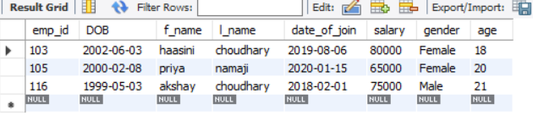

alter table emp add phoneno numeric;

update emp set phoneno = 7989507660 where emp_id=103;

update emp set phoneno = 8967185832 where emp_id=105;

update emp set phoneno = 9112653765 where emp_id=116;

alter table emp drop age;

SELECT * FROM emp;

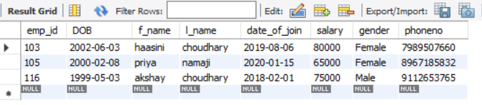

SELECT distinct gender from emp;

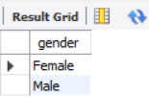

SELECT phoneno from emp where emp_id=116;

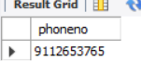

SELECT count(distinct gender) from emp;

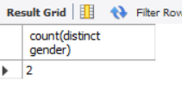

SELECT *FROM emp where salary>60000 ;

UPDATE emp set f_name='sheetal' where emp_id = 103;

SELECT * FROM emp;

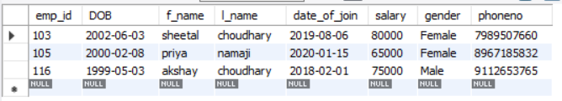

insert into emp values(100,'2001-01-03','haasini','choudhary','2020-02-03',60000,'Female',20);

SELECT * FROM emp;

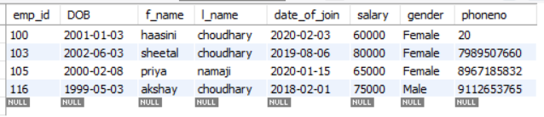

delete from emp where emp_id = 100;

SELECT * FROM emp;

