**EXPERIMENT-11**

**CREATION AND EXECUTION OF PROCEDURES**

use mydb;

show tables;

select * from product;

insert into product values(6,"changue",4,40);

insert into product values(7,"tofu ",3,12);

select * from product;

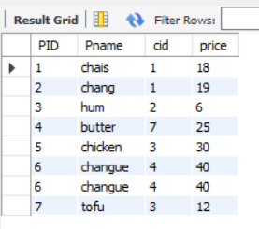

DELIMITER //

create procedure sam(in pnr numeric(33))

begin

select * from product;

end //

create procedure sam1(in pnr numeric(33))

begin

select * from product;

end //

create procedure sam2(in pnr numeric(32))

begin

select * from product;

end //

create procedure sam3(in pnr numeric(30))

begin

select * from product where price = pnr;

end //

DELIMITER //

create procedure sam4(out pnr numeric(3))

begin

select count(*) into pnr from product;

end //



Call sam(33);

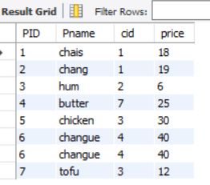

Call sam3(33);



Call sam4(@a);



Select @a;

