
OPERATING SYSTEMS AND SYSTEMS PROGRAMMING
Course Code: 25CS2104E
2026–27, Term-I
PROJECT REPORT
Linux File Descriptor and
File I/O Management System
A C-based demonstration of open, read, write, file-information and close operations using Linux system calls
Detail | Information
Section No. | 1
Team No. | 11
Project Title | Linux File Descriptor and File I/O Management System
Platform | Ubuntu (Linux), C programming language, GCC

Team Members
S.No. | Roll Number | Student Name
1 | 2520030265 | B. Haasini Reddy
2 | 2520030500 | M. Manasa
3 | 2520030285 | Arjun Tomar

1. Abstract
This project presents a set of five small C programs that make Linux file-descriptor handling visible. Each program uses low-level system calls — open(), read(), write(), lseek(), fstat(), fcntl() and close() — to perform one file operation on a path chosen by the user, and prints what the operating system returns, such as the file descriptor number, file size, owner and group IDs, hard-link count, inode number and timestamps. The programs were compiled with GCC on Ubuntu and tested on a plain-text file, daily_notes.txt, and screenshots of every module's run are included as evidence. The results show how descriptors are allocated, how data is read and written through them, and how errors and resources are handled.

2. Problem Statement
In Linux, file operations are handled through file descriptors and system calls. Understanding these mechanisms is important for learning Operating Systems and System Programming, but performing and observing low-level file I/O can be difficult for beginners.
The project develops a simple Linux File Descriptor and File I/O Management System that demonstrates how a process opens, reads, writes and closes files using Linux system calls, and shows how file descriptors are assigned and managed during each operation. It gives students a practical way to understand file descriptors, file I/O, system calls, file permissions, error handling and resource management in a Linux environment.

3. Objectives
- To understand and demonstrate file descriptors and their role in Linux file management.
- To implement basic file I/O operations such as open, read, write, append and close.
- To use the Linux system calls open(), read(), write(), lseek(), fstat(), fcntl() and close().
- To retrieve and display file metadata (inode, size, owner, group, links, permissions, type and timestamps) for a selected file.
- To provide a simple interface for performing and observing file-management operations, with proper error handling and release of resources.

4. Selected Commands and Workflow
The project uses the following Ubuntu commands and Linux system calls.

4.1 Ubuntu Commands
Command | Purpose
cd ~/ossp_file_project | Moves to the project folder.
gcc -Wall -Wextra -o program_name source_file.c | Compiles a C program with warnings enabled.
./program_name | Runs the compiled program.

4.2 Linux System Calls
System Call | Purpose | Used In
open() | Opens an existing file and returns a file descriptor. | Modules 1–5
read() | Reads data from an open file. | Modules 2, 3
write() | Writes data to an open file. | Module 3
lseek() | Moves the file offset to a chosen position, such as the matched word or the start of the file. | Module 2
fstat() | Retrieves file information such as inode, size, owner ID, group ID, hard-link count, permissions and timestamps. | Module 4
fcntl() | Checks whether a descriptor is still valid after it has been closed. | Module 5
close() | Closes an open file descriptor and releases the resource. | Modules 1–5

4.3 General Workflow
Every module follows the same life cycle, which mirrors how a Linux process handles any file:
Enter file path  open() → fd | → | Check for errors  report failures | → | Operate on fd  read / write / fstat | → | close() fd  release descriptor

5. Implementation
The project was implemented in the C programming language and developed on Ubuntu. It is divided into five modules, each stored in its own source file and compiled into a separate executable. The modules use Linux file-handling system calls directly: open() returns a file descriptor, read() and write() access file data, lseek() moves the file offset, fstat() retrieves file information, fcntl() checks whether a descriptor is still valid, and close() releases the descriptor.
Module | Function | System Calls
1 — Open and Close | Opens an existing file read-only, displays its path and descriptor, then closes it. | open(), close()
2 — Read File | Opens an existing file read-only and displays its full contents, or only the part starting from a searched word. | open(), read(), lseek(), close()
3 — Display and Edit Text | Displays a text file, then appends text, replaces the contents after confirmation, or exits without changes. | open(), read(), write(), close()
4 — File Information | Displays descriptor, inode, size, owner ID, group ID, hard links, permissions, file type and timestamps. | open(), fstat(), close()
5 — Close Demonstration | Opens a file, shows its descriptor, closes it and verifies that the descriptor is no longer valid. | open(), close(), fcntl()

6. Detailed Description of the Implementation
Each program performs one file-management task and asks the user for a file path, so different existing files can be selected at run time.

Module 1 — Open and Close
The program reads the file path entered by the user and calls open() with O_RDONLY | O_CLOEXEC to open the file for reading. On success it displays the path, the file descriptor returned by the operating system, the opening mode (Read Only) and the file status (OPEN). It then calls close() to release the descriptor and reports the status as CLOSED. If opening or closing fails, an error message is displayed.

Module 2 — Read File
The program opens the selected file in read-only mode and offers two reading options. In both cases it first reads the file into memory with read(). For option 1 it calls lseek() with SEEK_SET to return to the start of the file and then displays the entire file. For option 2 it asks for a single word and searches for it, reports the starting position of the first match, calls lseek() to move the file offset to that position, and displays the contents from that word to the end of the file. If the word is not present, a NOT FOUND message is shown. The file is then closed.

Module 3 — Display and Edit Text
The program first opens the selected text file in read-only mode and uses read() to display its current contents. It then offers three editing options. For Append and Replace, the text is collected first: it can run over several lines and is finished by typing a single dot (.) on a new line.
- Append: opens the file with O_WRONLY | O_APPEND | O_CLOEXEC. New text is added at the end while existing content is preserved.
- Replace: requests confirmation after the text has been entered (the user must type YES), then opens the file with O_WRONLY | O_TRUNC | O_CLOEXEC. This removes the old contents before the new text is written with write(). Typing anything other than YES cancels the replacement, and the file is never opened for writing.
- Exit: leaves the program without making any changes to the file.
After writing, the program displays the updated file contents. This module should be used with writable plain-text files such as daily_notes.txt, rather than PDF or protected system files.

Module 4 — File Information
The program opens the selected file and calls fstat() with its file descriptor. It displays the descriptor, file name, inode number, size, owner ID, group ID, number of hard links, file type, permissions (in rwx and octal form) and the last-accessed, last-modified and last-status-change timestamps, which are converted to readable dates with strftime(). The descriptor is closed after the information is retrieved.

Module 5 — Close Demonstration
The program asks for a file path, opens the file in read-only mode and displays the descriptor. It then calls close() and reports whether the operation succeeded. To verify the result, it calls fcntl() with F_GETFD on the same descriptor; because the descriptor has been released, the call fails with the error EBADF, which confirms that it is no longer valid. This demonstrates closing a descriptor as a separate step; Module 1 performs the same operation as part of its flow.

Error Handling and Resource Management
All programs check the return value of each system call and report errors such as a missing file or insufficient permissions. The file descriptor is closed after every operation so that the operating-system resource is always released.

7. Test Cases and Results
This section presents screenshots of the test runs for each module, with the sample inputs and the output produced. The table summarises the observed results.
Module | Test Input | Observed Result
1 — Open and Close | daily_notes.txt | File descriptor 3; mode Read Only; status OPEN, then CLOSED and descriptor released.
2 — Read File (entire) | daily_notes.txt, option 1 | Whole file displayed from “MY DAILY NOTES” to END OF FILE.
2 — Read File (from word) | daily_notes.txt, option 2, word “Wednesday” | Word found at position 192; contents displayed from “Wednesday” onwards.
3 — Append | daily_notes.txt, option 1 | New text added at the end; original content kept.
3 — Replace (cancelled) | Option 2, confirmation NO | Replacement cancelled; original file unchanged.
3 — Replace (confirmed) | Option 2, confirmation YES | Old content erased; file now contains only the new text.
4 — File Information | daily_notes.txt | Inode 13635, 734 bytes, UID 1000, GID 1000, 1 hard link, regular file, rw-r--r-- (0644).
5 — Close Demonstration | daily_notes.txt | Descriptor 3 closed; descriptor reported as no longer valid.

Observation: Every module received file descriptor 3 for the file it opened. Descriptors 0, 1 and 2 are already used by standard input, standard output and standard error, so 3 is the lowest number available to a newly opened file.

Module 1 — Open and Close
Module 1 was run on /home/saimanasa/daily_notes.txt. The program opens the file read-only and prints its path, the file descriptor returned by open() (3), the opening mode and the file status. It then calls close() and confirms that the descriptor has been released.
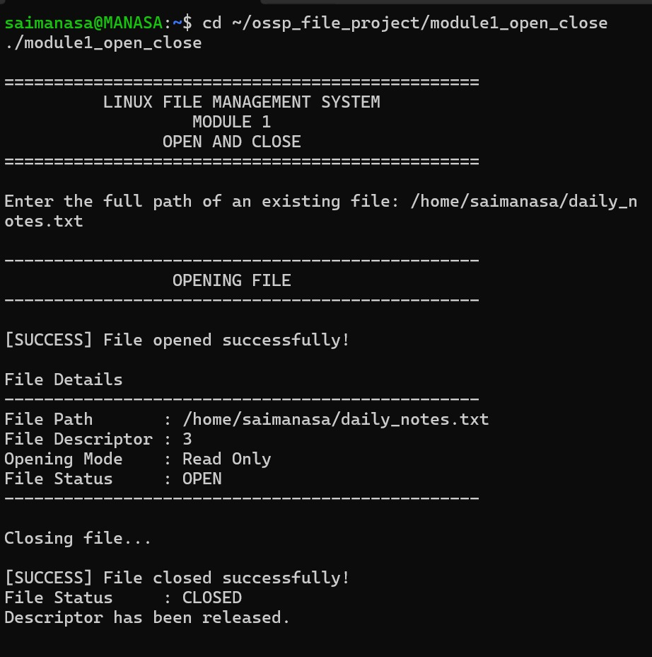  Figure 1: Module 1 – Opening the file and displaying its details | 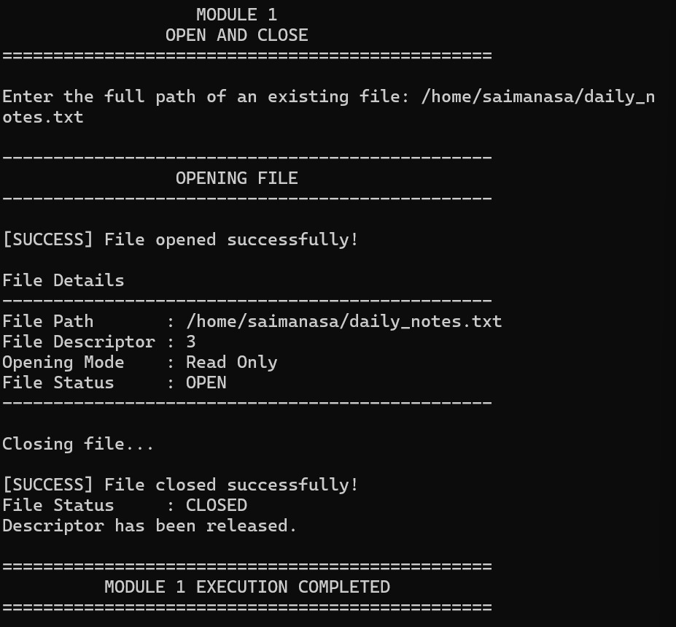  Figure 2: Module 1 – Closing the file and completion message

Module 2 — Read File
Module 2 was run on the same file and offers two reading options. Option 1 reads and displays the entire file; option 2 asks for a word and reads from its first occurrence to the end of the file.
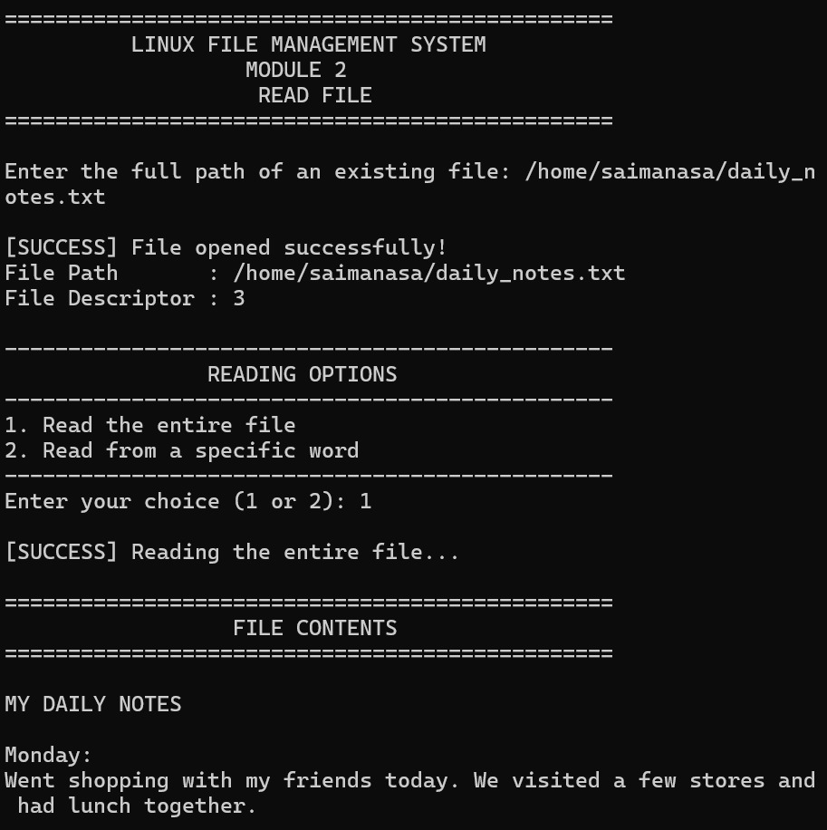  Figure 3: Module 2 – Option 1: entire file (start of output) | 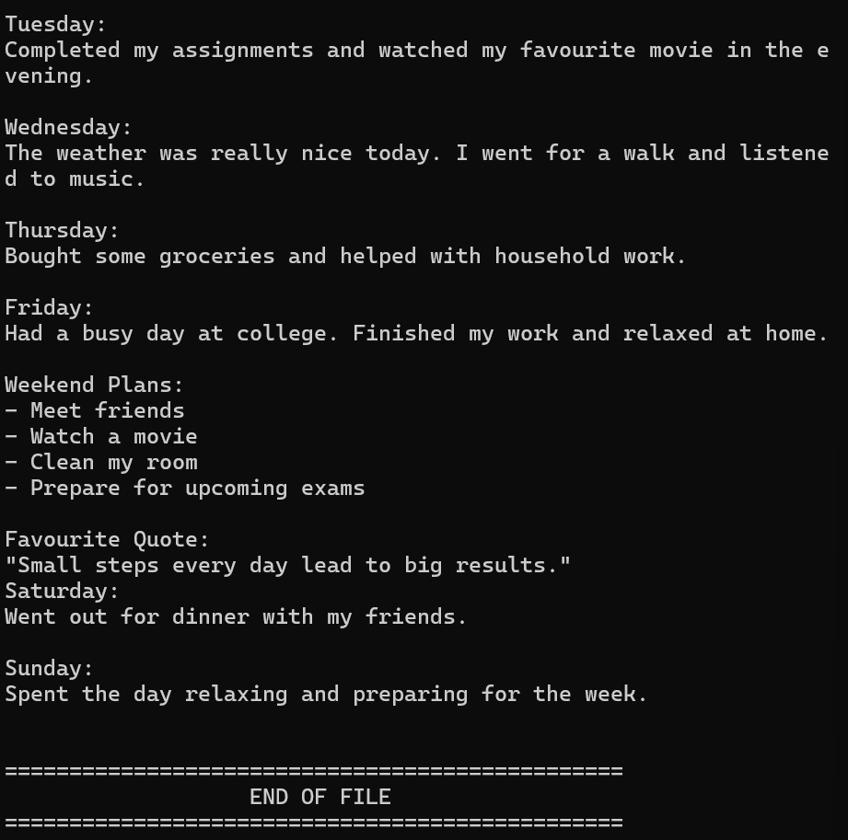  Figure 4: Module 2 – Option 1: remaining contents up to END OF FILE

With option 2 the word “Wednesday” was searched. The program reports that it was found at starting position 192 and displays the file contents from that word onwards, then closes the file.
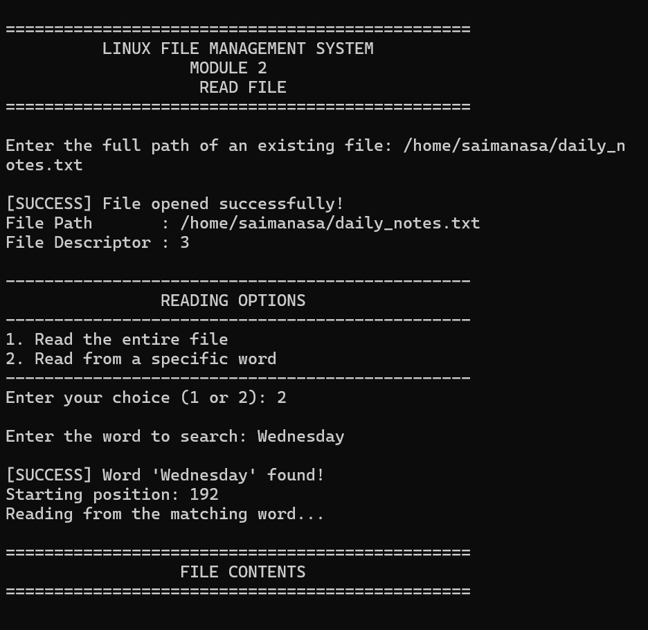  Figure 5: Module 2 – Option 2: word “Wednesday” found at position 192 | 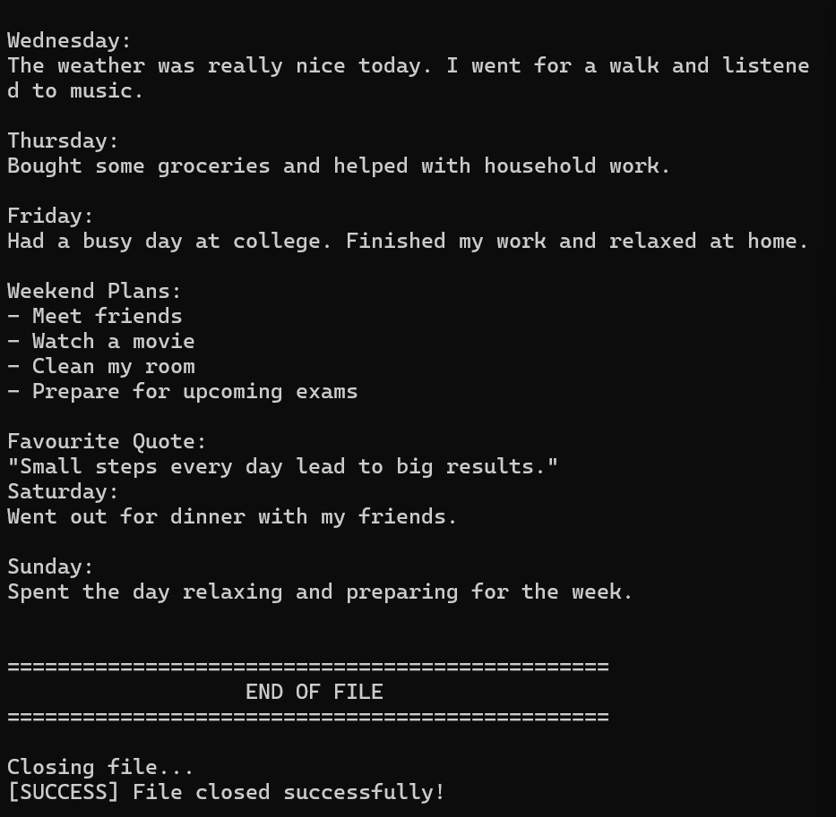  Figure 6: Module 2 – Option 2: contents from “Wednesday” onwards; file closed

Module 3 — Display and Edit Text
Module 3 was run on daily_notes.txt. The program first displays the current content and then offers three editing options: append, replace and exit. In the first test, option 1 appended the lines “My Updated Notes” and “Today I learned Linux file handling.”, and the original content was kept.
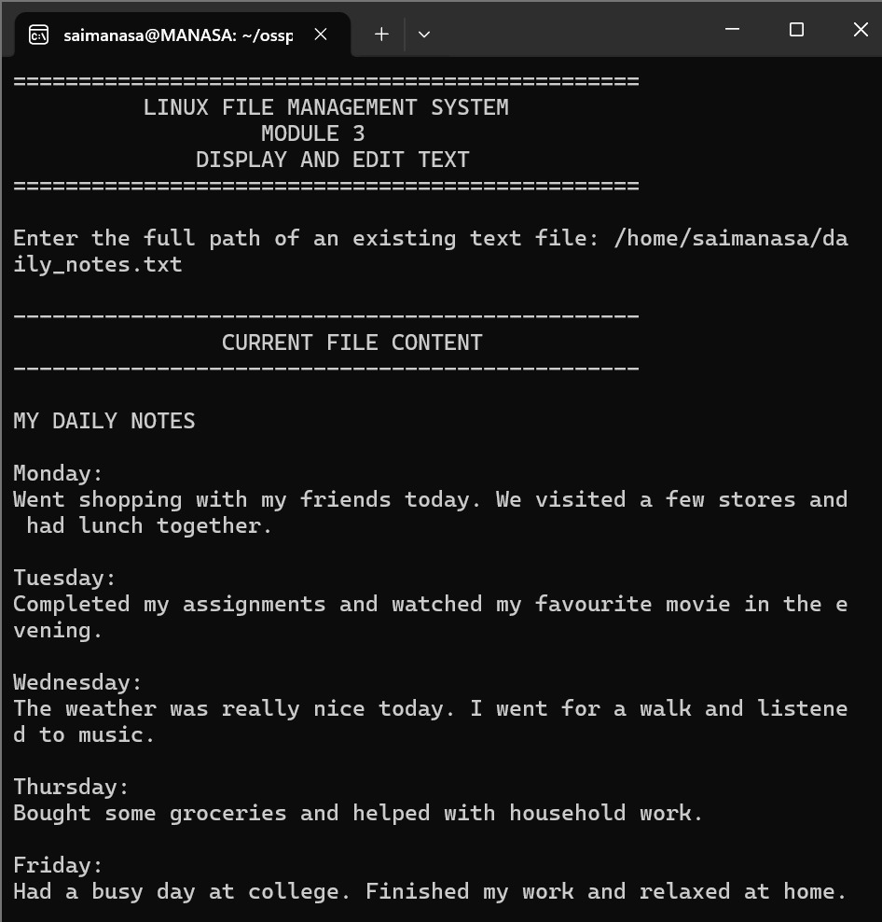  Figure 7: Module 3 – Current file content displayed before editing | 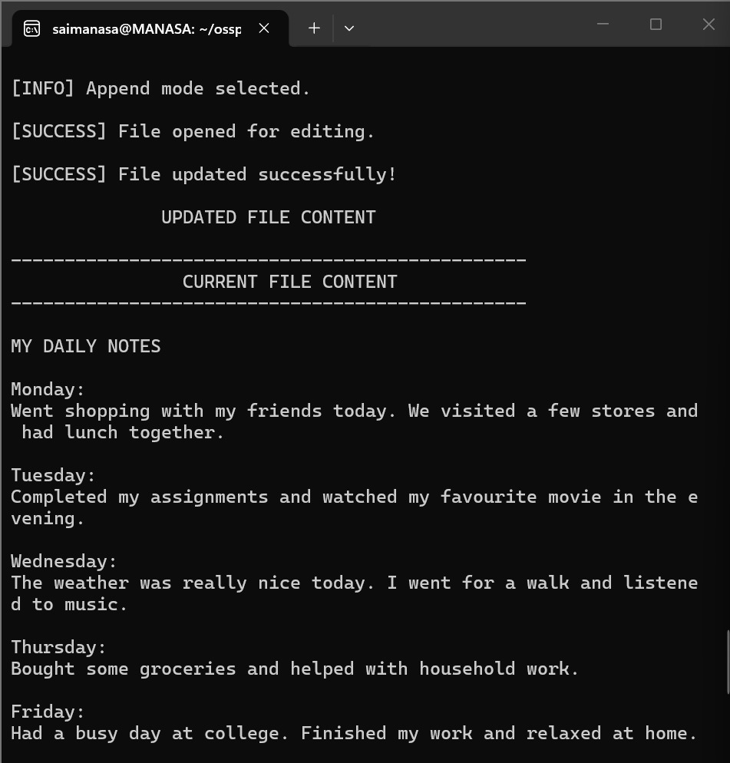  Figure 8: Module 3 – Append mode: file updated successfully

The appended text appears at the end of the updated content. In a second test, the Replace option was chosen but the confirmation was answered NO, so the replacement was cancelled and the file remained unchanged.
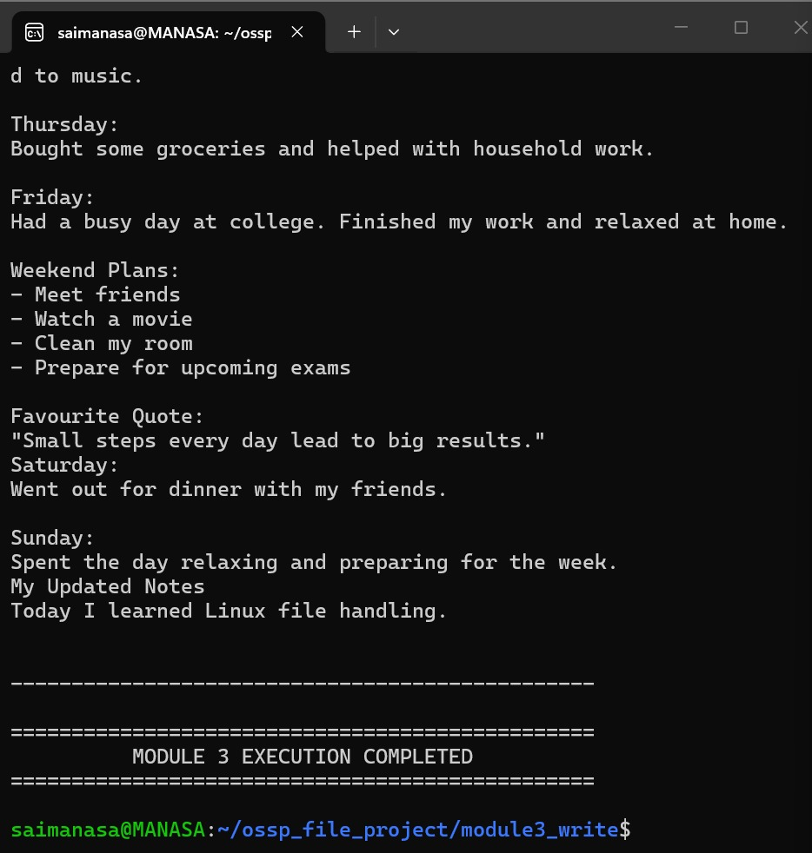  Figure 9: Module 3 – Append: end of the updated content with the new text | 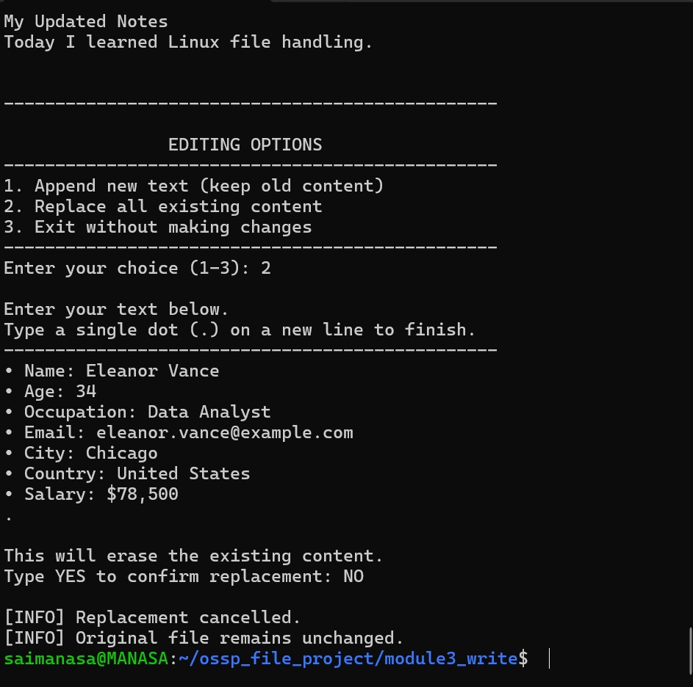  Figure 10: Module 3 – Replace cancelled by typing NO; file unchanged

Finally, Replace was chosen and confirmed with YES. The old content was erased and only the newly entered text was written to the file.
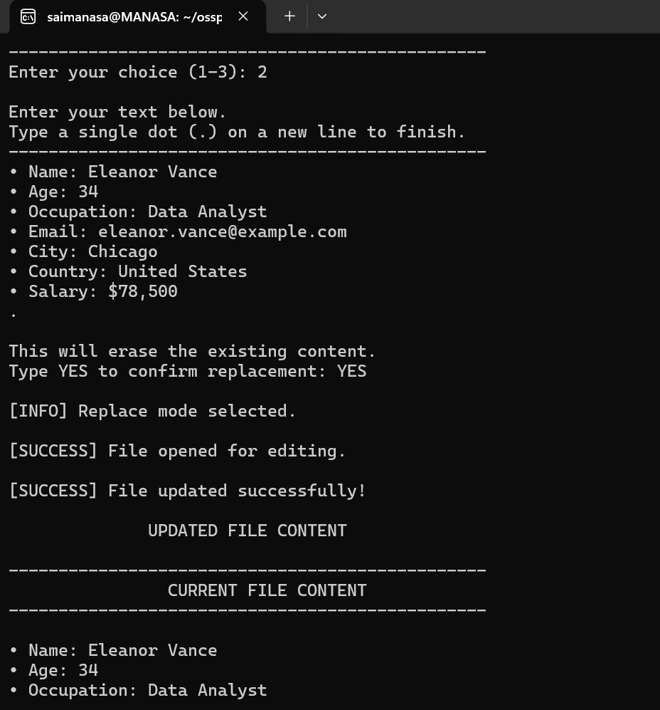  Figure 11: Module 3 – Replace: new text entered and confirmed with YES | 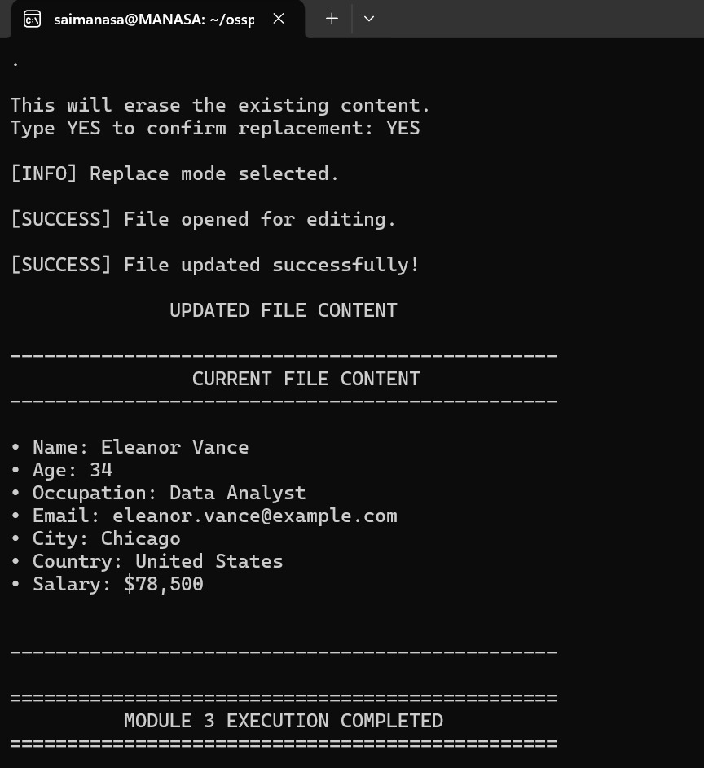  Figure 12: Module 3 – Replace: file now contains only the new text

Module 4 — File Information
Module 4 was run on daily_notes.txt. The program calls fstat() and displays the file descriptor, file name, inode number, size, owner ID, group ID, hard-link count, file type, permissions (rw-r--r--, octal 0644) and the three timestamps.
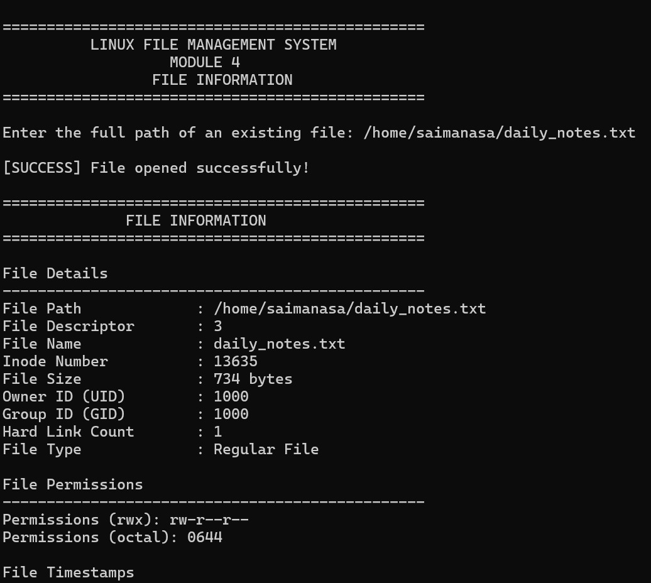  Figure 13: Module 4 – File information (start of output) | 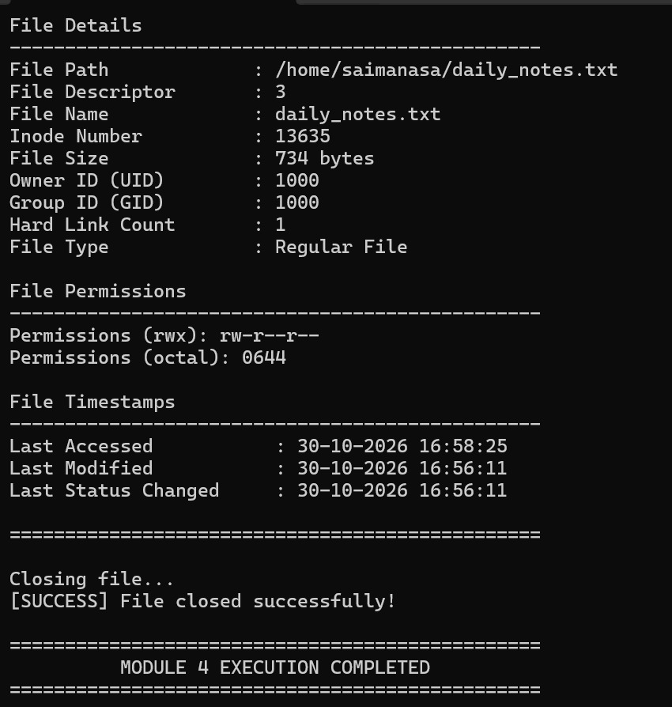  Figure 14: Module 4 – Permissions, timestamps and closing the file

Module 5 — Close Demonstration
Module 5 was run on daily_notes.txt. The program opens the file, displays the descriptor, closes the file and then verifies with fcntl() that the descriptor is no longer valid.
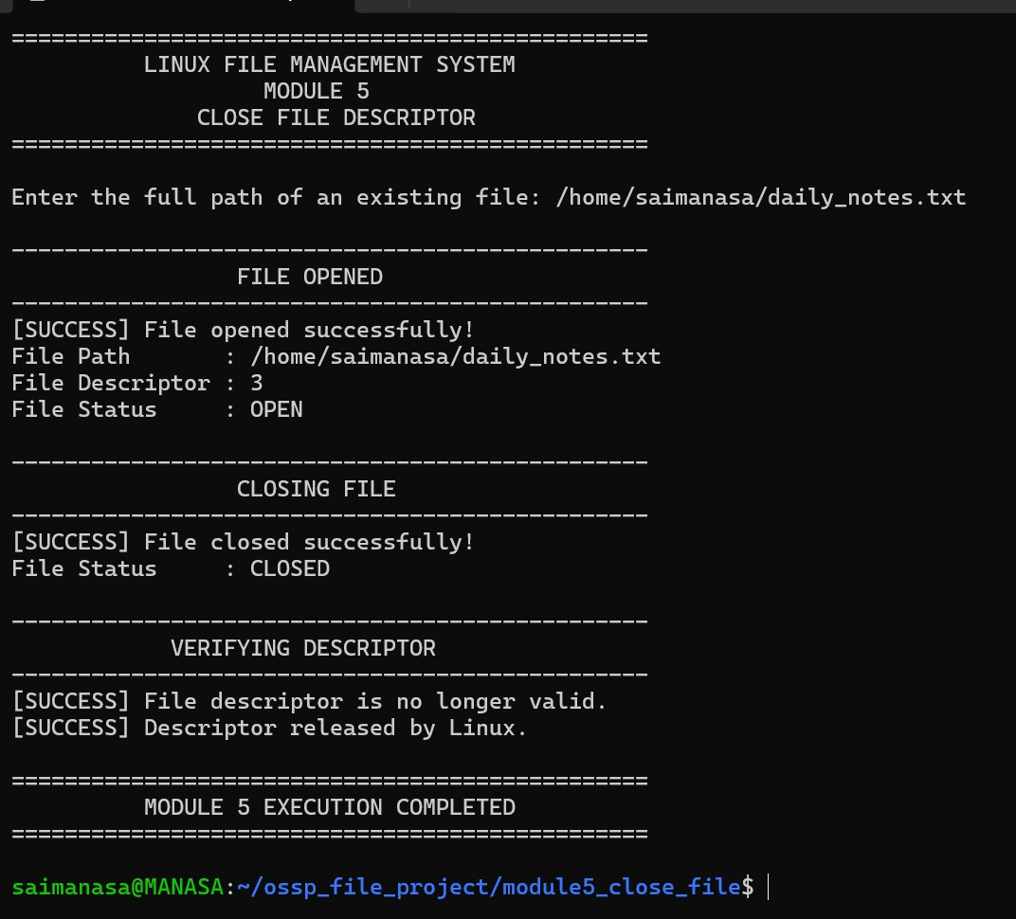
Figure 15: Module 5 – Close demonstration with descriptor verification

8. Drawbacks and Limitations
- Existing files only: the programs work on files that already exist; they do not create new files.
- No safe editing of binary files: PDFs and other binary formats have their own internal structure, and writing plain text into them may corrupt them. The editing module should therefore be used only with plain-text files such as daily_notes.txt.
- Manual path entry: the user must type the file path each time, and access to protected system files may be denied by Ubuntu.
- Whole-file editing only: the editing module can append text at the end or replace the entire content; it cannot change or delete a chosen line inside the file.

9. Future Scope
- Add an option to create new files with chosen permissions.
- Support random-access reading and writing at a chosen position in a file.
- Add an option to edit or delete a specific line instead of replacing the whole file.
- Combine the five modules into a single menu-driven program with file browsing.

10. Conclusion
The project demonstrates how Linux programs manage files through file descriptors and system calls. It covers opening and closing files, reading file contents (in full or from a searched word), appending or replacing text with confirmation, and retrieving file information such as the inode number, permissions and timestamps. Testing also showed how Linux reports errors such as missing files or insufficient permissions, and confirmed that a newly opened file receives the first free descriptor, 3. Overall, the project gave practical experience with file I/O in C on Ubuntu.

