Multithreaded Log Analysis System
Project Report - Hackathon, 17.10.2026
Team: Deadlock_OS SP
Roll Number | Name
2520030265 | Haasini Reddy B
2520030500 | M. Manasa
2520030285 | Arjun Tomar

1. Abstract
Modern servers generate very large log files. Reading them on a single thread is slow, and important events such as failed logins can be missed. This project implements a multithreaded log analyzer in C using POSIX threads. The log file is divided into chunks, one per thread. Every thread analyzes its own chunk in parallel, and the results are merged into one report that lists the number of errors, warnings and suspicious events, with sample matching lines.

2. Problem Statement
Develop a system that uses multiple threads to analyze large log files and identify errors, warnings and suspicious events. The solution must run on Ubuntu, produce correct counts regardless of the number of threads, and avoid race conditions.

3. System Design
The program follows a split, process in parallel, merge design:
- The log file is read into memory.
- The buffer is divided into N chunks. Each chunk boundary is moved forward to the next newline, so no line is ever split between two threads.
- N worker threads are created. Each thread scans only its own chunk, line by line, and keeps its own local counters, so no locking is needed during scanning.
- When a thread finishes, it adds its local counts to the shared total inside a mutex-protected critical section (once per thread).
- The main thread joins all threads and prints the final report.
Synchronization: a single mutex protects the shared totals. No thread ever holds two locks, so deadlock is not possible. Threads write only to their own chunk and their own Task structure, so there are no data races.

4. Implementation
Language and tools: C (gcc), POSIX threads (pthread), Ubuntu on WSL.
Component | Description
Task structure | Holds the chunk start/end pointers, local counters and up to 10 sample lines per category
worker() | Scans each line of the chunk and updates the local counters
Detection rules | Error: line contains "error". Warning: line contains "warn". Suspicious: line contains one of: failed password, invalid user, unauthorized, permission denied, access denied, brute force, sql injection, segfault, root login, port scan, authentication failure. Matching is case-insensitive.
Merge | Mutex lock, add local counters to the global totals, unlock
Validation | Thread count must be 1 to 256; file open, read and memory allocation errors are reported; if a thread cannot be created, its chunk is processed directly

5. Build and Run
gcc -O2 -Wall -pthread log_analyzer.c -o log_analyzer
./log_analyzer <logfile> [threads]
./log_analyzer sample.log 4
The first argument is the log file. The second argument is the number of threads and is optional (default 4).

6. Testing and Results
Test | Input | Result
Normal log | 9-line sample.log, 3 threads | 9 lines, 2 errors, 2 warnings, 3 suspicious events
Sample log (4 lines) | sample.log, 4 threads | 4 lines, 1 error, 1 warning, 1 suspicious event
Empty file | 0-byte file | All counts 0, no crash
Missing file | non-existent file name | Clear error message, clean exit
Invalid threads | abc and 0 | Message: Threads must be between 1 and 256
Stress test | 80,000 lines, run with 1 and 8 threads | 80,000 lines, 20,000 errors, 20,000 warnings, 20,000 suspicious in both runs

The identical totals for 1 and 8 threads show that chunk splitting does not lose or duplicate lines and that the mutex-protected merge is correct.
Figure 1 shows the program run on the 4-line sample log with 4 threads, and Figure 2 shows the 80,000-line stress test with 8 threads.
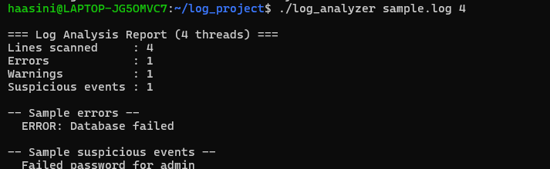
Figure 1: Sample log analyzed with 4 threads
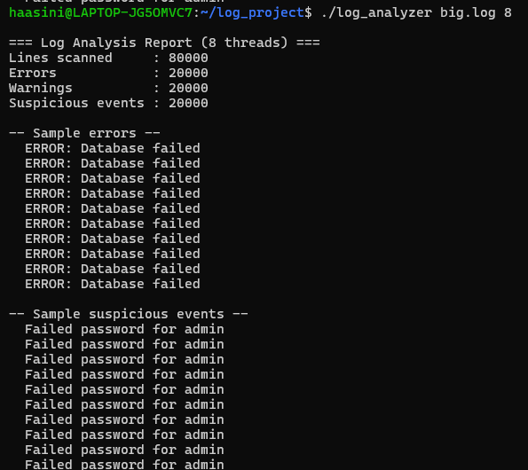
Figure 2: 80,000-line log analyzed with 8 threads

7. Limitations and Future Work
- The whole file is loaded into memory, so extremely large files (multi-GB) need a streaming approach.
- Detection is keyword based; it could be extended with configurable keywords or patterns.
- Possible additions: timestamp and IP address statistics, real-time monitoring, and a CSV or JSON report.

8. Conclusion
The project meets the problem statement: it analyzes a log file with multiple threads, identifies errors, warnings and suspicious events, and gives the same correct results for any thread count. It is safe from race conditions and deadlock, and it was tested on normal, empty, missing and large inputs.

9. Team Contributions
Member | Role
Haasini Reddy B (2520030265) | Chunking and file handling
M. Manasa (2520030500) | Threads and mutex synchronization
Arjun Tomar (2520030285) | Testing, validation and demo

