A PROJECT REPORT
ON
Waste Segregation Image Classifier: A Deep Learning Based Project for Classifying Waste into Biodegradable, Recyclable and Hazardous Categories
submitted in partial fulfilment of the requirements for the Course
MACHINE LEARNING (25SC2107E)
BACHELOR OF TECHNOLOGY
in
COMPUTER SCIENCE & ENGINEERING
A.Y.: 2026-27 | Trimester 4 | Section 1 | Team No: 17
by
Haasini Reddy B Roll No: 2520030265
Arjun Tomar Roll No: 2520030285

Under the Esteemed guidance of
Dr. G S Raghavendra
Department of Computer Science & Engineering



INDEX
Abstract
Introduction
Background
Motivation for the Project
Overview of the Work Carried Out
Scope and Responsible-Use Statement
Problem Statement
Case-Study Scenario
Central Case-Study Question
Formal Problem Definition
Objectives that Guide the Study
Assumptions and Limitations
Dataset and Exploratory Data Analysis
About the Dataset
Purpose of EDA
Preparation Steps Actually Performed
EDA Exploration - Implementation
Summary of EDA Findings
Algorithm Selection and Implementation
Data Pipeline and Augmentation
Baseline Convolutional Neural Network
Why Transfer Learning with ResNet50?
Training and Evaluation Results
Interface and Demonstration
Comparison of the Approaches
Planned versus Implemented Work
Conclusion
References
Signature of the Team members

1. Abstract
Improper waste segregation is a major obstacle to effective recycling and waste management. A large share of recyclable and hazardous material is still disposed of incorrectly because of manual sorting errors and lack of awareness. This project, Waste Segregation Image Classifier, treats the problem as a supervised image-classification task in which a photograph of a waste item is assigned to one of three categories: Biodegradable, Recyclable or Hazardous. Manually engineered sorting rules and simple classifiers trained from scratch tend to generalise poorly across varied lighting, backgrounds and item appearances, and the project therefore compares a convolutional neural network trained from scratch with transfer learning from a pretrained network.
The experiments use the NexTech14 Waste Dataset, a collection of 8,996 labelled images that is supplied already divided into 6,296 training, 1,348 validation and 1,352 test images. The three classes are close to balanced (31.7% Hazardous, 32.8% Biodegradable, 35.5% Recyclable). Every image is resized to 224 x 224 pixels and the training images are augmented with random horizontal flips, rotations and zooms. Two models were built with TensorFlow/Keras: a baseline CNN with three convolutional blocks and 110,147 trainable parameters, and a ResNet50 model pretrained on ImageNet whose convolutional base is frozen and whose new classification head (262,659 trainable parameters out of 23,850,371) is trained on the waste images.
On the unseen test set the baseline CNN, trained for three epochs, reaches an accuracy of 74.56% (macro F1-score 74.77%) and is weakest on the Recyclable class (F1-score 63.08%). The ResNet50 model, trained for only two epochs, reaches an accuracy of 98.52% with a test loss of 0.0450, which is about 24 percentage points higher than the baseline. The trained ResNet50 model was saved and deployed through a Gradio web interface, named EcoSort, in which a user uploads a photograph and receives the predicted category together with the class scores.
The work is a supervised learning study on one image dataset. It is a classification aid and not a guaranteed sorting or safety system: a prediction can be wrong, and a Hazardous or Recyclable prediction should not replace local waste-disposal rules. Per-class precision, recall and F1-score were computed for the baseline CNN only; the ResNet50 result is reported as overall accuracy and loss.
Keywords: waste segregation; image classification; deep learning; convolutional neural network; transfer learning; ResNet50; data augmentation; TensorFlow; smart waste management.

2. Introduction

2.1 Background
Households, offices and industries produce waste of many kinds. For recycling and safe disposal to work, the waste has to be separated at the source into streams that are handled differently. In this project three streams are used. Biodegradable (organic) waste, such as food scraps and peels, can be broken down by natural processes and composted. Recyclable waste, such as bottles, containers, caps and similar items, can be reprocessed into new material. Hazardous waste, such as batteries, needs special handling because it can harm people or the environment if it is mixed with ordinary waste. Sorting by hand is slow, depends on the knowledge of the person doing it and is easily affected by mistakes, so an automatic method that recognises the category of an item from a photograph is attractive.
Recognising the category of an item from a photograph is an image classification problem: an image is assigned to one of a fixed set of classes. A labelled collection of images supplies examples of each class, and a supervised learning algorithm learns which visual patterns (shape, colour, texture) belong to which class. Convolutional neural networks (CNNs) are the standard family of models for this task because their convolution and pooling layers learn visual features directly from pixels [7]. Training such a network from scratch needs many images and much computation. Transfer learning reduces this need by starting from a network that was already trained on a large general dataset and adapting it to the new task [4]. The ResNet50 architecture [1], pretrained on the ImageNet collection [3], is a widely used starting point; its residual connections make deep networks easier to train.
Supporting literature
Early public work on trash image classification, such as the TrashNet study by Yang and Thung [9], used a small dataset of photographs of single waste items and showed that learned image classifiers can separate material categories. He et al. [1] introduced residual networks, of which ResNet50 is one variant, and Pan and Yang [4] surveyed transfer learning, the idea of reusing knowledge learned on one task for another. Sandler et al. [2] proposed MobileNetV2, a lightweight network suited to devices with limited computing power, which is relevant to the smart-bin setting that motivates this work.
These works support the choice of the approach. They should be distinguished from the present project: the methodology followed here is the one implemented in the project notebook (data loading, augmentation, model training and evaluation described in Sections 4 and 5), and every number reported in this report was produced by that notebook and not taken from the cited papers.

2.2 Motivation for the Project
Waste is generated continuously and in large quantity, and manual sorting does not scale with it. The motivation for the project can be summarised as follows:
- Wrongly sorted waste reduces the quality of recycling, and hazardous items placed in ordinary bins are a risk to workers and the environment.
- Manual sorting depends on individual knowledge and attention; an image-based classifier gives a consistent, instant answer for every item shown to it.
- Waste items differ widely in appearance, lighting and background, so hand-written rules are hard to maintain, whereas a model can learn the patterns from labelled examples.
- Transfer learning makes a high-accuracy classifier feasible with classroom-scale computing resources, which suits a course project.
- The project gives practical exposure to image preprocessing, data augmentation, CNNs, transfer learning, model evaluation and simple deployment of a trained model.

2.3 Overview of the Work Carried Out
The work follows the pipeline implemented in the project notebook, which was run on Google Colab with the dataset stored on Google Drive. The dataset archive is extracted and the number of images in each class and split is counted; sample images are displayed for inspection; the images are loaded as batches of 224 x 224 RGB images with one-hot labels; a data-augmentation block is defined; a baseline CNN and a ResNet50 transfer-learning model are built, trained on the training split and monitored on the validation split; both are evaluated on the unseen test split; the ResNet50 model is tried on an uploaded photograph, saved, and wrapped in a Gradio interface. The workflow is shown in Figure 1 and summarised in Table 1.
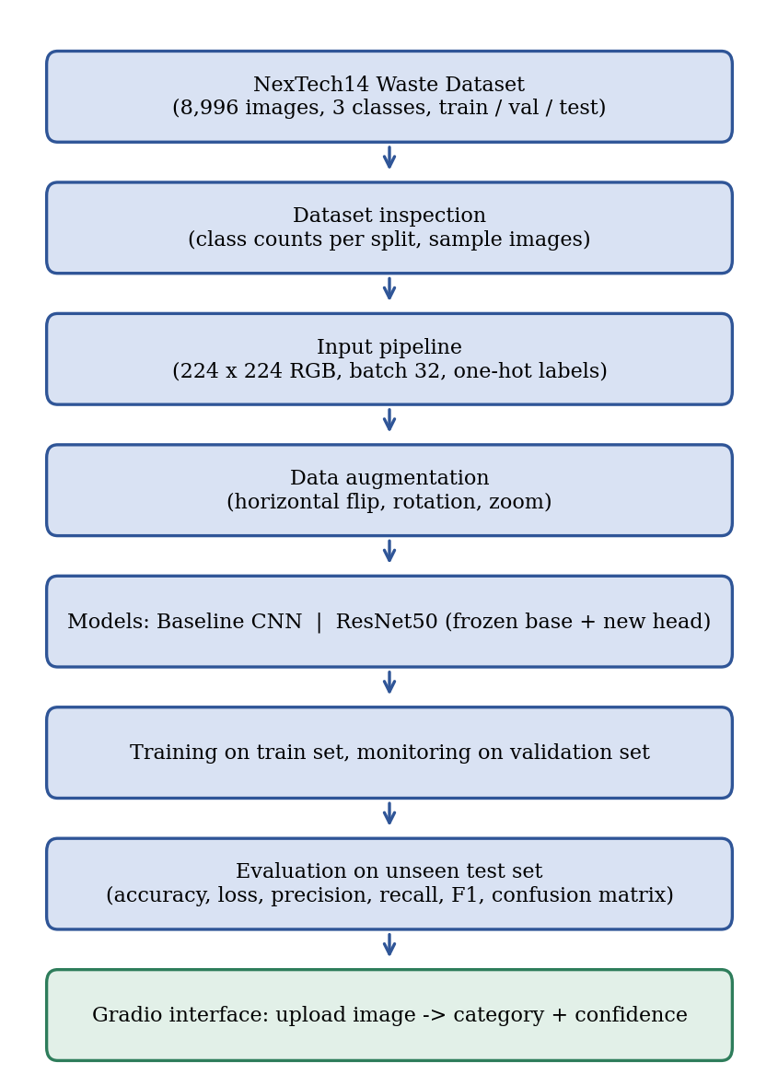
Figure 1: Workflow of the Waste Segregation Image Classifier (dataset to category prediction)
Table 1: Stages of the implemented pipeline
Stage | What is done | Tool used
Data loading | ZIP archive (NexTech14 Waste Dataset) copied from Google Drive and extracted; 8,996 images in train / val / test folders | zipfile, pathlib
Inspection | Images counted per class and split; random sample images displayed | pathlib, Matplotlib, PIL
Input pipeline | Images read from folders, resized to 224 x 224, batched (32) with one-hot labels | image_dataset_from_directory
Augmentation | Random horizontal flip, rotation and zoom applied to training images | Keras preprocessing layers
Modelling | Baseline CNN trained from scratch; ResNet50 (ImageNet weights, frozen base) with a new head | TensorFlow / Keras
Training | Adam optimiser, categorical cross-entropy; 3 epochs (CNN) and 2 epochs (ResNet50); early-stopping callback on validation loss | model.fit
Evaluation | Test accuracy and loss for both models; precision, recall, F1-score and confusion matrix for the baseline CNN | evaluate, scikit-learn, seaborn
Deployment | ResNet50 model saved (.keras) and served through a Gradio interface (EcoSort) | Gradio

2.4 Scope and Responsible-Use Statement
The scope of the project is limited to classifying a photograph of a waste item into Biodegradable, Recyclable or Hazardous using deep learning. The system is intended as a classification aid and not as a guaranteed sorting or safety system. The following boundaries apply to the whole report:
- The project is supervised: it learns from labelled images and predicts one of three classes. It does not identify the material or the specific object.
- A prediction can be incorrect. A Hazardous prediction does not make an item safe to handle, and a Biodegradable or Recyclable prediction does not replace local waste-disposal rules. The interface itself states that its output is an AI prediction and not a guarantee.
- The measurements come from one dataset and describe performance on images similar to it. They should not be read as a guarantee for photographs taken in other conditions, such as a camera mounted in a real bin.
- The interface is a classroom demonstration. Integration with sensors, cameras or a physical smart bin is outside the scope of this work.
- Example images shown in this report are taken from the dataset or supplied by the team and are used only to illustrate model behaviour.

3. Problem Statement
Waste is often placed in the wrong bin because people are unsure which category an item belongs to, and manual sorting at collection or processing points is slow and error-prone. Items differ in shape, colour, material and condition, they are photographed or seen under different lighting and against different backgrounds, and simple fixed rules (for example, "anything green is organic") fail on this variety. Mistakes are costly: recyclable material is lost, and hazardous items such as batteries end up in ordinary waste.
Therefore a machine learning-based system is required that analyses a photograph of a waste item and automatically classifies it as Biodegradable, Recyclable or Hazardous. This project builds such a system from labelled images, using a baseline CNN and a transfer-learning model based on ResNet50, compares them, and exposes the better model through a simple upload interface.
Table 2: Existing approach compared with the proposed approach
 | Existing approach | Proposed approach
Method | Manual sorting, or hand-written rules based on simple cues | Image preprocessing, augmentation and a trained deep neural network
Handling of visual variety | Only the cues a person remembers or writes down as rules | Visual patterns learned automatically from labelled images; augmentation adds robustness to flips, rotation and zoom
Adaptability | Rules must be revised by hand when new items appear | Model can be retrained or fine-tuned on new labelled images
Output | Subjective decision per item | Predicted category with class scores and measured accuracy on unseen images
Effort and cost | Requires trained people at every sorting point | Single model running behind a simple interface; low-cost pathway to smart bins

3.1 Case-Study Scenario
Consider a user who has a waste item and is unsure which bin it belongs in. The user opens the interface and uploads a photograph. The system converts the image to 224 x 224 pixels, passes it to the trained ResNet50 model, and receives three class scores that sum to one. The category with the highest score is shown together with its score and a short message.
For example, in the demonstration run in the notebook a photograph of fruit and vegetable scraps, including banana peels, potato slices and cucumber, was uploaded. The model classified it as Biodegradable and displayed a confidence of 100.00% (Figure 8). A photograph of a used battery would be expected to contain the visual patterns that were frequent in the Hazardous class during training and to be assigned to that class.
Case outcome. The system learns from previously labelled images and applies the learned patterns to new photographs. The case remains a classification aid: it does not inspect the material of an item, it does not decide how a hazardous item must be handled, and it does not replace the user's own judgement or local regulations.

3.2 Central Case-Study Question
The project is guided by the following central question:
How effectively can deep learning classify images of waste into Biodegradable, Recyclable and Hazardous categories, and how much does transfer learning with a pretrained ResNet50 improve on a baseline convolutional neural network trained from scratch?

3.3 Formal Problem Definition
Let D = {(x₁, y₁), (x₂, y₂), ..., (xₙ, yₙ)} be a collection of labelled images. Each image xᵢ is an array of 224 x 224 x 3 pixel values and its label yᵢ belongs to {Biodegradable, Recyclable, Hazardous}. The task is to learn a function fθ that maps an image to a vector p = (p₁, p₂, p₃) of class probabilities obtained through a softmax output layer. The predicted class is the one with the largest probability. The parameters θ are learned by minimising the categorical cross-entropy between the true one-hot labels and the predicted probabilities, using the Adam optimiser [5]. In the implementation n = 8,996 images, divided into 6,296 for training, 1,348 for validation and 1,352 for testing.
Table 3: Formal definition of the machine learning task
Element | Definition
Input | RGB image resized to 224 x 224 pixels (augmented during training); 8,996 labelled images in total
Process | Supervised training of a baseline CNN and of a ResNet50-based model on the training split, monitoring on the validation split, then prediction on unseen test images
Output | Predicted class for each image (Biodegradable, Recyclable or Hazardous) with three class probabilities
Goal | Classify unseen waste images correctly, with high accuracy and balanced precision and recall across the three categories
Learning type | Supervised learning, multi-class image classification (three classes)

3.4 Objectives that Guide the Study
- To prepare and inspect a labelled waste-image dataset with Biodegradable, Recyclable and Hazardous classes.
- To preprocess the images (resizing, scaling) and apply data augmentation so that the model is more robust to variations in orientation and scale.
- To implement a baseline convolutional neural network trained from scratch.
- To implement a transfer-learning model using a pretrained ResNet50 with a new classification head.
- To compare the two models using suitable evaluation measures, namely accuracy, loss, precision, recall, F1-score and the confusion matrix.
- To deploy the trained model through a simple interface that lets a user upload an image and receive an instant classification.

3.5 Assumptions and Limitations
Assumptions
- The images in the dataset are labelled correctly as Biodegradable (organic), Recyclable or Hazardous.
- The visual content of a photograph contains enough information to separate the three categories.
- The training, validation and test images come from the same source and distribution.
- The trained model is applied to new photographs that resemble the training images.
Limitations
- The experiments use one dataset. The source of the images, the conditions under which they were photographed and the labelling process are not documented in the notebook, so label quality is assumed and was not audited. One sample image labelled Biodegradable shows a heap of mixed packaging litter, which suggests that some labels may be ambiguous.
- Several sample images show black corners such as those produced by rotating a photograph, which suggests that the dataset may already contain augmented copies. No check was made for duplicate or near-duplicate images across the train, validation and test splits. If such copies exist, the test accuracy may be higher than performance on genuinely new photographs.
- Training was short: three epochs for the baseline CNN, whose validation loss was still falling, and two epochs for ResNet50. The baseline is therefore probably under-trained, and the gap between the two models should not be read as the pure benefit of transfer learning.
- The ResNet50 base was kept frozen; only the new classification head was trained. No fine-tuning of deeper layers and no systematic hyperparameter search was performed.
- Per-class precision, recall, F1-score and the confusion matrix were computed for the baseline CNN only. The ResNet50 model is reported by overall accuracy and loss, so its behaviour on each class, in particular on the Hazardous class, is not quantified.
- Each model was trained once with a single random seed, so no estimate of run-to-run variation is available. With 1,352 test images, one image changes the accuracy by about 0.07 percentage points.
- The three categories are coarse. Real waste can be mixed, dirty, packaged or made of several materials, and such cases were not studied.
- The abstract of the project also mentioned the TrashNet and Kaggle Waste Classification datasets and a MobileNetV2 model. These were not used in the final notebook (see Section 5.7).

4. Dataset and Exploratory Data Analysis

4.1 About the Dataset
The dataset used in this project is the NexTech14 Waste Dataset, supplied as a ZIP archive (174.1 MB) in the project folder on Google Drive. The folder also held a second archive, garbage_classification.zip (744.1 MB), but only the NexTech14 archive was extracted and used. The extracted dataset is already divided into three folders, train, val and test, and each of them contains three class folders: hazardous, organic and recyclable. The organic folder corresponds to the Biodegradable category, and the notebook renames it for display. In total the dataset has 8,996 images. The key facts are listed in Table 4.
Table 4: Summary of the dataset
Item | Value
Name | NexTech14 Waste Dataset (as supplied; extracted from NexTech14_Waste_Dataset.zip)
Data type | Colour photographs of waste items (jpg, jpeg, png, bmp or webp files)
Classes (3) | hazardous (Hazardous), organic (Biodegradable), recyclable (Recyclable)
Total images | 8,996
Training images | 6,296 (69.99%)
Validation images | 1,348 (14.98%)
Test images | 1,352 (15.03%)
Input size used | 224 x 224 pixels, 3 colour channels
Class index order used by Keras | 0 = hazardous, 1 = organic (Biodegradable), 2 = recyclable
The data are images and the labels are categorical, which makes the task a three-class problem. The classes are almost balanced (Section 4.4), which means that accuracy is a meaningful measure here, although per-class measures are still needed to see which category causes the errors.

4.2 Purpose of EDA
Exploratory Data Analysis (EDA) is carried out before modelling to understand the structure and quality of the dataset and to check that it is suitable for the techniques that follow. For an image dataset it aims to answer questions such as how many images each class has in each split, whether the classes are balanced, and what the images look like. Table 5 shows which aspects were examined in this project and which were not.
Table 5: EDA aspects and how they were addressed
EDA aspect | Addressed? | How
Number of images per split | Yes | Files counted per split with pathlib (Table 6)
Class distribution | Yes | Files counted per class in every split; bar and pie chart (Figure 2)
Visual inspection of samples | Yes | Random image grids per class (Figure 3)
Loading errors | Partly | Keras reported the same file counts as the manual count (6,296 / 1,348 / 1,352) and no loading error occurred during training or evaluation; no separate corruption check was run
Duplicate or near-duplicate images | No | Not checked
Image size and aspect-ratio statistics | No | Not computed; all images are resized to 224 x 224
Colour or pixel statistics | No | Not computed

4.3 Preparation Steps Actually Performed
The preparation steps present in the project notebook are listed in order in Table 6.
Table 6: Preparation steps performed
Step | Action | Result
1. Mount storage | Google Drive mounted in Colab; dataset folder located | Two archives found; NexTech14 archive selected
2. Extraction | NexTech14_Waste_Dataset.zip extracted with zipfile | Folder with train, val and test
3. Counting | Image files (jpg, jpeg, png, bmp, webp) counted per split and class | Train 6,296; val 1,348; test 1,352
4. Inspection | Random images of each class displayed | Visual check of content and labels (Figure 3)
5. Input pipeline | image_dataset_from_directory with image_size = (224, 224), batch_size = 32, label_mode = "categorical", seed = 42 | 197 training, 43 validation and 43 test batches
6. Ordering | Training data shuffled; validation and test data not shuffled (shuffle = False) | Fixed order, so predictions can be matched to labels in evaluation
7. Augmentation | Flip, rotation and zoom layers placed inside the models (Section 5.1) | Active during training only
8. Scaling | Pixel values divided by 255 in the CNN; ResNet50 preprocessing function in the ResNet50 model | Inputs match what each model expects
Class names and labels. Keras assigns class indices in alphabetical order of the folder names, giving hazardous = 0, organic = 1 and recyclable = 2. The display names used for results, Hazardous, Biodegradable and Recyclable, follow the same order. Labels are converted to one-hot vectors, which is required by the categorical cross-entropy loss.
What was not done. No images were removed, relabelled or balanced, and no images were checked for duplicates or corruption. The dataset arrived divided into training, validation and test folders, and this division was used as it was.
The key preparation code is shown below.
IMG_SIZE = (224, 224); BATCH_SIZE = 32; SEED = 42

train_ds = tf.keras.utils.image_dataset_from_directory(
DATASET_DIR / "train", image_size=IMG_SIZE, batch_size=BATCH_SIZE,
label_mode="categorical", seed=SEED)
val_ds = tf.keras.utils.image_dataset_from_directory(
DATASET_DIR / "val", image_size=IMG_SIZE, batch_size=BATCH_SIZE,
label_mode="categorical", shuffle=False)
test_ds = tf.keras.utils.image_dataset_from_directory(
DATASET_DIR / "test", image_size=IMG_SIZE, batch_size=BATCH_SIZE,
label_mode="categorical", shuffle=False)

print(train_ds.class_names) # ['hazardous', 'organic', 'recyclable']

4.4 EDA Exploration - Implementation
Class distribution
Table 7 and Figure 2 show the number of images in every class and split. The three classes are close to balanced: Recyclable is the largest class (3,196 images, 35.5%), followed by Biodegradable (2,950 images, 32.8%) and Hazardous (2,850 images, 31.7%), so the largest class is only about 1.12 times the size of the smallest. The class shares are almost identical in the three splits, which indicates that the split was made proportionally. A classifier that always answered "Recyclable" would reach an accuracy of only 480 / 1,352 = 35.50% on the test set, which is the reference level that any useful model has to exceed clearly.
Table 7: Number of images per class and split
Class | Train | Validation | Test | Total | Share
Hazardous | 1,994 | 427 | 429 | 2,850 | 31.68%
Biodegradable (organic) | 2,065 | 442 | 443 | 2,950 | 32.79%
Recyclable | 2,237 | 479 | 480 | 3,196 | 35.53%
Total | 6,296 | 1,348 | 1,352 | 8,996 | 100%
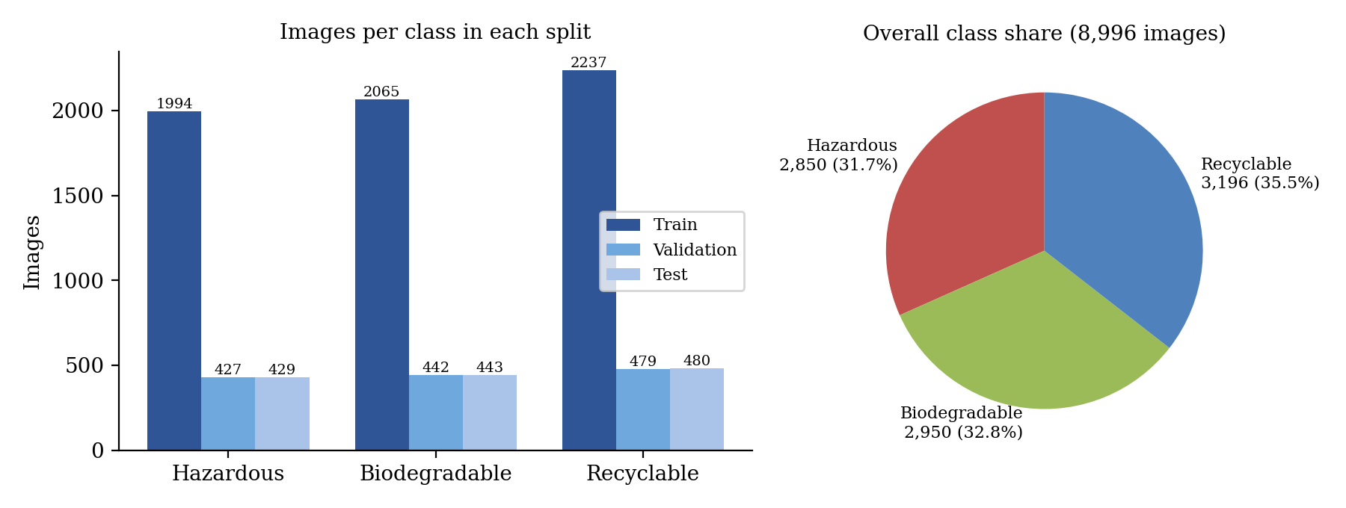
Figure 2: Number of images per class in each split (left) and overall class share (right)
Visual inspection of samples
Figure 3 shows randomly chosen training images of each class. The Biodegradable samples include a tea bag, a piece of fruit and a tea bag in a cup. The Recyclable samples include a cap, a plastic bottle and a small lid. The Hazardous samples are batteries. Most items are photographed alone on a plain, light background, which makes the task easier than classifying objects in cluttered scenes. Several samples have black corners, which is what remains after an image has been rotated, so some images in the dataset appear to be augmented copies. One Biodegradable sample shows a heap of mixed packaging litter instead of organic waste, a reminder that some labels may be noisy.
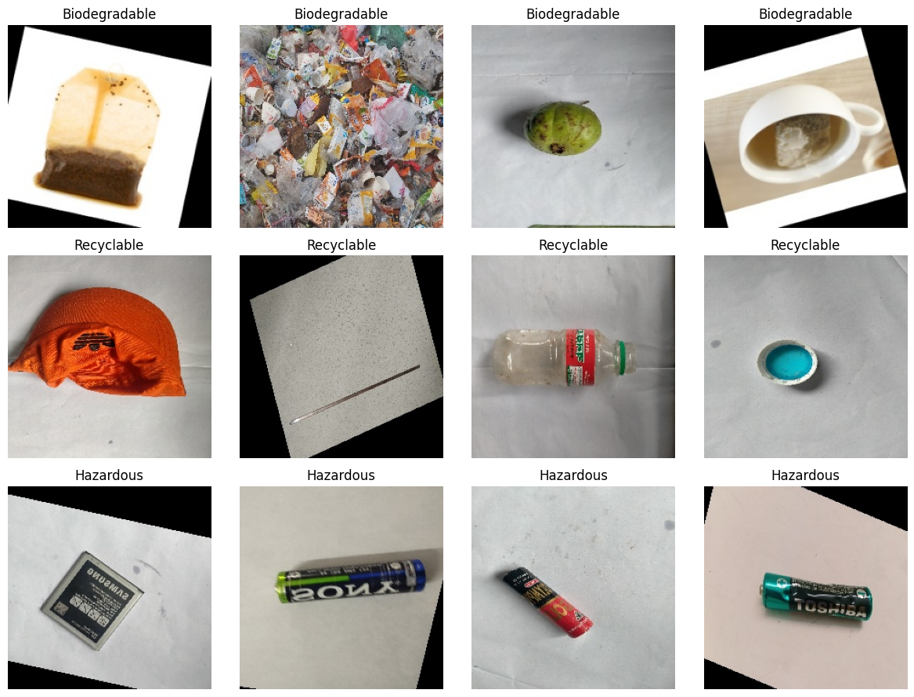
Figure 3: Random training images of each class (Biodegradable, Recyclable, Hazardous), as displayed in the notebook

4.5 Summary of EDA Findings
- The NexTech14 Waste Dataset has 8,996 labelled images in three classes, supplied as 6,296 training, 1,348 validation and 1,352 test images (about 70% / 15% / 15%).
- The classes are nearly balanced (31.7%, 32.8% and 35.5%) and have almost the same proportions in every split, so accuracy is a meaningful measure, with a majority-class reference of 35.50% on the test set.
- Items are mostly photographed individually against plain light backgrounds, which favours classification but may not match photographs taken in real bins.
- Some images show rotation artefacts, which suggests that augmented copies may already be present in the dataset. Duplicates across splits were not checked, so the test results may be optimistic.
- At least one sample appears mislabelled or ambiguous, so a small amount of label noise cannot be excluded.
- Image-size, colour and duplicate analyses were not carried out.

5. Algorithm Selection and Implementation
This section describes the data pipeline, the two models, how they were implemented and trained, and the results obtained. The project is a supervised multi-class classification task, so both models are evaluated on test images that were not used for training.
Algorithm followed
- Extract the dataset and count the images in every split and class.
- Build input pipelines that load the images at 224 x 224 pixels in batches of 32 with one-hot labels.
- Define the data-augmentation block (random flip, rotation and zoom).
- Build and train the baseline CNN on the training split, monitoring the validation split.
- Build the ResNet50 model with ImageNet weights and a frozen base, add a new classification head, and train the head on the training split.
- Evaluate both models on the test split; compute precision, recall, F1-score and the confusion matrix for the baseline CNN.
- Test the ResNet50 model on an uploaded photograph, save it, and serve it through a Gradio interface.
Implementation environment
Table 8: Software and libraries used
Item | Details
Programming language | Python 3
Environment | Google Colab notebook (Waste_Segregation_Image_Classifier.ipynb); dataset on Google Drive
Deep learning library | TensorFlow 2.21.0 with Keras [6]
Other libraries | NumPy, Matplotlib, seaborn, PIL (Pillow), scikit-learn [8] (classification_report, confusion_matrix), Gradio [10]
Pretrained weights | ResNet50 with ImageNet weights, downloaded through keras.applications
Random seed | 42 for the input pipeline (shuffling of the training data)

5.1 Data Pipeline and Augmentation
All images are resized to 224 x 224 pixels, the input size expected by ResNet50, and delivered in batches of 32 together with one-hot labels. Data augmentation creates slightly altered versions of the training images on the fly so that the network does not simply memorise the training photographs and becomes less sensitive to orientation and scale. The augmentation block consists of three Keras layers: a random horizontal flip, a random rotation with a factor of 0.08 (a fraction of a full turn, which corresponds to roughly plus or minus 29 degrees) and a random zoom of up to 10%. These layers are active only during training; during validation, testing and prediction they pass the images through unchanged.
data_augmentation = tf.keras.Sequential([
tf.keras.layers.RandomFlip("horizontal"),
tf.keras.layers.RandomRotation(0.08),
tf.keras.layers.RandomZoom(0.10)
], name="data_augmentation")

5.2 Baseline Convolutional Neural Network
A convolutional neural network applies small learnable filters across the image to detect local patterns such as edges and textures, uses pooling to reduce the image size, and combines the detected features in dense layers to produce class scores [7]. The baseline CNN of this project is a small network trained entirely from scratch, so it has to learn every visual feature from the 6,296 training images alone. It serves as the reference against which the transfer-learning model is judged.
The network applies the augmentation block and rescales the pixel values to the range 0 to 1. It then has three convolution and max-pooling blocks with 32, 64 and 128 filters of size 3 x 3 and ReLU activation, a global average pooling layer, a dense layer of 128 units with ReLU, a dropout layer with rate 0.3 [11] to reduce over-fitting, and a final dense layer with three units and softmax activation. Table 9 lists the layers.
Table 9: Architecture of the baseline CNN
Layer | Output shape | Parameters
Data augmentation, Rescaling (1/255) | 224 x 224 x 3 | 0
Conv2D (32 filters, 3 x 3, ReLU) | 222 x 222 x 32 | 896
MaxPooling2D | 111 x 111 x 32 | 0
Conv2D (64 filters, 3 x 3, ReLU) | 109 x 109 x 64 | 18,496
MaxPooling2D | 54 x 54 x 64 | 0
Conv2D (128 filters, 3 x 3, ReLU) | 52 x 52 x 128 | 73,856
MaxPooling2D | 26 x 26 x 128 | 0
GlobalAveragePooling2D | 128 | 0
Dense (128, ReLU) | 128 | 16,512
Dropout (0.3) | 128 | 0
Dense (3, softmax) | 3 | 387
Total (all trainable) |  | 110,147
The network was compiled with the Adam optimiser [5] at its default settings, the categorical cross-entropy loss and accuracy as the metric, and trained with an early-stopping callback that watches the validation loss (patience of 3 epochs, best weights restored).
baseline_cnn.compile(optimizer="adam",
loss="categorical_crossentropy",
metrics=["accuracy"])
callbacks = [tf.keras.callbacks.EarlyStopping(
monitor="val_loss", patience=3, restore_best_weights=True)]
history_cnn = baseline_cnn.fit(train_ds, validation_data=val_ds,
epochs=3, callbacks=callbacks)

5.3 Why Transfer Learning with ResNet50?
Transfer learning reuses a network that was already trained on a large dataset and adapts it to a new task [4]. ResNet50 [1] is a 50-layer residual network whose "skip connections" let the signal bypass groups of layers, which makes deep networks easier to train. When trained on the ImageNet collection [3], its early layers learn general visual features, such as edges, textures and shapes, that are useful for many kinds of images, including waste items. Reusing them means that only a small part of the model has to be learned from the 6,296 waste images, which is why transfer learning is attractive when data and computing power are limited.
In this project the ResNet50 convolutional base is loaded with ImageNet weights and frozen, so its 23,587,712 weights are not changed. A new head is added on top of it: global average pooling, a dense layer of 128 units with ReLU, a dropout layer of 0.3 and a dense softmax layer with three outputs. Only this head, with 262,659 parameters (1.1% of the total), is trained. The input passes through the same augmentation block and then through the preprocessing function of ResNet50 that matches its pretrained weights. The base is called in inference mode, so its normalisation statistics are not altered. Because the preprocessing is part of the model, an image can be given to the saved model as raw 0 to 255 pixel values, which is how the demonstration and the interface use it.
Table 10: Composition of the ResNet50 model
Component | Details | Parameters
ResNet50 base (frozen) | ImageNet weights, include_top = False, 224 x 224 x 3 input | 23,587,712 (non-trainable)
GlobalAveragePooling2D | Averages each of the 2,048 feature maps to one value | 0
Dense (128, ReLU) | 2,048 x 128 weights plus biases | 262,272
Dropout (0.3) | Randomly drops 30% of units during training | 0
Dense (3, softmax) | Output: probabilities of the three classes | 387
Total |  | 23,850,371 (262,659 trainable)
resnet_base = tf.keras.applications.ResNet50(weights="imagenet",
include_top=False, input_shape=(224, 224, 3))
resnet_base.trainable = False

x = data_augmentation(resnet_input)
x = tf.keras.applications.resnet50.preprocess_input(x)
x = resnet_base(x, training=False)
x = tf.keras.layers.GlobalAveragePooling2D()(x)
x = tf.keras.layers.Dense(128, activation="relu")(x)
x = tf.keras.layers.Dropout(0.3)(x)
out = tf.keras.layers.Dense(num_classes, activation="softmax")(x)

resnet_model.compile(optimizer=tf.keras.optimizers.Adam(learning_rate=0.001),
loss="categorical_crossentropy", metrics=["accuracy"])
history_resnet = resnet_model.fit(train_ds, validation_data=val_ds,
epochs=2, callbacks=callbacks)

Table 11: Explanation of the main code elements
Code | Explanation
image_dataset_from_directory(...) | Reads images from class folders, resizes them to 224 x 224 and returns batches of images with one-hot labels.
RandomFlip, RandomRotation, RandomZoom | Create randomly altered versions of the training images; inactive outside training.
Conv2D, MaxPooling2D | Learn local visual filters and reduce the spatial size of the feature maps.
GlobalAveragePooling2D | Replaces each feature map by its average, giving a compact feature vector.
Dropout(0.3) | Switches off 30% of the units at random in each training step to reduce over-fitting.
ResNet50(weights="imagenet", include_top=False) | Loads the pretrained convolutional base without its original 1,000-class output layer.
resnet_base.trainable = False | Freezes the pretrained weights so that only the new head is learned.
EarlyStopping(monitor="val_loss", patience=3) | Stops training if the validation loss does not improve for three epochs and restores the best weights.
model.evaluate(test_ds) | Computes loss and accuracy on the unseen test images.

5.4 Training and Evaluation Results
Training
The baseline CNN was trained for three epochs and the ResNet50 model for two epochs. The training log is summarised in Table 12 and plotted in Figure 4. The accuracy and loss of the baseline CNN were still improving when training ended, and its validation loss was lowest in the last epoch (0.5316), so the early-stopping callback did not intervene in either run. ResNet50 reached a validation accuracy of 98.59% after the first epoch and 98.52% after the second, while its validation loss fell from 0.0497 to 0.0398. The validation accuracy of the ResNet50 model is higher than its training accuracy in the first epoch because the training accuracy is measured on augmented images with dropout active. The time per epoch was about 14.4 minutes for the CNN and about 28 minutes for ResNet50 in the Colab session used; the accelerator type is not recorded in the notebook.
Table 12: Training log (accuracy and loss per epoch)
Model | Epoch | Train accuracy | Train loss | Val. accuracy | Val. loss
Baseline CNN | 1 | 66.26% | 0.6626 | 69.07% | 0.6366
Baseline CNN | 2 | 71.60% | 0.5927 | 77.60% | 0.5424
Baseline CNN | 3 | 73.92% | 0.5454 | 76.71% | 0.5316
ResNet50 | 1 | 92.65% | 0.1992 | 98.59% | 0.0497
ResNet50 | 2 | 97.95% | 0.0609 | 98.52% | 0.0398
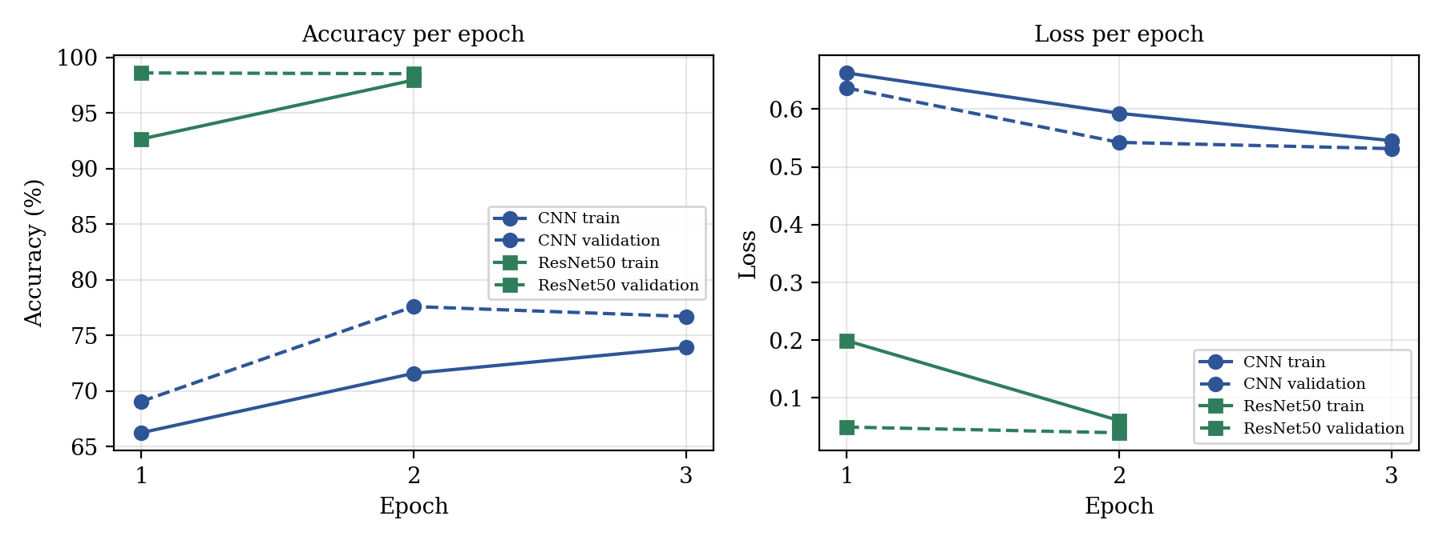
Figure 4: Accuracy and loss per epoch for the baseline CNN and ResNet50 (values from the training log)
Test-set results
Both models were then evaluated on the 1,352 test images. Table 13 and Figure 5 give the overall results. Accuracy is the share of images classified correctly, and the loss is the categorical cross-entropy, where lower is better.
Table 13: Test-set results of the two models
Model | Trained epochs | Test accuracy | Test loss | Correct / total | Errors
Baseline CNN | 3 | 74.56% | 0.5576 | 1,008 / 1,352 | 344
ResNet50 (frozen base, new head) | 2 | 98.52% | 0.0450 | 1,332 / 1,352 | 20
The ResNet50 model classifies 98.52% of the test images correctly, which is 23.96 percentage points above the baseline CNN, and it reduces the number of errors from 344 to 20. Both models are far above the 35.50% reference level of always predicting the largest class. The counts of correct images follow from the reported accuracies and the test-set size.
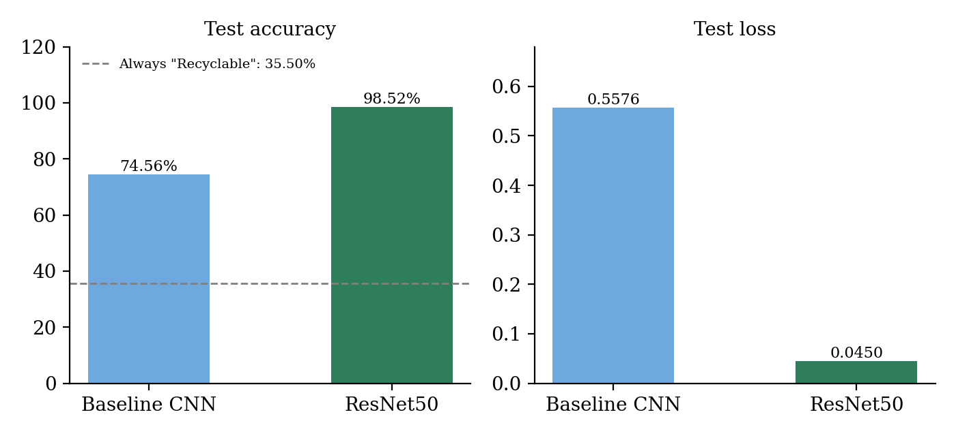
Figure 5: Test accuracy (left) and test loss (right) of the baseline CNN and ResNet50
Per-class results for the baseline CNN
Because certain categories are visually harder to distinguish than others, accuracy alone is not enough. For each class, precision is the share of images predicted as that class that really belong to it, recall is the share of the images of that class that were found, and the F1-score is the harmonic mean of the two. Table 14 and Figure 6 give these measures for the baseline CNN, and Figure 7 shows its confusion matrix.
Table 14: Per-class test results of the baseline CNN
Class | Precision | Recall | F1-score | Support
Hazardous | 73.78% | 81.35% | 77.38% | 429
Biodegradable | 85.12% | 82.62% | 83.85% | 443
Recyclable | 65.26% | 61.04% | 63.08% | 480
Macro average | 74.72% | 75.00% | 74.77% | 1,352
Weighted average | 74.47% | 74.56% | 74.42% | 1,352
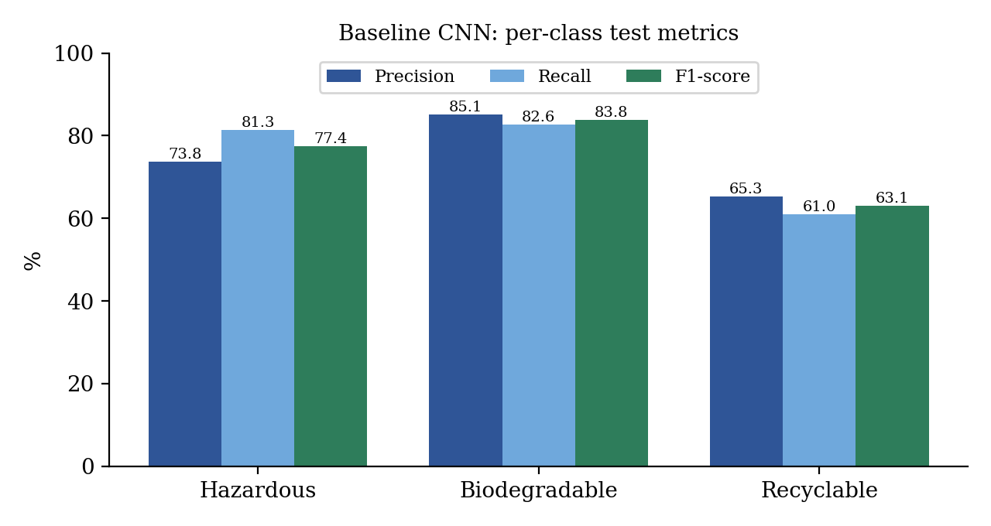
Figure 6: Precision, recall and F1-score of the baseline CNN for each class
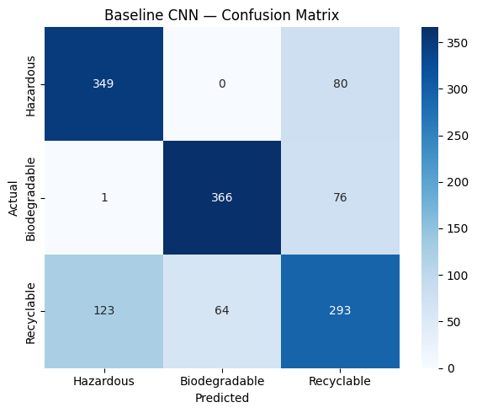
Figure 7: Confusion matrix of the baseline CNN on the test set (rows: actual class, columns: predicted class)
The baseline CNN separates Biodegradable items best (F1-score 83.85%) and Recyclable items worst (63.08%). Its main confusions involve the Recyclable class: 123 of the 480 Recyclable images were predicted as Hazardous and 64 as Biodegradable, and 80 Hazardous and 76 Biodegradable images were predicted as Recyclable. Almost no Hazardous image was confused with Biodegradable (0 and 1 images). A plausible reason, which was not tested separately, is that Recyclable is the largest class and covers the widest range of items, so it overlaps visually with both other classes. For a hazardous item, the 80 images (18.6% of 429) predicted as Recyclable are the most serious kind of error, since such an item would be sent to the wrong stream.
For the ResNet50 model no per-class measures or confusion matrix were computed in the notebook. Its class-wise behaviour, and in particular how many Hazardous items it misses among its 20 test errors, therefore remains unknown and is listed as future work.

5.5 Interface and Demonstration
The ResNet50 model was first tried on a photograph uploaded into the notebook. The photograph, shown in Figure 8, contains fruit and vegetable scraps, and the model returned the category Biodegradable with a displayed confidence of 100.00%. A single correct prediction is only a demonstration and not evidence of accuracy; the quantitative evidence is the test-set result in Table 13. A very high displayed confidence also does not prove that a prediction is right, because the softmax scores of a network are not guaranteed to be calibrated.
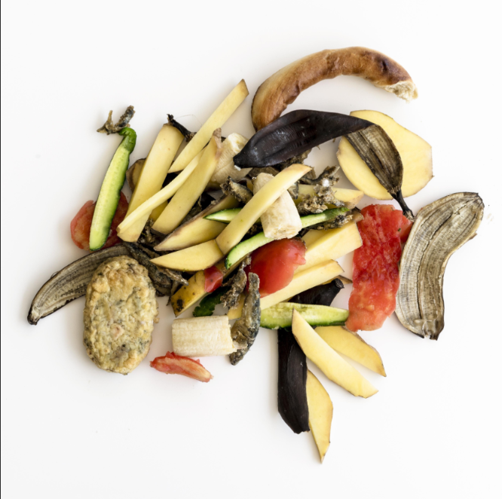
Figure 8: Demonstration image uploaded to the notebook, classified as Biodegradable (confidence displayed: 100.00%)
The model was then saved as resnet50_waste_classifier.keras and wrapped in a Gradio [10] web interface named EcoSort. The user uploads a photograph and presses a "Classify Waste" button. The function resizes the image to 224 x 224 pixels, runs the model, and returns the scores of the three classes together with a message: "likely biodegradable", "likely recyclable", or "may require special handling" for the Hazardous class. Every result is accompanied by the notice that it is an AI prediction and not a guarantee and that local waste-disposal rules should be followed. The interface was launched from Colab with a temporary public link that lasts for up to one week.
def classify_waste(image):
image = image.convert("RGB").resize((224, 224))
array = np.asarray(image, dtype=np.float32)[None, ...]
predictions = resnet_model.predict(array, verbose=0)[0]
best_index = int(np.argmax(predictions))
best_class = class_names[best_index] # Hazardous / Biodegradable / Recyclable
confidence = float(predictions[best_index]) * 100
...

5.6 Comparison of the Approaches
Table 15: Comparison of the baseline CNN and the ResNet50 transfer-learning model
Aspect | Baseline CNN | ResNet50 (transfer learning)
Type | Small convolutional network trained from scratch | Pretrained 50-layer residual network with a new classification head
Main idea | Learn all visual features from the waste images alone | Reuse ImageNet features and learn only the final classifier
Parameters | 110,147 (all trainable) | 23,850,371 (262,659 trainable)
Training | 3 epochs, about 14.4 min per epoch; accuracy still rising | 2 epochs, about 28 min per epoch; validation accuracy 98.5% from epoch 1
Test accuracy / loss | 74.56% / 0.5576 | 98.52% / 0.0450
Per-class results | Computed (F1-scores 63.08% to 83.85%) | Not computed
Strength in this project | Small, simple, a useful reference level | Very high accuracy with only two epochs of training of the head
Weakness | Weak on the Recyclable class; probably under-trained | Large model; class-wise errors not analysed; may be heavy for small devices
The two models answer the central question as follows. Deep learning can classify the three waste categories with high accuracy on this dataset, and the transfer-learning model is clearly the better of the two: it reaches 98.52% accuracy against 74.56% for the baseline and does so with a very short training of its head. Because the baseline was trained for only three epochs and the dataset may contain related images across the splits, the size of the difference should be treated with caution, but the direction of the result is consistent with the general benefit of reusing pretrained features.

5.7 Planned versus Implemented Work
The abstract submitted for the project described the intended work. Table 16 compares it with what the final notebook contains, so that the report states only what was actually carried out.
Table 16: Planned work (abstract) compared with the implemented work (notebook)
Item | Planned in the abstract | Implemented in the notebook
Dataset | TrashNet and Kaggle Waste Classification datasets | NexTech14 Waste Dataset (8,996 images); a second archive, garbage_classification.zip, was present on Drive but not used
Preprocessing and augmentation | Preprocessing and augmentation for robustness | Resizing to 224 x 224, scaling, random flip, rotation and zoom
Baseline | Baseline CNN trained for comparison | Implemented (110,147 parameters, 3 epochs)
Pretrained models | ResNet50 and MobileNetV2 with fine-tuned final layers | ResNet50 only; base frozen and a new head trained (no MobileNetV2)
Evaluation | Precision, recall, F1-score and confusion matrices for each category | Accuracy and loss for both models; precision, recall, F1-score and confusion matrix for the baseline CNN only
Deployment | Interface to upload or capture an image and receive an instant classification | Gradio interface with image upload (EcoSort); no live camera capture

6. Conclusion
This project applied deep learning to the classification of waste images into Biodegradable, Recyclable and Hazardous categories. The NexTech14 Waste Dataset of 8,996 images, divided into 6,296 training, 1,348 validation and 1,352 test images, was loaded at 224 x 224 pixels and augmented with random flips, rotations and zooms. A baseline CNN with 110,147 parameters was trained from scratch, and a ResNet50 model pretrained on ImageNet was adapted by freezing its base and training a new head of 262,659 parameters.
On the unseen test set the baseline CNN reached an accuracy of 74.56%, with the Recyclable class as its weakest category (F1-score 63.08%) and confusion between Recyclable and Hazardous items as the main error. The ResNet50 model reached an accuracy of 98.52% and a loss of 0.0450 after two epochs, about 24 percentage points above the baseline, which confirms that transfer learning is an effective and economical approach for this task. The trained model was saved and deployed in a Gradio interface that returns the predicted category and class scores for an uploaded photograph.
The project is a classification aid and not a guaranteed sorting or safety system. Several limits apply to the results: they come from one dataset that may contain related images across its splits, the models were trained for very few epochs and only once, the ResNet50 base was not fine-tuned, and per-class results were obtained for the baseline only. A prediction can be wrong, and a Hazardous or Recyclable prediction should not replace local waste-disposal rules.
Possible future extensions, which were not carried out in this work, include:
- computing precision, recall, F1-score and the confusion matrix for ResNet50, with particular attention to missed Hazardous items;
- checking the splits for duplicate and near-duplicate images, and testing the model on a separate dataset such as TrashNet or the Kaggle waste dataset, or on new photographs taken by the team;
- training the baseline for more epochs and fine-tuning the upper layers of ResNet50 with a low learning rate, so that the comparison is fairer;
- adding the lightweight MobileNetV2 model [2] for deployment on low-power devices;
- repeating the experiments with several random seeds to estimate the variation of the results;
- adding live camera capture and connecting the classifier to a prototype smart bin.

References
[1] He, K.; Zhang, X.; Ren, S.; Sun, J. Deep residual learning for image recognition. In Proceedings of the IEEE Conference on Computer Vision and Pattern Recognition (CVPR), 2016, pp. 770–778.
[2] Sandler, M.; Howard, A.; Zhu, M.; Zhmoginov, A.; Chen, L.-C. MobileNetV2: Inverted residuals and linear bottlenecks. In Proceedings of the IEEE Conference on Computer Vision and Pattern Recognition (CVPR), 2018, pp. 4510–4520.
[3] Deng, J.; Dong, W.; Socher, R.; Li, L.-J.; Li, K.; Fei-Fei, L. ImageNet: A large-scale hierarchical image database. In Proceedings of the IEEE Conference on Computer Vision and Pattern Recognition (CVPR), 2009, pp. 248–255.
[4] Pan, S.J.; Yang, Q. A survey on transfer learning. IEEE Transactions on Knowledge and Data Engineering 2010, 22(10), 1345–1359.
[5] Kingma, D.P.; Ba, J. Adam: A method for stochastic optimization. In International Conference on Learning Representations (ICLR), 2015.
[6] Abadi, M.; et al. TensorFlow: Large-scale machine learning on heterogeneous systems, 2015. Software available from tensorflow.org.
[7] LeCun, Y.; Bengio, Y.; Hinton, G. Deep learning. Nature 2015, 521, 436–444.
[8] Pedregosa, F.; et al. Scikit-learn: Machine learning in Python. Journal of Machine Learning Research 2011, 12, 2825–2830.
[9] Yang, M.; Thung, G. Classification of trash for recyclability status. CS229 project report, Stanford University, 2016.
[10] Abid, A.; Abdalla, A.; Abid, A.; Khan, D.; Alfozan, A.; Zou, J. Gradio: Hassle-free sharing and testing of ML models in the wild. arXiv:1906.02569, 2019.
[11] Srivastava, N.; Hinton, G.; Krizhevsky, A.; Sutskever, I.; Salakhutdinov, R. Dropout: A simple way to prevent neural networks from overfitting. Journal of Machine Learning Research 2014, 15, 1929–1958.
[12] NexTech14 Waste Dataset (zip archive of 8,996 waste images in train, val and test folders with classes hazardous, organic and recyclable), as used in the project notebook.
Signature of the Team members
Roll Number | Name of the Student | Signature
2520030265 | Haasini Reddy B
2520030285 | Arjun Tomar
Team No: 17 | Section: 1
Guide: Dr. G S Raghavendra
Signature of the Guide (remarks, if any): ______________________________

