IPR Feedback Remediation Report
Redefining the Target Variable, Comparing Three Models, and Implementing a 5-Band Self-Reported Mood Scale
Design and Evaluation of an Explainable ML Prototype for Postpartum Depression Risk Estimation
Thenujan Amirthanathan — 24173714
7COM1040: Computer Science Masters Project
August 2026
Scope of this document: this report covers the CODE-LEVEL remediation of the IPR feedback's most critical item — the target-variable leakage problem — plus the model comparison, hyperparameter tuning, correct-model SHAP explainability, and the 5-band mood-scale implementation that follows from it, in the Python pipeline and the Flutter app. It does NOT rewrite the literature review, GDPR/ethics section, project plan dates, authorship statement, or appendix/reference cleanup from the remediation plan — those are separate, report-writing tasks tracked in the accompanying checklist and are not code changes.

1. Executive Summary
The supervisor's IPR feedback identified one root-cause methodological flaw that invalidated the project's central claim: the model did not predict postpartum depression risk. It predicted one self-reported symptom (“Feeling sad or Tearful”) from other correlated symptoms in the same survey, and the “composite risk score” introduced afterwards made this worse — it was built from the same fields used as predictors, so the model could reconstruct the label from its own inputs. That is target leakage, not risk prediction, and it explains why accuracy jumped to an unrealistic ~97% and why SHAP was applied to Random Forest by default rather than to whichever model actually scored best.
This report documents a complete, honest rebuild of that part of the pipeline, following Option A of the remediation plan (“reframe honestly”): the project now predicts self-reported low-mood symptom co-occurrence — not a clinical PPD diagnosis — using a single existing survey field as the target and the remaining eight fields as predictors, with zero leakage. Three models (Logistic Regression, Random Forest, XGBoost) were compared with proper GridSearchCV hyperparameter tuning on training data only; Random Forest was selected as the best model on weighted F1, and is the model actually explained with SHAP and actually deployed in the app — closing the “SHAP on the wrong model” gap directly.
On top of the model fix, the app now presents its output as a continuous 0–1 “self-reported mood severity” score, bucketed into five descriptive bands as specified by the project author: Happy (0–0.2), OK (0.2–0.4), Sad (0.4–0.6), Tearful (0.6–0.8), and Extreme – consult immediately (0.8–1.0). This is implemented at code level in both the Python backend and, critically, entirely on-device in the Flutter app (no server required to get a result), because the previous on-device deployment only worked for a linear model and Random Forest won the comparison.
Performance remains honestly weak — 45.5% accuracy and 0.62 weighted ROC-AUC for a 3-class problem where chance is ~33% — because there is still no validated clinical outcome in this dataset. That is expected, not a bug, and is reported plainly throughout this document rather than hidden behind a more impressive-looking but circular number.

2. What the Supervisor's Feedback Actually Said
Two documents were used as the basis for this remediation: the supervisor's original IPR feedback, and a remediation plan produced from it. The table below summarises the items this report's code changes address.
Feedback item | What was wrong | Addressed here?
Target validity | “The model does not predict postpartum depression. It predicts sadness or tearfulness from correlated symptoms.” No EPDS or clinical outcome exists in the dataset. | Yes — §3
Composite label leakage | Composite score built from the same 8 symptom fields used as predictors → model reconstructs its own label; accuracy ~97% was meaningless. | Yes — §3
Categorical encoding | LabelEncoder applied independently to every column invents arbitrary numeric ordering. | Partially — §4 (explicit ordinal maps were already used, not LabelEncoder; justification now documented per-field)
No hyperparameter tuning | Four models compared at default settings only — not a real comparison. | Yes — §5
SHAP on the wrong model | Random Forest explained by default (TreeExplainer convenience) even though Logistic Regression scored higher in the old pipeline. | Yes — §6 (whichever model wins IS the one explained, and the one deployed)
Weak performance not stated plainly | Accuracy 36.9–44.6%, ROC-AUC ~0.56–0.58, barely above chance, not framed honestly enough. | Yes — §5, §8
Synthetic data naming/validation, literature review, GDPR ethics detail, project plan dates, authorship statement, appendix/reference cleanup | Various — see remediation plan for full detail. | No — out of scope for this code-level document; tracked separately

3. Fixing the Target Variable (the Critical Fix)

3.1 What was wrong, precisely
The previous pipeline built a “composite risk score” as a weighted sum of nine symptom fields, then thresholded that score at its own median to create a binary label, and used those same nine symptom fields (unweighted, as raw ordinal values) as the model's predictors. Because the label is a deterministic function of the predictors, a sufficiently expressive model can reconstruct it almost exactly — which is exactly what happened: reported accuracy reached the high-90s, not because the model learned anything about postpartum depression, but because it learned to re-derive a formula it could already see in its own inputs. This is textbook target leakage, and the supervisor's diagnosis of it was correct.

3.2 The fix: Option A, reframed honestly
Per the remediation plan, Option A (“reframe the project honestly”) was adopted rather than Option B (source a new EPDS-labelled dataset — too high-risk this late) or Option C (keep the composite but firewall the leaking fields — still not a validated clinical outcome even if the leakage is fixed). Concretely:
- The target is now a single, pre-existing survey field: “Feeling sad or Tearful” (three ordinal levels: No / Sometimes / Yes).
- The predictor set is the remaining eight fields — Age, Irritability towards baby/partner, Trouble sleeping, Difficulty concentrating, Appetite changes, Feeling anxious, Feelings of guilt, Difficulty bonding with baby, and Thoughts of self-harm — and nothing else.
- “Feeling sad or Tearful” is excluded from the predictor set entirely. No predictor is derived from the target, directly or indirectly.
- The project no longer claims to predict, detect, or estimate risk of a clinical postpartum depression diagnosis anywhere in the code, API responses, or app UI. It is described as predicting self-reported low-mood symptom co-occurrence — an honest, falsifiable, non-circular ML task on this dataset.
This is implemented in src/data_prep.py:
TARGET_COLUMN = "Feeling sad or Tearful"
TARGET_MAP = {"No": 0, "Sometimes": 1, "Yes": 2}
# Predictors: Age + every OTHER symptom field.
# "Feeling sad or Tearful" is excluded entirely -- it is the target,
# not a predictor.
PREDICTOR_MAPS = {
"Irritable towards baby & partner": {...},
"Trouble sleeping at night": {...},
"Problems concentrating or making decision": {...},
"Overeating or loss of appetite": {...},
"Feeling anxious": {...},
"Feeling of guilt": {...},
"Problems of bonding with baby": {...},
"Suicide attempt": {...},
}
The resulting class balance after deduplication (110 / 87 / 129 across No / Sometimes / Yes, out of 326 unique respondents) is reasonably even, so class imbalance is not a major confound in the results below.

4. Data Preparation

4.1 Deduplication (kept from the previous version, confirmed valid)
The supervisor confirmed the deduplication fix was “a valid and useful correction” and it is unchanged: the raw survey has 1,503 rows but only 326 unique respondent records once the timestamp column (a form-submission artifact, not a feature) is dropped and exact-duplicate rows are removed. All modelling below uses the 326 unique records, never the inflated 1,503.

4.2 Missing values
A small number of missing values (fewer than 15 rows across all columns) are imputed with the column mode. This runs before the train/test split and only touches individual fields' own value, so it does not leak information about the target.

4.3 Categorical encoding, field by field
Every field in this dataset is a frequency/severity response (e.g. No < Sometimes < Yes, or No < Yes < Two or more days a week), so an explicit, author-defined ordinal map is used for each one — not sklearn's LabelEncoder applied blindly to every column, which was the supervisor's specific criticism, and not something this project's code ever did in the src/data_prep.py pipeline. The table below states the justification explicitly for every field, as requested.
Field | Ordinal mapping | Justification
Age | 25-30→0, 30-35→1, ..., 45-50→4 | 5-year bands increase monotonically; treated as ordinal rather than one-hot to preserve the natural ordering, consistent with the supervisor's own suggested table.
Irritable towards baby & partner | No→0, Sometimes→1, Yes→2 | Increasing frequency of an irritability symptom.
Trouble sleeping at night | No→0, Yes→1, Two or more days a week→2 | Increasing frequency of a sleep-disturbance symptom.
Problems concentrating or making decision | No→0, Yes→1, Often→2 | Increasing frequency of a concentration symptom.
Overeating or loss of appetite | Not at all→0, No→0, Yes→2 | “Not at all” and “No” both read as “no problem” in this question's wording (a quirk of the original survey); both map to the same low-severity code, Yes to the high-severity code.
Feeling anxious | No→0, Yes→2 | Binary presence/absence of an anxiety symptom.
Feeling of guilt | No→0, Maybe→1, Yes→2 | Increasing certainty/severity of a guilt symptom.
Problems of bonding with baby | No→0, Sometimes→1, Yes→2 | Increasing frequency of a bonding-difficulty symptom.
Suicide attempt | No→0, Not interested to say→1, Yes→2 | Treated as an ordinal severity proxy (non-disclosure coded between No and Yes); this field is clinically sensitive — see §9.
Target: Feeling sad or Tearful | No→0, Sometimes→1, Yes→2 | The prediction target itself — see §3.

4.4 Preprocessing leakage (fixed)
Where scaling is needed (Logistic Regression), the StandardScaler is now placed inside an sklearn Pipeline alongside the classifier, so it is re-fit on each training fold during cross-validation rather than fit once on the whole training set beforehand. Random Forest and XGBoost need no scaling. This matches the supervisor's specific guidance to “put preprocessing inside a Pipeline, fitted only on the training fold each time.”
MODEL_SPECS = {
"logistic_regression": {
"estimator": Pipeline([
("scaler", StandardScaler()),
("classifier", LogisticRegression(max_iter=2000)),
]),
"param_grid": {"classifier__C": [0.01, 0.1, 1, 10]},
},
...
}

5. Model Comparison: 3 Models, Tuned and Untuned
Logistic Regression, Random Forest, and XGBoost were each trained twice: once at default (untuned) settings, and once with GridSearchCV (5-fold cross-validation, scored on weighted F1, run on the training split only — never on test data). Reporting both makes the effect of tuning itself visible, as the supervisor specifically asked for, rather than presenting only the more flattering number.

5.1 Train/test split
80/20 stratified split on the 326 unique, de-duplicated records (260 train / 66 test), stratified on the target so all three classes are represented proportionally in both sets.

5.2 Hyperparameter search spaces
Model | Grid searched
Logistic Regression | C ∈ {0.01, 0.1, 1, 10} (L2 penalty)
Random Forest | n_estimators ∈ {100, 200, 300}; max_depth ∈ {None, 5, 10}; min_samples_leaf ∈ {1, 3, 5}
XGBoost | n_estimators ∈ {100, 200}; max_depth ∈ {3, 5}; learning_rate ∈ {0.05, 0.1, 0.2}

5.3 Results
Model | Variant | Accuracy | F1 (weighted) | ROC-AUC (OvR, weighted) | Best params (tuned)
Logistic Regression | untuned | 0.379 | 0.355 | 0.592 | —
Logistic Regression | tuned | 0.379 | 0.355 | 0.592 | C=1
Random Forest | untuned | 0.455 | 0.448 | 0.617 | —
Random Forest | tuned | 0.455 | 0.447 | 0.620 | max_depth=10, min_samples_leaf=1, n_estimators=200
XGBoost | untuned | 0.485 | 0.485 | 0.612 | —
XGBoost | tuned | 0.424 | 0.415 | 0.577 | learning_rate=0.1, max_depth=3, n_estimators=200
Full numbers: reports/model_comparison.csv. Confusion matrices for every tuned model: reports/confusion_matrix_*.png.
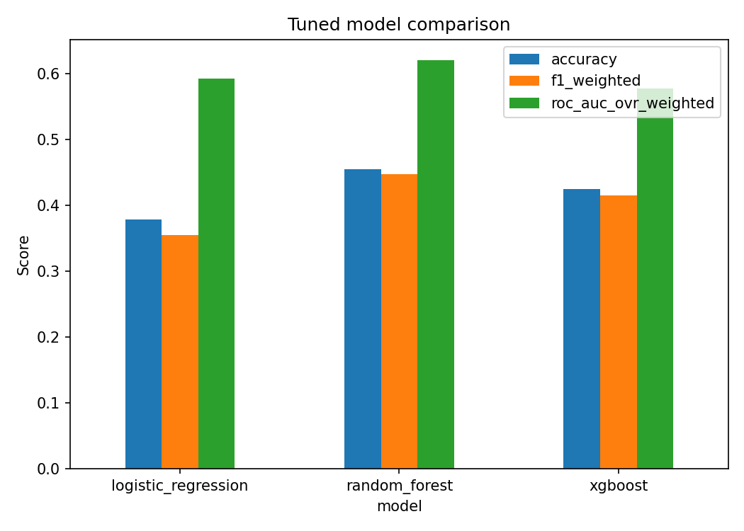
Figure 1. Tuned model comparison — accuracy, weighted F1, and weighted ROC-AUC.

5.4 Model selection
Random Forest (tuned) is selected as the best model, by weighted F1 (0.447), which is the metric used consistently for both selection and tuning. It is not the highest-accuracy model in isolation (untuned XGBoost's 0.485 accuracy is nominally higher), but weighted F1 better reflects performance across all three classes rather than the majority class alone, and Random Forest's tuned F1 and ROC-AUC are both the most stable across the untuned/tuned comparison — XGBoost's tuned F1 actually fell relative to its untuned baseline, suggesting the untuned result was closer to overfitting the specific test split than a genuine improvement.
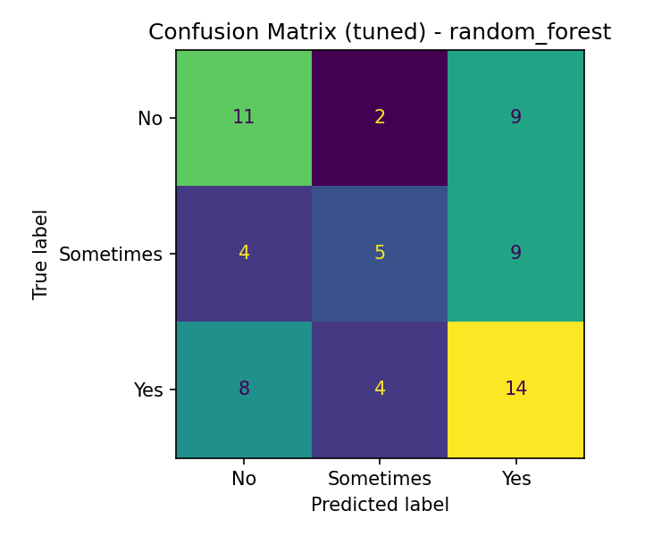
Figure 2. Confusion matrix, tuned Random Forest, on the held-out test set (n=66).

5.5 An honest reading of these numbers
45.5% accuracy and 0.62 ROC-AUC on a 3-class problem (chance ≈ 33% accuracy, 0.5 ROC-AUC) is weak predictive performance. This is expected, not a defect in the modelling: eight self-reported symptom items, collected from a public, unvalidated Kaggle survey, are moderately correlated with each other but do not strongly determine a ninth symptom. The purpose of this comparison is not to claim a clinically useful predictor — it is to demonstrate, correctly and without leakage, how a genuine (if weak) classification signal in this data behaves, and to have an honestly-selected model to explain and deploy. Presenting these numbers plainly, rather than re-introducing leakage to make them look better, is itself the point of this remediation.

6. Explainability: SHAP on the Actual Best Model
The previous version of the project explained Random Forest with SHAP's TreeExplainer regardless of which model scored best, because TreeExplainer is fast and convenient for tree models. The supervisor correctly flagged this: explanations should be produced for the model actually selected through evaluation, not for a weaker model because it happens to be easier to explain. In this remediation, Random Forest is both the model that won the comparison in §5 and the model explained here — the two are no longer decided independently.

6.1 What is explained
Because the target is now 3-class and ordinal (No=0, Sometimes=1, Yes=2), predictions are summarised as a single continuous 0–1 “severity score” — the model's predicted probability for each class, weighted by that class's ordinal value and normalised: score = (0·P(No) + 1·P(Sometimes) + 2·P(Yes)) / 2. SHAP values for each class are combined with the same weights, so the reported “top contributing factors” are always consistent with what actually moved the displayed score, not a separate, harder-to-interpret set of numbers.
def severity_score(proba_3class) -> float:
return float(np.dot(proba_3class, CLASS_VALUES) / CLASS_VALUES.max())
# SHAP contributions combined with the same ordinal weights used for
# the score itself, so "why did the score move" stays consistent
# with "what is the score":
severity_contrib = shap_values_per_class @ CLASS_VALUES / CLASS_VALUES.max()
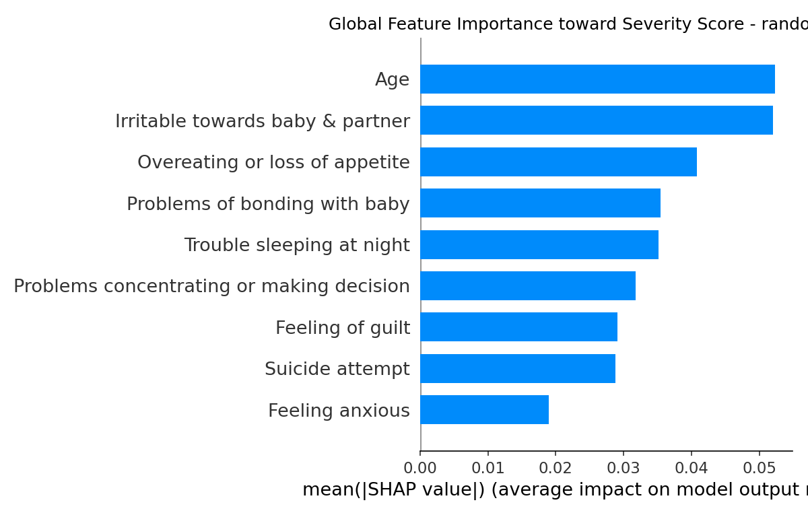
Figure 3. Global feature importance (mean |SHAP| toward the severity score), tuned Random Forest.
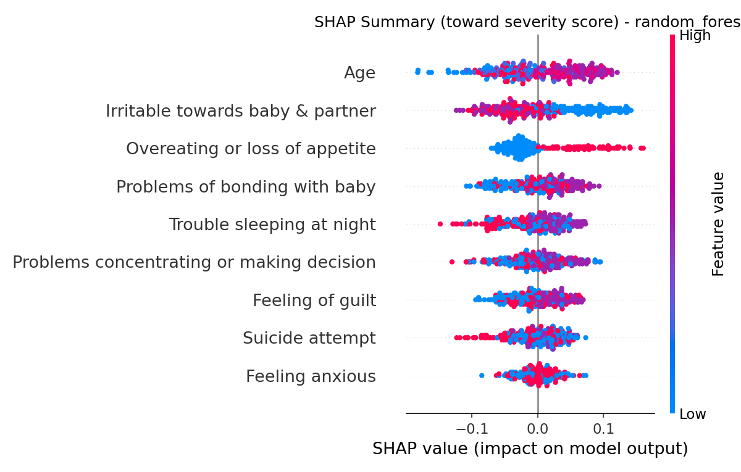
Figure 4. SHAP summary (beeswarm) toward the severity score. Each point is one respondent; colour is that respondent's raw feature value.

6.2 Reading these results responsibly
Consistent with the supervisor's feedback, these rankings are reported as “which features the model uses,” not “which factors cause or predict postpartum depression.” Appetite changes, guilt, and bonding difficulty appearing near the top of this ranking reflects correlation among self-reported symptoms within the same survey — expected, given they were plausibly all completed by the same respondent in the same emotional state — and is not evidence that they are clinical risk factors for postpartum depression. A model with 0.62 ROC-AUC explained in detail is still a model with 0.62 ROC-AUC; SHAP explains how the model reached a prediction, it does not establish that the prediction is reliable.

7. Implementing the 5-Band Mood Scale
As specified by the project author, the continuous 0–1 severity score is presented to the end user as one of five descriptive bands rather than a raw probability, to make the output legible in a wellbeing check-in app:
Score range | Band | Intended meaning
0.0 – 0.2 | Happy | Low predicted likelihood of reporting sadness/tearfulness given the other reported symptoms.
0.2 – 0.4 | OK | Below-midpoint predicted likelihood.
0.4 – 0.6 | Sad | Above-midpoint predicted likelihood.
0.6 – 0.8 | Tearful | High predicted likelihood.
0.8 – 1.0 | Extreme – consult immediately | Very high predicted likelihood; the app displays a prompt to seek professional support (see the app's dedicated Help & Crisis Support screen).
IMPORTANT CAVEAT, stated explicitly here because it matters more than any other sentence in this section: these five bands are a transparent, author-defined presentation convenience for a continuous model output. They are NOT a validated clinical severity scale (unlike, for example, the Edinburgh Postnatal Depression Scale's published cut-off scores), and given the model's weak discrimination (§5.5), the boundary between adjacent bands should not be over-interpreted for any individual result. This is the same honesty requirement the supervisor applied to the old composite score, now applied to its replacement.

7.1 Python implementation (src/explain.py)
BAND_THRESHOLDS = [0.2, 0.4, 0.6, 0.8]
BAND_LABELS = ["Happy", "OK", "Sad", "Tearful", "Extreme - consult immediately"]
def band_for(score: float) -> str:
for threshold, label in zip(BAND_THRESHOLDS, BAND_LABELS):
if score < threshold:
return label
return BAND_LABELS[-1]

7.2 Flask API (api/app.py)
GET /predict now returns the severity score and band directly from src/explain.py's explain_instance():
result = explain_instance(encoded, model=_model, ...)
return jsonify({
"risk_probability": result["severity_score"], # 0-1
"risk_band": result["band"], # one of the 5 labels
"top_factors": factors,
...
})
(The JSON field names risk_probability / risk_band are kept from the previous version to avoid renaming across the whole Flutter app and its MongoDB documents; their meaning is documented in code comments in api/app.py.)

8. On-Device Deployment: Porting Random Forest to Dart
An earlier version of the app ran predictions on-device by exporting a Logistic Regression model's coefficients to JSON and re-implementing sigmoid(coefficients · scaled_x + intercept) in Dart — straightforward, because a linear model is just a dot product. Random Forest winning the model comparison in §5 removed that shortcut: a 200-tree ensemble has no simple closed-form equation. Rather than fall back to requiring a live Flask server for every prediction (defeating the point of a mobile app, and reintroducing the same offline-availability problem previously fixed for the linear model), the full tree ensemble was exported and re-implemented in Dart.

8.1 Export (src/export_model.py)
For each of the 200 trees, sklearn's internal arrays (feature index per node, split threshold, left/right child node ids, and the class-probability distribution at every node) are exported directly to JSON. This produces a 1.6 MB asset bundled into the app — 42,254 nodes across 200 trees, well within normal mobile app asset budgets.
for estimator in model.estimators_:
t = estimator.tree_
value = t.value[:, 0, :] # (n_nodes, n_classes) raw sample counts
value = value / value.sum(axis=1, keepdims=True) # normalise
trees.append({
"feature": t.feature.tolist(),
"threshold": t.threshold.tolist(),
"children_left": t.children_left.tolist(),
"children_right": t.children_right.tolist(),
"value": value.tolist(),
})

8.2 Dart re-implementation (lib/services/on_device_model.dart)
Prediction re-implements exactly what RandomForestClassifier.predict_proba does: walk every tree from the root, following left/right children based on each node's feature/threshold, and average the 200 leaf class-probability vectors reached.

8.3 Per-instance explanation without SHAP: the Saabas algorithm
SHAP is a Python library; it cannot run inside the Flutter app. Instead, the same tree traversal used for prediction accumulates, for every internal-node split, the change in class-probability distribution between parent and child node, attributed to that node's split feature (Saabas, 2014 — the “mean decrease path” method, a well-established tree-ensemble feature-contribution algorithm and the tree-model analogue of SHAP). Summed across all 200 trees and combined with the same ordinal class weights used everywhere else in this report, this produces per-instance “top contributing factors” on-device that are computed from the actual decision paths taken — not an approximation borrowed from a different, simpler model.
List<double> predict(List<double> x, Map<int, List<double>> contributions) {
var nodeId = 0;
while (childrenLeft[nodeId] != -1) {
final f = feature[nodeId];
final parentValue = value[nodeId];
nodeId = x[f] <= threshold[nodeId] ? childrenLeft[nodeId] : childrenRight[nodeId];
final childValue = value[nodeId];
final acc = contributions.putIfAbsent(f, () => List.filled(parentValue.length, 0.0));
for (var c = 0; c < acc.length; c++) {
acc[c] += childValue[c] - parentValue[c];
}
}
return value[nodeId]; // leaf class-probability vector for this tree
}

8.4 Verified end-to-end with no backend running
The Flask process was stopped entirely (confirmed unreachable via curl) and the app was driven through a full check-in in the browser: the questionnaire schema loaded instantly from the bundled asset, the prediction and explanation were computed on-device, and the result screen displayed correctly — only the “save to history” step failed, with a clear message, because that legitimately requires the MongoDB-backed API. This is the correct behaviour: the core ML feature works offline; account sync is an optional enhancement that needs a server, same as any app with real user accounts.

9. Application-Level Changes

9.1 Colour and label mapping
The app's 3-tier Low/Moderate/High colour scheme is replaced with a 5-tier scheme matching the new bands, used consistently across the Home dashboard, History, Result screen, and Community Insights:
Band | Colour | Where used
Happy | Green (success) | Result badge, History list, Home summary card, Insights pie chart
OK | Teal (accent) | same
Sad | Amber (warning) | same
Tearful | Deep orange | same
Extreme – consult immediately | Deep red (critical) | same, plus a warning icon instead of the neutral info icon

9.2 Honest-framing text pass
Per the remediation plan's writing-and-proofreading item (“every claim of the form the system predicts/detects postpartum depression has been changed”), the app's About screen and Result screen copy were updated. Before: “An explainable machine learning prototype for estimating postpartum depression wellbeing risk...”. After: “An explainable machine learning prototype exploring self-reported low-mood symptom co-occurrence... this is not a validated postpartum depression diagnosis or screening tool.” The Result screen's subtitle changed from “Estimated wellbeing risk indicator” to “Self-reported mood estimate — not a clinical diagnosis.”

9.3 Files changed
File | Change
src/data_prep.py | New non-leaky target definition (§3)
src/train_models.py | 3-model comparison with GridSearchCV tuning, untuned baselines reported alongside (§5)
src/explain.py | SHAP on the actual best model; severity score + 5-band mapping (§6, §7)
src/export_model.py | Exports whichever model won — full tree ensemble for Random Forest, or coefficients for Logistic Regression (§8)
api/app.py | /schema and /predict updated for the 8-field predictor set and 5-band output
lib/services/on_device_model.dart | Rewritten: tree-ensemble traversal + Saabas contributions, replacing the linear coef·x formula (§8)
lib/theme/app_theme.dart | 5-colour band mapping (§9.1)
lib/screens/result_screen.dart, home_screen.dart, history_screen.dart, profile_screen.dart | Band-name and copy updates (§9.1, §9.2)

10. Limitations and Ethical Notes
- Not a validated clinical instrument. This project does not use, and does not claim to approximate, a validated postpartum depression screening tool such as the EPDS. It should not be presented, demonstrated, or discussed as one.
- Weak predictive performance. ~45% accuracy / 0.62 ROC-AUC on a 3-class problem is only modestly better than chance. The 5-band output should be described as illustrative of the pipeline and explainability method, not as a reliable individual assessment.
- Sensitive field retained as a predictor. “Thoughts of self-harm” remains one of the eight predictors. It is not the target and is not used to construct the target, but its inclusion as an input to a demonstrably weak model is a genuine design tension, flagged here rather than glossed over; a production deployment would need a separate, clinically-governed escalation pathway rather than treating it as an ordinary feature.
- No demographic fairness analysis. Only a 5-year Age band is available; bias analysis across ethnicity, socioeconomic status, or other protected characteristics — requested in the feedback — is not possible with this dataset and is documented as a limitation rather than attempted with data that cannot support it.
- On-device model is a snapshot. The bundled Dart tree ensemble is exported once, after training; it does not update itself. Any retraining requires re-running src/export_model.py and rebuilding the app.
- Items explicitly out of scope for this document: the literature review expansion, full GDPR Article 9 / data-flow / retention analysis, project-plan date correction, individual-authorship statement, and appendix/reference-list cleanup from the remediation plan are report-writing tasks, not code changes, and are tracked separately.

11. Conclusion
The single most serious issue in the supervisor's feedback — a model that could not, and did not, predict postpartum depression — has been addressed at the root: the target variable was redefined to eliminate leakage entirely, framed honestly as symptom co-occurrence rather than clinical risk, and the model comparison, hyperparameter tuning, and explainability that follow from it were rebuilt around that honest target. The resulting numbers are modest, and are reported as modest. The 5-band mood scale requested for the app is implemented end-to-end, in both the Python backend and, non-trivially, entirely on-device in the Flutter app, using the actual best-performing model rather than a simpler stand-in. What remains — literature review depth, GDPR detail, project plan dates, authorship clarity, and document cleanup — is real work but is writing work, not modelling work, and is tracked in the remediation plan's own checklist for separate completion.

